

IEEE COMPUTER SOCIETY SIT

THE UNVEILED SERIES EPSIDOE 7– RETRIEVAL AUGMENTED GENERATION

NAME OF THE ORGANIZING UNIT: IEEE COMPUTER SOCIETY SIT
DATE OF EVENT: Saturday , 6th January 2024
TOPIC: THE UNVEILED SERIES EPSIDOE 7 - RETRIEVAL AUGMENTED GENERATION
MODE OF EVENT: Online
TARGET AUDIENCE: Student Members
ATTENDANCE: 60
EVENT SUMMARY:
It is an online event which covered information about retrieval augmented generation. From Tomato graph to ground reality, It also Had discussion on cutting edge NLP techniques like tokenization, syntactical parsing,and POS tagging , followed by RAG concept to retrieve knowledge from DB.
TIMINGS: 7:00 pm – 8:30 pm
It is an online event , In this enlightening session, we explored cutting-edge NLP techniques like tokenization, syntactical parsing, NER, and POS tagging. The discussion extended to the innovative RAG concept, blending retrieval and generation methods for enhanced knowledge utilization. The session's success lay in its dynamic exchange, unveiling the forefront of NLP advancements. Participants gained insights into extracting meaningful information and contextual knowledge retrieval, ready for real-world applications. Overall, the session successfully intertwined theoretical knowledge with practical applications, empowering participants with valuable insights into the evolving landscape of NLP.

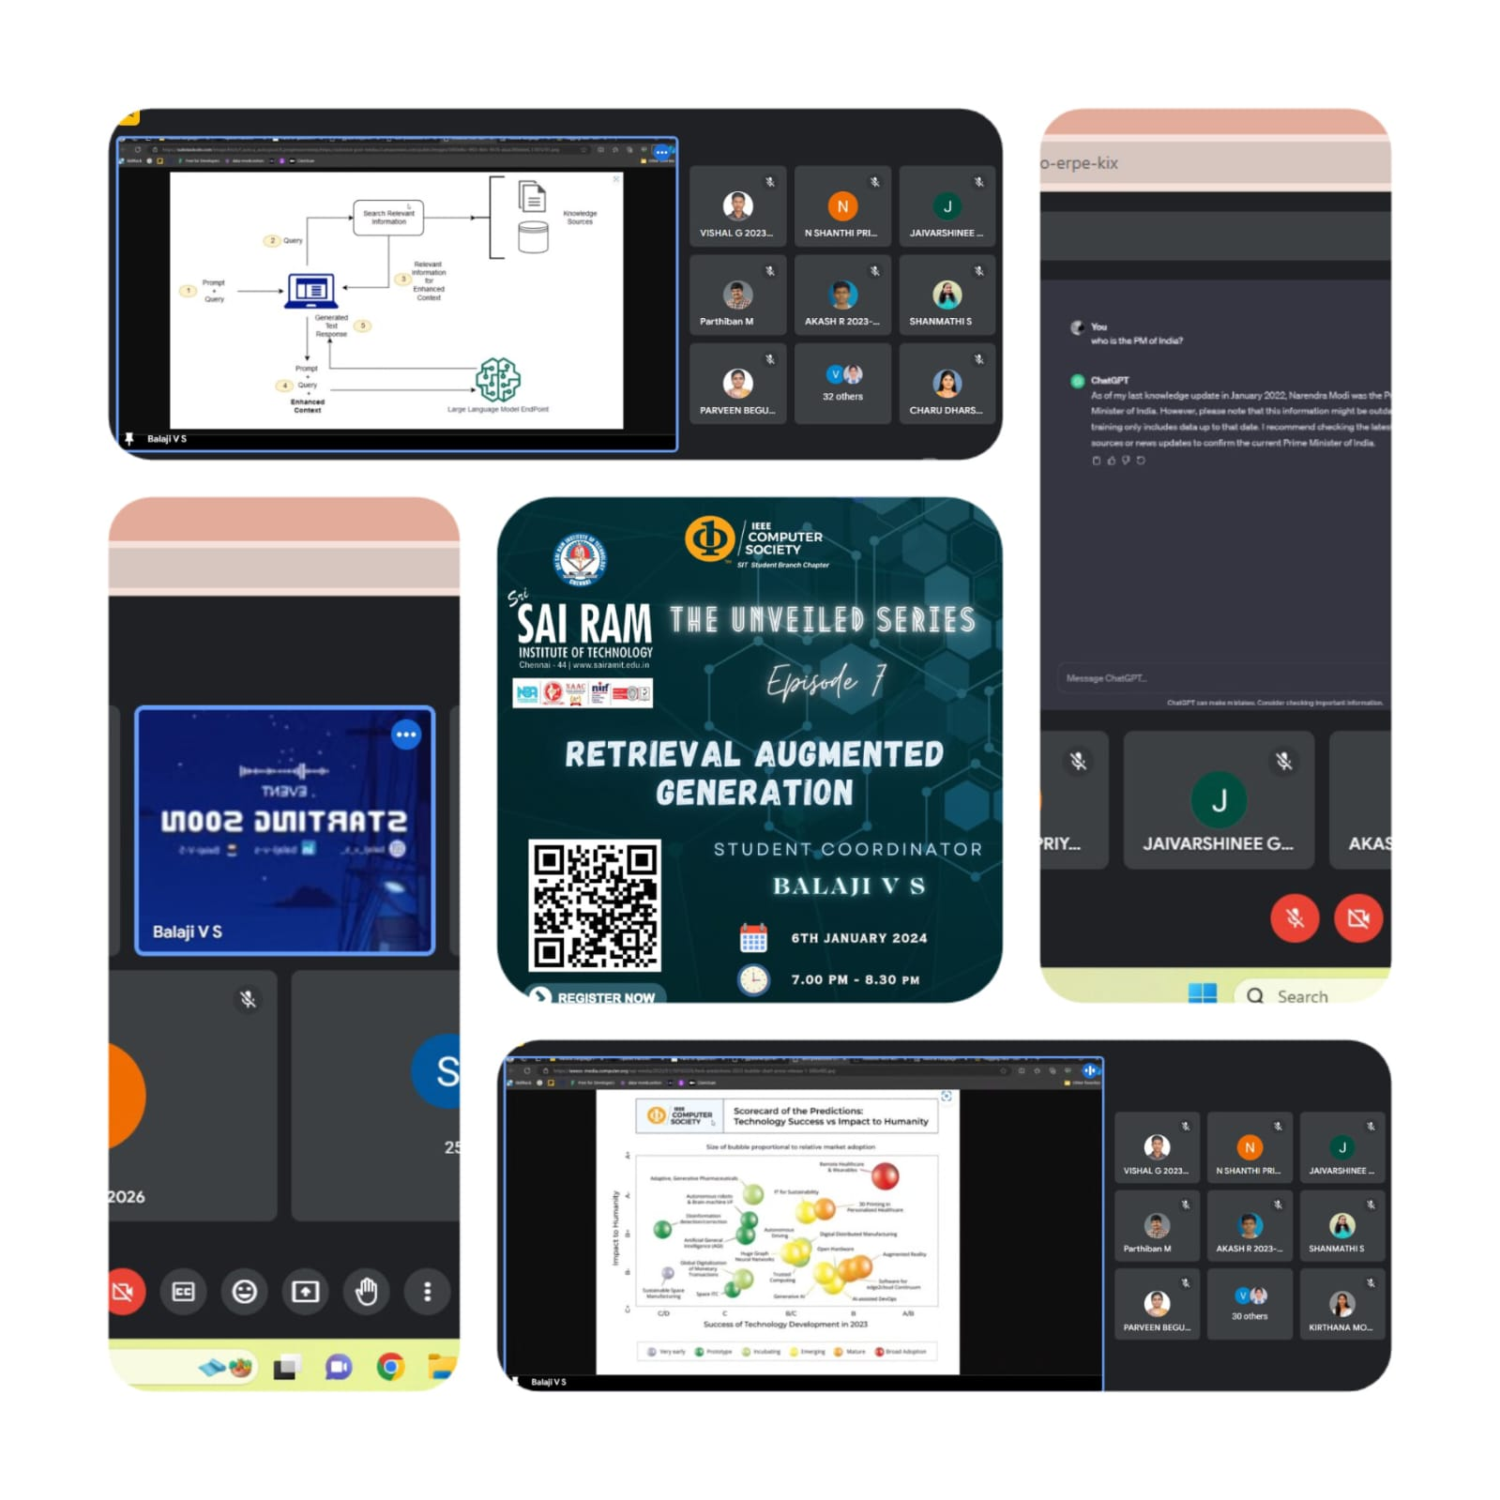
REPORTED BY:
KIRTHANA MOHAN R - – IEEE CS SECRETARY

