

IEEE COMPUTER SOCIETY SIT

BEHIND THE LENS – PHOTOGRAPHY AND VIDEOGRAPHY BASICS AND SCOPES
NAME OF THE ORGANIZING UNIT: IEEE COMPUTER SOCIETY SIT
DATE OF EVENT: Monday , 18th December , 2023
TOPIC: BEHIND THE LENS – PHOTOGRAPHY AND VIDEOGRAPHY BASICS AND SCOPES
MODE OF EVENT: Offline
TARGET AUDIENCE: Student Members
ATTENDANCE: 50
EVENT SUMMARY:
It is an offline event regarding photography and videography basics and scopes. The speakers illuminated the realm of photography, exploring cameras, modes, diverse photography genres, phone photography, editing tools, videography, career paths, and competitions.
TIMINGS: 1:15 pm – 4:00 pm
It is an offline event , where the speakers covered all the basics and the scopes around photography and videography. The speakers elaborated on the realms of photography , different camera modes , diverse photography genres and different editing tools for videography. The speaker also engaged with the students by providing information on the various competitions and career paths regarding photography and videography.

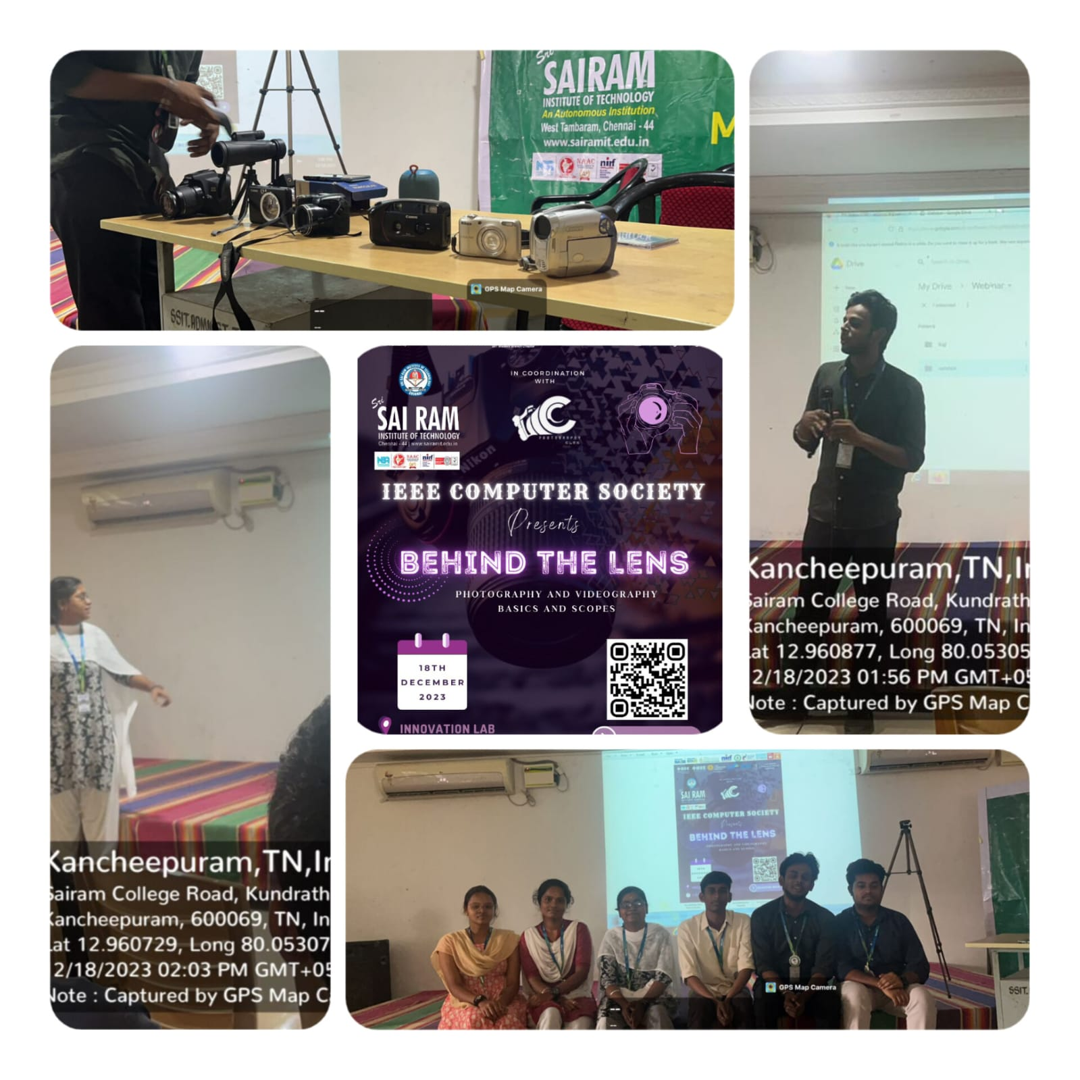

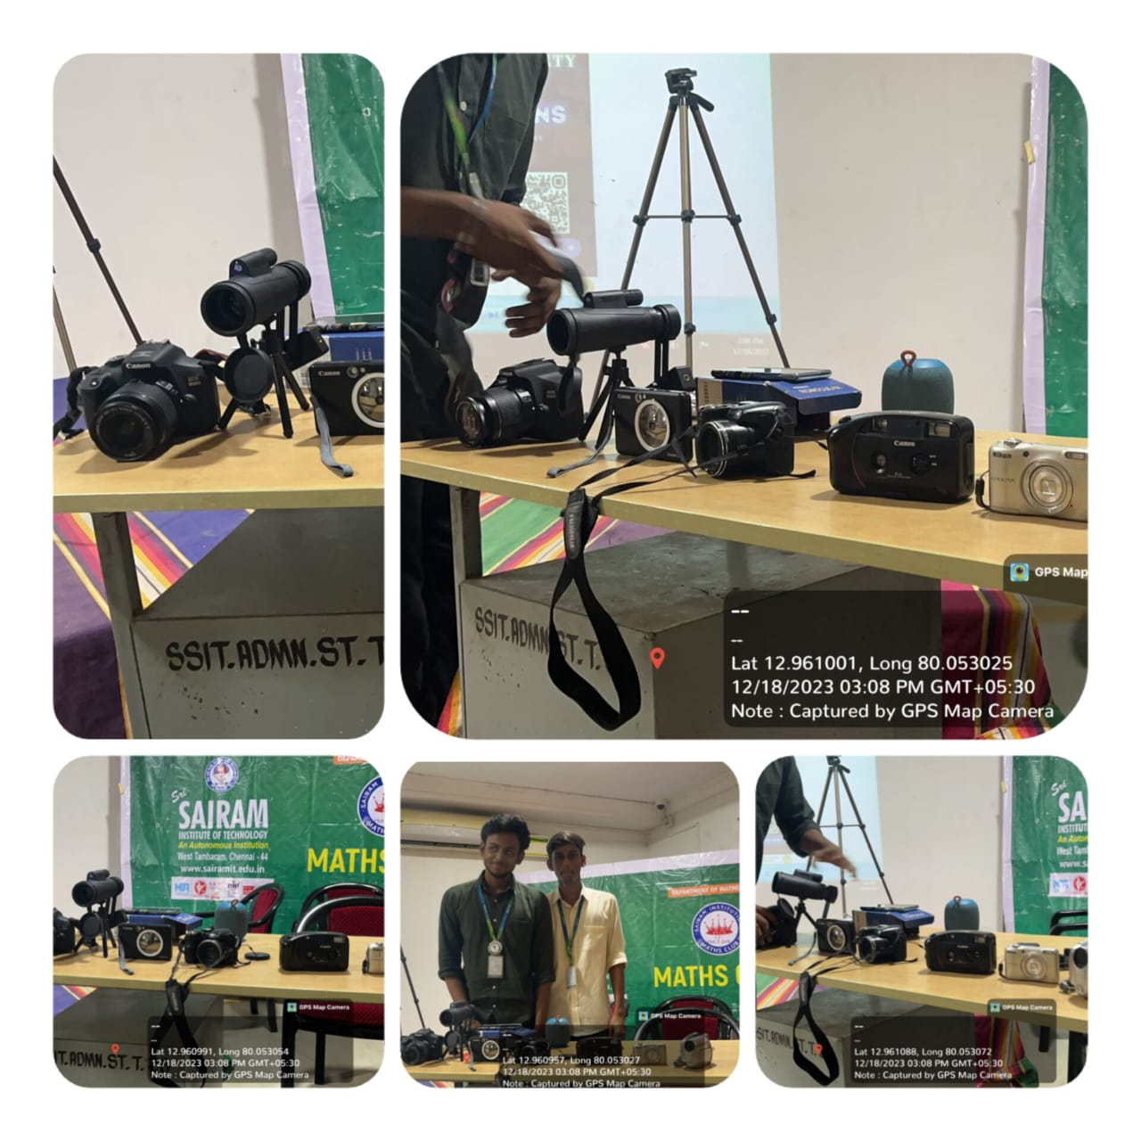

REPORTED BY:
KIRTHANA MOHAN R - – IEEE CS SECRETARY

