

IEEE COMPUTER SOCIETY SIT

THE UNVEILED SERIES EPSIDOE 6 – USING INDUSTRIAL AUTOMATION TO MONITOR VERTICAL FARMING

NAME OF THE ORGANIZING UNIT: IEEE COMPUTER SOCIETY SIT
DATE OF EVENT: Friday , 15th December , 2023
TOPIC: THE UNVEILED SERIES EPSIDOE 6 - USING INDUSTRIAL AUTOMATION TO MONITOR VERTICAL FARMING
MODE OF EVENT: Online
TARGET AUDIENCE: Student Members
ATTENDANCE: 60
EVENT SUMMARY:
It is an online event which covered information about Industrial automation in vertical farming involves using sensors, robotics, and AI to regulate environmental conditions, monitor plant health, and optimize resource usage
TIMINGS: 7:00 pm – 8:30 pm
It is an online event , where the speaker initially shared the information about monitoring farming using automation. Then they discussed about how the system precisely manages environmental factors like temperature, humidity, and light, monitors plant growth in real-time, automates tasks such as planting and harvesting, and analyzes data to optimize resource utilization. The event speaker covered a lot of details due to which students were been interactive throughout the session. A menti-meter quiz was also conducted by the speaker at then end of the meet in which the student actively participated.

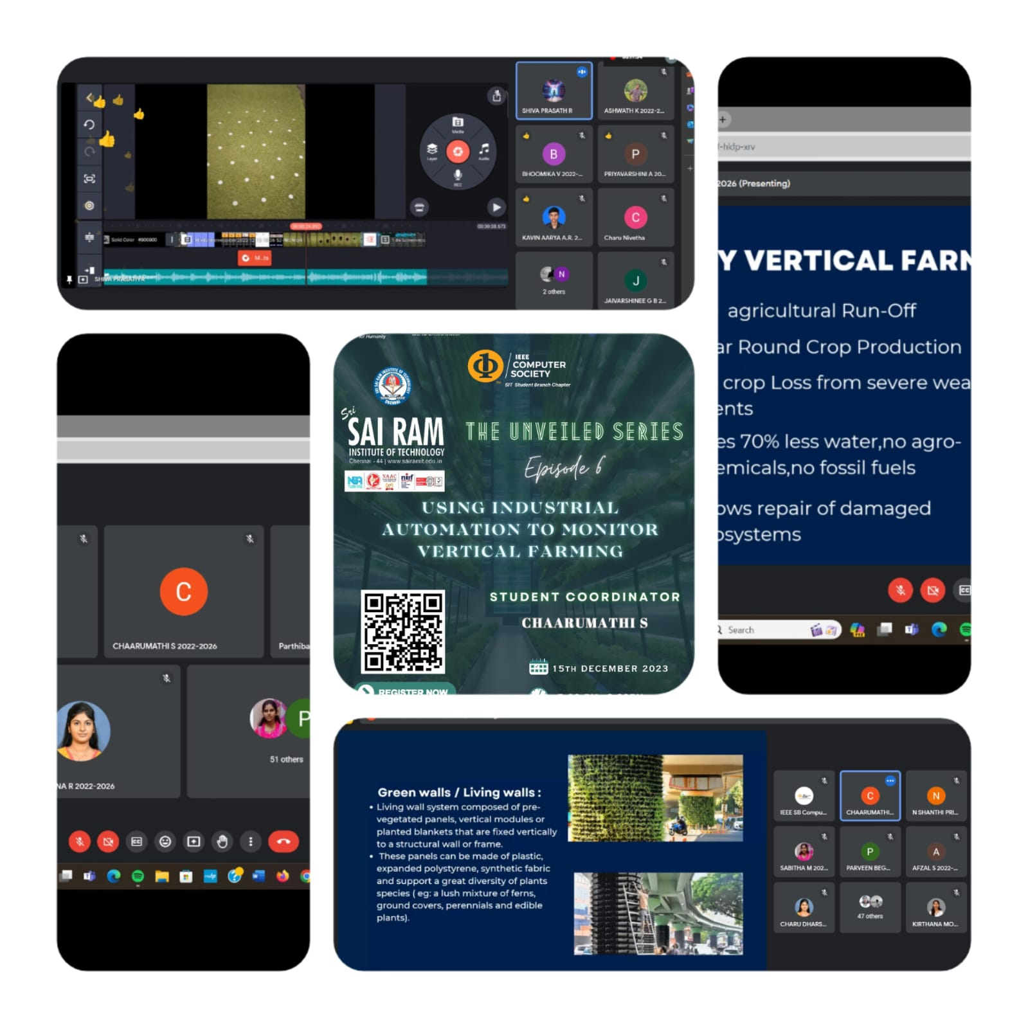

REPORTED BY:
KIRTHANA MOHAN R - – IEEE CS SECRETARY

