

IEEE COMPUTER SOCIETY SIT

THE UNVEILED SERIES EPISODE 10
UNLOCKING QUANTUM FRONTIERS AT AMBIENT CONDITIONS

NAME OF THE ORGANIZING UNIT: IEEE COMPUTER SOCIETY SIT

DATE OF EVENT: 1st April , Monday

TOPIC: THE UNVEILED SERIES EPSIDOE 10 - UNLOCKING QUANTUM FRONTIERS AT AMBIENT CONDITIONS

MODE OF EVENT: Online

TARGET AUDIENCE: Student Members
ATTENDANCE: 60

EVENT SUMMARY:
At the initial , in the event Quantum Computing at Ambient conditions was introduced. Foundational Principles of Quantum Theory concepts were like superposition , entanglement and enable quantum computing at ambient conditions. Along with the principals of quantum computing , the mechanics behind it , quantum algorithms and their potential applications were also taught. Its implications across various industries and its future directions were discussed in the end.
TIMINGS: 7:00 pm – 8:30 pm

Initially the shift towards quantum computing in everyday environments and the significance of quantum computing at ambient conditions were discussed. The speakers delved into the key concepts like superposition and entanglement.
The fundamental principles of quantum theory and mechanics of quantum computing was explained briefly along with their potential applications.
The further advancements in quantum technologies were explored and discussed. Later the implications of quantum computing across various industries and future directions were discussed.
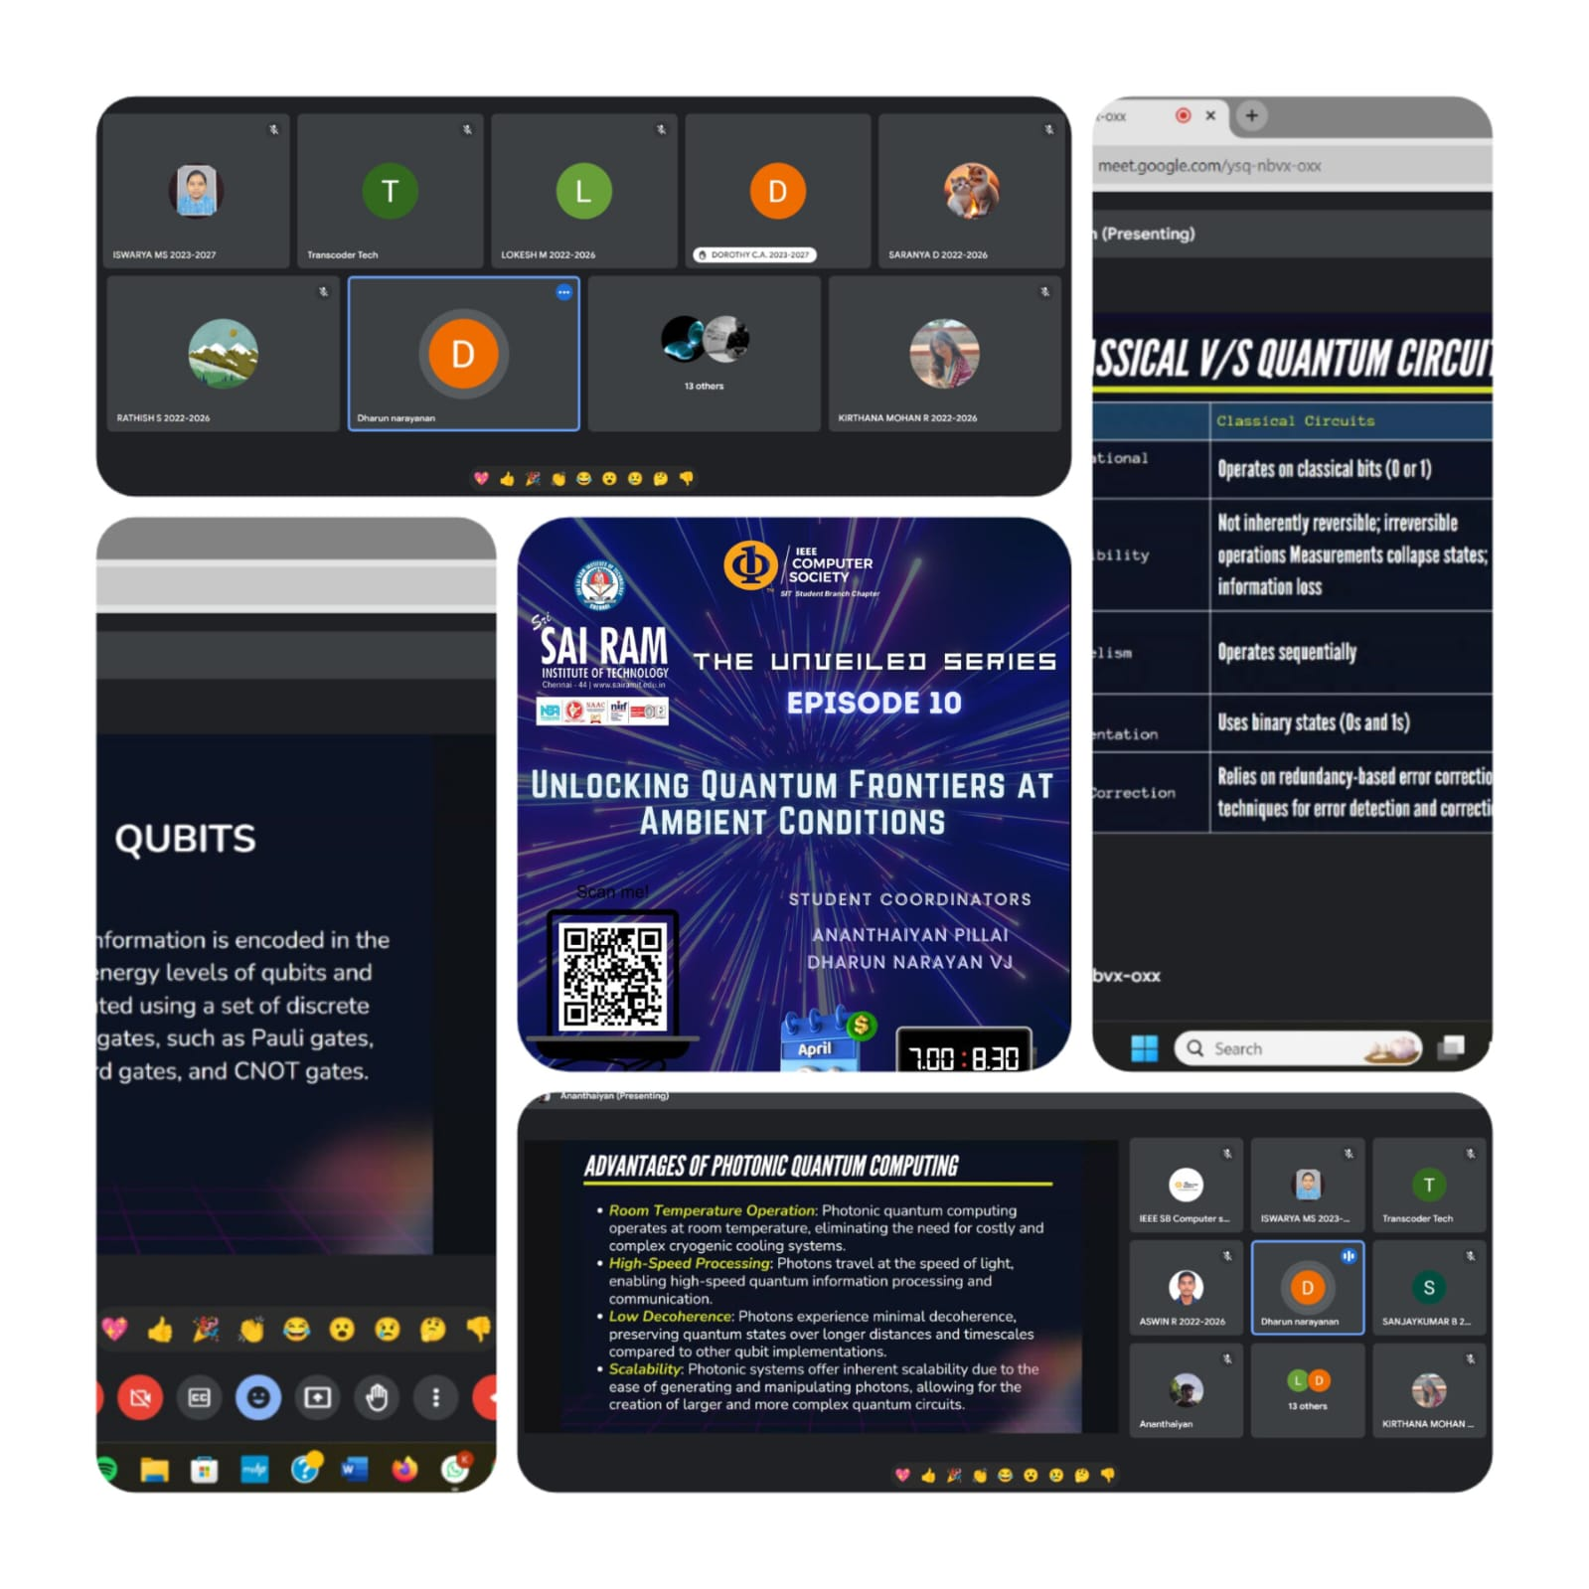
REPORTED BY:
KIRTHANA MOHAN R - – IEEE CS SECRETARY

