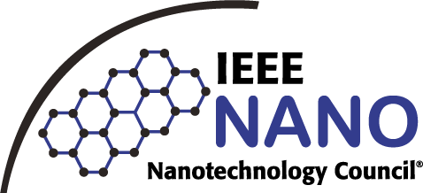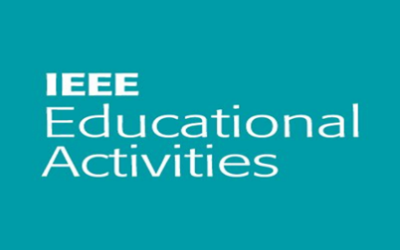

|  |  |
| --- | --- |
| **EVENT DETAILS** | C:\Users\Administrator\Downloads\IMG-20240416-WA0094.jpg  Group photo of the IEEE EA 2024 Program Virtually  With the digital landscape constantly changing, Cyber security is an ever evolving field. It must adapt to new technologies advancements, as well as shifts in the ways we use technology. As tech countries to become more closely interconnected with various aspects of our lives protecting our digital assets only becomes that much more important. IEEE Educational Activities, Hyderabad Section celebrates IEEE EA Celebration Week from 14 – 20 April 2024, as apart of the program, IEEE EA of Hyderabad Section organized a webinar on “Cyber security and its Significance under the theme of “Cyber Security and Sustainability (Waste Management) of IEEE Region 10 of EA. The Event was organized in association with WIE and NTC of Hyderabad Section and IEEE SRU Student Branch.  Speaker: Prof. Saikumar Tara, Chairman, IEEE EA, Hyderabad Section. |
| **Type of activity:**  A Webinar on ‘Cyber Security and its Significance ” as a part of IEEE EA Celebration Week.  **Section:**  Hyderabad Section  **Name of the Event:**  IEEE EA Celebration Week  **Dates/Duration:**  16/4/2024  **Organized by:**  IEEE Educational Activities, Hyderabad Section  **Host Organization:**  IEEE Educational Activities, Hyderabad Section  **Flyer/Banner:**  **Sponsored by:**  IEEE WIE, Hyderabad Section,  IEEE NTC ,Hyderabad Section,  IEEE SRU Student Branch |
| **Organizer/Contact person Details**  **Name**:Prof. Saikumar Tara  **Designation**: IEEE EA Chair,2024  **Mobile No**.: 9849702404  **Email id:**saikumar9@ieee.org | **Attendee Details:**  Target Audience: B.Tech, M.Tech Ph.D Scholar / Professional members  Registered participants:55  Attended participants:  IEEE members:40  Non-IEEE members: 15  Special awards/achievements (if any): |

**N.B.: Strictly adhere to this format. Do not change the text font size/style, spacing etc. in this format.Also fill the google form:** [**https://forms.gle/RosyPhDmeBguuyRJ8**](https://forms.gle/RosyPhDmeBguuyRJ8)f**For any queries, reach out us at- Dr G. Prasad Acharya (9849937691- gprasad04@gmail.com), Srivani (9063787131)**