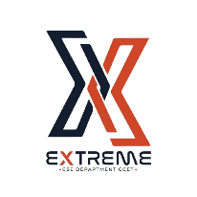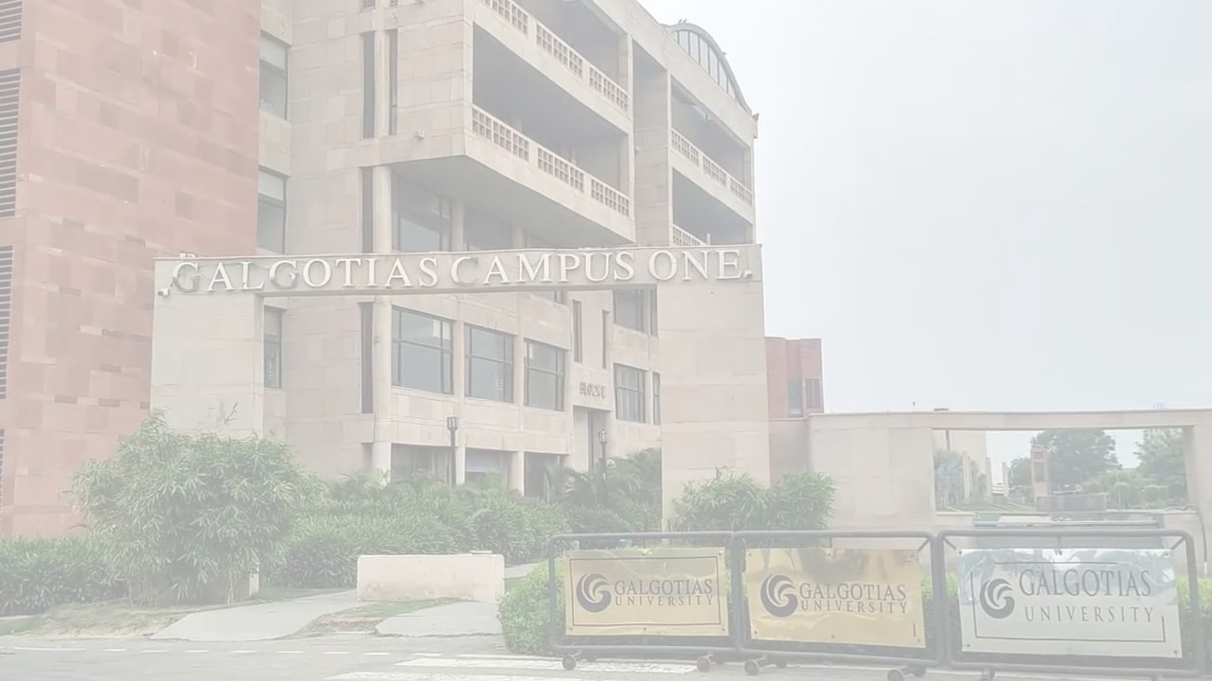



EVENT

REPORT

**REPORTED BY:**

Editorial Team, Extreme Club and STB07021

**GALGOTIAS COLLEGE OF ENGINEERING AND TECHNOLOGY**

A Seminar On Java With

Springboot Microservices

|  |
| --- |
| *By:- Manish Bhatia*  *Co-founder Codesquadz* |

|  |  |
| --- | --- |
| **Date** | 5th March, 2024 |
| **Time** | 2:30pm – 5:00pm |
| **Venue** | D-Block Auditorium, Galgotias College of Engineering and Technology |

|  |
| --- |
| **EVENT DETAILS** |
| The Extreme Club of CSE Department and STB07021 organized a **Seminar on JAVA WITH SPRINGBOOT MICROSERVICES by Manish Bhatia ( Co-founder codesquadz).** The Seminar was highly informative and engaging.  Mr. Bhatia expertly elucidated the intricacies of developing **microservices using Java and Spring Boot**, highlighting best practices and real-world applications. Attendees gained valuable insights into architecting scalable and efficient microservices-based systems, with Bhatia's deep industry experience shining through in his clear explanations and practical examples.  The seminar served as an excellent platform for knowledge exchange and networking among students, faculty, and industry professionals alike, further solidifying the CSE department's commitment to staying at the forefront of cutting-edge technology education. Students from all the branches had participated in the event. |

|  |  |
| --- | --- |
| **E**  **V**  **E**  **N**  **T**  **P**  **O**  **S**  **T**  **E**  **R** |  |

|  |  |  |
| --- | --- | --- |
|  |  | **E**  **V**  **E**  **N**  **T**  **P**  **I**  **C**  **T**  **U**  **R**  **E**  **S** |
|  |  |

|  |  |
| --- | --- |
| LEARNING OUTCOMES | |
| LO 1 | Participants gained a comprehensive understanding of Java programming language fundamentals, including syntax, data structures, and object-oriented principles, enabling them to develop robust applications. |
| LO 2 | Attendees acquired practical skills in building microservices architecture using Spring Boot framework, learning how to create RESTful APIs, implement security measures, and integrate with various databases. |
| LO 3 | By the end of the seminar, participants were be able to apply their knowledge of Java and Spring Boot to design and develop scalable, efficient, and maintainable microservices-based applications, empowering them to contribute effectively to modern software development projects. |

**Reported By:**

Kritika Singh, CSD

Ridhi Rajput, CSE-B

|  |  |
| --- | --- |
| EVENT SUMMARY | |
| Title of the event | Java With Springboot Microservices |
| Start time | 2:30 pm |
| End Time | 5:00 pm |
| Category of the event | Interactive |
| Sub- Category of the event | Informative |
| Time Zone | India |
| Primary Host Organization Unit | Galgotias College of Engineering and Technology (STB07021) |
| Primary Host Contact Event | sachin.kumar@galgotiacollege.edu |
| Platform | Offline, D-Block Auditorium |
| Physical Address | Galgotias College of Engineering and Technology, Knowledge Park-2, Greater Noida, Uttar Pradesh, India |
| Registration Starts/Date | 04/03/2024 |
| Registration Ends/Date | 05/03/2024 |
| Participants | Students of GCET |
| Number of Participants | 100 |
| Event Co-ordinator | Ms. Arti Ranjan  Mr. Rajiv Kumar Nath  Ms. Shikha Singh |