A Report on the Celebration of World Telecommunication and Information Society Day
Of
IEEE ComSoc Chapter-Guwahati (Kolkata Section) and IEEE Guwahati Subsection

On the occasion of World Telecommunication and Information Society Day (May 17, 2024), we conducted the following events:
- The PhD research scholars and MTech final year students presented posters from their recent research work in the broad areas of communication and networks in the EEE Department Foyer from 11 AM to 12.30 PM.
- We had two invited technical talks from well-known academicians, Prof. Manav Bhatnagar (IIT Delhi) and Prof. Sudhan Majhi (IISc Bangalore), in the EEE Seminar Room from 3.15 PM - 4.15 PM and 4.15 PM - 5 PM, respectively.

The details of the events are summarized below:
Event 1: Poster Presentations
Poster Presentations: PhD research scholars and MTech final year students
Venue: EEE Department Foyer, IIT Guwahati
Time: 11.00 am to 12.30 pm (IST)
Date: May 17, 2024 (Friday)
Mode: In person

There were in total a 6 participants presented the posters from their recent research work in the broad areas of communication and networks. The participants were PhD research scholars and MTech final year students from the department of Electronics and Electrical Engineering (EEE), Computer Science and Engineering (CSE), and the School of Data Science & Artificial Intelligence.

Photos from the event 1:

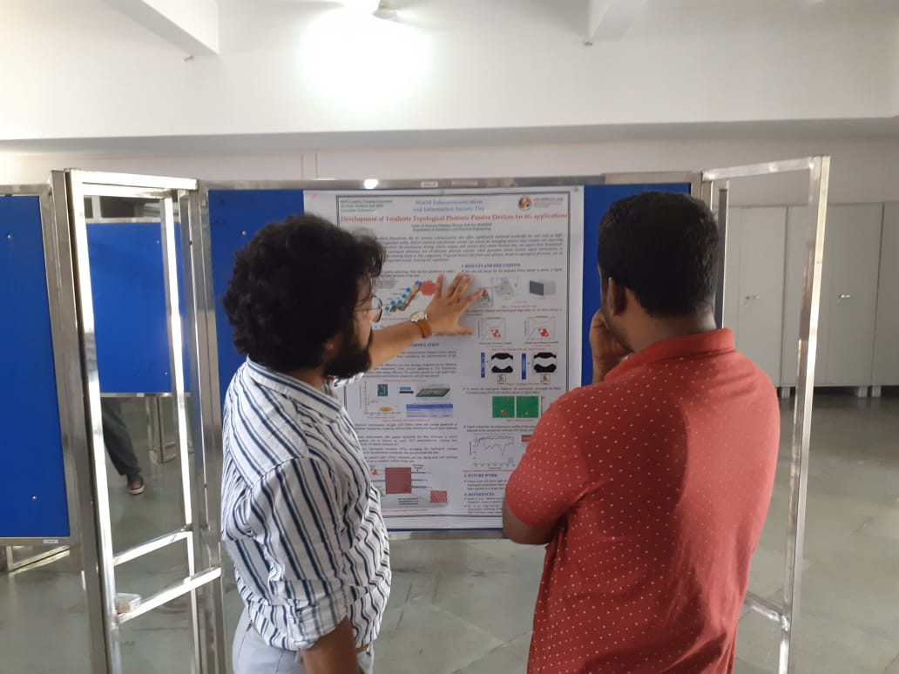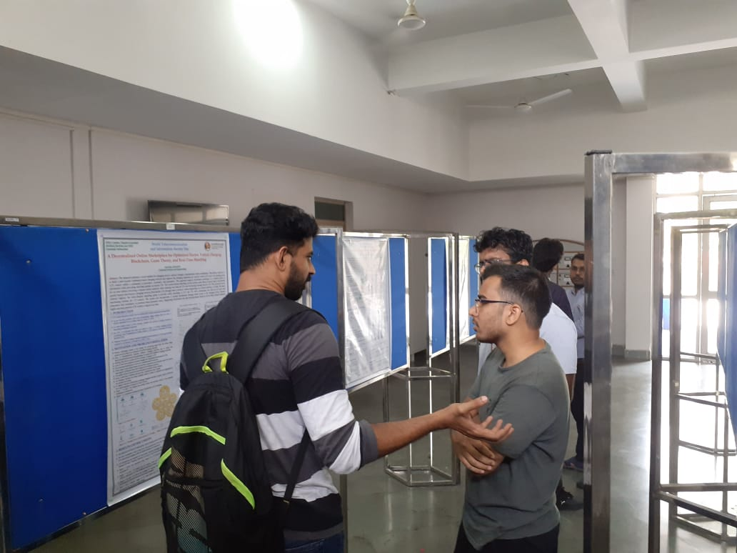
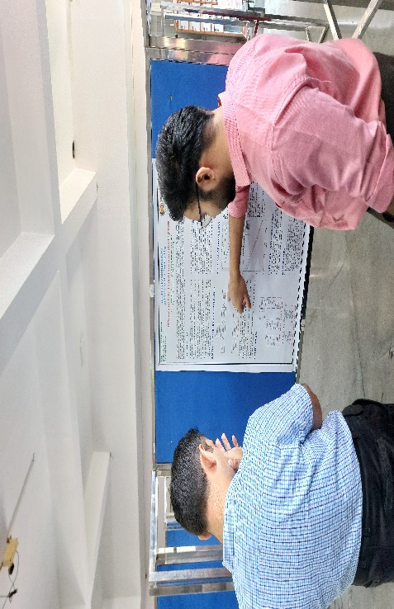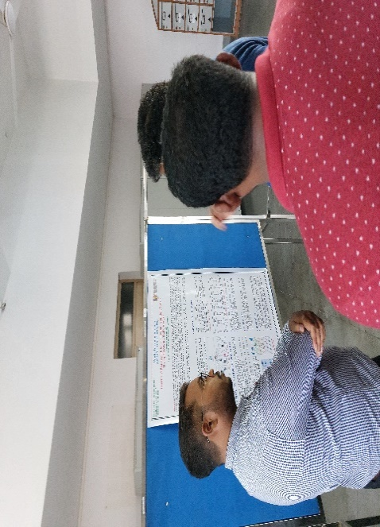
Event 2: Invited Talks
The talk was attended by faculty members from the department of Electronics and Electrical Engineering (EEE), Computer Science and Engineering (CSE), and research scholars of EEE, CSE, and Data Science from the institutes across the IEEE Guwahati subsection. Around 50 people (both online and offline) attended the talk and actively interacted with the speakers.
Talk 1
Title: Jamming in Free Space Optics
Speaker: Prof. Manav Bhatnagar, IIT Delhi
Venue: Seminar Room, IIT Guwahati
Time: 3.15 pm to 4.15 pm
Date: May 17, 2024 (Friday)
Mode: Hybrid

The invited talk by Prof. Manav Bhatnagar was delivered in online mode. During the talk, Prof. Manav Bhatnagar introduced free space optics (FSO) system, its advantages, use cases, and security aspects of FSO systems. The speaker also discussed about jamming, common jamming types in FSO, and abating jamming. Further, the FSO system performance evaluation through bit error rate analysis and results were presented. All the attendees benefitted immensely through this interaction.
An abstract of the talk and the biography of the speaker is given below.
Abstract:
In recent years, free space optical (FSO) communication has emerged to imprint its valuable contribution in high speed wireless communication society due to its manifold advantages. FSO systems have immense potential for providing high-data-rate communication link and can be easily deployed over wide ranges of applications. However, reliable communication cannot be assured in security-constrained protocol-based FSO applications (especially in military platforms) due to technical constraints imposed on FSO system design and deployment (like high field-of-view, confined optical wavelengths). Under such technical circumstances, the FSO system may become vulnerable as it can be hampered by intentional or unintentional jammer that cannot be easily avoided by the legitimate sources. So, it becomes crucial to investigate different protocol based FSO systems to explore the performance statistics in presence of detrimental jamming activity and also to develop communication strategies to alleviate the impact of jamming during the data transmission between the authorized users.
Biography:
Dr. Manav Bhatnagar is currently a Professor with the Department of Electrical Engineering, IIT Delhi, New Delhi, India, where he is also a Brigadier Bhopinder Singh Chair Professor. He holds a global rank of 517 in the area of Networking & Telecommunications among the top 2% scientists in a global list compiled by the prestigious Stanford University. He is a Fellow of INAE, NASI, IET, IETE, and OSI. He has received prestigious NASI-Scopus Young Scientist Award, Shri Om Prakash Bhasin Award, and Dr. Vikram Sarabhai Research Award. He has been an Editor of the IEEE Transactions on Wireless Communications during 2011-2014. Currently, he is an Editor of the IEEE Transactions on Communications. He has published more than 120 high quality IEEE journal papers out of which 10 are single-authored. His research interests include signal processing for MIMO systems, free-space optical communication, molecular communications, satellite communications, and machine learning.

Photos from the invited talk 1:
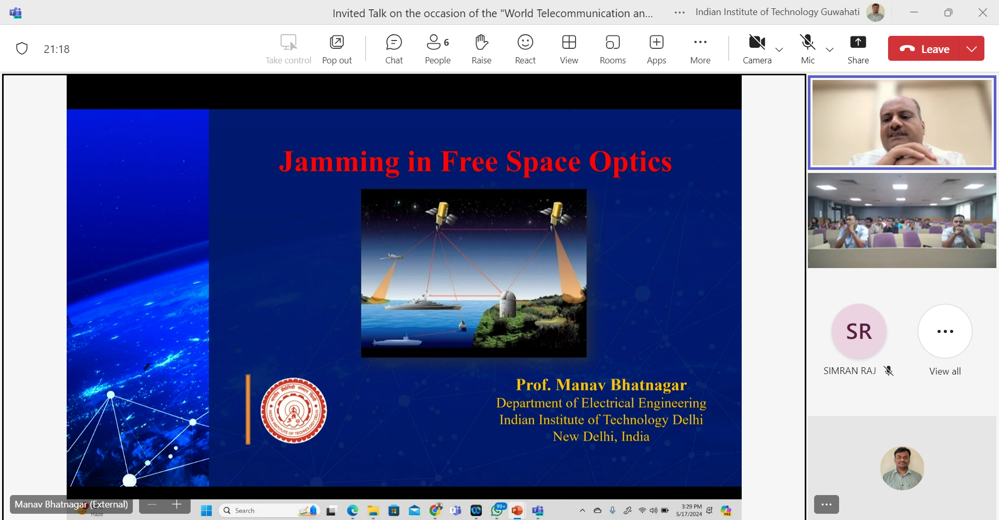

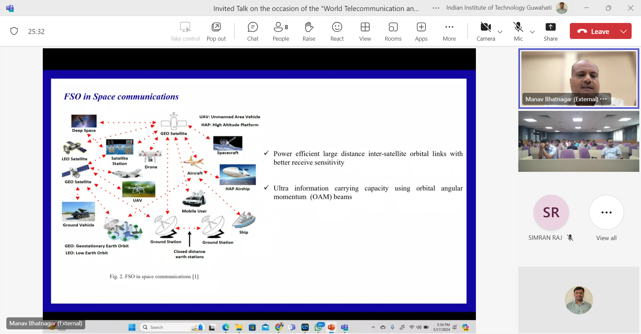

Talk 2
Title: Channel Estimation and Symbol Detection for OTFS Systems Impaired by Impulsive Noise
Speaker: Prof. Sudhan Majhi, IISc Bangalore
Venue: Seminar Room, IIT Guwahati
Time: 4.15 pm to 5.00 pm
Date: May 17, 2024 (Friday)
Mode: Hybrid

The invited talk by Prof. Sudhan Majhi was delivered in online mode. During the talk, Prof. Sudhan Majhi introduced the fundamental concepts of frequency flat and frequency-selective fading channels to provide a motivation to understand the differences between OFDM and OTFS techniques. The OTFS signal modelling was discussed and some results were shown on channel estimation and symbol detection for the wireless systems employing OTFS technique. All the attendees benefitted immensely through this interaction.
An abstract of the talk and the biography of the speaker is given below.
Abstract:
The most widely used conventional message-passing detector (MPD) requires channel state information and delivers suboptimal performance for orthogonal time frequency space (OTFS) systems in the presence of impulsive noise (IN). To circumvent this limitation, in this letter, we propose a novel l0 -norm constrained maximum Versoria criterion ( l0 -MVC) based channel estimator for the OTFS systems impaired by IN with an optimal adaptive tuning of the sparsity regularization parameter. Furthermore, we propose a robust message-passing based on the maximum Versoria criterion (MP-MVC) for OTFS symbol detection in the presence of IN. Analytical and simulation results indicate that the proposed l0 -MVC channel estimator and MP-MVC symbol detector outperforms the existing state-of-the-art approaches.
Biography:
SUDHAN MAJHI received an M.Tech degree in computer science and data processing (CSDP) from Indian Institute of Technology (IIT) Kharagpur, India and a Ph.D. degree from Nanyang Technological University (NTU), Singapore. He has post-doctoral experience with the University of Michigan, Dearborn, USA, the Institute of Electronics and Telecommunications Rennes (IETR), France, and Nanyang Technological University, Singapore. He was an Assistant professor jointly with the Mathematics and Electrical Engineering department at IIT Patna. He was also an associate professor in the Department of Electrical Engineering at IIT Patna. Currently, he is an associate professor in Electrical Communication Engineering (ECE) at Indian Institute of Science, Bangalore. He is a fellow of Sir Visvesvaraya Young Faculty Research. He has received SERB-TETRA and SERB- STAR awards in 2022 and 2023, respectively. He was an Editor of IEEE Transactions on Vehicular Technology Journal, IEEE Communications Letters , and Circuits, Systems and Signal processing (CSSP) – Springer. Recently he has been selected best Editor for IEEE Wireless Communications Letters. His research interest is signal processing for 6G wireless communications.
Photos from the invited talk 2:

