

# IEEE DeVry University Student Branch and CompTIA Student Club

# Present

**"Managing users accounts in Linux”**

**By: Dr. Simon Obeid**

|  |
| --- |
| **Date/Time: Thursday, June 6th @ 5:00 pm CST/6:00 pm EST** |

In this workshop, we will discuss user management in Linux. We learn how to create a user account, add it to a group and delete users accounts. Also disabling users accounts and changing passwords will be demonstrated.

**To Join:**

[**https://devry.engageli.com/devry/current/cr8-h7v-4op/**](https://devry.engageli.com/devry/current/cr8-h7v-4op/)**?**

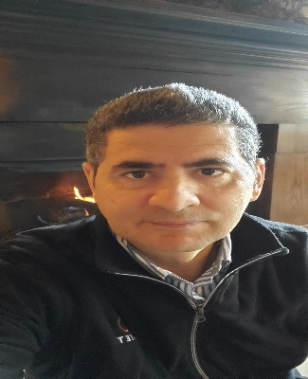

Dr. Simon Obeid earned his Ph.D. in electrical engineering from the University of North Carolina in 2008, where he also earned his Master of Science degree in electrical and computer engineering and Graduate Certificate in Information Security. A member since 2003, Obeid served as the chair of the IEEE (Institute of Electrical and Electronics Engineers) Computer Society for the DeVry Charlotte chapter from 2009-2012, and as vice chair the year before. He is ABET evaluator since 2015. For Widely published, Obeid has presented his research at dozens of conferences and has served as a reviewer or guest speaker for many others. He was invited to speak to Tech Tactics conference 2023 about Security Awareness for K-12 education.