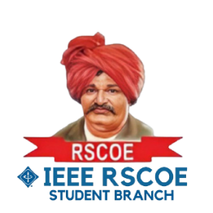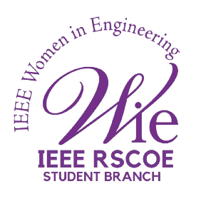

**Cloud Computing for next generation**

**Session name: Cloud Computing for next generation:** **Career path and opportunities**

**Date: July 07, 2024**

**Mode of session: Online**

**Number of attendees: 50**

**Speakers: 1. Sourav Bera** - Solution Architect at Microsoft

**2. Yashwant L M** - ATSE at Databricks

The IEEE Women in Engineering (WIE) Affinity Group of **IEEE RSCOE Student Branch**, in collaboration with the **IEEE Education Society YP Adhoc Committee** and **IEEE Pune Section**, organized an insightful online panel discussion on cloud computing to celebrate **IEEE WIE Day 2024**. The event brought together industry experts, **Mr. Sourav Bera**, Solution Architect at Microsoft, and **Mr. Yashwanth L.M**., ATSE at Databricks, along with enthusiasts to explore the latest trends, innovations, and future possibilities in cloud technology.

The event commenced with a warm welcome and an overview of the session's agenda by the host. The importance of cloud computing in the modern technological landscape was highlighted, setting the stage for the discussions to follow.

Our speakers engaged in a series of discussions on key topics, including cloud security, scalability, and future trends in cloud computing. They addressed concerns and provided solutions for maintaining data integrity and privacy in cloud environments, emphasizing the importance of robust security measures. Techniques and tools for ensuring that cloud infrastructures can efficiently scale to meet growing demands were also explored, highlighting the need for flexibility and adaptability in managing cloud resources. Additionally, the speakers shared predictions and insights into the future of cloud computing, focusing on emerging technologies and innovations such as artificial intelligence and edge computing that are set to shape the industry's future.

Participants had the opportunity to interact directly with our speakers during the live Q&A sessions. This segment allowed attendees to pose their burning questions and receive expert advice and insights.

The event also provided a platform for networking, enabling participants to connect with industry professionals, share ideas, and build valuable relationships.

The feedback from attendees was overwhelmingly positive. Many appreciated the depth of knowledge shared by the speakers and the interactive format of the event. Key takeaways included a better understanding of cloud security practices, strategies for scalable cloud solutions, and excitement about future trends in cloud computing.

The online panel discussion on the future of cloud computing was an enriching experience for all participants. The event successfully achieved its goal of providing a comprehensive overview of current trends and future possibilities in cloud technology. We extended our heartfelt thanks to our speakers, attendees, and everyone involved in making this event a success.

**Event Flyer:**

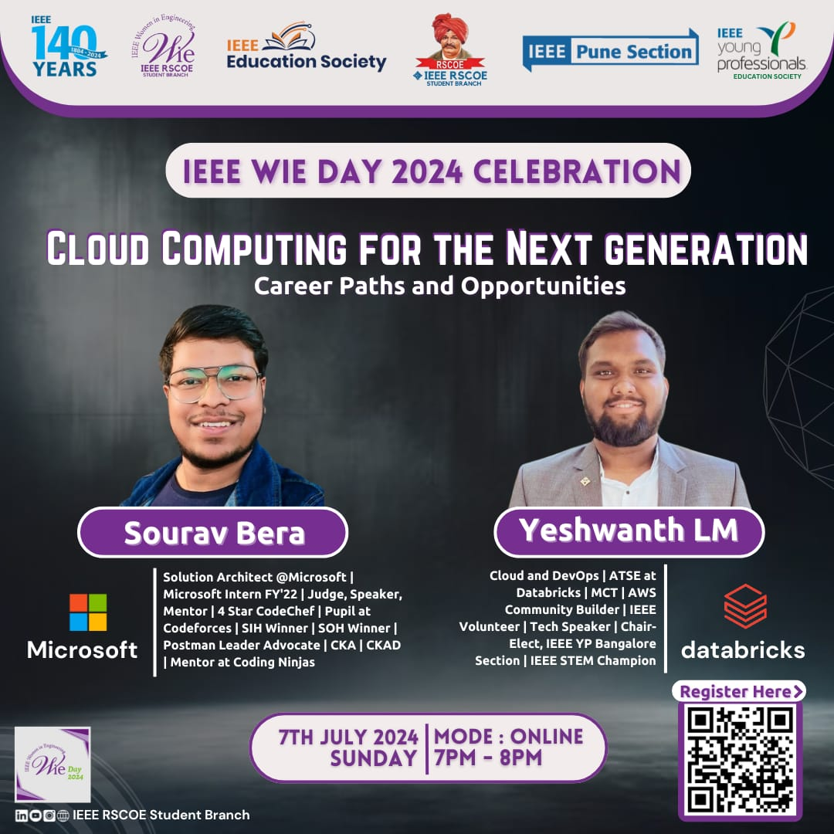

**Here are few Glimpses of the event:**

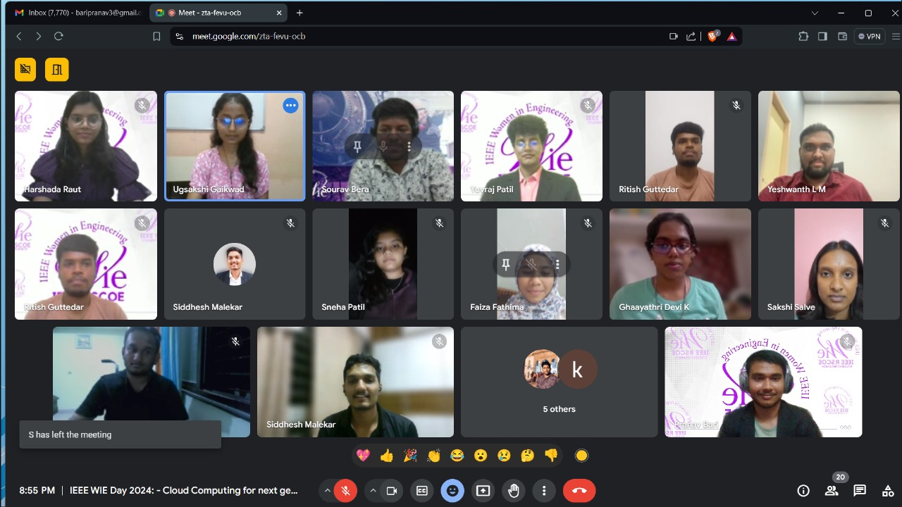

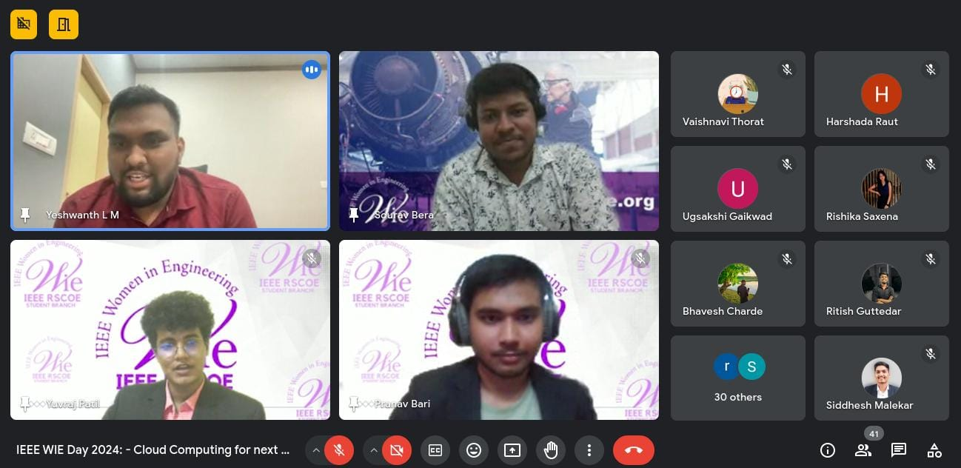

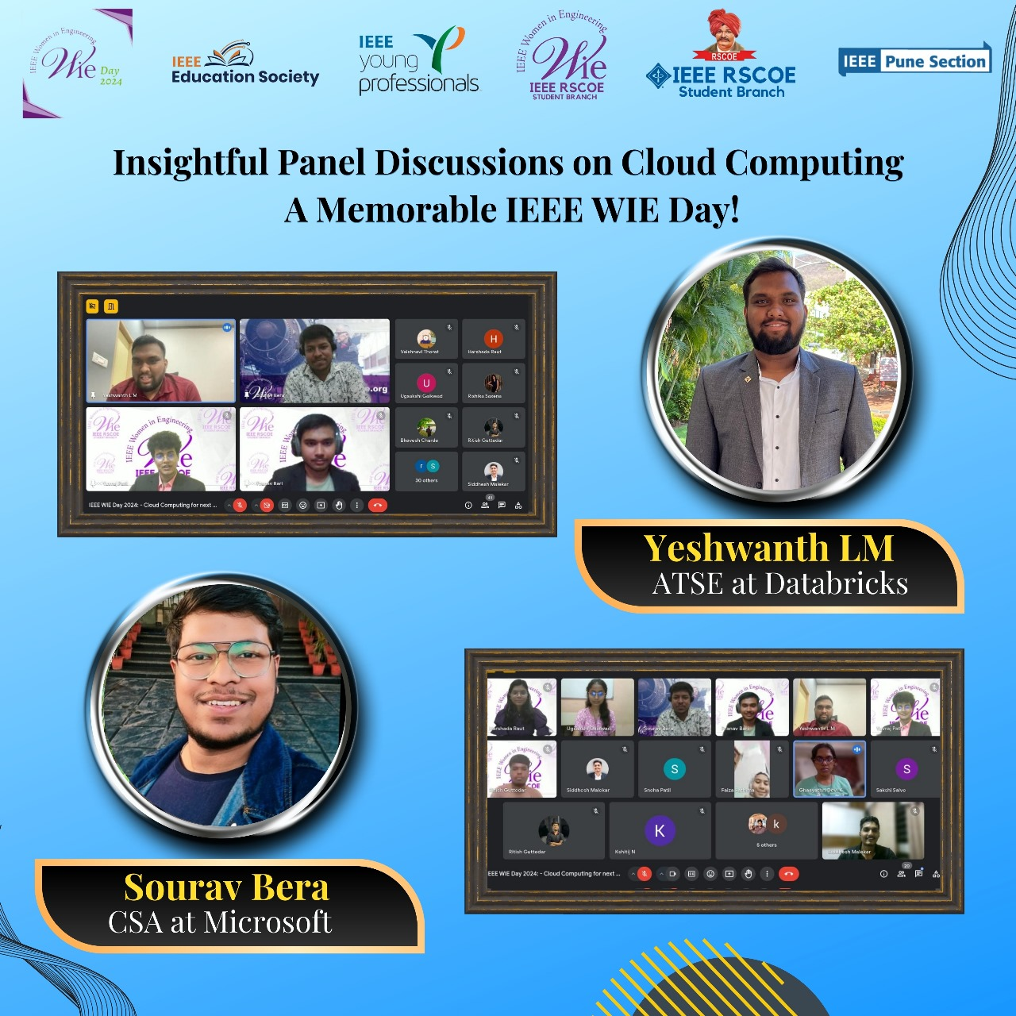**After Event Publicity:**

**Token of Appreciation presented to the Guest Speakers:**

