**REPORT OF THREE-DAY HANDS-ON WORKSHOP ON ADVANCED EXCEL**



IEEE JUIT SB organized organized a three-day hands-on workshop on Advanced Excel from July 15-17, 2024 in CL9, Jaypee University of Information Technology, Solan, Himachal Pradesh. Dr. Vikas Baghel, Department of Electronics and Communication Engineering was the resource person of the workshop.  In total 45 faculty/ staff members of different departments gained the knowledge. The event was coordinated by Prof. Ashish Kumar and Prof. Shruti Jain

The primary aim was to enhance participants’ proficiency in advanced Excel, equipping them with practical skills to manage complex data tasks and improve decision-making processes. Advanced Excel workshop typically includes equipping participants with more specialized skills and knowledge beyond the basics. An advanced Excel workshop provides significant value by equipping individuals and organizations with the skills needed to leverage Excel as a powerful tool for data analysis, decision-making, and operational efficiency in today's data-driven world. The intensive sessions covered advanced formulas, data visualization techniques, and efficient data handling practices. Attendees left the workshop with significantly improved capabilities, ready to leverage Excel for sophisticated data analysis and operational efficiency. This initiative foster continuous professional development and technological expertise, ensuring its community stays adept in the evolving data-driven landscape.

## C:\Users\shruti.jain\Desktop\Excel pics\WhatsApp Image 2024-07-17 at 19.02.05.jpeg

## The schedule of the program is as follows :

|  |  |  |
| --- | --- | --- |
| **Date** | **Time** | **Topic** |
| **15/07/2024** | **Session 1:**  **10:00 AM - 12:00 PM** | **Getting Started with Excel**  - Introduction to Excel interface  - Basic data entry and cell formatting  - Basic functions (SUM, AVERAGE, etc.)  - Data Sorting and Filtering  - Print a worksheet or workbook  - Hands-on exercises |
| **Session 2:**  **3:00 PM - 5:00 PM** | **Advanced Formulas and Functions**  - Advanced functions (VLOOKUP, HLOOKUP, INDEX, MATCH)  - Nested functions  - Conditional functions (IF, SUMIF, COUNTIF)  - Text functions (CONCATENATE, LEFT, RIGHT)  - Hands-on exercises |
| **16/07/2024** | **Session 3:**  **10:00 AM - 12:00 PM** | **Data Validation and Conditional Formatting**  - Creating drop-down lists  - Setting up data validation rules  - Applying conditional formatting  - Custom conditional formatting formulas  - Hands-on exercises |
| **Session 4:**  **3:00 PM - 5:00 PM** | **PivotTables and PivotCharts**  - Creating PivotTables  - Customizing PivotTables  - Grouping data in PivotTables  - Creating and formatting PivotCharts  - Hands-on exercises |
| **17/07/2024** | **Session 5:**  **10:00 AM - 12:00 PM** | **Advanced Data Analysis and Visualization Tools**  - Introduction to Power Query  - Introduction to macros  - Introduction to VBA  - Creating interactive dashboards  - Hands-on exercises |
| **Session 6:**  **3:00 PM - 5:00 PM** | **Summary and wrap-up**  - Open Q&A session  - Addressing participant queries and challenges  - Hands-on group project  - Group project presentation and evaluation |

|  |  |
| --- | --- |
| WhatsApp Image 2024-07-15 at 19.57.56.jpeg | WhatsApp Image 2024-07-16 at 18.54.40.jpeg |
| WhatsApp Image 2024-07-16 at 18.54.41 (1).jpeg | WhatsApp Image 2024-07-16 at 18.54.42.jpeg |
| WhatsApp Image 2024-07-17 at 20.00.22.jpeg | WhatsApp Image 2024-07-16 at 18.54.41.jpeg |
| WhatsApp Image 2024-07-19 at 16.16.42.jpeg | WhatsApp Image 2024-07-17 at 19.02.06.jpeg |

**Social Media**

https://www.linkedin.com/posts/dr-shruti-jain-92705b130_institutions-innovation-council-iic-in-activity-7220021480879742976-Dsph?utm_source=share&utm_medium=member_desktop

**Newspaper :**

https://crazynewsindia.com/juit-organize-workshop-on-advanced-excel/admin/

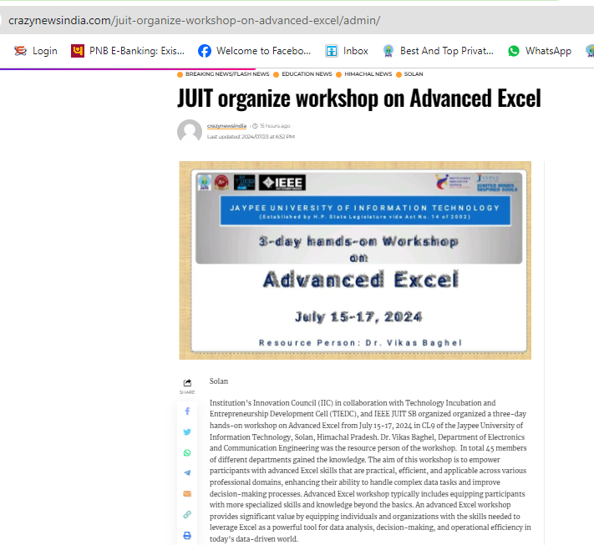

https://himachaltonite.com/himachal/juit-hosts-transformative-advanced-excel-workshop/

