

IEEE COMPUTER SOCIETY SIT

THE UNVEILED SERIES EPISODE 14
CONTENT MANAGEMENT SYSTEM AND DRUPAL

NAME OF THE ORGANIZING UNIT: IEEE COMPUTER SOCIETY SIT

DATE OF EVENT: 1st August , Thursday

TOPIC: THE UNVEILED SERIES EPSIDOE 14 – CONTENT MANAGEMENT SYSTEM AND DRUPAL

MODE OF EVENT: Online

TARGET AUDIENCE: Student Members

ATTENDANCE: 60

EVENT SUMMARY:
On August 1, 2024, a workshop was held focusing on "Content Management System & Drupal," providing participants with a detailed introduction to one of the most widely used content management systems globally. The online event offered an in-depth, hands-on experience, helping attendees to expand their skills and explore new technologies, particularly within the Drupal ecosystem. The event also fostered collaboration among like-minded individuals, allowing for knowledge-sharing and networking opportunities. Hosted via Google Meet, the event attracted a diverse group of participants eager to enhance their technical expertise in content management systems.

TIMINGS: 7:00 pm – 8:30 pm

The online event about "Content Management System & Drupal" took place on 1st August ,2024. It gave a clear and practical introduction to Drupal, a popular tool for managing website content. Participants engaged in hands-on activities to improve their skills and learn about new features in Drupal. The session explained how businesses use Drupal to manage their content, covering both basic and advanced aspects. Hosted on Google Meet, the event also allowed attendees to connect with each other, share ideas, and network. Additionally, it provided real-world examples and best practices for using Drupal in various projects.

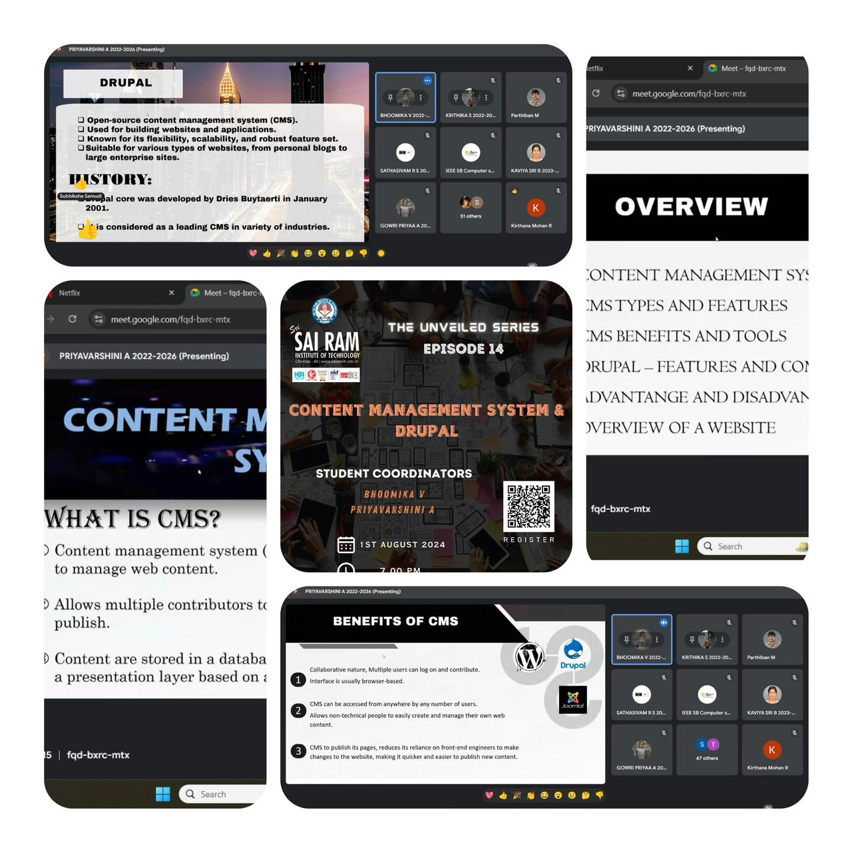

REPORTED BY:
KIRTHANA MOHAN R - – IEEE CS SECRETARY

