IEEE Hyderabad Section Social Media Posting
Name: Dr. Y. Padma Sai
Email ID: padmasai_y@ieee.org
Phone Number:9000037660
Event Name: “Improving Parameter Estimation of Target Parameters in a MIMO-OFDM Dual Function Radar Communication System”
Date of the Event: 2nd March 2024
Society Chapter / AG / Council: IEEE Signal Processing Society
Upload Poster:
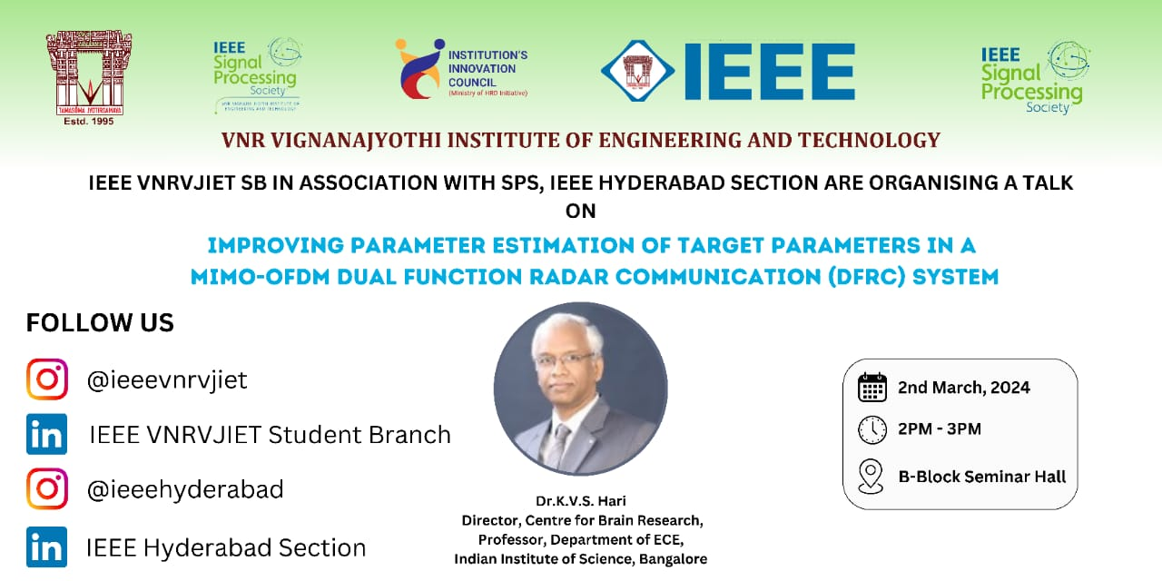
Social Media Post Content:
“In the Realm of Electronics, Creativity Sparks the Brightest Ideas.”
Greetings!
VNR Vignana Jyothi institute of engineering and technology in association with SPS and IEEE Hyderabad Section are organising A talk on "Improving Parameter Estimation of Target Parameters in a MIMO-OFDM Dual Function Radar Communication System”.
Speaker:
Dr.K.V.S. Hari , Director, Centre of Brain Research, Professor, Dept. of ECE, Indian Institute of Science, Bangalore
Date: 2nd March 2024
Timings: 2 P.M. to 4 P.M.
Venue: B Block Seminar Hall
“In the Digital Age, Communication Isn’t Just About What You Say but How Effectively You Transmit Your Thoughts Through the Wires of Technology.”
Registration Link: Physical (In Person)

