**IEEE SPS & TEMS IEEE HYDERABAD SECTION IN ASSOCIATION WITH IEEE VNR VJIET SB ARE ORGANIZING A TALK ON GENERATIVE AI : THE NEXT FRONTIER**

**Date:** 24th Feb, 2024

**Venue:** Dr. A. P. J. Abdual Kalam Hall (Offline)

**Time:** 2:30 PM to 4PM

**Participants Count:**80

**Poster:**

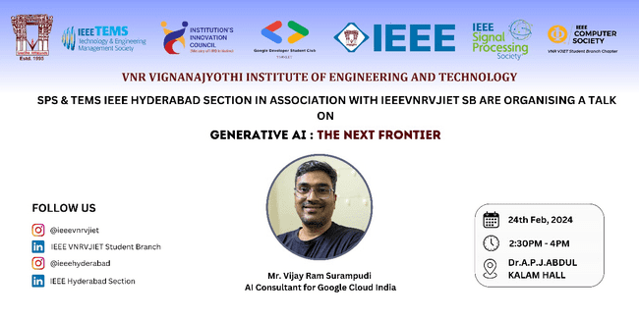

**Details of the Event:**

**Speaker Bio:**Mr.Vijay Ram Surampudi is a seasoned IT consultant who is fascinated by the possibilities that AI can enable the way we think and operate. In his current role as an AI consultant for Google Cloud India, he works on developing solutions and advisory for different customers on implementation of AI/ML. Prior to joining Google, he worked in diverse roles including presales, consulting and delivery.

**Topic:**Generative AI is a branch of artificial intelligence that focuses on creating new content, including text, images, music, and code. The agenda of the session will be to share some basics of Generative AI and discuss how it is going to revolutionize how we interact with the digital content and the world around us.



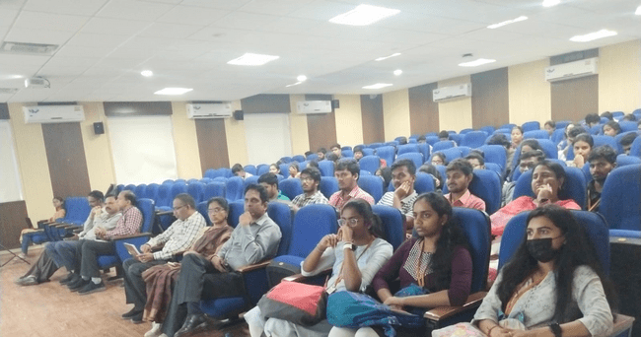

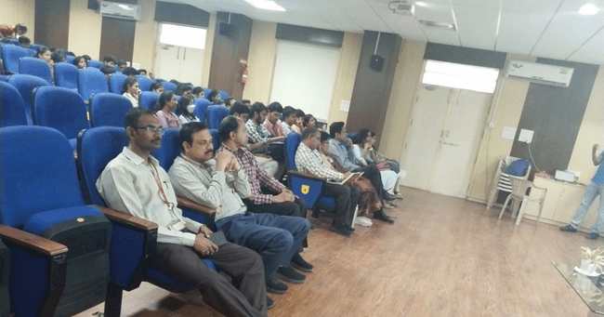

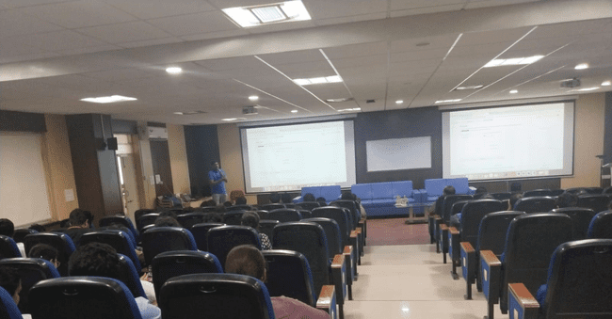

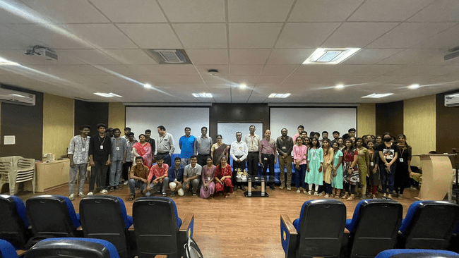

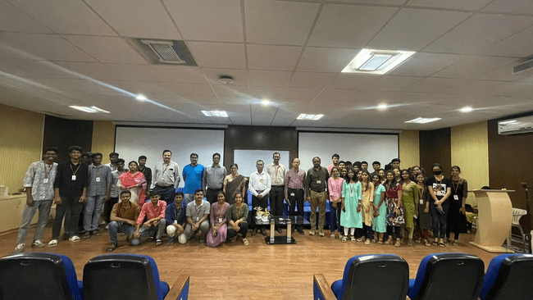

**Outcome of the Event:**

In conclusion, Mr. Vijay Ram Surampudi, with his extensive experience as an AI consultant for Google Cloud India, brings a wealth of knowledge to the exploration of Generative AI. His session, delving into the fundamentals of Generative AI and its potential to reshape our interaction with digital content and the world at large, likely left the audience with a deeper understanding of the transformative power of this technology.

**Participants List:**

