**Name of the Event :** **Training Session on ANSYS HFSS (3D High Frequency Simulation**

**Software)**

**Moderator : Kush Parikh**

**Mode of Conduct :** Online

**Venue :**Seminar Hall, Block-2, GPCET, Kurnool

**Date of the Event : 27**th July 2024

**About the event :**

G. Pullaiah College of Engineering and Technology has organized a webinar on 27-07-2024, GPCET. An insightful and motivational webinar titled "Training Session on ANSYS HFSS (3D High Frequency Simulation Software) " by esteemed speaker, the Kush Parikh” Ansys HFSS (High-Frequency Structure Simulator)* is a popular software tool used for simulating and analyzing high-frequency electromagnetic fields. It’s widely used in the design and analysis of antennas, microwave components, RF circuits, and more.

**EVENT POSTER**

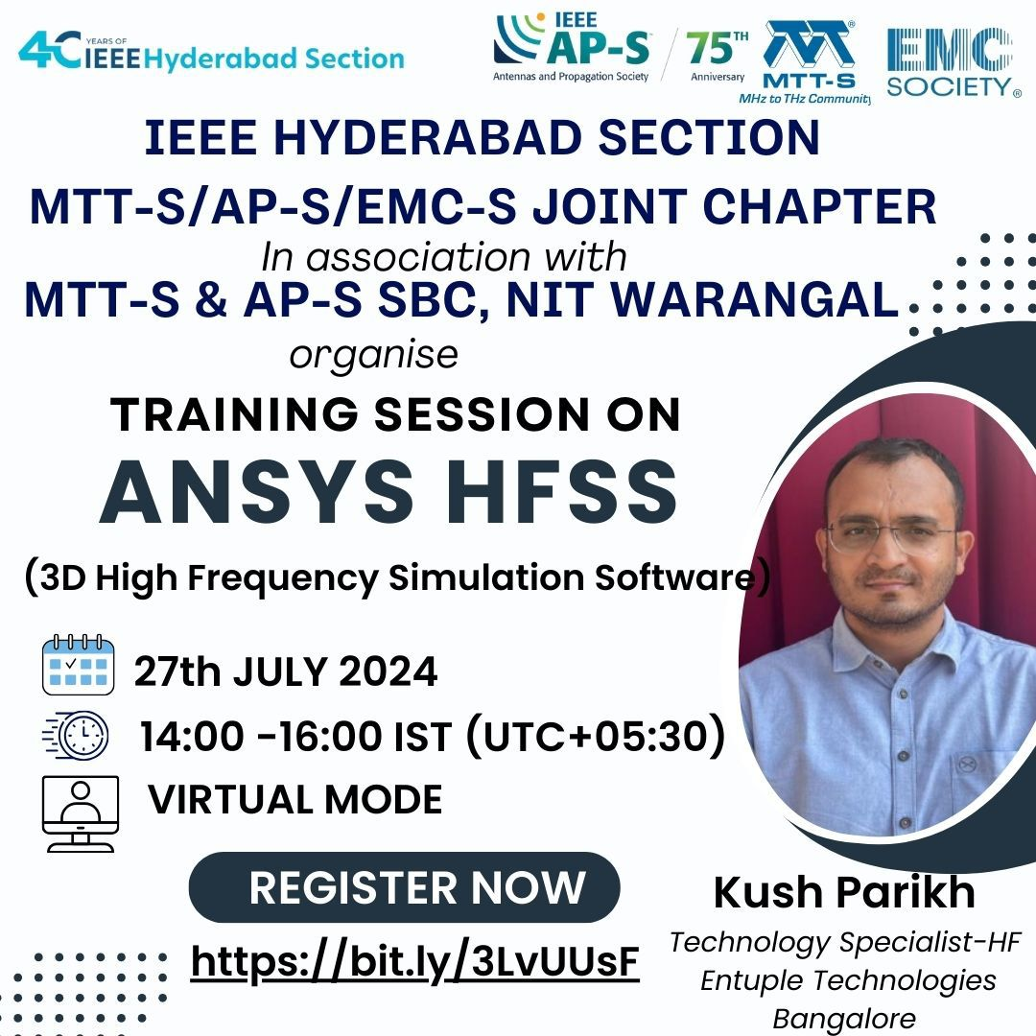

**Brief Report :**

*Ansys HFSS (High-Frequency Structure Simulator)* is a popular software tool used for simulating and analyzing high-frequency electromagnetic fields. It’s widely used in the design and analysis of antennas, microwave components, RF circuits, and more.

To help you get started, here’s a basic outline for a training session on Ansys HFSS 3D:

1. Introduction to Ansys HFSS

- Overview of the software.

- Applications and use cases.

- Basic principles of electromagnetic simulation.

2. Setting Up a New Project

- Starting a new project in HFSS.

- Understanding the user interface.

- Overview of the project tree, design window, and solution setup.

3. Geometry Creation

- Creating and importing 3D geometries.

- Defining materials and assigning them to geometries.

- Setting up boundary conditions and excitations.

4. Meshing

- Introduction to meshing in HFSS.

- Mesh operations and refinement.

- Mesh convergence and accuracy considerations.

5. Solution Setup

- Defining solution setups and frequency sweeps.

- Specifying the type of analysis (e.g., driven modal, eigenmode).

- Setting up ports and excitations.

6. Simulation and Results Analysis

- Running the simulation.

- Visualizing fields, currents, and other electromagnetic quantities.

- Analyzing S-parameters, radiation patterns, and other outputs.

7. Advanced Features

- Parametric analysis and optimization.

- Using HFSS with other Ansys tools (e.g., Ansys Mechanical for thermal analysis).

- HFSS scripting and automation.

8. Practical Examples

- Design and simulation of a basic antenna.

- Analysis of a waveguide or filter structure.

- Custom examples relevant to your industry or research.

9. Troubleshooting and Best Practices*

- Common issues and solutions in HFSS.

- Tips for improving simulation accuracy and efficiency.

Dr. M. RAMA PRASAD REDDY

COUNSELLOR

IEEE GPCET STUDENT BRANCH