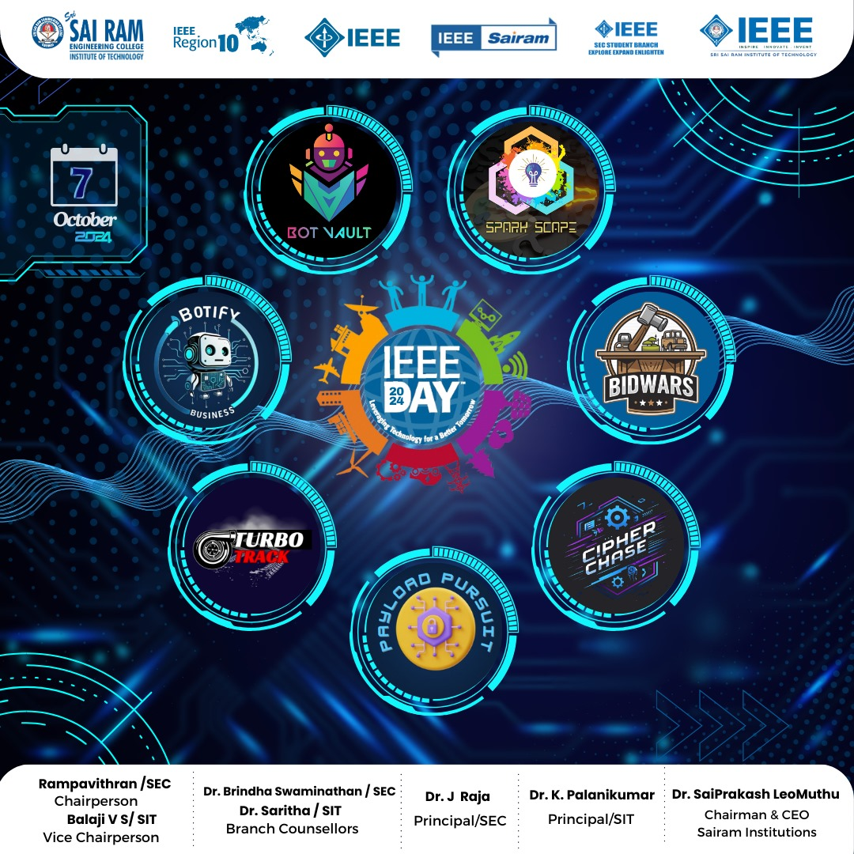

IEEE DAY 2024 is almost here! 🌍

🎉 Mark your calendars for October 7, 2024 as IEEE Region 10 gears up for a tech extravaganza like no other! Get ready to challenge your mind, ignite your passion, and dive into an exciting lineup of 7 thrilling events that will push your skills to the next level. 💡

⚡ Here’s a sneak peek at what’s in store:

🤖 BOT VAULT: Explore the world of automation and sensors in a hands-on robotics challenge designed to introduce you to cutting-edge tech.

🏎 RC TURBO TRACK: Build and race your self-made RC cars through a custom-designed track after acing the design rules and showcasing your engineering prowess.

💼 BOTIFY BUSINESS: Dive into the future of AI-driven business with generative AI tools, creating promotional content and building business chatbots to solve real-world problems.

🎲 BID WARS: A high-stakes auction where your strategy and IEEE knowledge will determine who wins the ultimate tech bid!

🎯 PAYLOAD PURSUIT: Race against time in a Capture the Flag (CTF) challenge, solving IEEE-themed puzzles and uncovering hidden flags.

💡 SPARK SCOPE: Pitch innovative ideas, design creative posters, and tackle crossword puzzles in this multi-faceted tech challenge.

🔐 CIPHER CHASE: Use your coding skills and teamwork to crack codes and solve complex programming tasks in a fast-paced, adrenaline-fueled race.

The countdown has begun – are you ready to Innovate, Compete, and Win? 🏆🚀

🌟 Big surprises, epic moments, and endless opportunities are waiting for YOU. Gather your team, sharpen your skills, and get ready to be part of something unforgettable!

📅 October 7, 2024

📍 Sri Sai Ram Engineering College, West Tambaram

🔥 7 electrifying events – Who will take the crown! 👑

Stay tuned for more updates, and let’s make this IEEE Day a celebration to remember! 🎊