***EXPERT TALK SESSION 2***

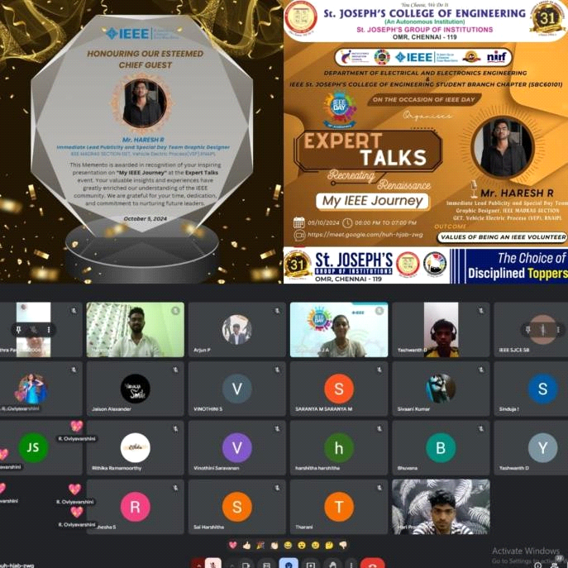

**On 05th October 2024, We the IEEE St. Joseph’s College of Engineering Student Branch Chapter** successfully conducted the second session of the **EXPERT TALKS- RECREATING RENAISSANCE series**. The Session featured **Mr. HARESH R,** recognized for his contribution Immediate **Lead Publicity and Special Day Team Graphic Designer, IEEE Madras Section, GET**, **Vehicle Electrical Process (VEP), RNAIPAL,** provided valuable perspective on Electrical and Electronics Engineering and the boarder IEEE Society. The event facilitated meaningful interaction between the speaker and the participants, allowing for an exchange of knowledge and ideas. Around 30 attendees left the session feeling motivated and equipped with new perspectives for their academic professional endeavours

**OUTCOME**:

Shared experience and guidance, juniors brought fresh ideas about academics, mentorship and actionable solutions.

**INSTAGRAM:**

[https://www.instagram.com/p/DAsel6jTXmN/?igsh=MWc1Zmg4OHVzaGZocw==](https://www.instagram.com/p/DAsel6jTXmN/?igsh=MWc1Zmg4OHVzaGZocw%3D%3D)