***POSTER DESIGN COMPETITION***

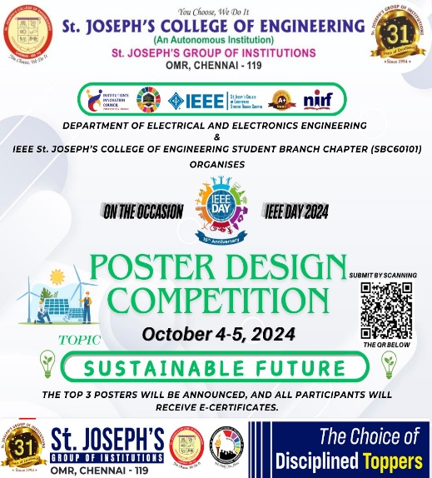

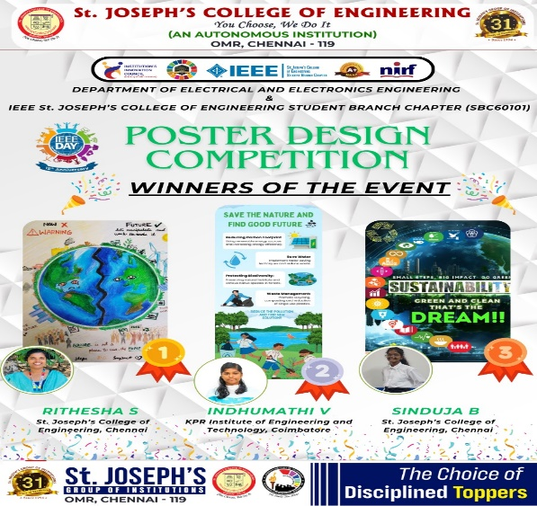

**On 5th October 2024**, the **IEEE St. Joseph’s College of Engineering Student Branch Chapter (SBC60101)** successfully hosted a **Poster Design Competition** in celebration of IEEE Day 2024. The competition, themed around Sustainable Future, encouraged participants to showcase their creativity while promoting sustainability. **The event ran from 4th October to 5th October 2024, with a submission deadline of 6:00 PM on the final day**.

We were thrilled to receive **over 30 poster submissions** from students across various institutions. After careful evaluation, the best posters were shortlisted, on the basis of innovation and the level of awareness about sustainability. The top 3 winners were:

**1st Place: Rithesha S, St. Joseph's College of Engineering**

**2nd Place: Indhumathu V, KPR Institute of Engineering and Technology**

**3rd Place: Sinduja B, St. Joseph's College of Engineering**

Each winner demonstrated outstanding creativity and a commitment to envisioning a sustainable future through their designs. The winners were selected based on creativity, relevance to the theme, and overall impact of the poster. All participants received E-certificates as a token of appreciation for their efforts and contributions.

**Outcome:**  
The event fostered awareness of sustainability and inspired students to think creatively about global environmental challenges. Participants walked away with a renewed commitment to driving change through design, and the event facilitated an exchange of innovative ideas that can help create a more sustainable world.

**G-FORM LINK:** <https://forms.gle/wLFKSn5SDzPEzopW7> **INSTAGRAM:** [**https://www.instagram.com/p/DAs98qnTRCq/?igsh=c2FwNG9taDB1bXdy**](https://www.instagram.com/p/DAs98qnTRCq/?igsh=c2FwNG9taDB1bXdy)