***TECH TRIVIA: QUIZ NIGHT:***

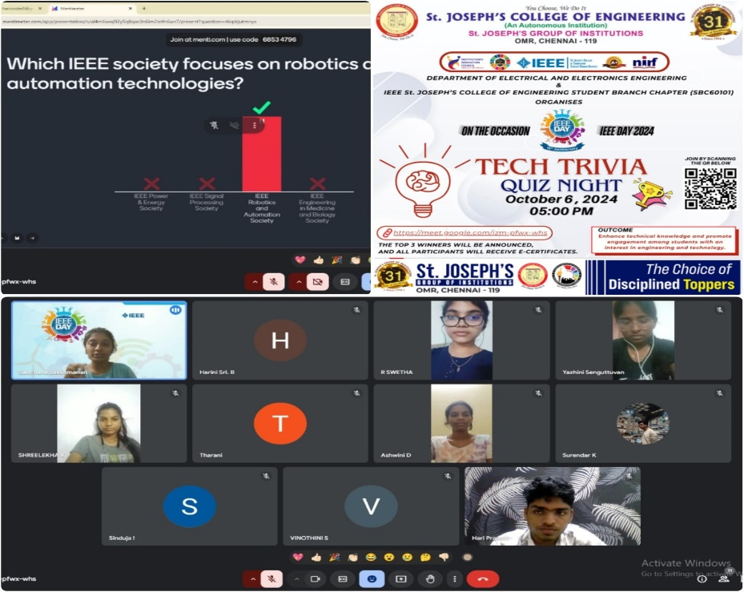

On **5th October 2024**, the **IEEE St. Joseph’s College of Engineering Student Branch Chapter (SBC60101)** successfully conducted the **Tech Trivia** event in celebration of **IEEE Day 2024**. The event aimed to challenge participants with technical questions from various domains such as **industry trends, technology, and IEEE initiatives**, allowing students to broaden their knowledge and understanding.

The quiz featured several rounds that tested participants expertise across a range of subjects, including emerging technologies and real-world applications through Mentimeter platform. This interactive format encouraged healthy competition while promoting peer learning.

* **1st Place:** SINDUJA B (II-EEE), St. Joseph's College of Engineering
* **2nd Place:** SWETHA R (II-EEE), St. Joseph's College of Engineering
* **3rd Place:** SHREELEKHA (II-EEE), St. Joseph's College of Engineering

Each of these students demonstrated exceptional knowledge and quick thinking, securing their spots as winners. All participants received **certificates of appreciation** for their involvement and enthusiasm.

**Outcome:**

The IEEE Day Tech Trivia provided participants with a deeper insight into key **technological and industrial domains** while fostering a strong sense of community. Students walked away with enhanced technical knowledge and a better understanding of IEEE's contributions to the tech world. The event inspired participants to stay informed about advancements in their fields, further motivating them to engage in future IEEE activities.  
  
**INSTAGRAM LINK:** [**https://www.instagram.com/p/DAweAGpT4By/?igsh=MWQyNmxwa3NoMmxmaw==**](https://www.instagram.com/p/DAweAGpT4By/?igsh=MWQyNmxwa3NoMmxmaw==)