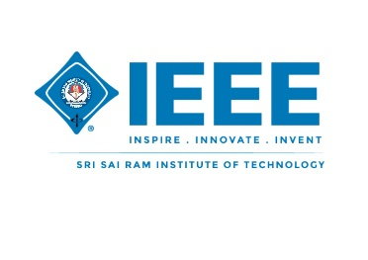
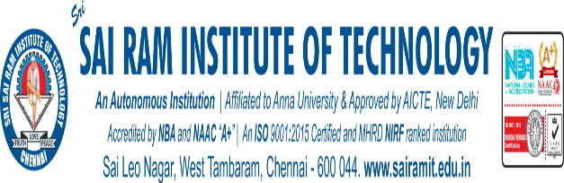

IEEE SIT
Botify Business (IEEE Day 2024)

NAME OF ORGANIZING UNIT: IEEE Sri Sairam Institute of Technology

DATE OF EVENT: Friday, 4th October 2024

TOPIC: Botify Business - Round 1 (IEEE Day)

OVERALL COORDINATOR: Vishali R – Botify Business Event Organizer & Coordinator

MODE OF EVENT: Online

TARGET AUDIENCE: IEEE Members & Students

ATTENDANCE: 30+ Teams

TIMINGS: 07.00pm – 09:00 pm

EVENT ORGANIZERS:
- VASANTH R- Lead
- NIVETHA RUVAH D- Master of Ceremonies

EVENT SUMMARY:
On Friday, October 4th, 2024, the IEEE of Sri Sairam Institute of Technology kicked off the first round of Botify Business with an exciting online challenge which was conducted by Vishali R , Event Organizer &Coordinator -IEEE Day. Participants were tasked with using generative AI to create promotional content for fun, relatable business scenarios, like AI competing in traditional Indian games, haggling with street vendors, and navigating the chaos of an Indian train journey. The creativity on display was remarkable, as participants cleverly guided AI to engage with culturally rich situations in humorous and innovative ways. The submissions stood out for their originality, blending AI technology with human experiences in ways that sparked both thought and laughter. Judges were impressed by the inventive ways AI was woven into everyday scenarios, making the event as entertaining as it was technically impressive. This first round has set a strong tone for the competition, with anticipation building for even more inventive AI challenges in the rounds ahead.

REPORTED BY:

Janani Vasupradha S & Krithika G
Content Team

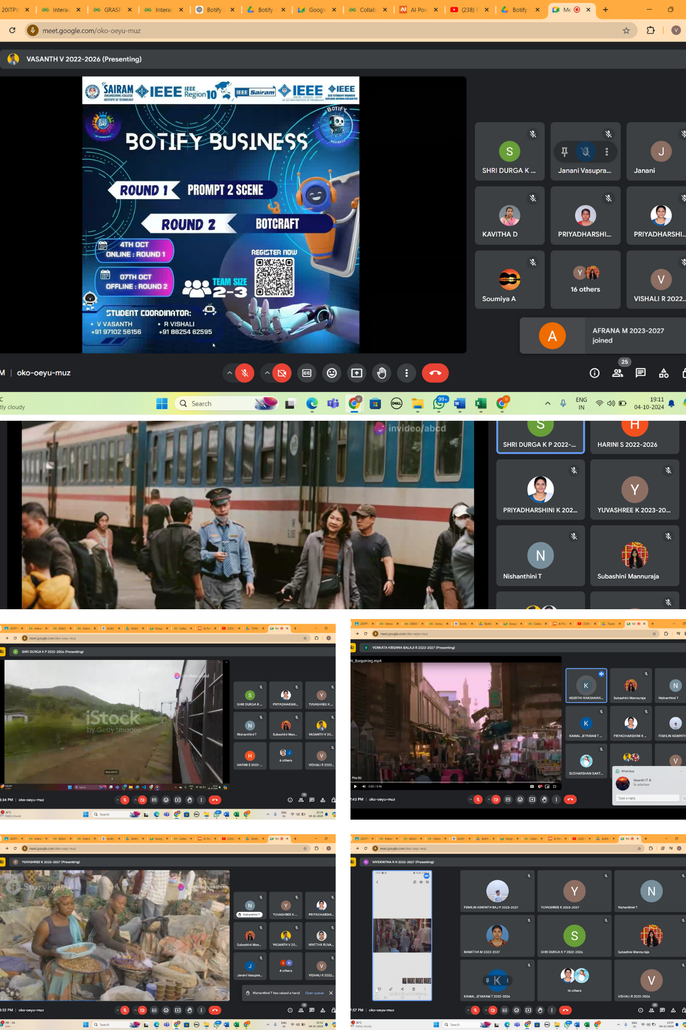
EVENT PHOTOS:

DATE OF EVENT: Monday, 7th October 2024

TOPIC: Botify Business - Round 2 (IEEE Day)

MODE OF EVENT: Offline

TARGET AUDIENCE: IEEE Members & Students

ATTENDANCE: 16 Teams (37 members)

TIMINGS: 10.00 am – 12.30 pm

EVENT ORGANIZERS:
- VISHALI R- Lead
- VASANTH R- Lead
- NIVETHA RUVAH D- MC
- JANANI VASUPRADHA- Content lead
- KRITHIKA G- Content lead
- SOUMIYA- Registration lead

EVENT SUMMARY:
On Monday, October 7th, 2024, the IEEE of Sri Sairam Institute of Technology continued the 'Botify Business' competition with the much-anticipated second round, led by Vishali R and Vasanth, Event Coordinators for IEEE Day. Following the success of the first round, 15 standout teams advanced to this stage, where they faced a more technically challenging task.

In this round, participants were asked to develop chatbots based on three distinct scenarios. Each team had to leverage AI to build functional, responsive chatbots that could handle real-world situations creatively and practically. The challenge pushed teams to showcase their skills in natural language processing and prompt engineering.

From the 16 teams, 3 emerged as the winners, impressing the judges with their innovative and efficient chatbot designs. The event demonstrated a strong combination of technical expertise and ingenuity, setting a high standard for future competitions at the institute.

JURY DETAILS:
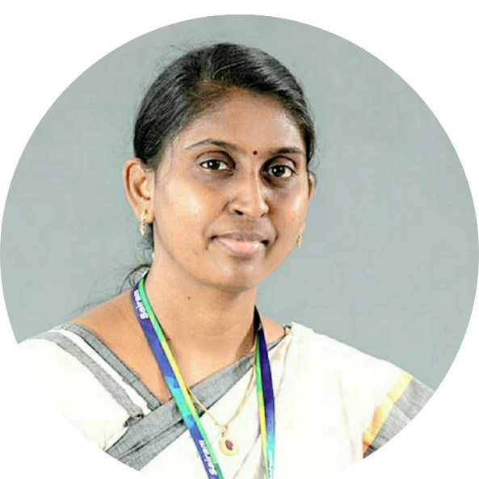

Ms. Mathupriya S
Associate Professor- CSE Department

WINNERS:
1ST
TEAM NAME: ASTRO TEENS
MEMBERS : Priyadharshini R (SIT23IT029)- II IT
Ashwin M (SIT23AD066)- II AIDS
Abdul halim S (SIT23AD096) -II AIDS
2ND
TEAM NAME: TECH BUZZERS
MEMBERS: Hari Dharshini G (SIT23IT142) -II IT
Femilin Aswinth Raj P (SIT23IT068) -II IT
Sri Dhanush S (SIT23IT021 )-II IT
3RD
TEAM NAME: TREK BOT
MEMBERS: Jayapriya S(SEC22CI052) -III IOT
Kamal Jeyaram T(SEC22CI033)-III IOT

EVENT PHOTOS:

