 

**ORGANIZING UNITS:** Sri Sairam Institute of Technology SB - STB03109

Sri Sairam Engineering College SB - STB60981

**EVENT NAME :** Bid Wars

**DATE :** 07/10/2024

**VENUE:** Smart Classroom – 1

**TYPE OF THE EVENT:** Non - Technical

**MODE OF EVENT:** Offline

**EVENT ORGANIZERS:**

1. Savitha - Lead
2. Arun - Co-Lead
3. Harish - Co-Lead

**DESCRIPTION:**

The Bid Wars event, part of IEEE Day 2024, featured two rounds designed to enhance knowledge and teamwork. Round 1 tested participants' understanding of IPL auction strategies and IEEE topics through a quiz. In Round 2, teams engaged in competitive bidding for roles, showcasing their strategic management plans for an IEEE Society. The event emphasized collaboration, creativity, and negotiation skills, preparing participants for future challenges.

**ROUND 1:**

Round 1 of the Bid Wars event, part of IEEE Day 2024, took place on October 3, 2024, at 8:00 PM via Quiz.com. A total of 50 participants, organized into teams of three, engaged in a quiz that tested their knowledge of IPL auction strategies and IEEE topics. The quiz featured 20 questions with varying time limits, designed to challenge participants' quick thinking and knowledge. There was no negative marking for incorrect answers. The top-scoring teams progressed to Round 2, with results announced promptly.

Teams Presented: 50

No. of Participants: 50 (Teams of 3 members with one representative from each event)

**ROUND 2:**

Round 2 occurred on October 7, 2024, at 9:00 AM in Smart Classroom 1, where 15 teams competed to bid for 12 available roles, each comprising 5 members with varying attributes: leadership, creativity, volunteering, endurance, and experience. Teams had a budget of 2.5 crores for their bids.

After purchasing their members, teams presented their strategies for managing an IEEE Society with their selected candidates, highlighting how their members' skills would contribute to effective leadership and project execution. The bidding was competitive, and all roles were filled successfully. The event showcased effective negotiation and collaboration among teams, setting a positive tone for the next phases of the competition.

Teams Presented: 15

No. of Participants: 45

**JURY DETAILS:**

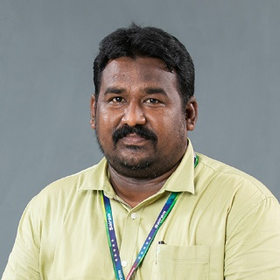

Dr. P. Venkatesh

Associate Professor - MBA/SEC

**CONCLUSION:**

The Bid Wars event proved to be an engaging and dynamic experience, fostering collaboration, strategic thinking, and creativity among participants. Both rounds successfully encouraged teamwork and knowledge application, preparing teams for future challenges within IEEE. The competitive spirit and innovative strategies displayed promise for a fruitful continuation of the competition, with participants eager to further develop their skills and contribute to the IEEE community.

**BID WARS WINNERS LIST**

**1st Place**

Team Name : Elite

1. Abinaya R
2. Madhumidhaa A P
3. Ananthi V

**2nd Place**

Team Name : Bid Pros

1. Pradeep S
2. Rajesh S

**3rd Place**

Team Name: Black Rock

1. Suryaputhiran T
2. Siva P
3. Sreevatsan V

**EVENT PHOTOS**

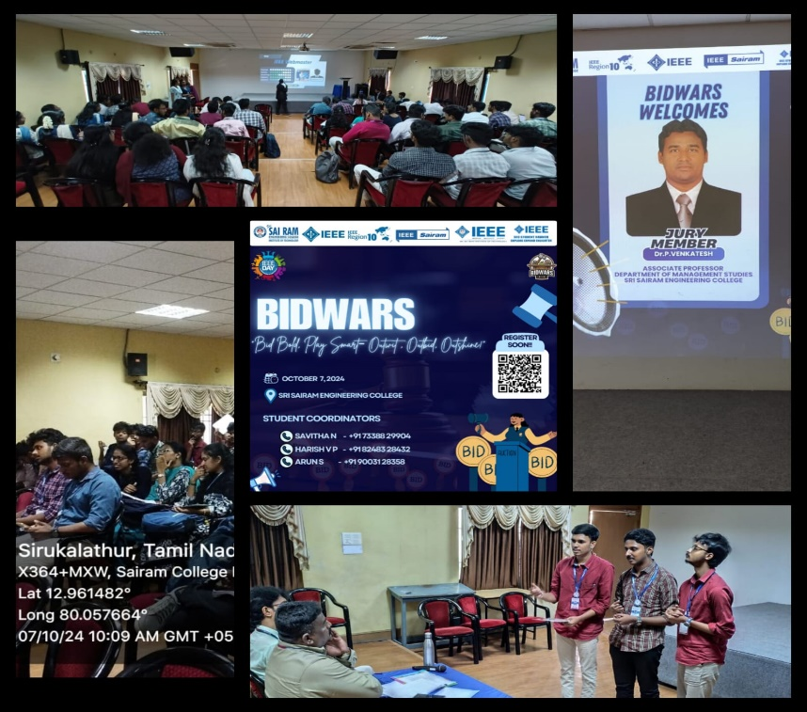

**SOCIAL MEDIA**

**INSTAGRAM:** <https://www.instagram.com/sec_ieee.sb?igsh=MWFtOHkwMnk2Y2hnNw==>

**LINKED IN:** <https://www.linkedin.com/company/sri-sairam-engineering-college-ieee-student-branch/>