 

**ORGANIZING UNITS:** Sri Sairam Institute of Technology SB - STB03109

Sri Sairam Engineering College SB - STB60981

**EVENT NAME:** Bot Vault

**DATE:** 07/10/2024

**VENUE:** Incubation center

**TYPE OF THE EVENT:** Technical

**MODE OF EVENT:** Offline

**EVENT ORGANIZERS:**

1. Trisha - Lead
2. Tharushi - Co lead
3. Gowtham - Co Lead
4. Sri Raman - Co Lead
5. Abirami - Co Lead
6. Srinath - Co Lead

**EVENT DESCRIPTION:**

The event is a two-round competition focused on robotics and automation. Round 1 features an online quiz to assess participants' knowledge of robotics, automation, and sensors, shortlisting candidates for the next phase. Round 2 involves teams developing and presenting a hardware prototype based on automation and sensors during a live event on IEEE DAY. This competition promotes practical skills, innovation, and collaboration in tackling real-world challenges in robotics.

**ROUND 1:**

The event begins with an online quiz designed to test participants' basic knowledge of robotics, automation, and sensor technologies. This quiz will assess participants' initial understanding and spark their interest in these fields. Conducted in mentimeter on October 1 2024 from 7.00pm.All team leaders attended the quiz in mentimeter and other members are connected through Google meet. Totally 21 teams(63 members) registered for the event and among 21 teams,14 teams(42 members) participated in round 1 and 13 teams are shortlisted for round 2.

No of teams: 14

Participants: 42

**ROUND 2:**

Participants who perform well in the quiz will advance to Round 2. In this phase, shortlisted participants are required to develop a prototype hardware based on a provided theme related to automation and sensors. Participants will work on creating and refining their prototypes prior to the event day. On IEEE DAY oct 7 2024,participants brought their developed prototypes for presentation and demonstration. Among 13 shortlisted teams for round 2,10 teams(30 members) were present and came with prototype. After the presentation of all teams, the jury panel with scope members discussed and announce 3 teams(9 members) as winners.

No of teams: 10

Participants: 30

**Conclusion :**

The "Bot Vault" competition concluded successfully, starting with an engaging preliminary round that tested participants' knowledge in robotics and automation through a dynamic online quiz. This round set the stage for the final phase, where teams showcased their creativity and technical skills by presenting innovative prototypes focused on automation and sensors. Overall, the event celebrated the participants' achievements and fostered collaboration, culminating in an inspiring experience on IEEE DAY.

**JURY DETAILS:**

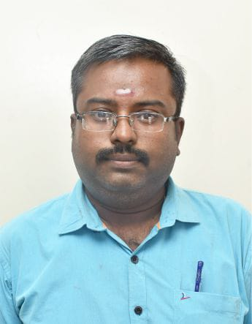

Dr VINAYAGA MURUGA PANDY

Assistant Professor / Department of mechanical engineering – SEC

**BOT VAULT WINNERS LIST**

**1st Place ;**

Team Name : Graspers

1. Nataraj E L - AIDS / II /SEC
2. Janani R - AIDS / II / SEC
3. Sujith S M - AIDS / II / SEC

**2nd Place :**

Team Name : Tech Nimbus

1. Keerthika S - CSBS / II / SEC
2. Dheepayalini R  - CSBS / II / SEC
3. Seerin Farhana S M - CSBS / II / SEC

**3rd Place :**

Team Name: Glucomate

1. Perumal B – ICE / III / SEC
2. Flemine K – ICE / III / SEC
3. Sai Losini K – ICE / III / SEC

**EVENT PHOTOS**

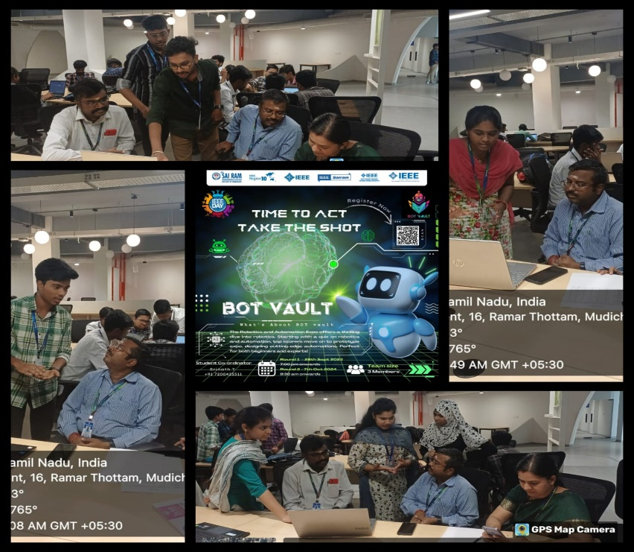

**SOCIAL MEDIA**

**INSTAGRAM:** <https://www.instagram.com/sec_ieee.sb?igsh=MWFtOHkwMnk2Y2hnNw==>

**LINKED IN:** <https://www.linkedin.com/company/sri-sairam-engineering-college-ieee-student-branch/>