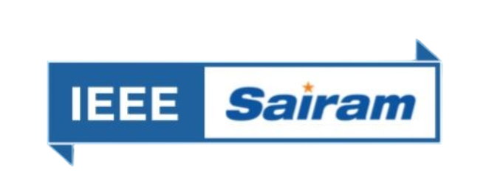 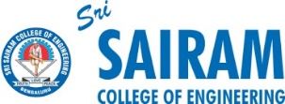

**ORGANIZING UNITS:** Sri Sairam Engineering College SB - STB60981

Sri Sairam Institute of Technology SB - STB03109

**EVENT NAME :** Turbo Track

**DATE :** 07/10/2024

**VENUE:** Mechatronics Lab

**TYPE OF THE EVENT:** Technical

**MODE OF EVENT:** Offline

**EVENT ORGANIZERS:**

1. Yeshwanth Raj - Lead
2. Pranesh - Co-Lead

**EVENT DESCRIPTION:**

The RC Car Competition consists of three rounds testing design and performance skills. Round 0 is an online session covering design principles and a demo model. In Round 1, all 15 teams present their prototype RC cars for evaluation, with non-compliant teams disqualified. Round 2 features the top 10 teams racing their cars on a custom track, evaluated on speed, maneuverability, innovation, lap time, endurance, and durability.

**ROUND 0:**

The Turbo Track event began with Round 0 on October 1st, 2024, serving as an online preliminary session to help participants prepare for the main event. Teams attended an informative Q&A session, where they clarified competition rules and expectations. The event team showcased a demo RC car with basic features, giving participants a firsthand look at the design elements and performance capabilities required for the competition. The session provided valuable insights, helping participants fine-tune their own models.

**ROUND 1:**

The first round of the Turbo Track event was completed on October 4th, 2024. This round served as a project expo, where participants brought their custom-made RC cars and presented them to the juries. Teams explained their unique design features and technical innovations they implemented in their cars, showcasing their creativity. The event also provided an opportunity for participants to discuss the competition flow with event volunteers and network with fellow teams. Overall, the event was a success, with strong participation and a positive exchange of ideas.

Teams Presented : 8 teams

No of Participants : 24

**ROUND 2:**

The second round of the Turbo Track event was held on October 7th, 2024. At the start, teams were given time to examine the custom track designed by the event team and ensure their RC cars could handle its challenges. Once the jury arrived, the event kicked off, with each team running their cars for up to 2 laps on the track. The jury members closely evaluated each car’s design, performance, and maneuverability. After a thorough assessment, the top 3 teams with the most innovative designs, best performance, and fastest lap times were awarded prizes, marking a successful completion of Round 2 and the Turbo Track competition.

Teams Participated : 8 teams

No of Participants : 24

**JURY DETAILS:**

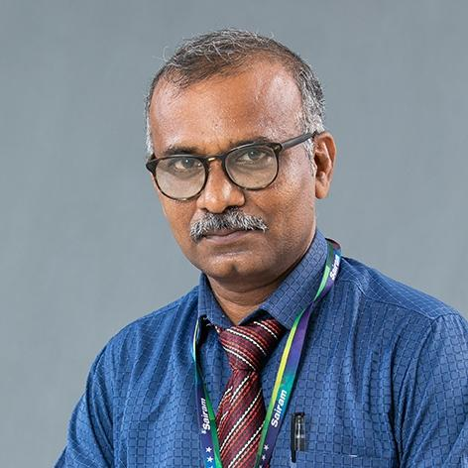

Dr.L.Saravanakumar

Associate Professor/ Department of Mechanical Engineering (SEC)

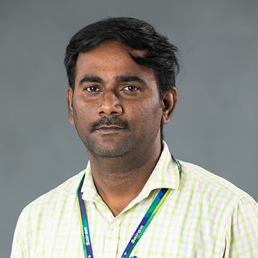

Dr.R.Dhanasekar

Associate professor /Department of EEE (SIT)

**CONCLUSION :**

The Turbo Track event was more than just a competition; it was a vibrant celebration of innovation, teamwork, and the relentless pursuit of excellence. Participants not only showcased their technical skills but also forged connections and shared their passion for engineering.

**WINNERS LIST**

**1st PRIZE:**

Team Name : Aurora

1. Harini K L
2. Anuradha S
3. Kavyadharshini S M

**2nd PRIZE :**

Team Name : Hack Slayers

1. Rajalakshmi K
2. Jaswanth Raj J
3. Somanath E R

**3rd PRIZE :**

Team Name : SparkNerds

1. Lithika Sri G
2. Asmitha S J
3. Abinesh M

**EVENT PHOTOS**

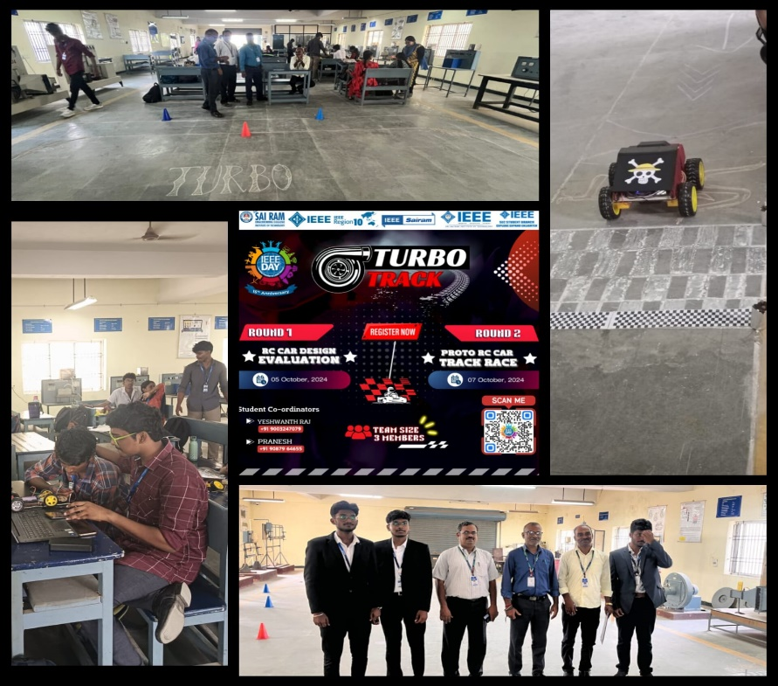

**SOCIAL MEDIA**

**INSTAGRAM:** <https://www.instagram.com/sec_ieee.sb?igsh=MWFtOHkwMnk2Y2hnNw==>

**LINKED IN:** <https://www.linkedin.com/company/sri-sairam-engineering-college-ieee-student-branch/>