 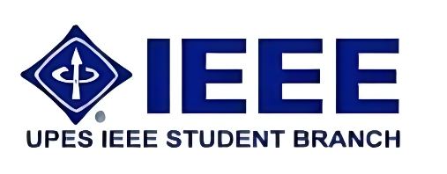

**IEEE Student Chapter**

**Electrical Cluster**

**Events-**

**Celebrating IEEE Week**

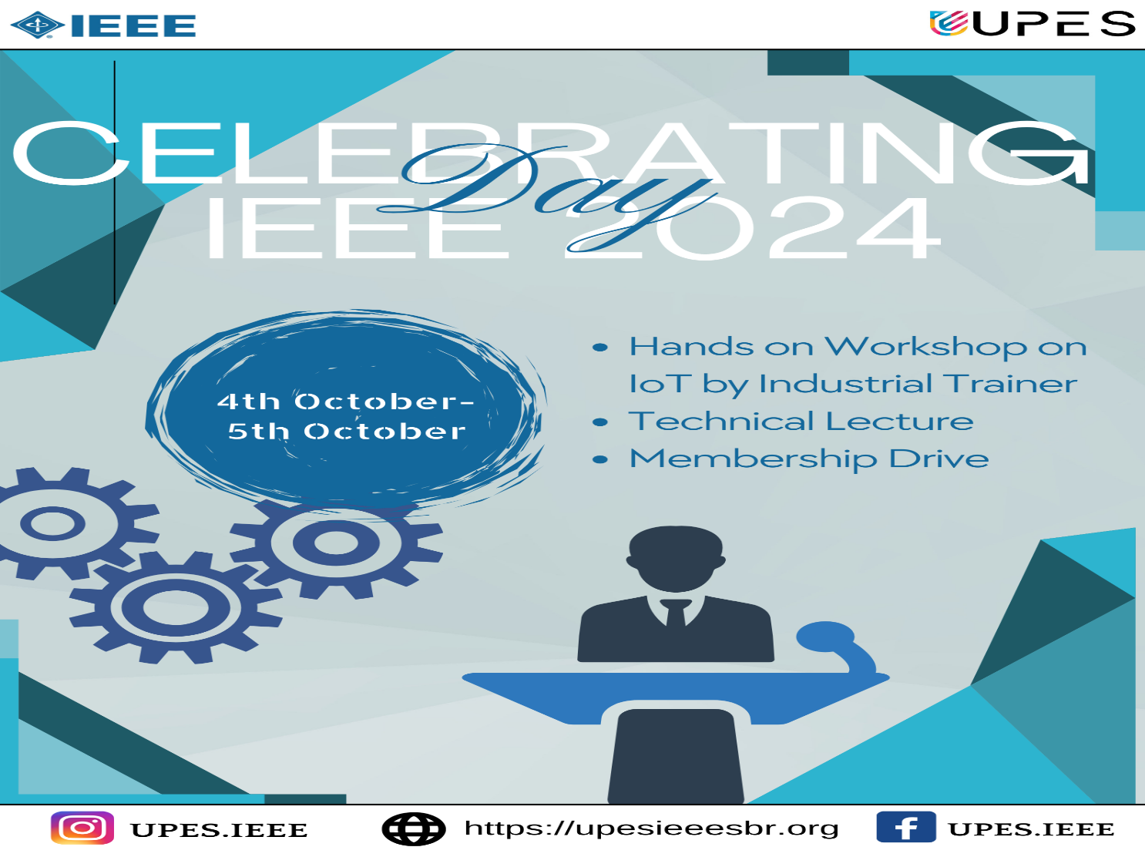

**Membership Drive :-**

The IEEE Student Chapter membership drive was conducted with the primary objective of increasing the chapter's member base and fostering a strong community of future engineers and tech enthusiasts. Our goals included not only boosting membership numbers but also ensuring that new members are actively engaged and aware of the benefits and opportunities available within the chapter. By highlighting upcoming events and activities, we aimed to showcase the value of being a part of the IEEE Student Chapter and to inspire participation in our initiatives.

**Outcomes:-**

During the IEEE Student Chapter membership drive. The positive response was particularly strong among first-year students and those majoring in computer science and engineering.

Additionally, we received inquiries from over 60 students who expressed interest in participating in future events and possibly joining the chapter later on. This level of interest indicates a growing enthusiasm and awareness of our chapter’s benefits and activities.

**Feedback:-**

We gathered feedback from the new members who joined during the drive,

Some new members suggested having more interactive sessions and hands-on workshops that cater to various skill levels. There was also interest in having mentorship programs where senior members can guide new members.

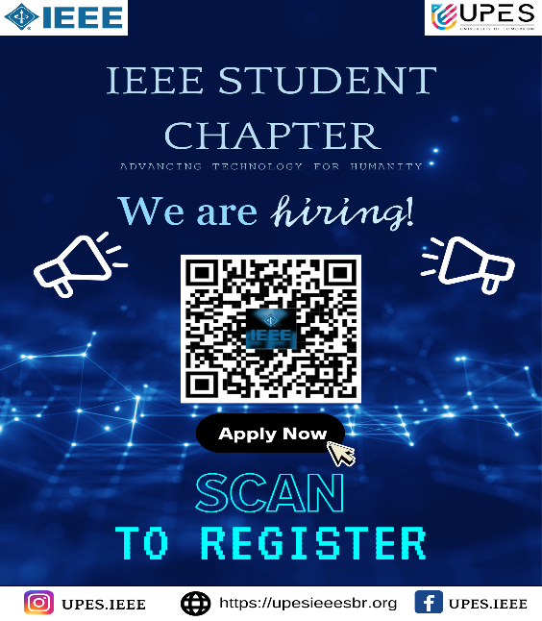 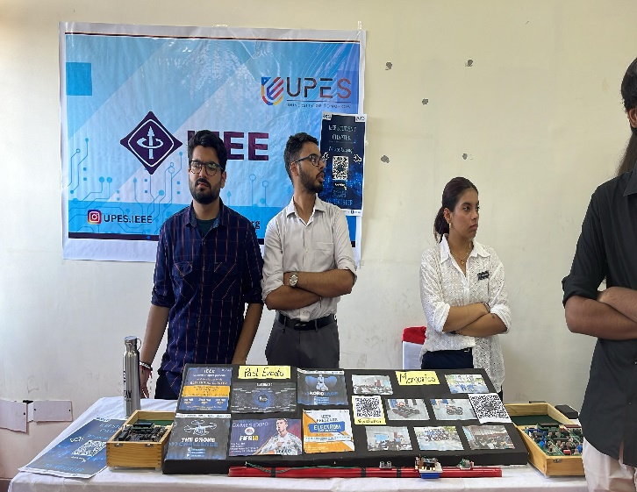

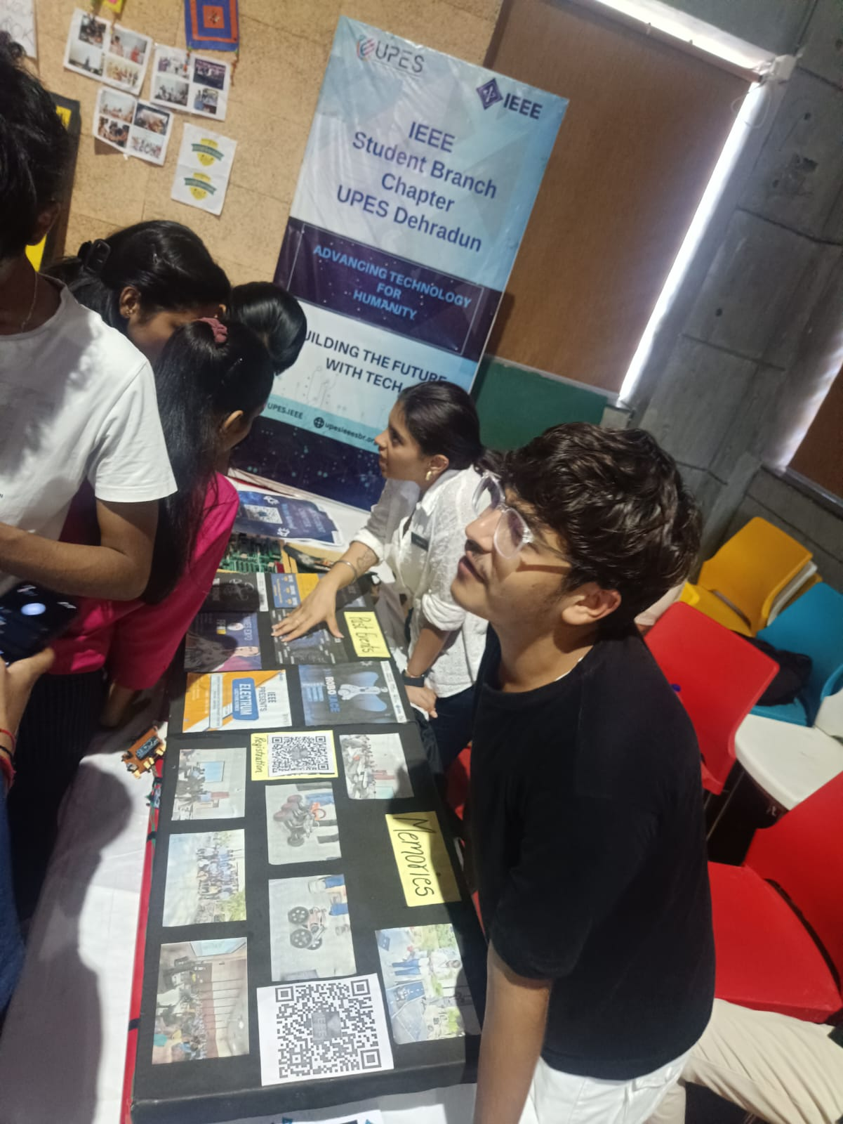

The IEEE Student Chapter membership drive was a resounding success, surpassing our recruitment goal and generating significant interest in our upcoming events. We have expanded our community and laid a solid foundation for future growth. The feedback from new members highlights their excitement for the chapter's offerings and their eagerness to get involved.

[#UPESIEEE](https://www.linkedin.com/feed/hashtag/?keywords=upesieee&highlightedUpdateUrns=urn%3Ali%3Aactivity%3A7114833673153110016) [, #ElectricalCluster](https://www.linkedin.com/feed/hashtag/?keywords=electricalcluster&highlightedUpdateUrns=urn%3Ali%3Aactivity%3A7114833673153110016) [, #UPES](https://www.linkedin.com/feed/hashtag/?keywords=upes&highlightedUpdateUrns=urn%3Ali%3Aactivity%3A7114833673153110016)

**Cleanliness Drive:-**

On Gandhi Jayanti, October 2nd, the IEEE Student Chapter organized a cleanliness drive to honour Mahatma Gandhi's vision of a clean and sustainable environment. This initiative aimed to foster community spirit and promote environmental awareness among members and residents.

We are excited to invite you to a special Cleanliness Drive on 2nd October organised by IEEE and NSS, on the occasion of Gandhi Jayanti. This event is a wonderful opportunity to honour the legacy of Mahatma Gandhi and contribute to a cleaner, greener environment.

Event Details:

• Date: October 2nd

• Time: 7:30 AM

• Venue: Bidholi Campus Main Gate

After the drive, a shraddhanjali (tribute) will also take place to pay our respects to the Father of the Nation.

This initiative is conducted by the National Service Scheme (NSS), UPES in collaboration with IEEE, UPES. Together, we aim to make a significant impact on our campus and surrounding areas. Embrace the principles of cleanliness and self-reliance championed by Mahatma Gandhi.

Let’s come together to make a difference and celebrate Gandhi Jayanti in a meaningful way. Your participation will not only help in keeping our surroundings clean but also inspire others to follow suit.

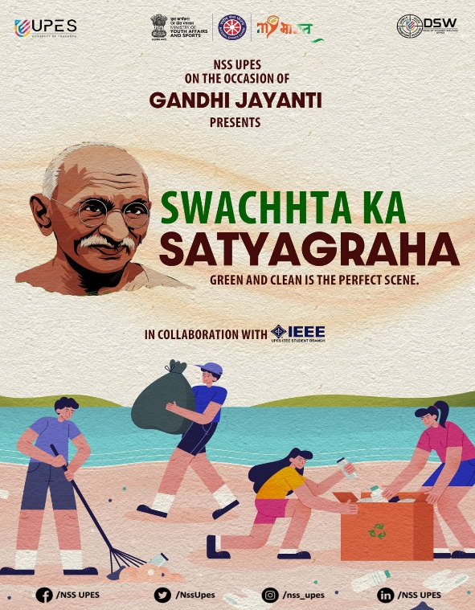 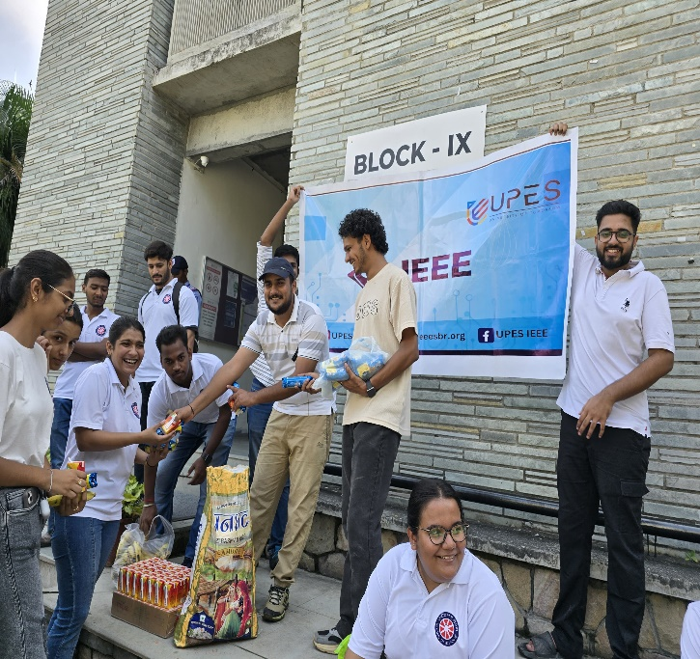

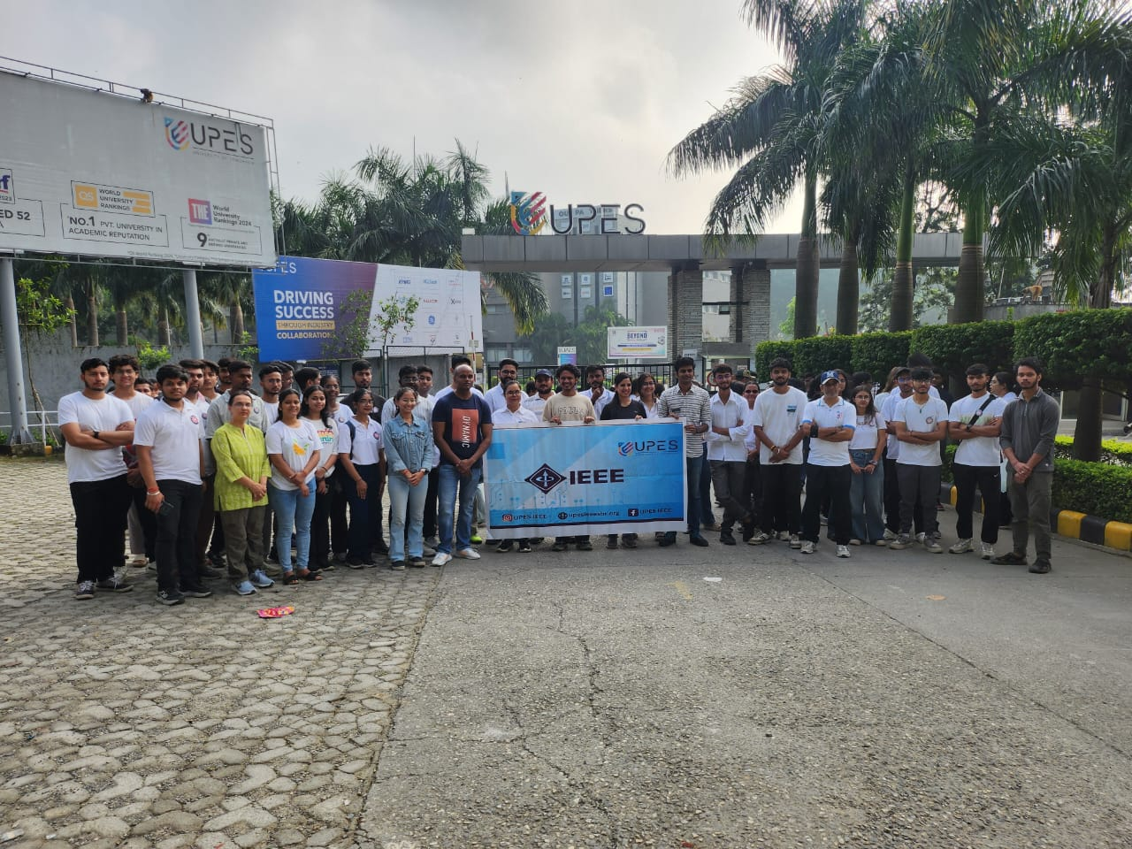

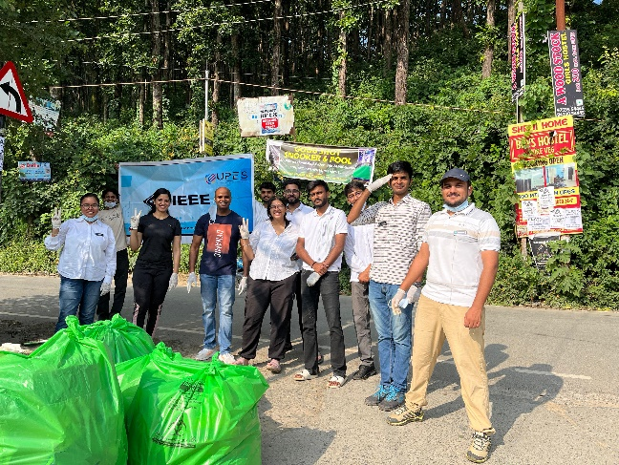 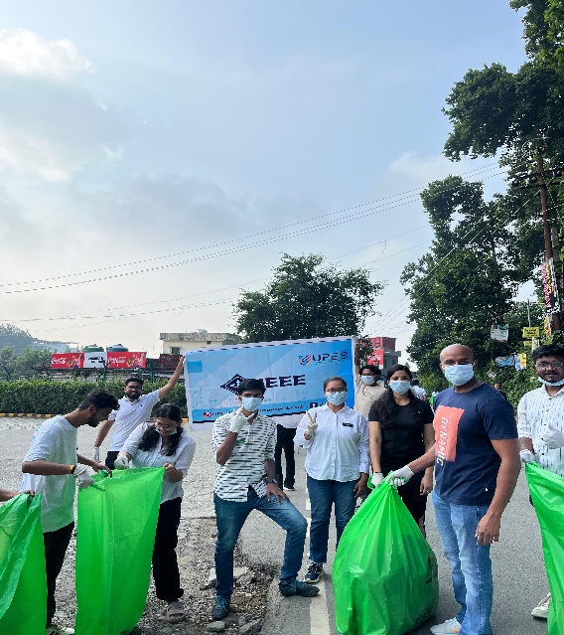

Conclusion

The cleanliness drive was a meaningful way to celebrate Gandhi Jayanti, bringing together the community and fostering a spirit of environmental stewardship. The event’s success highlights the positive impact of collaborative efforts towards a cleaner, greener future.

[#UPESIEEE](https://www.linkedin.com/feed/hashtag/?keywords=upesieee&highlightedUpdateUrns=urn%3Ali%3Aactivity%3A7114833673153110016) [, #ElectricalCluster](https://www.linkedin.com/feed/hashtag/?keywords=electricalcluster&highlightedUpdateUrns=urn%3Ali%3Aactivity%3A7114833673153110016) [, #UPES](https://www.linkedin.com/feed/hashtag/?keywords=upes&highlightedUpdateUrns=urn%3Ali%3Aactivity%3A7114833673153110016)

**Workshop:-**

The IEEE Student Chapter organized a highly insightful seminar on **"Harnessing Embedded Systems and IoT for Next-Gen Applications**" to delve into the emerging trends and innovative applications of these technologies. The event aimed to educate members on the latest advancements and practical implementations of Embedded Systems and IoT.

Exciting Workshop Alert ‼ ‼

**Harnessing Embedded Systems and IoT for Next-Gen Applications!**

Are you ready to dive into the world of cutting-edge technology? Join us for an exhilarating workshop titled “Harnessing Embedded Systems and IoT for Next-Gen Applications”. This event is set to ignite your passion for innovation and equip you with the skills to shape the future!

Event Details:

• Dates: 4th October – 5th October, 2024

• Time: 10:00 AM onwards (both days)

Why Attend? This workshop is a golden opportunity to learn from the best in the field. Conducted by Ashok Kumar, the visionary Founding Director of Ensino, and organized in collaboration with IEEE, UPES, this event promises to be a game-changer for aspiring engineers and tech enthusiasts.

Don’t miss out on this chance to enhance your skills and broaden your horizons. Whether you’re a seasoned professional or a curious beginner, this workshop has something for everyone.

Register Now and be a part of this transformative experience. Let’s harness the power of technology together!

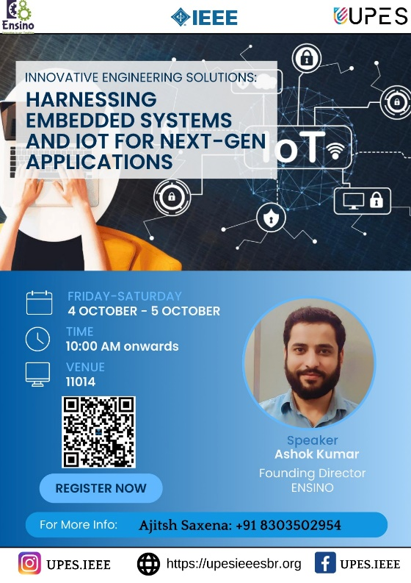 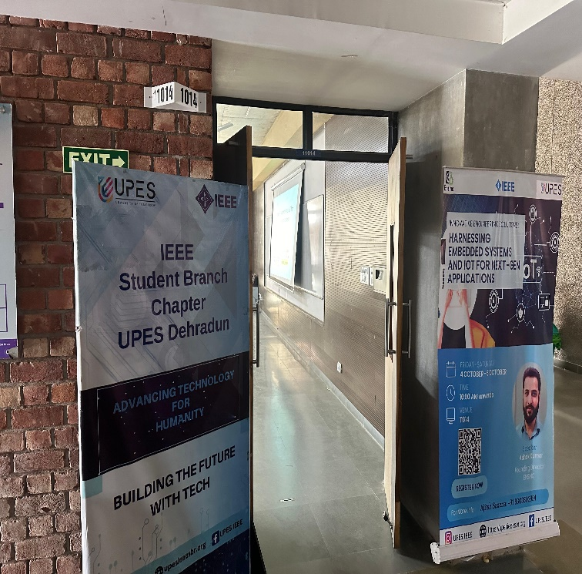

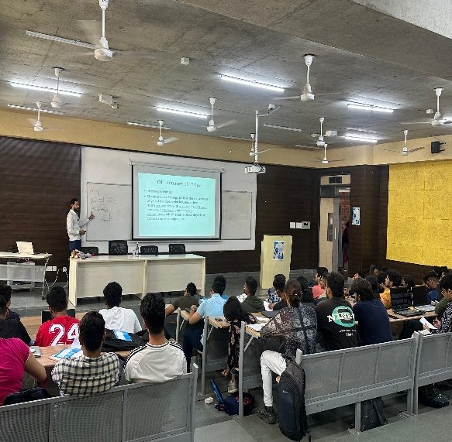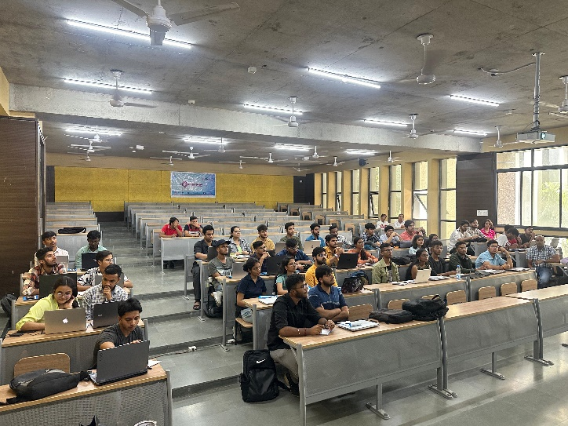

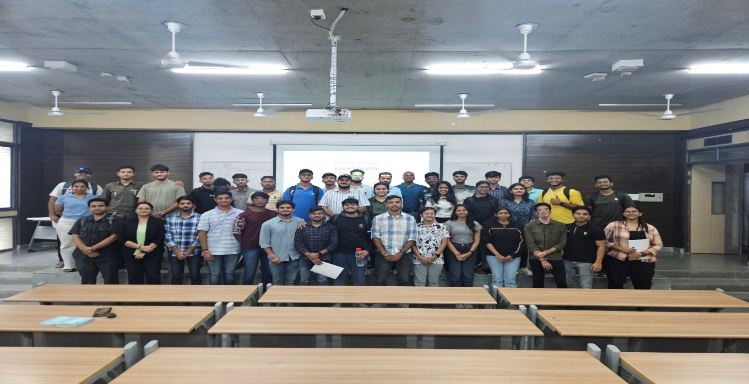

**Feedback**

* **Positive Response**: Attendees appreciated the depth of content and the hands-on experience.
* **Suggestions**: Requests for more advanced workshops and continued interaction with industry professionals.

**Conclusion**

The seminar was a significant success, fulfilling its objectives of education, innovation, and engagement. It has sparked a keen interest in Embedded Systems and IoT among students, paving the way for future initiatives. The IEEE Student Chapter plans to organize follow-up events to build on this momentum and continue fostering innovation and collaboration.

[#UPESIEEE](https://www.linkedin.com/feed/hashtag/?keywords=upesieee&highlightedUpdateUrns=urn%3Ali%3Aactivity%3A7114833673153110016) [, #ElectricalCluster](https://www.linkedin.com/feed/hashtag/?keywords=electricalcluster&highlightedUpdateUrns=urn%3Ali%3Aactivity%3A7114833673153110016) [, #UPES](https://www.linkedin.com/feed/hashtag/?keywords=upes&highlightedUpdateUrns=urn%3Ali%3Aactivity%3A7114833673153110016)

**Expenses:-**

|  |  |
| --- | --- |
| Category | Estimated Budget |
| Membership Drive :-  Posters  Standiee  Stationary | Rs. 2,800 |
| Cleanliness Drive:-  Refreshments  Gloves  Masks  Disposal Bags | Rs. 3,000 |
| Workshop:-  Bouquet  Standiee & Posters  Refreshments  Goodies | Rs. 10,000 |
| Total | Rs. 15,800 |

