 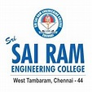

**ORGANIZATION UNIT**

Sri Sairam Engineering College SB – STB60981V

Event Name: SAIRAM IEEE DAY CELEBRATION 2024

|  |  |
| --- | --- |
| Designation | Name |
| Principal | Dr. J. Raja |
| Student Branch Counsellor | Dr. Brindha S |
| Student Branch ChairPerson | Mr. Rampavithran R |
| IEEE Day Campus Ambassador | Ms. Nasreen Begam Z |

**DESCRIPTION:**

IEEE Day 2024 at Sri Sai Ram Engineering College, West Tambaram, was a spectacular celebration of technology and innovation, featuring **seven thrilling events** that captivated participants.

The **RC Turbo Track** event saw students designing and racing custom-built RC cars, showcasing their engineering prowess. **Cipher Chase** tested speed and collaboration as teams solved complex coding problems in a fast-paced, two-round competition. The **Bot Vault**, organized by the IEEE Robotics and Automation Society, introduced students to the fundamentals of automation and sensor technology through hands-on activities. **Bid Wars** combined quiz challenges on IEEE topics with a strategic bid-based presentation round, highlighting participants' creativity and strategic thinking. **Botify Business** focused on leveraging AI for business applications, where participants generated promotional content and built chatbots to tackle real-world problems. The **Payload Pursuit (CTF Challenge)** featured an exhilarating seven-level Capture The Flag competition, engaging teams in technical problem-solving. Finally, **SparkScape** invited teams to pitch innovative ideas, design posters, and solve puzzles, blending business and technology in a creative contest. IEEE Day 2024 was a resounding success, fostering collaboration, innovation, and a passion for technology among all participants, leaving everyone inspired and eager for future challenges.

**TURBO TRACK**

**EVENT NAME :** Turbo Track

**DATE :** 07/10/2024

**VENUE:** Mechatronics Lab

**TYPE OF THE EVENT:** Technical

**MODE OF EVENT:** Offline

**EVENT ORGANIZERS:**

1. Yeshwanth Raj - Lead
2. Pranesh - Co-Lead

**EVENT DESCRIPTION:**

The RC Car Competition consists of three rounds testing design and performance skills. Round 0 is an online session covering design principles and a demo model. In Round 1, all 15 teams present their prototype RC cars for evaluation, with non-compliant teams disqualified. Round 2 features the top 10 teams racing their cars on a custom track, evaluated on speed, maneuverability, innovation, lap time, endurance, and durability.

**ROUND 0:**

The Turbo Track event began with Round 0 on October 1st, 2024, serving as an online preliminary session to help participants prepare for the main event. Teams attended an informative Q&A session, where they clarified competition rules and expectations. The event team showcased a demo RC car with basic features, giving participants a firsthand look at the design elements and performance capabilities required for the competition. The session provided valuable insights, helping participants fine-tune their own models.

**ROUND 1:**

The first round of the Turbo Track event was completed on October 4th, 2024. This round served as a project expo, where participants brought their custom-made RC cars and presented them to the juries. Teams explained their unique design features and technical innovations they implemented in their cars, showcasing their creativity. The event also provided an opportunity for participants to discuss the competition flow with event volunteers and network with fellow teams. Overall, the event was a success, with strong participation and a positive exchange of ideas.

Teams Presented : 8 teams

No of Participants : 24

**ROUND 2:**

The second round of the Turbo Track event was held on October 7th, 2024. At the start, teams were given time to examine the custom track designed by the event team and ensure their RC cars could handle its challenges. Once the jury arrived, the event kicked off, with each team running their cars for up to 2 laps on the track. The jury members closely evaluated each car’s design, performance, and maneuverability. After a thorough assessment, the top 3 teams with the most innovative designs, best performance, and fastest lap times were awarded prizes, marking a successful completion of Round 2 and the Turbo Track competition.

Teams Participated : 8 teams

No of Participants : 24

**JURY DETAILS:**

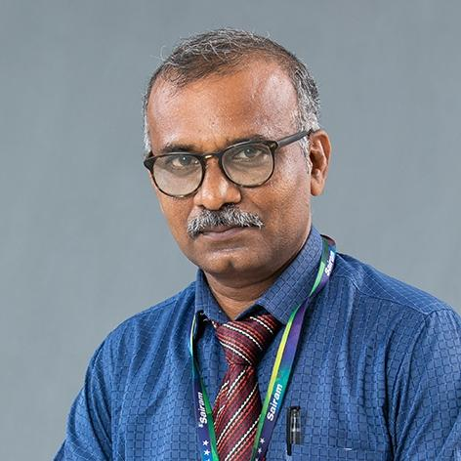

Dr.L.Saravanakumar

Associate Professor/ Department of Mechanical Engineering (SEC)

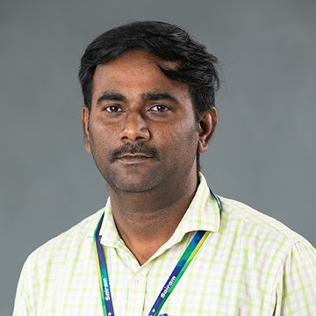

Dr.R.Dhanasekar

Associate professor /Department of EEE (SIT)

**CONCLUSION :**

The Turbo Track event was more than just a competition; it was a vibrant celebration of innovation, teamwork, and the relentless pursuit of excellence. Participants not only showcased their technical skills but also forged connections and shared their passion for engineering.

**WINNERS LIST**

**1st PRIZE:**

Team Name : Aurora

1. Harini K L
2. Anuradha S
3. Kavyadharshini S M

**2nd PRIZE :**

Team Name : Hack Slayers

1. Rajalakshmi K
2. Jaswanth Raj J
3. Somanath E R

**3rd PRIZE :**

Team Name : SparkNerds

1. Lithika Sri G
2. Asmitha S J
3. Abinesh M

**EVENT PHOTOS**

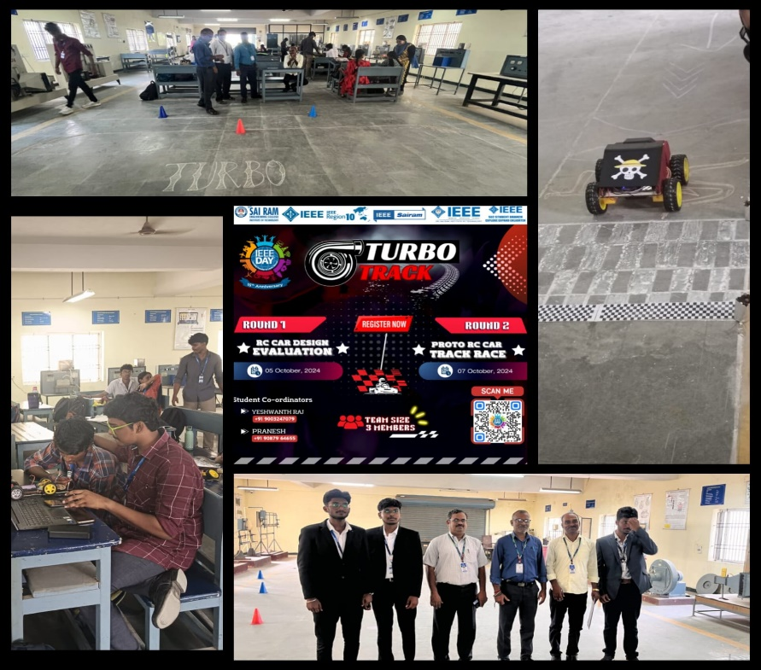

**CIPHER CHASE**

**EVENT NAME :** Cipher Chase

**DATE :** 07/10/2024

**VENUE:** Computer Center - 2

**TYPE OF THE EVENT:** Technical

**MODE OF EVENT:** Offline

**EVENT ORGANIZERS:**

1. Jenefer - Lead
2. Ganesh - Co-lead
3. Ilakkiya S - Co-lead
4. Vinoth - Co-lead

**EVENT DESCRIPTION:**

Cipher Chase, held on October 7, 2024, as part of IEEE Day 2024 celebrations at Sri Sairam Engineering College, was a fast-paced two-round technical competition. The event challenged participants on both logical reasoning and technical coding skills, testing their ability to solve puzzles and program effectively under pressure.

A total of 25 teams participated in the event, each composed of two members. The first round was conducted via Educaplay, focusing on future and emerging technologies, while the second round was held on HackerRank, emphasizing multi-language programming.

**ROUND 1:**

The Turbo Track event began with Round 0 on October 1st, 2024, serving as an online preliminary session to help participants prepare for the main event. Teams attended an informative Q&A session, where they clarified competition rules and expectations. The event team showcased a demo RC car with basic features, giving participants a firsthand look at the design elements and performance capabilities required for the competition. The session provided valuable insights, helping participants fine-tune their own models.

Teams Presented: 25

No. of Participants: 50

**ROUND 2:**

In the second round, Treasure Hunt – Code to Win, teams were challenged with multi-language programming tasks on HackerRank. The round featured a unique dynamic where only one team member could code at a time, while the other was kept away from the workspace. Teams were required to switch between coding turns, making seamless communication and strategy critical for success. The task involved solving programming problems in C, Python, Java, and C++ to reveal missing letters in a partially completed word. Success in this round demanded not only technical proficiency in multiple programming languages but also effective collaboration between team members, as they frequently swapped roles.The top teams to correctly decode and complete the word by solving all the coding challenges were declared the winners.

Teams Presented: 10

No. of Participants: 20

**JURY DETAILS:**

1. Dr. Adiline Macriga /  IT / SEC /  Professor

2. Mrs.G.Nirmaladevi /  CSE / SIT / Assistant Professor

3. Dr. I. Vimal Kannan / MECH & AUTO / SEC /  Associate Professor

4. Mr.Gopinath N / CSE /  SEC / Assistant Professor

5. Mrs.A.Sathiya / AI&DS / SIT / Assistant Professor

**CONCLUSION :**

Cipher Chase successfully engaged participants in a fast-paced technical competition that combined logical reasoning and coding skills. The transition from the quick-fire puzzle-solving of AlphaSprint to the strategic coding challenges of Treasure Hunt highlighted participants' adaptability and teamwork. The event fostered collaboration and quick thinking, celebrating innovation and technical expertise, making it a memorable part of the IEEE Day celebrations at Sri Sairam Engineering College.

**WINNERS LIST**

**1st Place**

Team Name : Duo Developers

1. Navin B - AIDS / III /SEC
2. Ashwanth P - AIDS / III / SEC

**2nd Place**

Team Name : Nexus

1. Praveen M - IT / III / SEC
2. Surya U - IT / III / SEC

**3rd Place**

Team Name: The Baskins

1. Hemapriya R C - AIDS / III / SEC
2. Aravind M - AIDS / III / SEC

**EVENT PHOTOS**

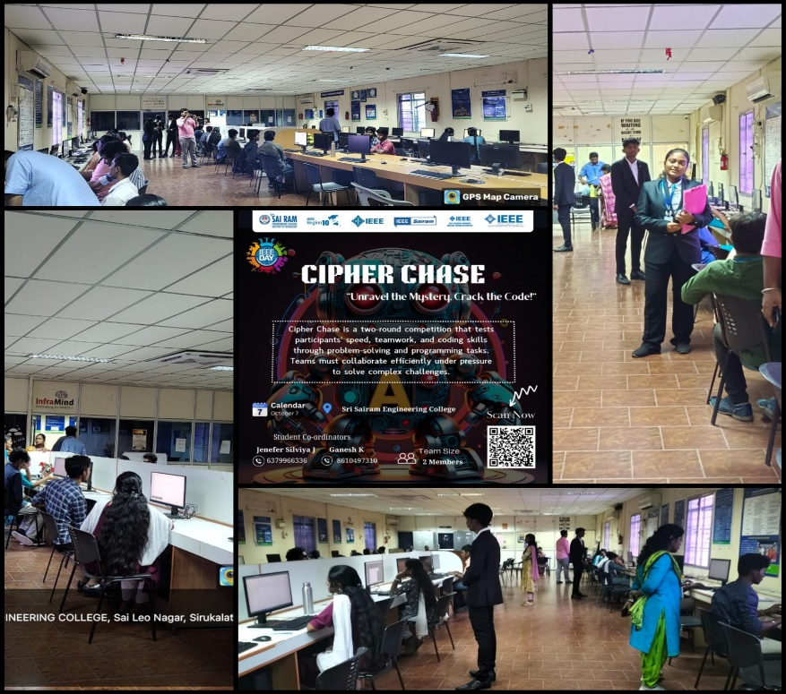

**BID WARS**

**EVENT NAME :** Bid Wars

**DATE :** 07/10/2024

**VENUE:** Smart Classroom – 1

**TYPE OF THE EVENT:** Non - Technical

**MODE OF EVENT:** Offline

**EVENT ORGANIZERS:**

1.Savitha - Lead

2.Arun - Co-Lead

3.Harish - Co-Lead

**DESCRIPTION:**

The Bid Wars event, part of IEEE Day 2024, featured two rounds designed to enhance knowledge and teamwork. Round 1 tested participants' understanding of IPL auction strategies and IEEE topics through a quiz. In Round 2, teams engaged in competitive bidding for roles, showcasing their strategic management plans for an IEEE Society. The event emphasized collaboration, creativity, and negotiation skills, preparing participants for future challenges.

**ROUND 1:**

Round 1 of the Bid Wars event, part of IEEE Day 2024, took place on October 3, 2024, at 8:00 PM via Quiz.com. A total of 50 participants, organized into teams of three, engaged in a quiz that tested their knowledge of IPL auction strategies and IEEE topics. The quiz featured 20 questions with varying time limits, designed to challenge participants' quick thinking and knowledge. There was no negative marking for incorrect answers. The top-scoring teams progressed to Round 2, with results announced promptly.

Teams Presented: 50

No. of Participants: 50 (Teams of 3 members with one representative from each event)

**ROUND 2:**

Round 2 occurred on October 7, 2024, at 9:00 AM in Smart Classroom 1, where 15 teams competed to bid for 12 available roles, each comprising 5 members with varying attributes: leadership, creativity, volunteering, endurance, and experience. Teams had a budget of 2.5 crores for their bids.

After purchasing their members, teams presented their strategies for managing an IEEE Society with their selected candidates, highlighting how their members' skills would contribute to effective leadership and project execution. The bidding was competitive, and all roles were filled successfully. The event showcased effective negotiation and collaboration among teams, setting a positive tone for the next phases of the competition.

Teams Presented: 15

No. of Participants: 45

**JURY DETAILS:**

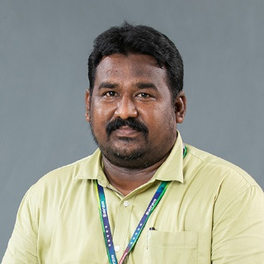

Dr. P. Venkatesh

Associate Professor - MBA/SEC

**CONCLUSION:**

The Bid Wars event proved to be an engaging and dynamic experience, fostering collaboration, strategic thinking, and creativity among participants. Both rounds successfully encouraged teamwork and knowledge application, preparing teams for future challenges within IEEE. The competitive spirit and innovative strategies displayed promise for a fruitful continuation of the competition, with participants eager to further develop their skills and contribute to the IEEE community.

**BID WARS WINNERS LIST**

**1st Place**

Team Name : Elite

1. Abinaya R
2. Madhumidhaa A P
3. Ananthi V

**2nd Place**

Team Name : Bid Pros

1. Pradeep S
2. Rajesh S

**3rd Place**

Team Name: Black Rock

1. Suryaputhiran T
2. Siva P
3. Sreevatsan V

**EVENT PHOTOS**

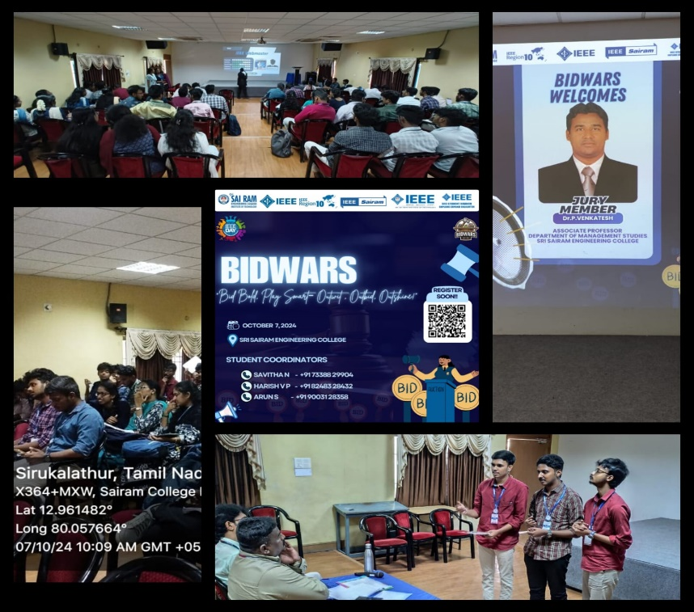

**BOT VAULT**

**EVENT NAME:** Bot Vault

**DATE:** 07/10/2024

**VENUE:** Incubation center

**TYPE OF THE EVENT:** Technical

**MODE OF EVENT:** Offline

**EVENT ORGANIZERS:**

1.Trisha - Lead

2.Tharushi - Co lead

3.Gowtham - Co Lead

4.Sri Raman - Co Lead

5.Abirami - Co Lead

6.Srinath - Co Lead

**EVENT DESCRIPTION:**

The event is a two-round competition focused on robotics and automation. Round 1 features an online quiz to assess participants' knowledge of robotics, automation, and sensors, shortlisting candidates for the next phase. Round 2 involves teams developing and presenting a hardware prototype based on automation and sensors during a live event on IEEE DAY. This competition promotes practical skills, innovation, and collaboration in tackling real-world challenges in robotics.

**ROUND 1:**

The event begins with an online quiz designed to test participants' basic knowledge of robotics, automation, and sensor technologies. This quiz will assess participants' initial understanding and spark their interest in these fields. Conducted in mentimeter on October 1 2024 from 7.00pm.All team leaders attended the quiz in mentimeter and other members are connected through Google meet. Totally 21 teams(63 members) registered for the event and among 21 teams,14 teams(42 members) participated in round 1 and 13 teams are shortlisted for round 2.

No of teams: 14

Participants: 42

**ROUND 2:**

Participants who perform well in the quiz will advance to Round 2. In this phase, shortlisted participants are required to develop a prototype hardware based on a provided theme related to automation and sensors. Participants will work on creating and refining their prototypes prior to the event day. On IEEE DAY oct 7 2024,participants brought their developed prototypes for presentation and demonstration. Among 13 shortlisted teams for round 2,10 teams(30 members) were present and came with prototype. After the presentation of all teams, the jury panel with scope members discussed and announce 3 teams(9 members) as winners.

No of teams: 10

Participants: 30

**Conclusion :**

The "Bot Vault" competition concluded successfully, starting with an engaging preliminary round that tested participants' knowledge in robotics and automation through a dynamic online quiz. This round set the stage for the final phase, where teams showcased their creativity and technical skills by presenting innovative prototypes focused on automation and sensors. Overall, the event celebrated the participants' achievements and fostered collaboration, culminating in an inspiring experience on IEEE DAY.

**JURY DETAILS:**

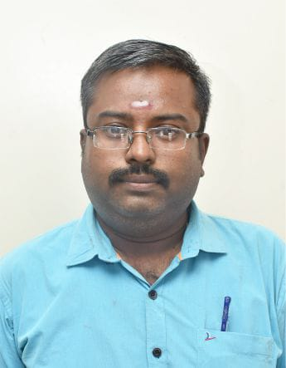

Dr VINAYAGA MURUGA PANDY

Assistant Professor / Department of mechanical engineering – SEC

**BOT VAULT WINNERS LIST**

**1st Place ;**

Team Name : Graspers

1. Nataraj E L - AIDS / II /SEC
2. Janani R - AIDS / II / SEC
3. Sujith S M - AIDS / II / SEC

**2nd Place :**

Team Name : Tech Nimbus

1. Keerthika S - CSBS / II / SEC
2. Dheepayalini R  - CSBS / II / SEC
3. Seerin Farhana S M - CSBS / II / SEC

**3rd Place :**

Team Name: Glucomate

1. Perumal B – ICE / III / SEC
2. Flemine K – ICE / III / SEC
3. Sai Losini K – ICE / III / SEC

**EVENT PHOTOS**

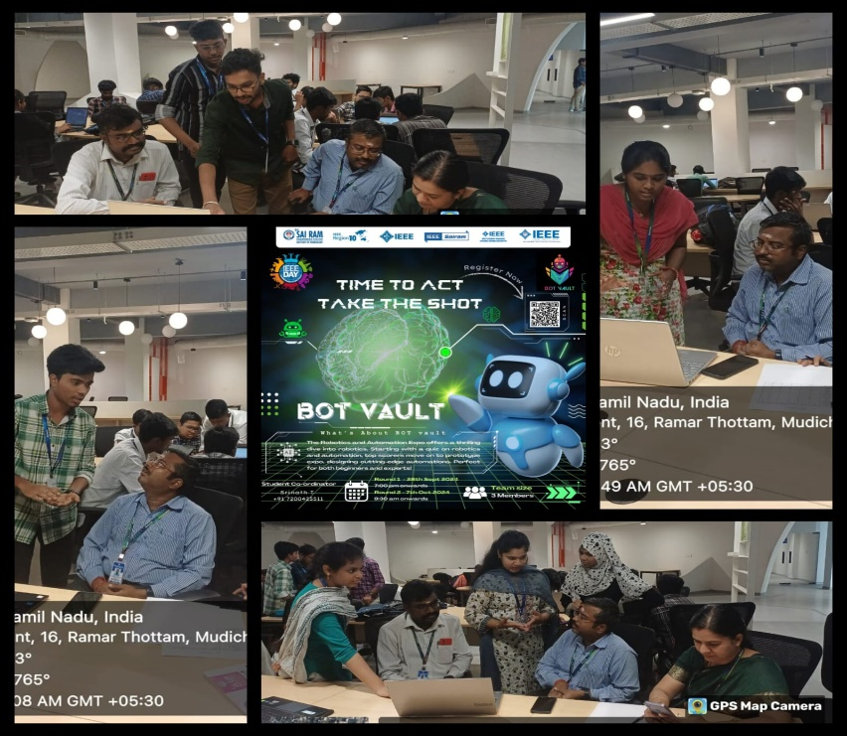

**Botify Business (IEEE Day)**

**NAME OF ORGANIZING UNIT: IEEE Sri Sairam Institute of Technology**

**DATE OF EVENT**: Monday, 7th October 2024

**WHETHER FUNDS RECEIVED FROM IEEE EXCLUSIVELY FOR EVENT? : No**

**TOPIC :** Botify Business - (IEEE Day)

**SPEAKER DETAILS**: Vishali R – Botify Business Event Organizer & Coordinator,

Vasanth V - Botify Business Event Organizer & Coordinator

**MODE OF EVENT**: Offline

**TARGET AUDIENCE**: IEEE Members & Students

**ATTENDANCE: 40+**

**TIMINGS : 09.00am – 12:30 pm**

**EVENT SUMMARY:**

On Friday, October 4th, 2024, the IEEE of Sri Sairam Institute of Technology kicked off the first round of *Botify Business* with an exciting online challenge which was conducted by Vishali R , Event Organizer &Coordinator -IEEE Day. Participants were tasked with using generative AI to create promotional content for fun, relatable business scenarios, like AI competing in traditional Indian games, haggling with street vendors, and navigating the chaos of an Indian train journey. The creativity on display was remarkable, as participants cleverly guided AI to engage with culturally rich situations in humorous and innovative ways. The submissions stood out for their originality, blending AI technology with human experiences in ways that sparked both thought and laughter. Judges were impressed by the inventive ways AI was woven into everyday scenarios, making the event as entertaining as it was technically impressive. This first round has set a strong tone for the competition, with anticipation building for even more inventive AI challenges in the rounds ahead. On Monday, October 7th, 2024, the IEEE of Sri Sairam Institute of Technology continued the 'Botify Business' competition with the much-anticipated second round, led by Vishali R and Vasanth, Event Coordinators for IEEE Day. Following the success of the first round, 15 standout teams advanced to this stage, where they faced a more technically challenging task. In this round, participants were asked to develop chatbots based on three distinct scenarios. Each team had to leverage AI to build functional, responsive chatbots that could handle real-world situations creatively and practically. The challenge pushed teams to showcase their skills in natural language processing and prompt engineering. From the 15 teams, 3 emerged as the winners, impressing the judges with their innovative and efficient chatbot designs. The event demonstrated a strong combination of technical expertise and ingenuity, setting a high standard for future competitions at the institute.

**REPORTED BY:**

Janani Vasupradha S & Krithika G

Content Team

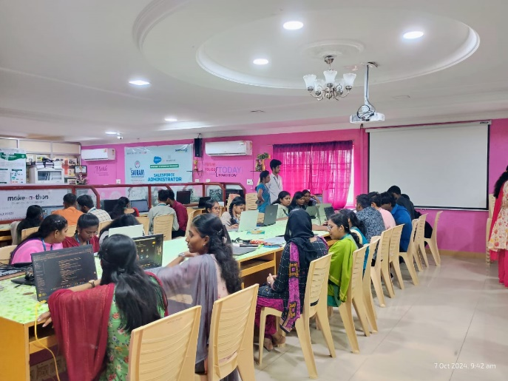

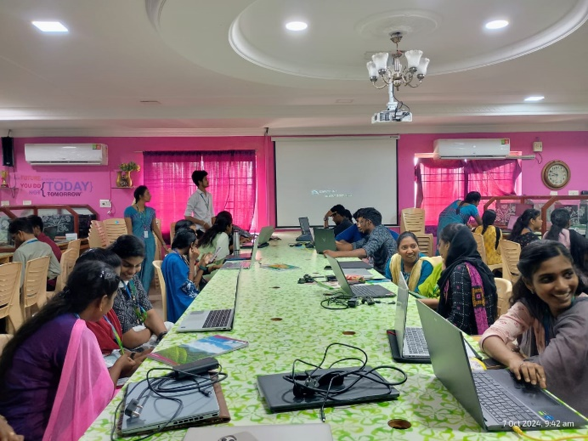

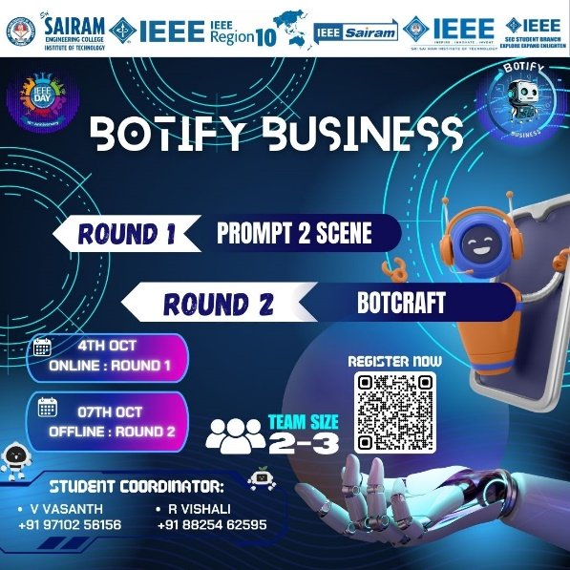

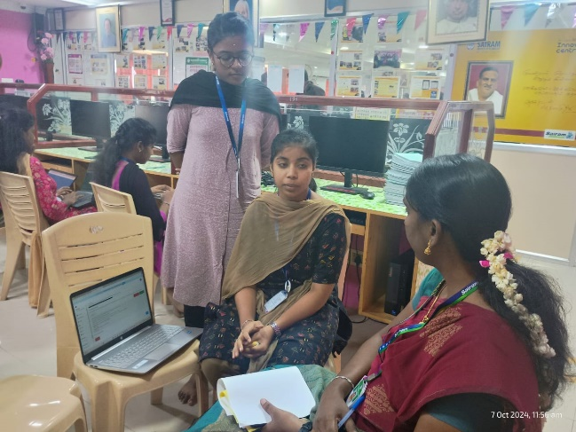 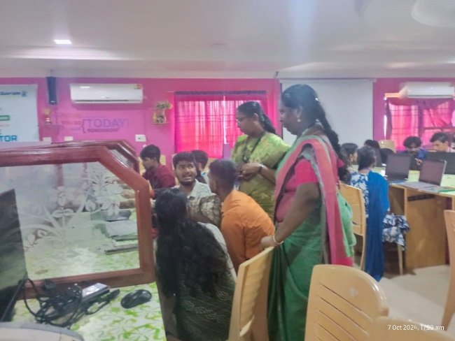

**SPARK SCAPE**

**ORGANIZING UNITS:** Sri Sairam Institute of Technology SB - STB03109

Sri Sairam Engineering College SB - STB60981

**DATE OF EVENT:** 7th August 2024

**EVENT NAME:** IEEE DAY: SPARK SCAPE

**TYPE OF THE EVENT:** Technical

**MODE OF EVENT:** Offline

**TARGET AUDIENCE:** IEEE Students

**NUMBER OF IEEE PARTICIPANTS:** 75

**NUMBER OF NON-IEEE PARTICIPANTS:** -

**NUMBER OF VOLUNTEERS:** 10

**EVENT START TIME:** 9:30AM

**REGISTRATION LINK:** https://forms.gle/4Kz39cX5R3HeJPGp6

**EVENT DESCRIPTION:**

This engaging event brings together teams of three students from different disciplines to brainstorm creative solutions to real-world challenges. After selecting their problem statements, each team will not only pitch their innovative ideas but also create a visually striking poster to showcase their concept. A fun twist comes with the bottle-flipping challenge, offering teams a chance to earn additional rewards. On top of that, teams will participate in a quiz, solving crossword puzzles at intervals throughout the event. Scoring is comprehensive, factoring in idea pitches, poster design, and quiz performance, with bonuses like design help and priority presentation slots for standout teams.

**EVENT SUMMARY:**

In the event summary, teams of three students from different disciplines come together to take on problem statements and generate creative, innovative solutions. After selecting their challenge, each team develops a product or idea and presents it to the judges. To enhance their pitch, they also design a poster that visually communicates their concept, ensuring their idea is clearly understood and impactful.

Adding a fun twist, teams participate in a bottle-flipping challenge, where successfully flipping the bottle and solving questions will earn them advantages. This can give them an edge by offering additional points or perks that can improve their standing.

Simultaneously, teams are also involved in a quiz that tests their general knowledge and problem-solving skills through crossword puzzles. The quiz questions are introduced at regular intervals, making it a continuous challenge throughout the event. The combination of idea pitching, poster design, and quiz participation makes the event competitive yet engaging.

Scoring is a key aspect, with final tallies based on how well teams perform across all activities. Teams that excel in pitching, poster design, and quizzes are rewarded with bonuses, such as assistance from design experts to improve their projects and prime presentation slots for their ideas. The event is structured to reward creativity, teamwork, and quick thinking.

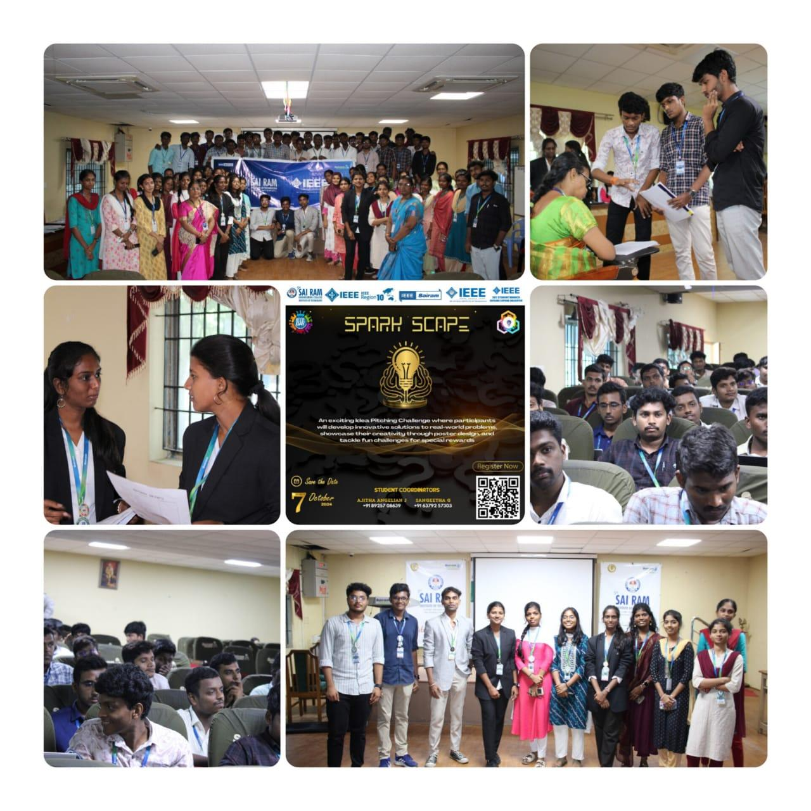

**WINNERS:**

**1st Prize:**

**Team name:** Walten white

1. Sundharacholan S L - CSBS - 2nd year - SEC

2. Zaidh Ahamed M S - AI&DS - 2nd year - SIT

3. Najamuddin R – EEE – 2nd year – SIT

**2nd Prize:**

**Team name:** EcoTrail

1. Venishree N - AI&DS - 3rd year - SIT

2. Subbiksha S - CSE - 2nd year - SIT

3. Akshitha B- IT - 2nd year – SIT

**3rd Prize:**

**Team name:** Flare

1. Praveen kumar P - CSBS - 2nd year - SEC

2. Seshagiri R - EEE - 2nd year - SIT

3. Hariharan S - EIE - 2nd year – SEC

**EVENT END TIME:** 4:00PM

**PAYLOAD PURSUIT**

**ORGANIZING UNITS:** Sri Sairam Institute of Technology SB - STB03109

Sri Sairam Engineering College SB - STB60981

**DATE OF EVENT:** 7th August 2024

**EVENT NAME:** IEEE DAY: Payload Pursuit

**TYPE OF THE EVENT:** Technical

**MODE OF EVENT:** Offline

**TARGET AUDIENCE:** IEEE Students

**NUMBER OF IEEE PARTICIPANTS:** 50

**NUMBER OF NON-IEEE PARTICIPANTS:** -

**NUMBER OF VOLUNTEERS:** 7

**EVENT START TIME:** 9:30AM

**REGISTRATION LINK:** https://forms.gle/jdXVmU4TTEe8t4TE9

**EVENT DESCRIPTION:**

"Payload Pursuit" is a Capture The Flag (CTF) challenge designed with 7 exciting levels. Each level presents questions and flags related to IEEE, testing participants' technical knowledge, problem-solving skills, and teamwork. Participants will race against time to capture as many flags as possible to win the competition.

**EVENT SUMMARY:**

**Introduction and Rules Briefing:**

* The event began with a detailed explanation of the CTF format. Participants were briefed on the competition structure, objectives, and how to tackle challenges effectively.
* Instructions were provided on how to solve the challenges and capture flags, covering essential cybersecurity tools and techniques. Teams were also informed about the rules, scoring process, and timelines to ensure smooth execution throughout the event.

**Level 1-7 Challenges:**

* The competition featured seven distinct levels, each increasing in difficulty to test participants’ critical thinking, problem-solving, and teamwork.
* Levels involved various technologies and cybersecurity concepts, such as cryptography, reverse engineering, web exploitation, and network forensics.
* Hints were released at strategic intervals to support participants, helping them progress through particularly challenging levels while still preserving the integrity of the competition.

**Flag Submission and Scoring:**

* Teams were required to submit flags after solving each challenge. These flags served as proof of successful completion.
* A Google Form was used to collect flag submissions, which allowed the event organizers to maintain a clear record of timestamps for each submission. This system helped in tracking the real-time progress of the teams and ensured accurate scoring.

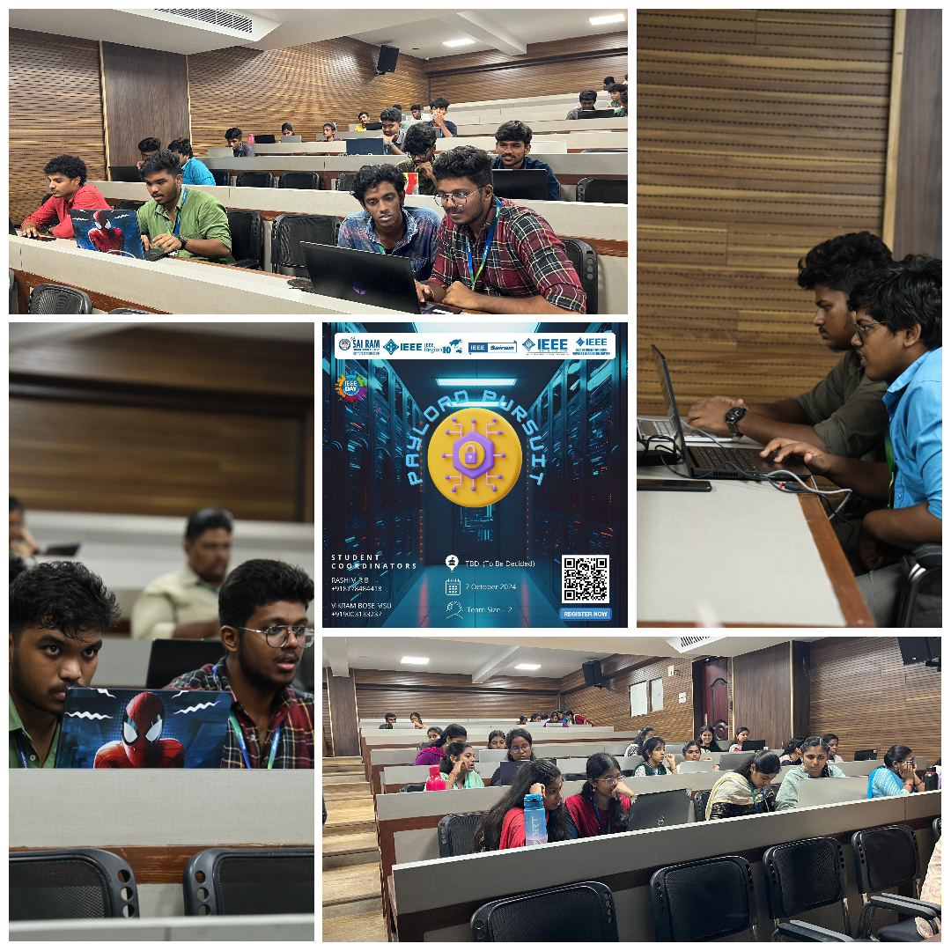

**WINNERS:**

**1st Place:** Suriya P, III - Cyber Security, SIT

Dharshan SP, III - Cyber Security, SIT

**2nd Place:** Kamesh K, III - Cyber Security, SIT

Galvin A Xavier, III - Cyber Security, SIT

**3rd Place:** Kaashi T, III - Cyber Security, SIT

Abinav Karthick S, III - Cyber Security, SIT

**EVENT END TIME:** 4:00PM

**SOCIAL MEDIA**

**INSTAGRAM:** <https://www.instagram.com/sec_ieee.sb?igsh=MWFtOHkwMnk2Y2hnNw==>

**LINKED IN:** <https://www.linkedin.com/company/sri-sairam-engineering-college-ieee-student-branch/>