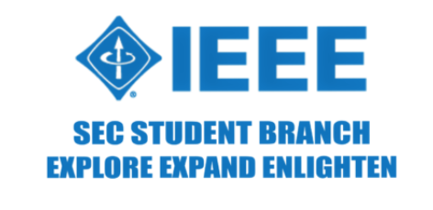 

**ORGANIZING UNITS:** Sri Sairam Engineering College SB - STB60981

Sri Sairam Institute of Technology SB - STB03109

**EVENT NAME :** Cipher Chase

**DATE :** 07/10/2024

**VENUE:** Computer Center - 2

**TYPE OF THE EVENT:** Technical

**MODE OF EVENT:** Offline

**EVENT ORGANIZERS:**

1. Jenefer - Lead
2. Ganesh - Co-lead
3. Ilakkiya S - Co-lead
4. Vinoth - Co-lead

**EVENT DESCRIPTION:**

Cipher Chase, held on October 7, 2024, as part of IEEE Day 2024 celebrations at Sri Sairam Engineering College, was a fast-paced two-round technical competition. The event challenged participants on both logical reasoning and technical coding skills, testing their ability to solve puzzles and program effectively under pressure.

A total of 25 teams participated in the event, each composed of two members. The first round was conducted via Educaplay, focusing on future and emerging technologies, while the second round was held on HackerRank, emphasizing multi-language programming.

**ROUND 1:**

The Turbo Track event began with Round 0 on October 1st, 2024, serving as an online preliminary session to help participants prepare for the main event. Teams attended an informative Q&A session, where they clarified competition rules and expectations. The event team showcased a demo RC car with basic features, giving participants a firsthand look at the design elements and performance capabilities required for the competition. The session provided valuable insights, helping participants fine-tune their own models.

Teams Presented: 25

No. of Participants: 50

**ROUND 2:**

In the second round, Treasure Hunt – Code to Win, teams were challenged with multi-language programming tasks on HackerRank. The round featured a unique dynamic where only one team member could code at a time, while the other was kept away from the workspace. Teams were required to switch between coding turns, making seamless communication and strategy critical for success. The task involved solving programming problems in C, Python, Java, and C++ to reveal missing letters in a partially completed word. Success in this round demanded not only technical proficiency in multiple programming languages but also effective collaboration between team members, as they frequently swapped roles.The top teams to correctly decode and complete the word by solving all the coding challenges were declared the winners.

Teams Presented: 10

No. of Participants: 20

**JURY DETAILS:**

1. Dr. Adiline Macriga /  IT / SEC /  Professor

2. Mrs.G.Nirmaladevi /  CSE / SIT / Assistant Professor

3. Dr. I. Vimal Kannan / MECH & AUTO / SEC /  Associate Professor

4. Mr.Gopinath N / CSE /  SEC / Assistant Professor

5. Mrs.A.Sathiya / AI&DS / SIT / Assistant Professor

**CONCLUSION :**

Cipher Chase successfully engaged participants in a fast-paced technical competition that combined logical reasoning and coding skills. The transition from the quick-fire puzzle-solving of AlphaSprint to the strategic coding challenges of Treasure Hunt highlighted participants' adaptability and teamwork. The event fostered collaboration and quick thinking, celebrating innovation and technical expertise, making it a memorable part of the IEEE Day celebrations at Sri Sairam Engineering College.

**WINNERS LIST**

**1st Place**

Team Name : Duo Developers

1. Navin B - AIDS / III /SEC
2. Ashwanth P - AIDS / III / SEC

**2nd Place**

Team Name : Nexus

1. Praveen M - IT / III / SEC
2. Surya U - IT / III / SEC

**3rd Place**

Team Name: The Baskins

1. Hemapriya R C - AIDS / III / SEC
2. Aravind M - AIDS / III / SEC

**EVENT PHOTOS**

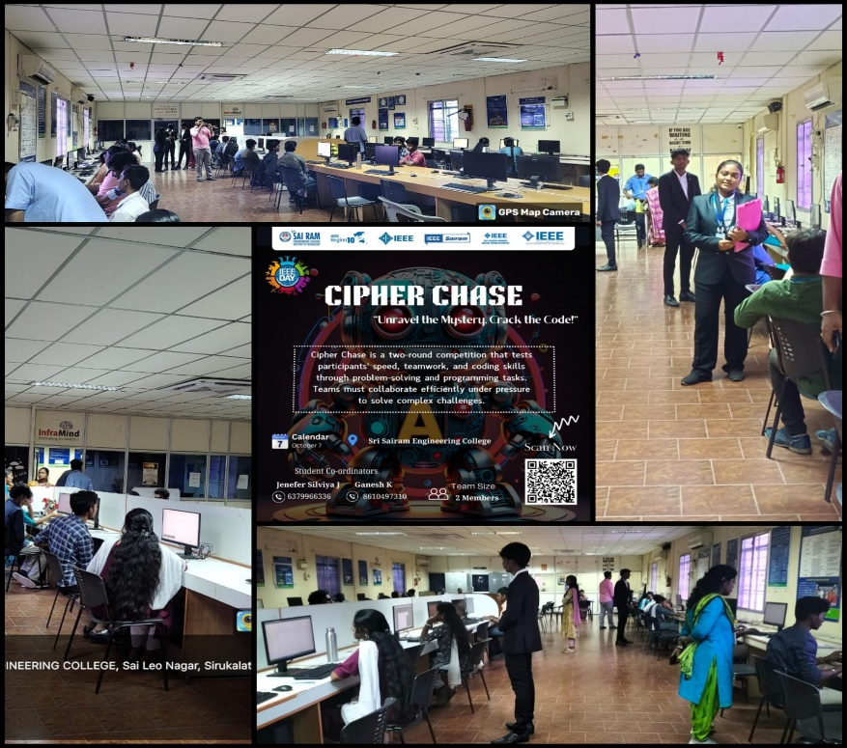

**SOCIAL MEDIA**

**INSTAGRAM:** <https://www.instagram.com/sec_ieee.sb?igsh=MWFtOHkwMnk2Y2hnNw==>

**LINKED IN:** <https://www.linkedin.com/company/sri-sairam-engineering-college-ieee-student-branch/>