### *Happy Volunteering*

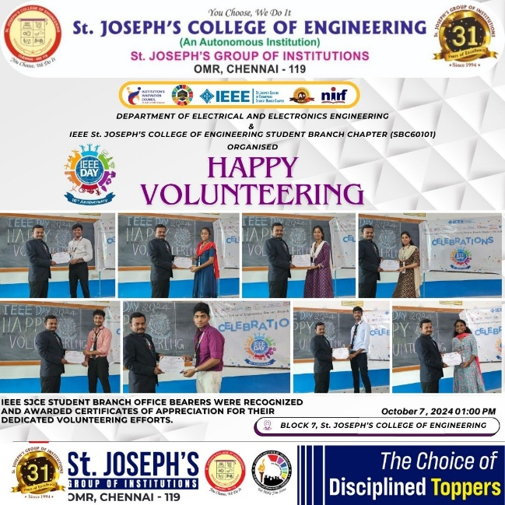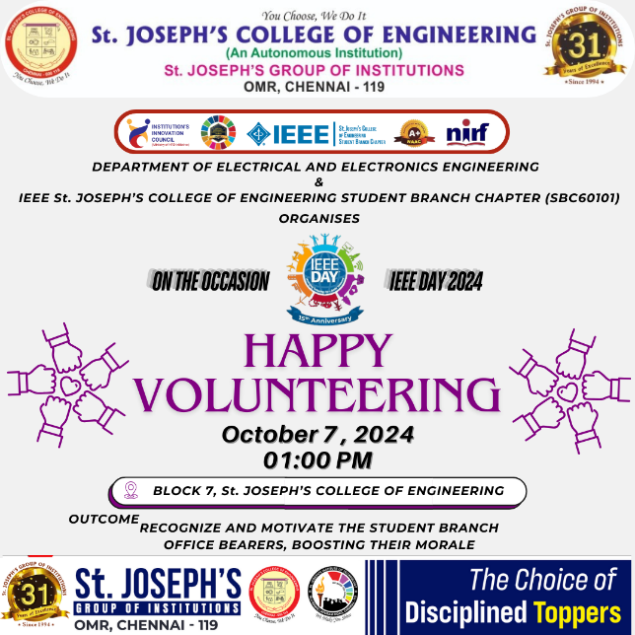

On **7th October 2024**, the **IEEE St. Joseph’s College of Engineering Student Branch Chapter (SBC60101)** hosted the **Happy Volunteering** event in celebration of **IEEE Day 2024**. This event was held to honour and recognize the unwavering dedication of the student branch's volunteers, who have significantly contributed to the success of various IEEE initiatives throughout the year.

During the event, over **280+ volunteers** were awarded **Certificates of Appreciation** for their outstanding service and commitment to the IEEE student branch activities. The event served as a heartfelt expression of gratitude to all those who generously gave their time, energy, and skills to help organize and manage IEEE events, workshops, and seminars.

The program emphasized the importance of volunteering and the impact it has on both the individual and the community.

#### **Outcome:**

The event reinforced the sense of unity and collaboration within the IEEE student community. By acknowledging the contributions of its volunteers, the event strengthened the culture of service, motivating students to continue engaging in volunteer activities and take pride in being part of IEEE.