***COVER TO COVER: IEEE SPECTRUM READING***

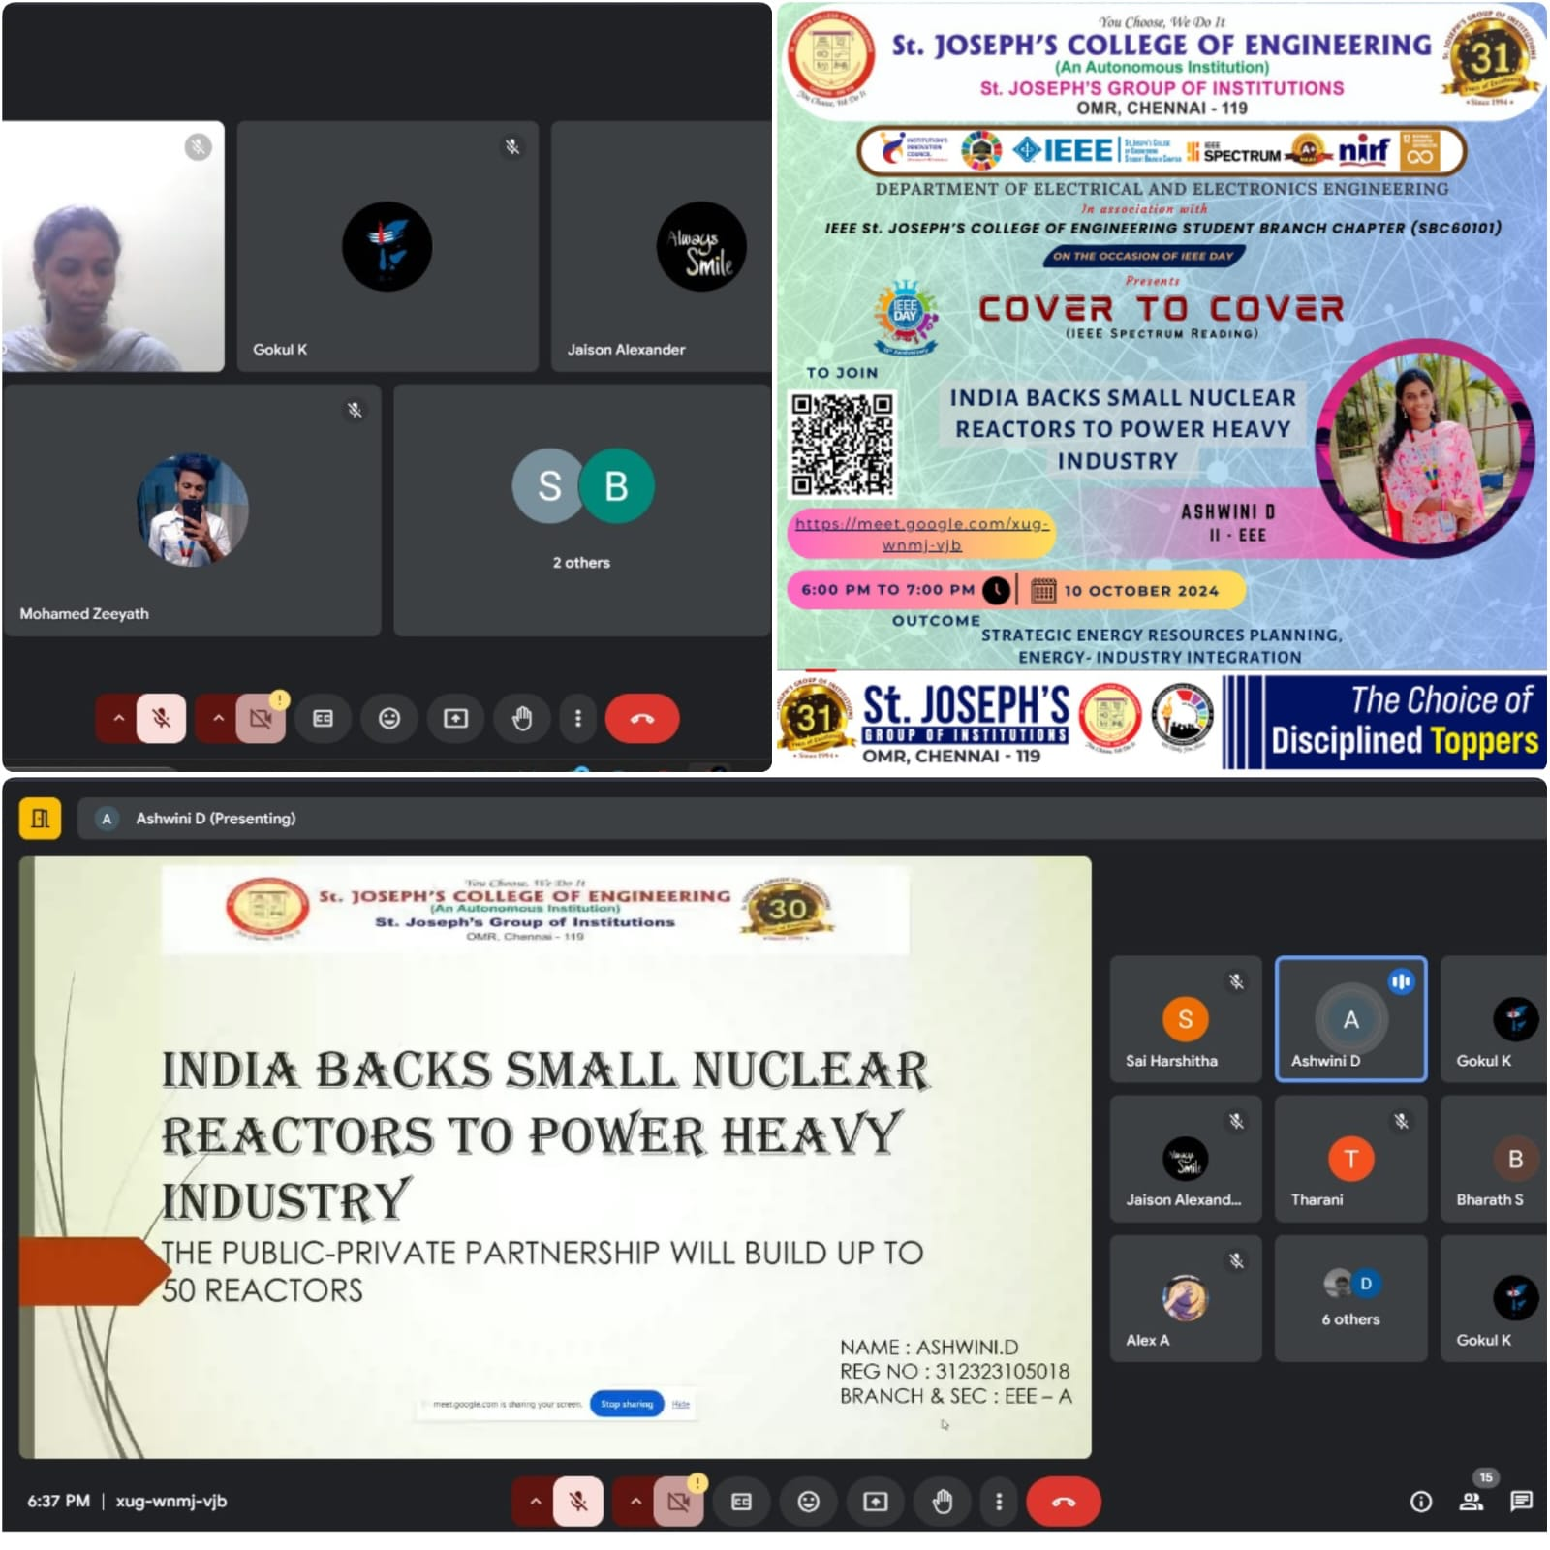

On **IEEE Day 2024**, the **IEEE St. Joseph’s College of Engineering Student Branch Chapter (SBC60101)** successfully hosted the **Cover to Cover (IEEE Spectrum Reading)** event on **10th October 2024**. The event featured a detailed discussion on the topic "India Backs Small Nuclear Reactors to Power Heavy Industry," presented by **Ashwini D**, a second-year EEE student.

The session explored the growing potential of small nuclear reactors in India’s energy landscape, with a focus on their application in powering heavy industry. Ashwini provided in-depth insights into how this technology can promote energy efficiency and sustainability, sparking engaging discussions among attendees about the future of nuclear energy in industrial applications.

**Outcome**:  
The event not only increased awareness of small nuclear reactor technology but also provided participants with a broader understanding of its real-world implications. Attendees left with a renewed appreciation for the role of nuclear power in advancing India’s industrial sector and enhancing energy independence. The event fostered curiosity and motivated students to explore IEEE Spectrum articles and stay up-to-date with technological advancements.