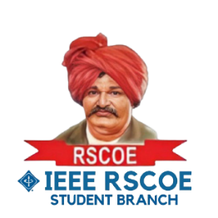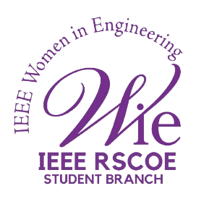

**IEEE Day Week Quiz Competition**

**Session name:** IEEE Day Week Quiz Competition

**Date:** October 11, 2024

**Mode of session:** Offline

**Number of participants:** 40

The IEEE RSCOE Student Branch organized a quiz competition to commemorate IEEE Day Week. The primary objective of the quiz was to engage students with the history, values, and contributions of the IEEE organization while also testing their general knowledge.

The quiz was conducted online using the Kahoot platform. This interactive platform allowed for real-time participation and immediate scoring. The questions were designed to challenge participants' understanding of IEEE's history, its significance in the field of technology, and their general knowledge.

A significant number of students from the RSCOE SB participated in the quiz. The competition was fierce, with participants demonstrating their knowledge and enthusiasm. After a series of questions, Aniket Kashid emerged as the winner.

The IEEE Day Week quiz proved to be a successful event. It not only celebrated the contributions of IEEE but also provided a fun and engaging learning experience for the students.

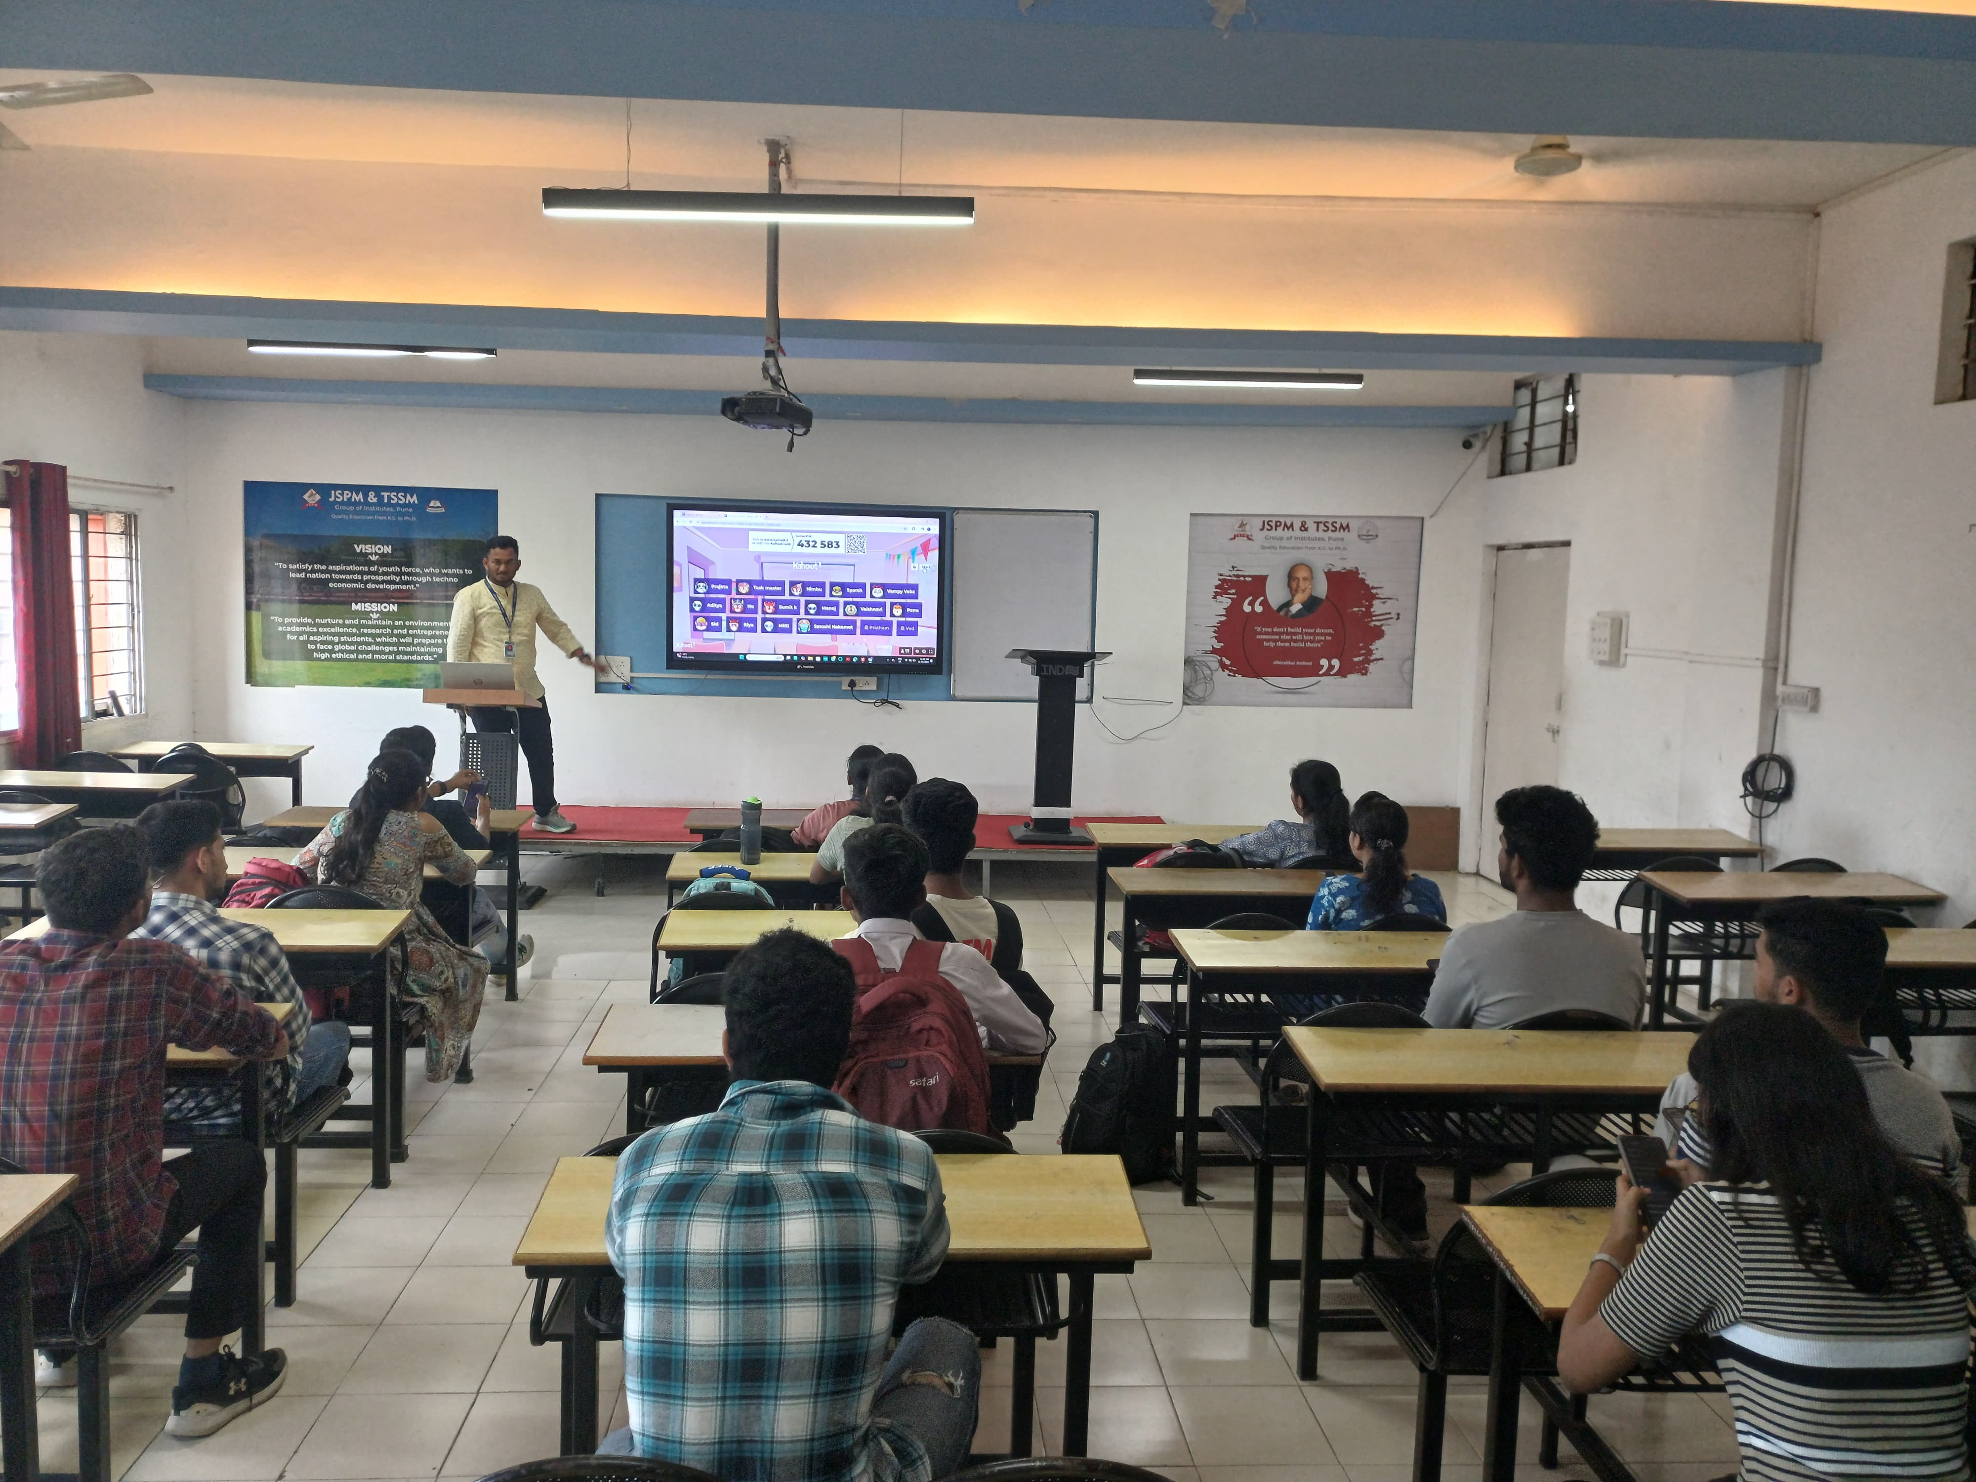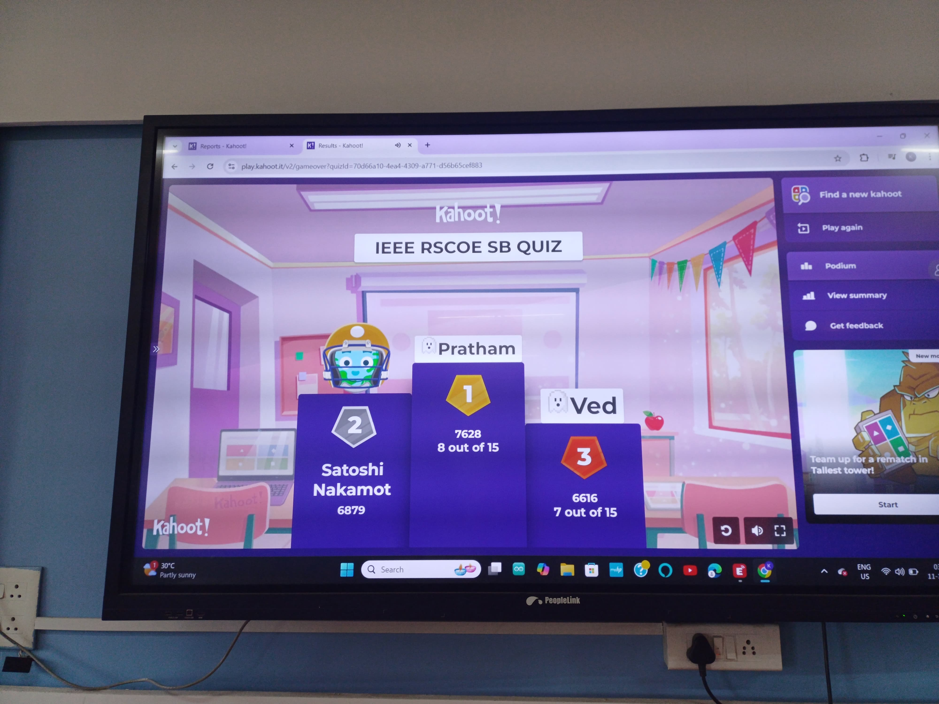Here are few glimpses of the event:

