***COVER TO COVER: IEEE SPECTRUM READING***

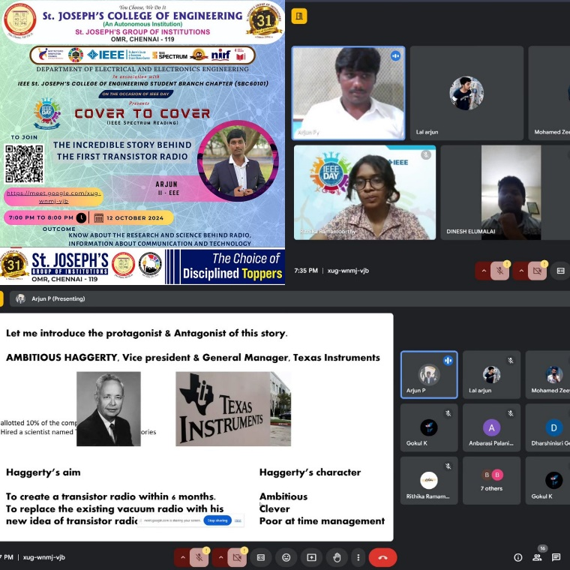

On **IEEE Day 2024**, the **IEEE St. Joseph’s College of Engineering Student Branch Chapter (SBC60101)** successfully hosted the **Cover to Cover (IEEE Spectrum Reading)** event on **12th October 2024.** The event featured an engaging talk by Arjun P, a second-year EEE student, on the topic "The Incredible Story Behind the First Transistor Radio."

Arjun delved into the fascinating history of how the first transistor radio revolutionized the electronics industry. He explained the pivotal role that this invention played in shaping modern communication, highlighting key breakthroughs and the contributions of notable engineers. The presentation sparked thought-provoking discussions among attendees, as Arjun illustrated how the development of the transistor radio laid the foundation for many of today's portable electronic devices.

**Outcome:** The event not only provided participants with a deeper understanding of the historical significance of the transistor radio but also ignited curiosity about the evolution of electronics and communication technologies. Attendees left inspired to explore more IEEE Spectrum articles and appreciate the innovations that continue to shape the world of electronics. The session successfully fostered an atmosphere of learning and inquiry into technological advancements

**INSTAGRAM LINK:**[**https://www.instagram.com/p/DBAusoUTBBz/?igsh=OWQ0ZTh0dHo1bm01**](https://www.instagram.com/p/DBAusoUTBBz/?igsh=OWQ0ZTh0dHo1bm01)