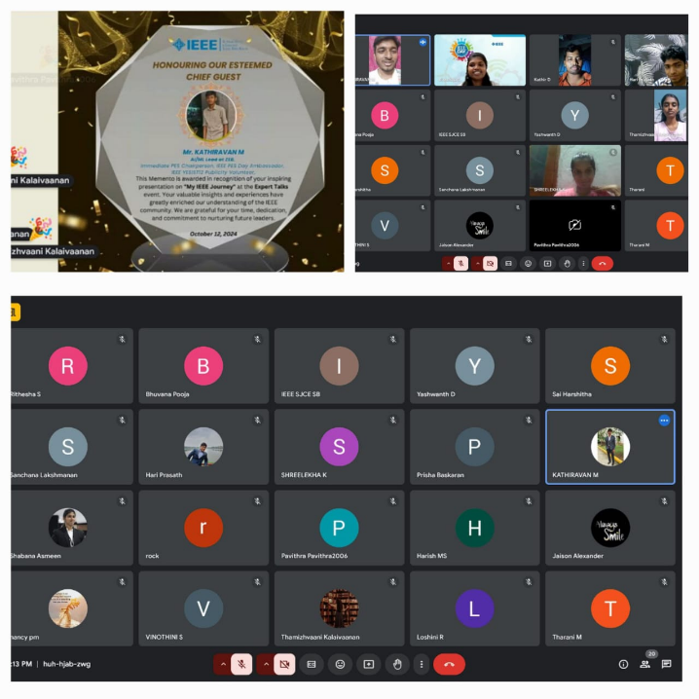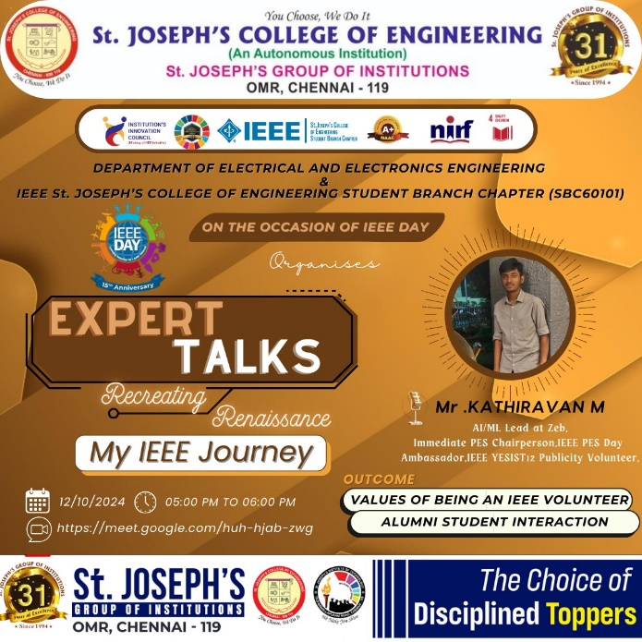 ***EXPERT TALKS SESSION 3***

On Behalf of IEEE day 2024, on 12th October 2024, IEEE SJCE SB successfully conducted the Third session of the EXPERT TALKS ("Recreating Renaissance") series. The session featured Mr. Kathiravan M, AI/ML Lead at Zeb, Immediate Past Chairperson of IEEE SJCE PES, IEEE PES DAY Ambassador, IEEE YESIST12 Publicity Volunteer, provided valuable perspectives on Electrical and Electronics Engineering and the broader IEEE society. The event facilitated meaningful interactions between the speaker and the participants, allowing for an exchange of knowledge and ideas. Around 30 Attendees left the session feeling motivated and equipped with new perspectives for their academic and professional endeavour.

**OUTCOME:**

Steps and Tricks to excel in IEEE Journey.

**Instagram:**

<https://www.instagram.com/p/DBAuY8hT5wP/>