**Event Report: IEEE Day at Sanskriti University**

**Event Name**: IEEE Day - Leveraging Technology for a Better Tomorrow  
**Session Focus**: Creativity & Innovation  
**Date**: 10th October 2024  
**Time**: 3:30 PM - 4:30 PM  
**Venue**: Seminar Hall / Online Mode  
**Organized by**: School of Engineering & Information Technology, Sanskriti University  
**Supported by**: IEEE UP Section (India) and Institution's Innovation Council (Ministry of HRD Initiative)

**1. Introduction:**

Sanskriti University's School of Engineering and Information Technology organized a special event in celebration of IEEE Day 2024. The theme was focused on "Leveraging Technology for a Better Tomorrow," with a special session dedicated to "Creativity & Innovation."

**2. Objective:**

The session aimed to explore the vital role of creativity and innovation in shaping the future of technology. It addressed how these elements can be leveraged to create a better tomorrow through engineering and technological advancements.

**3. Chief Resource Person:**

* **Prof. (Dr.) Pankaj Kumar Goswami**, Professor and Head of Department (HoD), SoEIT, Sanskriti University, served as the chief resource person. Prof. Goswami's expertise in engineering and technological innovation made him an ideal speaker for this event.

**4. Guiding Sources:**

* **Prof. (Dr.) M.B. Chetti**, Vice Chancellor of Sanskriti University, and **Prof. (Dr.) S Vairaichillai**, Professor and Dean, SoEIT, provided guidance and support for the event. Their leadership was instrumental in the planning and execution of the session.

**5. IEEE Coordinator:**

* **Prof. (Dr.) Garima Goswami**, Professor, SoEIT, acted as the IEEE Coordinator for the event. She played a key role in facilitating the connection between the university and the IEEE UP Section. She has given the welcome address of the event.

**6. Participants:**

The event was open to all undergraduate, postgraduate, and PhD students, promoting inclusivity and engagement among aspiring engineers and researchers.

**7. Mode of Participation:**

The session was held in a hybrid format, allowing participants to attend both in person at the Seminar Hall and online, making it accessible to a broader audience.

**8. Key Highlights:**

* The session provided an insightful discourse on how creativity drives technological innovation.
* Prof. Goswami emphasized the need for out-of-the-box thinking in engineering and discussed practical examples of how innovative approaches have led to breakthroughs in technology.
* The event underscored the importance of interdisciplinary collaboration in solving complex technological problems.

**9. Contact Information:**

For any further queries, participants were encouraged to contact via phone at **9410835690**.

**10. Conclusion:**

The IEEE Day session on "Creativity & Innovation" was a well-organized event that successfully highlighted the significance of innovation in technology. It provided a platform for students and faculty to discuss the future of engineering and the role of technology in creating a sustainable and innovative future.

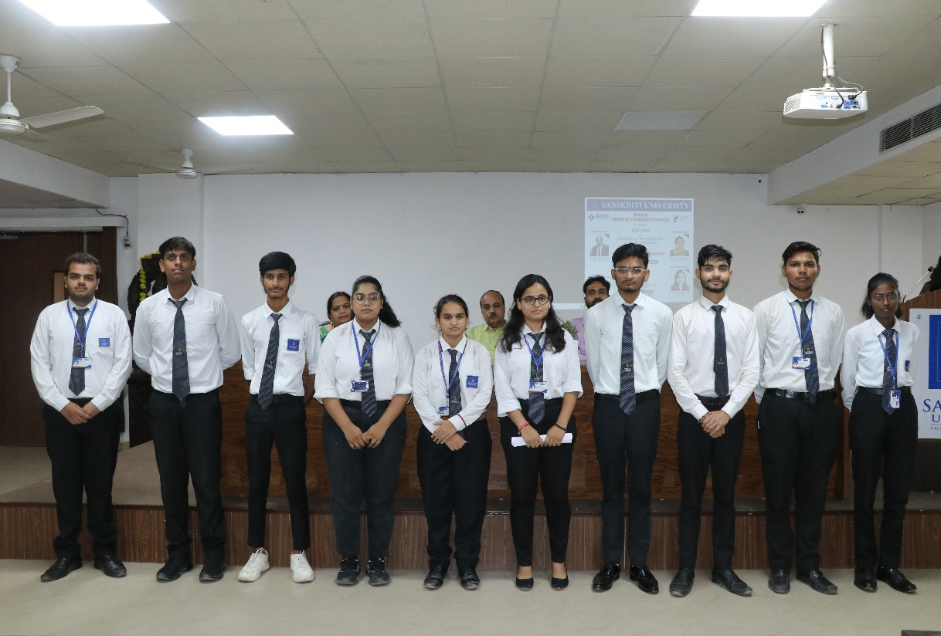

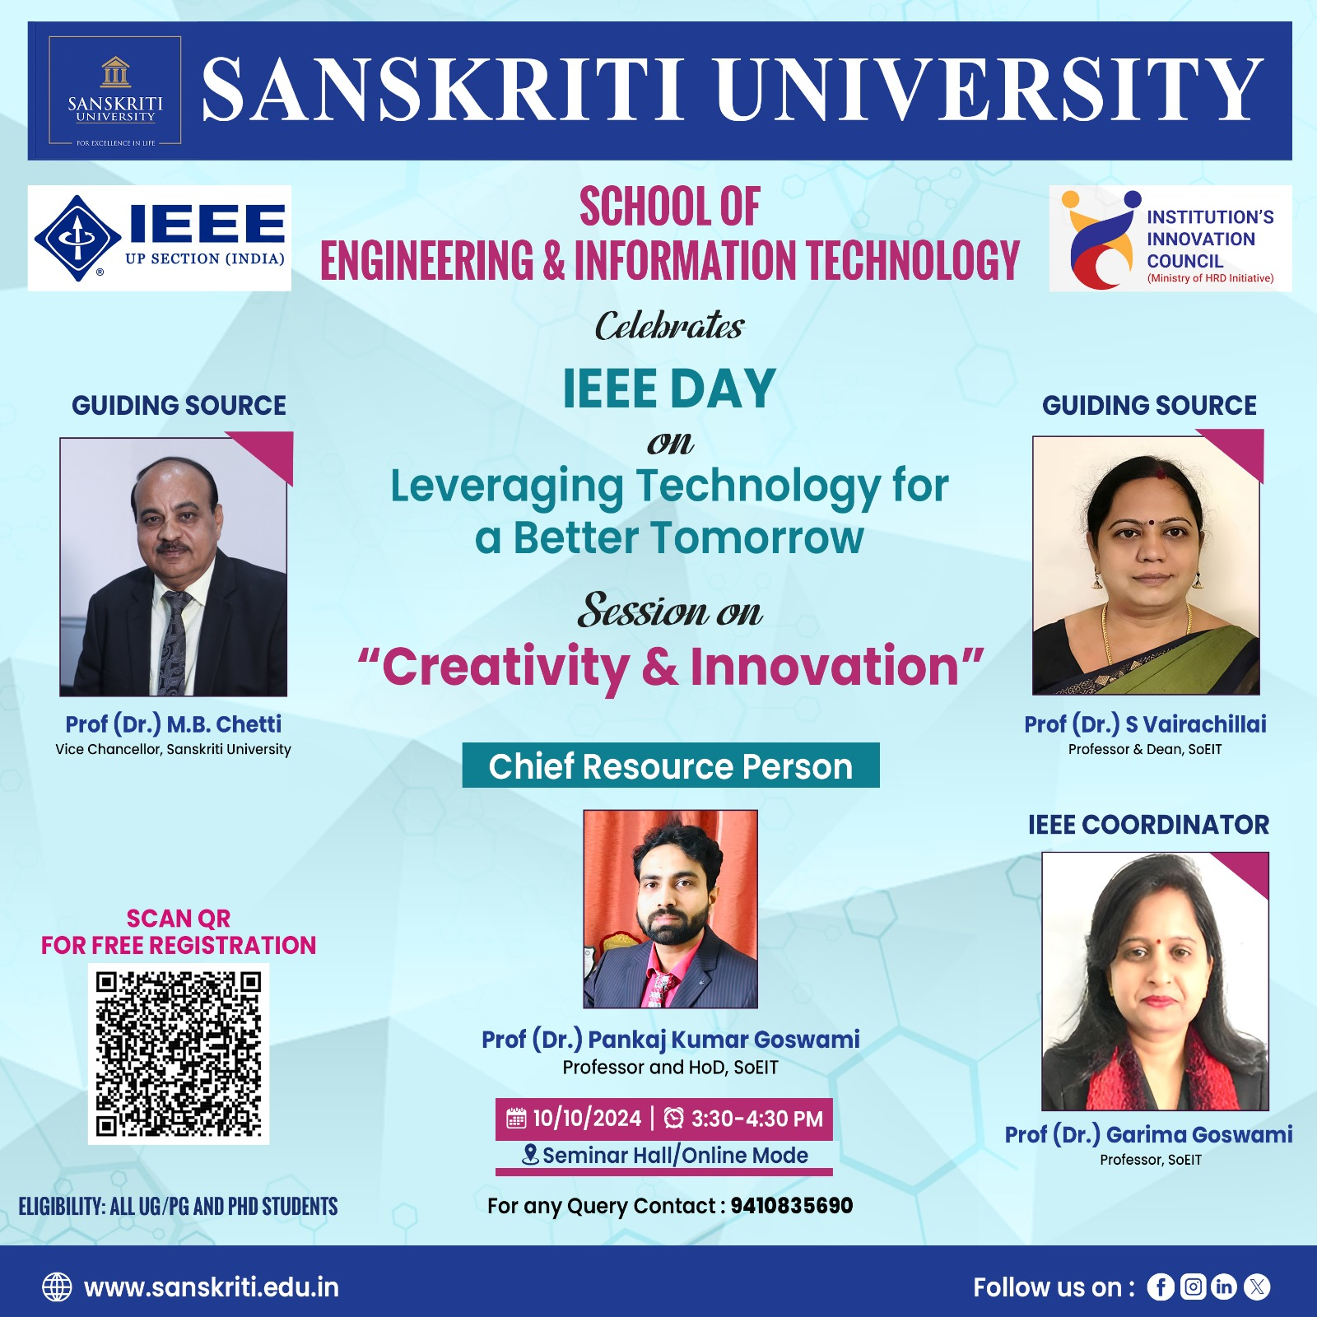

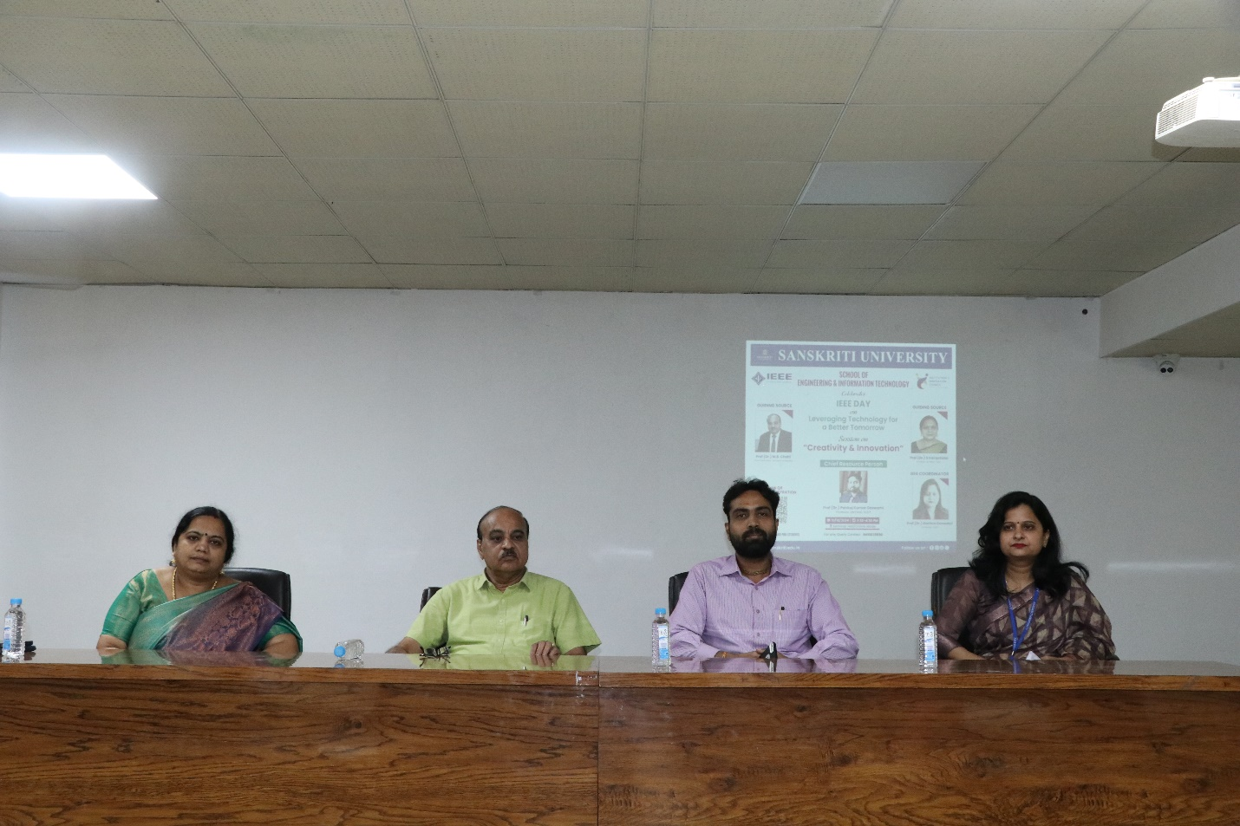

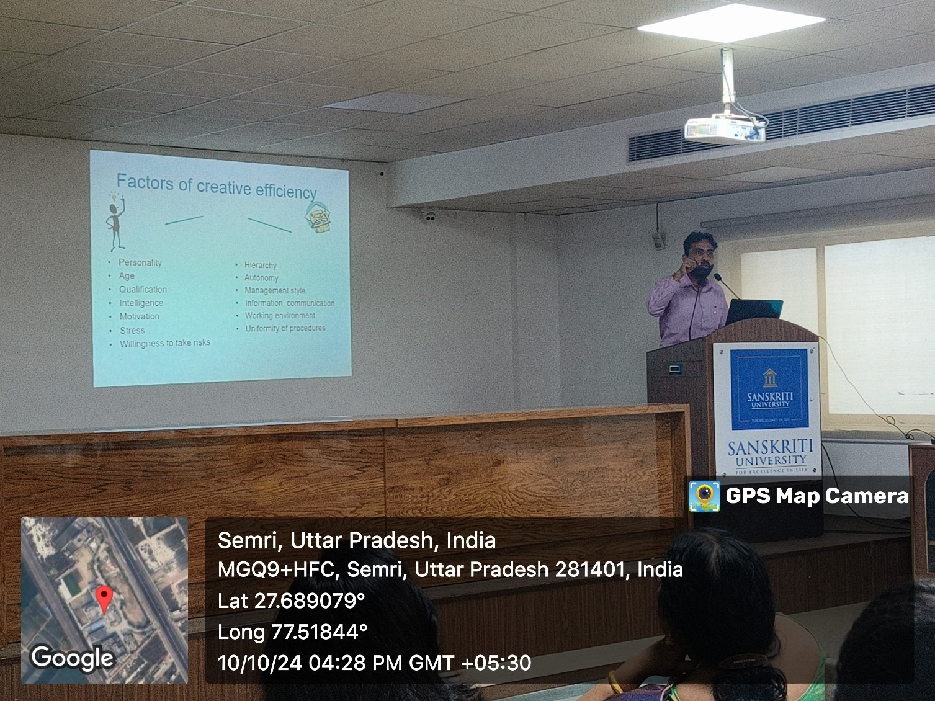

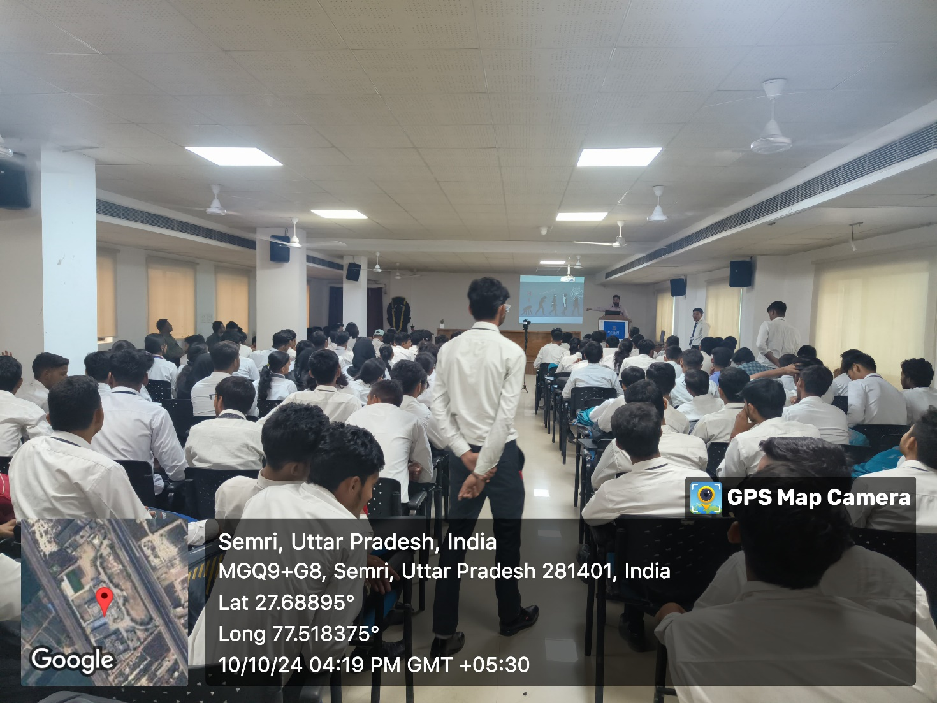

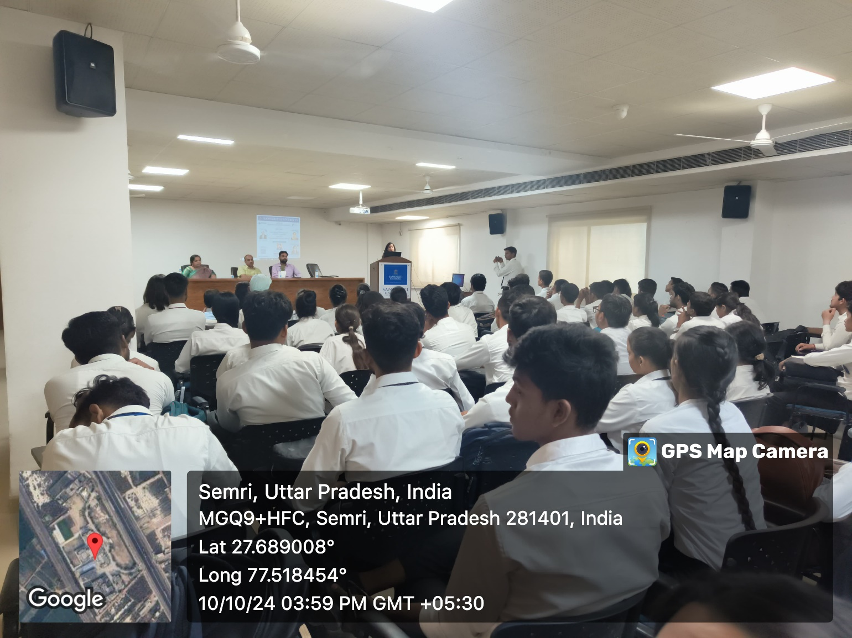

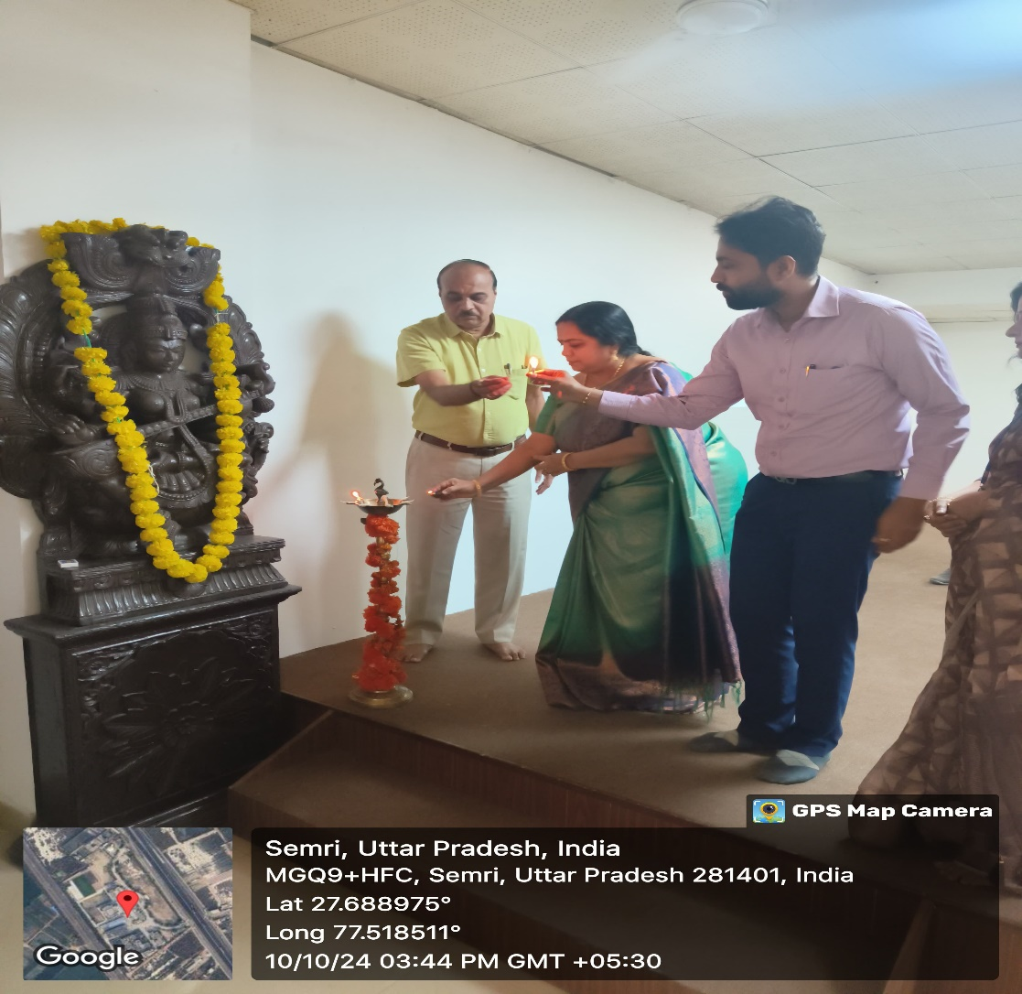

Google form Registration

|  |  |  |  |  |  |  |  |  |  |  |  |  |  |  |
| --- | --- | --- | --- | --- | --- | --- | --- | --- | --- | --- | --- | --- | --- | --- |
| Timestamp | Name of Participant | Program Name | Semester | School Name | Phone number | E mail address | College/University name | Column 9 |  |  |  |  |  |  |
| 10/8/2024 18:43:27 | Anuj Pratap Singh | Phd chemistry | 2 | Sanskriti University mathura | 6398462363 | Anujthakurpratap@gmail.com | Sanskriti University |  |  |  |  |  |  |  |
| 10/8/2024 18:46:34 | Nazia Zeeshan | IEEE Day Celebration on "Leveraging Technology for a Better Tomorrow" | Third Semester | School of Basic and Applied Sciences | 9634608552 | naziazeeshan174@gmail.com | Sanskriti University |  |  |  |  |  |  |  |
| 10/9/2024 10:15:01 | Govind singh Chauhan | BTech cse AI and Ml | 1st | SOEIT | 8127539868 | gc1833334@gmail.com | Sanskriti University |  |  |  |  |  |  |  |
| 10/9/2024 12:01:28 | Shiv mahajan | B tech ai and ml | 1st | Engineering and information technology | 9068790473 | coolmahajan2005@gmail.com | Sanskriti university |  |  |  |  |  |  |  |
| 10/9/2024 12:04:24 | Vikash yadav | B.Tech | 1st | School of engineering and technology | 7505296546 | vikashyadavyadav120@gmail.com | Sanskrit University |  |  |  |  |  |  |  |
| 10/9/2024 12:31:53 | Sudeep Saxena | B.tech CSE (AI&ML) | 1 | School of Management and technology | 8006011735 | sudeepsaxena938@gmail.com | Sanskriti University |  |  |  |  |  |  |  |
| 10/9/2024 12:52:00 | AKASH KUMAR | BCA | Fifth | SOEIT | 9759009289 | Akash.2202309014@sanskriti.ac.in | Sanskriti University Mathura |  |  |  |  |  |  |  |
| 10/9/2024 15:44:44 | Dolly saraswat | BBA | 5th | School of management and commerce | 7536002553 | dollysaraswat058@gmail.com | Sanskriti university |  |  |  |  |  |  |  |
| 10/9/2024 15:46:07 | Bhanu Pratap | BA LLB | 9 | School of law and legal studies | 9896939245 | raghavsharma9927@gmail.com | Sanskriti University |  |  |  |  |  |  |  |
| 10/9/2024 18:03:26 | Shwet Pratap Singh | B. Tech. CSE | 1 | School of Engineering and Information Technology | 9795784297 | shwetpratapsingh3@gmail.com | Sanskriti University |  |  |  |  |  |  |  |
| 10/9/2024 20:37:18 | Nandini Chaturvedi | BCA AIML | 3 | SOEIT | 7895307074 | cnandiniofficial@gmail.com | Sanskriti University |  |  |  |  |  |  |  |
| 10/9/2024 20:39:20 | Abhay Saroha | B tech | 1 | S D S Convent School | 7037595200 | chabhay70375@gmail.com | Sanskriti University |  |  |  |  |  |  |  |
| 10/9/2024 20:40:52 | Rajarshi Shukla | B.tech CSE(AIML) | 1st | School of Engineering | 7505902968 | rajarshishukla06@gmail.com | Sanskriti University |  |  |  |  |  |  |  |
| 10/9/2024 20:40:57 | Sukhvendra kumar | Mca | 3rd | Sanskriti university of mathura | 8475805035 | yadavsukhvendra9@gmail.com | Sanskriti university of mathura |  |  |  |  |  |  |  |
| 10/9/2024 20:41:13 | Devendra Singh | B. Tech CSE | First | School of information and technology | 8604011400 | devendragautam051206@gmail.com | Sanskriti University |  |  |  |  |  |  |  |
| 10/9/2024 20:41:31 | Sachin Kumar | BCA(Cyber Security) | 3 | SOEIT | 8287838628 | Sachinprajapati8287@gmail.com | Sanskriti University |  |  |  |  |  |  |  |
| 10/9/2024 20:41:50 | Durgesh Kumar Bagri | Bachelor of Pharmacy | 3RD | SCHOOL OF PHARMACY | 9548412025 | dbagri180@gmail.com | SANSKRITI UNIVERSITY |  |  |  |  |  |  |  |
| 10/9/2024 20:41:51 | Manepalli Harisankar | IEEE day celebration | 1 | SOEIT | 7981636343 | manepalliharisankar@gmail.com | Sanskriti university |  |  |  |  |  |  |  |
| 10/9/2024 20:41:58 | GAURAV DHAKAD | B.tech CSE (AIML) | 3rd | SOEIT | 7668759906 | g4777636@gmail.com | SANSKRITI University |  |  |  |  |  |  |  |
| 10/9/2024 20:42:12 | Amrit Sagar Pandey | Bachelor of Technology CSE | 1st | SOIET | 7390095367 | pandeyamritsagar@gmail.com | Sanskriti University |  |  |  |  |  |  |  |
| 10/9/2024 20:42:15 | Ankit Singh | B.tech CSE | 1 | School of engineering and information technology | 7270085139 | as8984739@gmail.com | Sanskrit University |  |  |  |  |  |  |  |
| 10/9/2024 20:43:23 | Nalin Kr Singh | Btech CSE AIML | 1 | School Of Engineering and Information Technology | 7388789396 | nalinsingh568p@gmail.com | Sanskriti University |  |  |  |  |  |  |  |
| 10/9/2024 20:43:25 | Kamal Kant Sharma | BCA AIML | 3rd | School of Engineering and Information technology | 7078236855 | kamalkant23105@gmail.com | Sanskriti University |  |  |  |  |  |  |  |
| 10/9/2024 20:43:31 | Kartik Tiwari | BCA (Aiml) | 3rd | SOEIT | 8791687353 | Kt089317@gmail.com | Sanskriti university |  |  |  |  |  |  |  |
| 10/9/2024 20:43:53 | Harsh yadav | BCA | 5th | SOEIT | 9528490462 | harshyaddvv@gmail.com | Sanskriti University |  |  |  |  |  |  |  |
| 10/9/2024 20:44:00 | M.karthik reddy | Btech ai &ml | 1 | SOEIT | 8179640920 | karthikreddy5924@gmail.com | Sanskriti University |  |  |  |  |  |  |  |
| 10/9/2024 20:45:37 | Vishal Sharma | MCA | 3 | SOIT | 8266997761 | vishalsharma01122001@gmail.com | Sanskriti University |  |  |  |  |  |  |  |
| 10/9/2024 20:47:08 | Yash Shrivastava | Btech CSE | 5 | SOEIT | 7393932701 | yashshrivastava2701@gmail.com | Sanskriti university |  |  |  |  |  |  |  |
| 10/9/2024 20:47:15 | Gopal sisodia | Bachelor of technology | 1 | Csrv vidya aashram | 8864970643 | gopalsisodia871@gmail.com | Sanskriti university |  |  |  |  |  |  |  |
| 10/9/2024 20:47:41 | Gaurav kulshrestha | IEEE day | First | Champa agrawal | 8923141352 | kulshresthagaurav68@gmail.com | Sanskriti university |  |  |  |  |  |  |  |
| 10/9/2024 20:47:42 | Prabhtesh Mishra | BCA | 5th | SOEIT | 8869864534 | arhimanshu4567@gmail.com | Sanskriti University |  |  |  |  |  |  |  |
| 10/9/2024 20:48:11 | Hemant Kumar | B Tech(C.S.E) | 5th | School of Engineering and Information Technology | 7903321538 | hemantkumar748874@gmail.com | Sanskriti University |  |  |  |  |  |  |  |
| 10/9/2024 20:48:27 | Aditya Singh | B.tech | 5 | School of engineering and information technology | 9555621585 | ADITYASINGHRU9555@GMAIL.COM | Sanskriti University |  |  |  |  |  |  |  |
| 10/9/2024 20:48:42 | Khushal | BCA | 3rd | SOEIT | 7983878006 | kumarkhushal255@gmail.com | Sanskriti University Mathura |  |  |  |  |  |  |  |
| 10/9/2024 20:49:56 | Ishwar | BCA | 3 | SOEIT | 9548243560 | ishwarpathak86045@gmail.com | Sanskriti University |  |  |  |  |  |  |  |
| 10/9/2024 20:50:18 | Chirag Pratap Singh | BCA(AI&ML) | 3 | SOEIT | 8868820783 | cpsingh1908@gmail.com | Sanskriti University |  |  |  |  |  |  |  |
| 10/9/2024 20:50:50 | Prashant Kumar | Bachelor of technology | First | School of engineering and information technology | 9627182810 | p3711908@gmail.com | Sanskriti University,Mathura |  |  |  |  |  |  |  |
| 10/9/2024 20:51:07 | Lara Sharma | Bca | 2nd | Soeit | 8126010783 | larasharma36300@gmail.com | Sanskriti University |  |  |  |  |  |  |  |
| 10/9/2024 20:51:55 | Rahul Verma | BCA | 5th | SOEIT | 9548961117 | er.rahul.verma@gmail.com | Sanskriti University, Mathura |  |  |  |  |  |  |  |
| 10/9/2024 20:52:00 | Prashant Kumar | Bachelor of technology | First | School of engineering and information technology | 9627182810 | p3711908@gmail.com | Sanskriti University, Mathura |  |  |  |  |  |  |  |
| 10/9/2024 20:54:25 | Gungun Chaurasiya | Bachelor of Pharmacy | 3rd | School of pharmacy Sanskriti university | 8476860861 | gunnuchaurasiya2408@gmail.com | Sanskriti university mathura |  |  |  |  |  |  |  |
| 10/9/2024 20:54:36 | Lara Sharma | BCA | 2nd | Soeit | 8126010783 | larasharma36300@gmail.com | Sanskriti University |  |  |  |  |  |  |  |
| 10/9/2024 20:55:17 | Mohan | Btech CSE (AI & ML) | 1st | School of engineering and information technology | 7983331288 | umayank252@gmail.com | Sanskriti university, chata |  |  |  |  |  |  |  |
| 10/9/2024 20:55:36 | VIVEK | BCA | 2 | 3 | 8218862279 | vivekgodher011@gmail.com | Sanskriti University |  |  |  |  |  |  |  |
| 10/9/2024 20:56:21 | I. Sri Harsha | Btech CSE -AIML | 1 | School of engineering and technology | 8309274172 | sreeh0721@gmail.com | Sanskriti University |  |  |  |  |  |  |  |
| 10/9/2024 20:56:31 | Nishant Chaudhary | Bca | 3 | Soiet | 7217412053 | Nc6605503@gmail.com | Sanskrit university |  |  |  |  |  |  |  |
| 10/9/2024 20:56:52 | Aman Sharma | B.Tech(DS&BA) | 1 | Engineering and Information Technology | 9119791812 | radhakrishnan7265@gmail.com | Sanskriti University |  |  |  |  |  |  |  |
| 10/9/2024 20:57:05 | B.Adithya | CSE AI ML | 1 | Soeit | 8341534228 | bedigiadithya754@gmail.com | Sanskriti University |  |  |  |  |  |  |  |
| 10/9/2024 20:57:19 | Arpit Saxena | Btech | 3 | SOEIT | 6397 667 193 | arpitsaxena5444@gmail.com | Sanskriti University |  |  |  |  |  |  |  |
| 10/9/2024 20:57:36 | Vanshika Aggarwal | Bsc in radiology and imaging technology | 3 | School of medical and allied science | 7505955889 | vanshikagarwal50505@gmail.com | Sanskriti University |  |  |  |  |  |  |  |
| 10/9/2024 20:58:53 | Aditi singh | MCA | III | SOEIT | 7078033108 | aditi9999singh@gmail.com | Sanskriti university mathura |  |  |  |  |  |  |  |
| 10/9/2024 20:59:04 | Ekta Kumari | MCA | 3rd | SOEIT | 9304458083 | ekumari428@gmail.com | Sanskriti University |  |  |  |  |  |  |  |
| 10/9/2024 20:59:49 | Harsh Vardhan | B.tech cse al&ml | 1 | SOEIT | 7017276190 | harshhhhvardhan@gmail.com | Sanskrit University mathura |  |  |  |  |  |  |  |
| 10/9/2024 20:59:53 | Vishesh sharma | Btech AIML | 1 | School of information and technology | 8755503753 | visheshsharma1302@gmail.com | Sanskriti university |  |  |  |  |  |  |  |
| 10/9/2024 21:00:03 | Shoheb amin | B. Tech | 3 | SOEIT | 7457858969 | shohebamin6@gmail.com | Sanskriti University |  |  |  |  |  |  |  |
| 10/9/2024 21:00:05 | My class | BCA | 3rd | SOEUT | 7465915381 | hetram7465@gmail.com | Sanskrit University |  |  |  |  |  |  |  |
| 10/9/2024 21:00:12 | B Mukesh | Betech | 3rd | Soeit | 9618717079 | bandimukesh143@gmail.com | Sanskriti University |  |  |  |  |  |  |  |
| 10/9/2024 21:00:21 | SATYAM SINGH | Bachelor in computer application | 3 | S.O.E.I.T | 8545022267 | satyamsingh0464@gmail.com | SANSKRITI UNIVERSITY MATHURA |  |  |  |  |  |  |  |
| 10/9/2024 21:00:34 | Pari goyal | Bca | 1 | Lord Krishna public school hathras | 6397564064 | agrawalpari971@gmail.com | Sanskriti University |  |  |  |  |  |  |  |
| 10/9/2024 21:00:44 | Ramakant | Bca core | 1st | Sanskriti university | 9258026051 | ramakantmtr2006@gmail.com | Sanskriti university |  |  |  |  |  |  |  |
| 10/9/2024 21:02:23 | Sadhana Singh | BCA | 5 | School of engineering and technology | 8755263395 | singhsadhana4474@gmail.com | Sanskriti University |  |  |  |  |  |  |  |
| 10/9/2024 21:03:04 | VARUN KUMAR | B.Tech(CSE) | 5th | S.O.E&I.T | 7678128661 | varunsharma2949@gmail.com | Sanskriti university |  |  |  |  |  |  |  |
| 10/9/2024 21:03:24 | Sakshi | Bca | 3rd | SOEIT | 8958595745 | thakurshikha516@gmail.con | Sanskriti University |  |  |  |  |  |  |  |
| 10/9/2024 21:05:16 | Shravan verma | Creativity and innovation | 1 | Sanskriti university | 9536918525 | vshravan087@gmail.com | Sanskriti university mathura |  |  |  |  |  |  |  |
| 10/9/2024 21:06:09 | Salim Akhtar | BCA | 5th | SOEIT | 9110152483 | sahbajansari769@gmail.com | Sanskriti University |  |  |  |  |  |  |  |
| 10/9/2024 21:07:12 | Rohit Sikarwar | BTech cse | 3rd | SOEIT | 6395169127 | rohitsikarwar1895@gmail.com | Sanskriti university chhata Mathura |  |  |  |  |  |  |  |
| 10/9/2024 21:07:34 | Komal Kumari | Mca | 3 | SOEIT | 6202395466 | kk9943453@gmail.com | Sanskriti university chhata Mathura |  |  |  |  |  |  |  |
| 10/9/2024 21:08:23 | Shravan verma | Creativity and innovation | 1 | Sanskar public school | 9536918525 | vshravan087@gmail.com | Sanskriti university mathura |  |  |  |  |  |  |  |
| 10/9/2024 21:09:28 | Sriram Manwani | B.Tech CSE(AIML) | 3rd | School of Engineering and Information Technology | 9325461226 | shriram.2302728@sanskriti.ac.in | Sanskriti University |  |  |  |  |  |  |  |
| 10/9/2024 21:11:31 | Yuvraj Singh | BCA AIML | 3 | SOEIT | 8433075079 | yuvrajsingh8433075079@gmail.com | Sanskriti University |  |  |  |  |  |  |  |
| 10/9/2024 21:11:38 | Roshan Kumar | MCA | 3rd | Cs | 7488152679 | roshancool9431285371@gmail.com | Sanskriti University Mathura |  |  |  |  |  |  |  |
| 10/9/2024 21:12:16 | Prashant yadav | Bca | First | Police morder school | 9456464659 | py1104710@gmail.com | Sanskriti university |  |  |  |  |  |  |  |
| 10/9/2024 21:13:57 | Ananya Saraswat | BTech | 3rd | SOEIT | 796903345 | ananya.saraswat2006@gmail.com | Sanskriti University |  |  |  |  |  |  |  |
| 10/9/2024 21:15:30 | Krishan | BCA | 3rd | School of engineering and instrumentation technology | 6395399245 | krishanrawat592006@gmail.com | Sanskriti university |  |  |  |  |  |  |  |
| 10/9/2024 21:17:20 | Harendra Singh | B tech CSE | 1 | Sanskriti university | 7088953614 | harendrasinghh85212429@gmail.com | Sanskriti university |  |  |  |  |  |  |  |
| 10/9/2024 21:19:50 | Anoop Singh Pratihar | BCA AI&ML | 1st sem | Engineering And Information technology | 6398281624 | rdxpratiharksj@gmail.com | Sanskriti University |  |  |  |  |  |  |  |
| 10/9/2024 21:20:49 | Ram upkar vishwakarma | BCA+MCA | 9th | SOCIT | 8979814703 | ramupkarvishwakarma2580@gmail.com | Sanskriti university |  |  |  |  |  |  |  |
| 10/9/2024 21:24:20 | Piyush Gupta | BCA AIML | 1st | SOEIT | 7983702019 | piyushytff@gmail.com | Sanskriti University |  |  |  |  |  |  |  |
| 10/9/2024 21:27:09 | Abhishek Tiwari | Btech | 3Rd | SOEIT | 8577867993 | abhishektiwaricoolboy@gmail.com | Sanskriti University Mathura |  |  |  |  |  |  |  |
| 10/9/2024 21:28:38 | Lalit | B techw | 5th | Soeit | 8077287453 | sam246353@gmail.com | Sanskriti university |  |  |  |  |  |  |  |
| 10/9/2024 21:29:22 | Ramesh Kumar | BCA | 1 | Soeit | 8115879945 | socialinfo.co.in@gmail.com | Sanskriti University |  |  |  |  |  |  |  |
| 10/9/2024 21:35:45 | Vishal | B.tech | 3rd | SOEIT | 6397180953 | vc9099908@gmail.com | Sanskriti University |  |  |  |  |  |  |  |
| 10/9/2024 21:37:13 | pramod | B.Tech | 5 | S.O.E.I.T. | 7456026045 | pramodsisodiya12@gmail.com | sanskriti university |  |  |  |  |  |  |  |
| 10/9/2024 21:39:54 | Satyendra kumar | Bca | 3rd | Sanskriti University | 8811044915 | Yadavsatyendrakumar539@gmail.com | Sanskriti University |  |  |  |  |  |  |  |
| 10/9/2024 21:42:28 | Dushyant Sharma | BCA | 5 | School of Engineering and Technology | 7906301915 | dushyant790s@gmail.com | Sanskriti University |  |  |  |  |  |  |  |
| 10/9/2024 21:43:36 | Shivam | Website design | Third | SOEIT | 9555782516 | sc8990196@gmail.com | Sanskriti university |  |  |  |  |  |  |  |
| 10/9/2024 21:44:41 | Manish | BTech | 5 | SOEIT | 8433199809 | st690034@gmail.com | Sanskriti university mathura |  |  |  |  |  |  |  |
| 10/9/2024 21:48:59 | A. Likith sai | Btech cse aiml | 1st | SOEIT | 8978298259 | likithsai642@gmail.com | Sanskriti university |  |  |  |  |  |  |  |
| 10/9/2024 21:51:38 | SHIVAM | BCA | 1st | SANSKRITI UNIVERSITY | 9991045330 | SOMAYMAHLAWAT3@GMAIL.COM | SANSKRITI UNIVERSITY |  |  |  |  |  |  |  |
| 10/9/2024 21:54:40 | Monu Sisodia | MCA | 3 | SOEIT | 9068087165 | monusisodia11@gmail.com | Sanskriti university |  |  |  |  |  |  |  |
| 10/9/2024 21:57:27 | Harshjeet Pandey | BCA (cyber security ) | 3rd | SOEIT | 8429075039 | pandeyharshjeet@gmail.com | Sanskriti university |  |  |  |  |  |  |  |
| 10/9/2024 21:57:38 | Arjun chaudhary | Btech | 5 | Information and technology | 8630732903 | arjunchaudhary5941@gmail.com | Sanskriti University |  |  |  |  |  |  |  |
| 10/9/2024 21:57:39 | Abhishek Kumar | Btech cse | 1 | Army public school mathura cantt | 9389357871 | Abhishek Kumar | Sanskriti university |  |  |  |  |  |  |  |
| 10/9/2024 21:58:12 | Arshdeep Singh | BCA cybersecurity | 3rd | SOEIT | 8699007406 | www.arshdeepsaini123@gmail.com | Sanskriti university |  |  |  |  |  |  |  |
| 10/9/2024 22:04:43 | Sneha | BTech CSE | 1 | School of engineering and information technology | 7906601773 | snehabhadauriya245@gmail.com | Sanskriti University |  |  |  |  |  |  |  |
| 10/9/2024 22:08:32 | Siddharth saini | Bca AIML | 1 | Happy blue bird public school | 7300809576 | siddharthsaini481@gmail.com | Sanskriti university |  |  |  |  |  |  |  |
| 10/9/2024 22:13:41 | Kashish yadav | BCA | 3rd | SOEIT | 9368515265 | Kashishyadav851@gmail.com | Sanskriti University |  |  |  |  |  |  |  |
| 10/9/2024 22:14:34 | Mahima Yadav | Btech CSE | 3 | SOEIT | 6397127180 | rajniyadavmahimayadav@gmail.com | Sanskriti University chhata mathura |  |  |  |  |  |  |  |
| 10/9/2024 22:14:48 | khittarpal | b.tech | 3rd | information & technology | 9368477737 | khittarpalrajoot@gmail.com | sanskrity university mathura |  |  |  |  |  |  |  |
| 10/9/2024 22:17:22 | Kanha sharma | B.tech | 5th | SOEIT | 7505043727 | ksharma66972@gmail.com | Sanskriti university chhata mathura |  |  |  |  |  |  |  |
| 10/9/2024 22:27:25 | Shivam Yadav | BCA (Cyber Security) | 3rd | SOEIT | 7253077262 | thesilentstark@gmail.com | Sanskriti University |  |  |  |  |  |  |  |
| 10/9/2024 22:45:53 | Saurabh Kumar | MCA | 3rd | SOEIT | 9634756223 | sgawr420@gmail.com | Sanskriti University |  |  |  |  |  |  |  |
| 10/9/2024 22:54:02 | Tanuj Chaudhary | Btech | 3 | SOEIT | 7451090132 | tanujchaudhary2525@gmail.com | Sanskriti university mathura |  |  |  |  |  |  |  |
| 10/9/2024 22:54:23 | Tarun Meena | BCA CYBERSECURITY | 3 | SOEIT | 9368035121 | tm546279@gmail.com | SANSKRITI UNIVERSITY |  |  |  |  |  |  |  |
| 10/9/2024 22:58:35 | Aftab Saleem | B tech | 5 | Sanskriti university | 6399227177 | saftab474@gmail.com | Sanskriti university |  |  |  |  |  |  |  |
| 10/9/2024 23:05:43 | Mayank Gupta | B.Tech | 3 | SOEIT | 9068356543 | mayankmayank47670@gmail.com | Sanskriti University |  |  |  |  |  |  |  |
| 10/10/2024 0:00:49 | Amarjeet Singh | MCA | 3rd | School of Engineering and Information Technology | 7068681827 | amarjeet40703a@gmail.com | Sanskriti University |  |  |  |  |  |  |  |
| 10/10/2024 0:27:59 | Kalyani Gupta | B.Tech CSE AI &ML | 3 | SOEIT | 9369299041 | guptakalyani71@gmail.com | Sanskrit University |  |  |  |  |  |  |  |
| 10/10/2024 1:13:51 | Gauranshi Gupta | BTech CSE (AIML) | 3 | SOEIT | 8534895327 | 0987gauranshi@gmail.com | Sanskriti University |  |  |  |  |  |  |  |
| 10/10/2024 5:31:14 | Prashant Kumar | Bachelor of technology | First | School of engineering and information technology | 9627182810 | p3711908@gmail.com | Sanskriti University, Mathura |  |  |  |  |  |  |  |
| 10/10/2024 6:07:14 | Vishnu jadaun | Bca | 1 | Sanskriti University | 7668786647 | vt1577767@gmail.com | Sanskriti University |  |  |  |  |  |  |  |
| 10/10/2024 6:54:14 | Bulbul | Bca 2nd year | 3rd | Soeit | 9058876749 | deepmohan8735517@gmail.com Switch ac | Sanskriti university |  |  |  |  |  |  |  |
| 10/10/2024 6:57:32 | Priya | Bca | 1 | Adarsh vidya mandir | 8979276102 | Renusharma31782@gmail.com | Sanskirity university |  |  |  |  |  |  |  |
| 10/10/2024 7:06:32 | Tarun kumar | B.tech | 1st | School of engineering and information technology | 7906531189 | Kumartarun0027@gmail.com | Sanskriti university |  |  |  |  |  |  |  |
| 10/10/2024 7:35:13 | Satya Ram | B.tech CSE (AI&ML) | Third semester | Sanskriti University chhata mathura uttar pradesh India | 6390317539 | s09084268@gmail.com | Sanskriti University chhata mathura uttar pradesh India |  |  |  |  |  |  |  |
| 10/10/2024 7:38:16 | Satya Ram | B.tech CSE (AI&ML) | Third semester | Sanskriti University | 6390317539 | s09084268@gmail.com | Sanskriti University |  |  |  |  |  |  |  |
| 10/10/2024 7:56:03 | Vishnu tiwari | Bca | 3 | Soeit | 8858509316 | vishnuroshan610@gmail.com | Sanskriti university |  |  |  |  |  |  |  |
| 10/10/2024 8:33:16 | Yash Tiwari | Btech | 3 | Soeit | 7500200024 | Yashtiwarivbn@gmail.com | Sanskriti university |  |  |  |  |  |  |  |
| 10/10/2024 8:33:28 | Mohit shukla | Bca | 3 | SOEIT | 6399139678 | mohitshukla875516@gmail.com | Sanskriti university |  |  |  |  |  |  |  |
| 10/10/2024 8:34:22 | Krishna sharma | Bca | 1 | School of engineering and information technology | 8006607505 | Krishnashar954820@gmail.com | Sanskriti university mathura |  |  |  |  |  |  |  |
| 10/10/2024 9:01:21 | Puneet Kumar Nagar | BCA (Cyber security) | 3 | SOEIT | 9027153908 | puneetkumar200626@gmail.com | Sanskriti University |  |  |  |  |  |  |  |
| 10/10/2024 9:04:17 | Deepak Sharma | B tech cse | 1 | School of engineering and information technology | 8006247355 | deepaksharma945318@gmail.com | Sanskriti university |  |  |  |  |  |  |  |
| 10/10/2024 9:06:07 | Divya Verma | Btech | 1st | School of engineering and information technology | 9140856743 | dv892302@gmail.com | Sanskriti University |  |  |  |  |  |  |  |
| 10/10/2024 9:07:37 | Vaibhav Agrawal | B.tec cse | 1 | School of Engineering and information technology | 7302233351 | vaibhavagrawal82186@gmail.com | Sanskiriti university |  |  |  |  |  |  |  |
| 10/10/2024 9:09:30 | Anmol Singh | Btech CSE | 1st | School of engineering and information technology | 7453911984 | asingh281006@gmail.com | Sanskriti University |  |  |  |  |  |  |  |
| 10/10/2024 9:11:51 | Kanha | Btech cse | First | School of engineering and information technology | 7078482544 | sharmakanha88811@gmail.com | Sanskriti university, Mathura |  |  |  |  |  |  |  |
| 10/10/2024 9:17:45 | Gaurav kulshrestha | IEEE | 1 | Champa agrawal inter College | 8923141352 | kulshresthagaurav68@gmail.com | Sanskriti university |  |  |  |  |  |  |  |
| 10/10/2024 9:19:41 | Dhairya | B tech CSE | 1 | Jaat college BAGHPAT | 9729792718 | dhairyadhaka94935@gmail.com | Sanskriti University |  |  |  |  |  |  |  |
| 10/10/2024 9:21:51 | Ramest Kumar jha | MCA | 3rd sem | SOEIT | 7632966717 | rnjha339@gmail.com | Sanskriti university mathura |  |  |  |  |  |  |  |
| 10/10/2024 9:39:09 | Ashi Agarwal | Btech CSE | 1 | School of engineering and information technology | 9538495677 | ashiagarwal2006@gmail.com | Sanskriti university |  |  |  |  |  |  |  |
| 10/10/2024 9:40:25 | Kajal | Btech CSE | 1st | School of engineering and information technology | 9389282653 | kajalchahar45@gmail.com | Sanskriti university |  |  |  |  |  |  |  |
| 10/10/2024 9:50:31 | Bhavna Sharma | Bachlor Of Business Administration | 3 | School of management and commerce | 9258446112 | sharmabhavna9639@gmail.com | Sanskriti university |  |  |  |  |  |  |  |
| 10/10/2024 10:11:44 | Rajan sharma | Mca | 3 | SOEIT | 7579996887 | Rajanshar543@gmail.com | Sanskrit university |  |  |  |  |  |  |  |
| 10/10/2024 10:13:49 | Tejveer | Mca | 3 | SOEIT | 7037657065 | tejveer20singh@gamil.com | Sanskriti university |  |  |  |  |  |  |  |
| 10/10/2024 10:15:38 | SONU | MCA | 3 | SOEIT | 9813376655 | sonusarpach141@gmail.com | Sanskriti university |  |  |  |  |  |  |  |
| 10/10/2024 10:15:50 | Manish baghel | MCA | 3rd | SOEIT | 9104975012 | baghelboykosi987@gmail.com | Sanskriti university |  |  |  |  |  |  |  |
| 10/10/2024 10:17:20 | PAVAN Dhangar | MCA | 3rd | SOEIT | 9389704190 | pavandhangar6544@gmail.com | Sanskriti University |  |  |  |  |  |  |  |
| 10/10/2024 10:17:25 | Krishnakant sharma | mca | 3 | soeit | 9368238692 | krishnakantsharma560@gmail.com | Sanskriti univerity |  |  |  |  |  |  |  |
| 10/10/2024 10:20:44 | Sachin Kumar | B tech(CSE) | 5th | School of engineering and information technology | 6299184702 | sachinroy09092002@gmail.com | Sanskriti University |  |  |  |  |  |  |  |
| 10/10/2024 10:22:46 | Saurav Kumar | B.tech | 5 | School of engineering and information technology | 9142174908 | samratyadavsaurav@gmail.com | Sanskriti University |  |  |  |  |  |  |  |
| 10/10/2024 10:23:16 | Rohit Mani Tripathy | BTech | 5th | School of engineering and information technology | 8507883148 | rohitmanitripathi381@gmail.com | Sanskriti University |  |  |  |  |  |  |  |
| 10/10/2024 10:25:16 | Shivam Chaudhary | B.tech ALML | 1st | School of engineering and information technology | 7818889069 | shivamchaudharydagurshab@gmail.com | Sanskriti university |  |  |  |  |  |  |  |
| 10/10/2024 10:27:58 | MEDEKUNDA SIVARAMAKRISHNA | B Tech AI AND ML | 3 | SOEIT | 9491653011 | srk9491653011@gmail.com | Sanskriti University |  |  |  |  |  |  |  |
| 10/10/2024 10:28:00 | Kunal Vaishnav | Btech | 3rd | SOEIT | 9653641458 | Balajihw09@gmail.com | Sanskriti University |  |  |  |  |  |  |  |
| 10/10/2024 10:28:27 | Anjali Singh | B.tech (AI&ML) | 3rd | School of engineering and information technology | 9580114191 | anjalisin1212@gmail.com | Sanskriti University |  |  |  |  |  |  |  |
| 10/10/2024 10:35:38 | Talari Manohar naidu | Btech aiml | 3 semester | Prathibha model school | 9959520482 | manumanoharnaidu507@gmail.com | Sanskriti university |  |  |  |  |  |  |  |
| 10/10/2024 10:36:15 | M Vasanth Kumar Goud | B-Tech CSE(aiml) | 3 | SOEIT | 8328038729 | molgaramvasanthgoud@gmail.com | Sanskriti University |  |  |  |  |  |  |  |
| 10/10/2024 10:36:29 | B.Mukesh | Betech | 3 | SOEIT | 9618717079 | bandimukesh143@gmail.com | Sanskriti University |  |  |  |  |  |  |  |
| 10/10/2024 10:36:47 | Talari Manohar naidu | Btech aiml | 3 semester | SOUIT | 9959520482 | manumanoharnaidu507@gmail.com | Sanskriti university |  |  |  |  |  |  |  |
| 10/10/2024 10:37:43 | K.Rajesh | Btech | 3 | SOEIT | 6302834768 | www.rajeshmuni3@gmail.com | Sanskriti university |  |  |  |  |  |  |  |
| 10/10/2024 10:41:34 | R venkata Siva | B tech CSE (aiml) | 3rd | Soelt | 9491048695 | rvenkatashiva1@gmail.com | Sanskriti university |  |  |  |  |  |  |  |
| 10/10/2024 10:41:44 | Kalavanthula sekhar | B.Tech CSE (Ai&ML) | 3 | SOEIT | 9441313980 | Kalavanthulasekhar@gmail.com | SANSKRITI UNIVERSITY |  |  |  |  |  |  |  |
| 10/10/2024 10:42:38 | U Tharun kumar | Btech | 3 | School of engineering and information technology | 6300746825 | tharuninjothi@gmail.com | Sanskriti university |  |  |  |  |  |  |  |
| 10/10/2024 10:43:51 | Jayanthgedda | B.tech | 1 | SOEIT | 7396231689 | jayanthgedda666@gmail.com | Sanskriti University |  |  |  |  |  |  |  |
| 10/10/2024 10:46:34 | Narender | BCA | 5th | Sanskriti university | 9389791035 | narenderbeniwal33462@gmail.com | Sanskriti university |  |  |  |  |  |  |  |
| 10/10/2024 10:50:03 | Mopidevi pothuraju | B tech | 3rd | IFOF | 9177651467 | pothurajumopidevi6@gmail.com | Sanskriti university |  |  |  |  |  |  |  |
| 10/10/2024 11:08:39 | Madhav Mittal | B.Tech (AI/ML) | 1 | School of engineering and information technology | 7701884556 | madhavmittal056@gmail.com | Sanskriti university |  |  |  |  |  |  |  |
| 10/10/2024 11:08:52 | Ritik sengar | B.tech aiml | 1 | School of engineering and technology | 8527796354 | ritiksengar43@gmail.com | Sanskrit University mathura |  |  |  |  |  |  |  |
| 10/10/2024 11:09:28 | Man Mohan | Btech ai ml | 1st | School of engineering and information technology | 9870652668 | harsh7248119356@gmail.com | Sanskriti University |  |  |  |  |  |  |  |
| 10/10/2024 11:09:46 | Shivam Chaudhary | B.tech ai ml | 1 st | School of engineering | 7088820664 | saurychaudhary6@gmail.com | Sanskriti university |  |  |  |  |  |  |  |
| 10/10/2024 11:09:46 | Suraj | Bbtech ai&ml | 1 | SOEIT | 8218662983 | surajkk40224@gmail.com | Sanskriti university |  |  |  |  |  |  |  |
| 10/10/2024 11:10:01 | Ridhima Dwivedi | B tech | 5 | SOEIT | 6306868825 | dwivediridhima71@gmail.com | Sanskriti University |  |  |  |  |  |  |  |
| 10/10/2024 11:10:02 | Neitik Jangid | B Tech CSE Artificial Intelligence and Machine Learning | 1 | SOEIT | 9760704804 | neitikjangra@gmail.com | Sanskrit University |  |  |  |  |  |  |  |
| 10/10/2024 11:10:05 | SHIVANI GAUTAM | B. tech cse | 5 | SOEIT | 9756061561 | shivani3346gautam@gmail.com | sanskriti university |  |  |  |  |  |  |  |
| 10/10/2024 11:10:12 | Rudraksh Dwivedi | B.Tech AI&ML | 1st | School of Engineering and Information Technology | 9305355211 | rudraksh7678@gmail.com | Sanskriti University |  |  |  |  |  |  |  |
| 10/10/2024 11:10:26 | Anjali Baghel | Btech cse ai ml | 1st | Soeit | 7902170985 | baghelanjali9411@gmail.com | Sanskriti University |  |  |  |  |  |  |  |
| 10/10/2024 11:10:36 | Satyam Singh | B-tech | 1 | SOEIT | 7985073988 | singhsatyam1704@gmail.com | Sanskriti University |  |  |  |  |  |  |  |
| 10/10/2024 11:10:45 | Sagarika Das | B.tech (AI ML) | 1st | SOEIT | 6909743089 | sagarika.das315471@gmail.com | Sanskriti University |  |  |  |  |  |  |  |
| 10/10/2024 11:11:01 | KAUSHAL AGRAWAL | B tech (AIML) | 1st | School of engineering | 8076779295 | itskaushalbro@gmail.com | Sanskriti University |  |  |  |  |  |  |  |
| 10/10/2024 11:11:39 | Prakash Das | Btech | 1st | Soeit | 8218253763 | Dasprakash448321@gmail.com | Sanskrit university |  |  |  |  |  |  |  |
| 10/10/2024 11:11:56 | Ayushman Soni | B.Tech (AI/ML) | 1 | School of engineering and information technology | 9554201788 | ayushsuraj032@gmail.com | Sanskriti University |  |  |  |  |  |  |  |
| 10/10/2024 11:12:02 | Nandita mishra | Btech | 3 | SOEIT | 7307065650 | nanditamishra8400@gmail.com | Sanskriti university |  |  |  |  |  |  |  |
| 10/10/2024 11:12:09 | Arwa Abid | Btech ai/ml | 1st | Information technology and engineering | 9055127725 | arwaabid224@gmail.com | Sanskriti university |  |  |  |  |  |  |  |
| 10/10/2024 11:12:12 | Krish Khanna | B-tech | 1 | SOEIT | 9369561439 | khannakrish2006@gmail.com | Sanskriti University |  |  |  |  |  |  |  |
| 10/10/2024 11:12:14 | Aditya Gupta | Btech aiml | 1 | SOEIT | 6396998494 | adityagupta975662@gmail.com | Sanskrit university |  |  |  |  |  |  |  |
| 10/10/2024 11:12:19 | Nitin kumar | Btech cse | 1st | Sanskriti | 7017240531 | nk3684689@gmail.com | Sanskriti university |  |  |  |  |  |  |  |
| 10/10/2024 11:13:46 | Nitin kumar | Btech cse | 1st | Sanskriti university | 7017240531 | nk3684689@gmail.com | Sanskriti university |  |  |  |  |  |  |  |
| 10/10/2024 11:14:12 | Moradhwaj Chaudhary | BTech AIML | 1st Semester | Sanskriti University of Engineering and technology | 7017439163 | mordhwaj1029@gmail.com | Sanskriti University |  |  |  |  |  |  |  |
| 10/10/2024 11:16:05 | Shivam Kushwaha | Batchelor of technology CSE AI & ML | First | School of engineering and Information technology | 7800491009 | shivamkushwaha47250@gmail.com | Sanskriti University |  |  |  |  |  |  |  |
| 10/10/2024 11:16:08 | Yogesh tomar | Btech aiml | 1st | Sanskriti university | 9817038865 | Yogeshrajput8685@gmail.com | Sanskriti university |  |  |  |  |  |  |  |
| 10/10/2024 11:16:18 | Mausam Singh | BCA AI&ML | 1 | Dr.Badri Prasad Pandey smark sarvoday inter college ramganj ayodhya. | 9335359981 | singhmausam381@gmail.com | Sanskriti University mathura |  |  |  |  |  |  |  |
| 10/10/2024 11:17:27 | Satyaveer singh | Btech cse aiml | 1 | Sanskriti university | 9457803092 | RajkarnRajput2021@gmail.com | Sanskriti university |  |  |  |  |  |  |  |
| 10/10/2024 11:18:19 | Dharmendra Singh | Btech aiml | 1 | School of engineering and information technology | 7078139080 | rajputfacts@gmail.com | Sanskriti university |  |  |  |  |  |  |  |
| 10/10/2024 11:19:58 | Satyaveer singh | Btech cse aiml | 1 | Sanskriti university | 9457803091 | RajkarnRajput2021@gmail.com | Sanskriti university |  |  |  |  |  |  |  |
| 10/10/2024 11:22:44 | Neitik Jangid | B Tech CSE Artificial Intelligence and Machine Learning | 1 | SOEIT | 9760704804 | neitikjangra@gmail.com | Sanskrit University |  |  |  |  |  |  |  |
| 10/10/2024 11:26:10 | Rupali Mahajan | Phd | Final | Sharda university, greater Noida | 9457059900 | rupali_mahajan61@rediffmail.com | Sharda university |  |  |  |  |  |  |  |
| 10/10/2024 11:26:39 | B.venkat | B.tech | 3rd | SOITE | 9392736066 | venkatbellam383@gmail.com | Sanskriti university |  |  |  |  |  |  |  |
| 10/10/2024 13:38:56 | Riddhi pachehara | btech | 3rd | soeit | 8077189209 | riddhuriddhu83@gmail.com | sanskriti University |  |  |  |  |  |  |  |
| 10/10/2024 14:16:07 | Prashansa Mishra | Btech | 3 | SOEIT | 7348786269 | prashansamishra298@gmail.com | Sanskriti University |  |  |  |  |  |  |  |
| 10/10/2024 14:16:28 | Monika Kumari | Btech CSE(core) | 3rd | SOEIT | 9389868804 | monikasisodiya128@gmail.com | Sanskriti University |  |  |  |  |  |  |  |
| 10/10/2024 14:49:43 | Kalluri karthik | Btech cse[Aiml] | 1 | SOEIT | 7670925165 | kallurikarthik77@gmail.com | Sanskriti university |  |  |  |  |  |  |  |
| 10/10/2024 14:50:24 | Singisetti venkata krishna Laxmi kanth | Btech CSE (Aiml) | 1 | SOEIT | 8247476738 | laxmikanthsingisetti@gmail.com | Sanskriti university |  |  |  |  |  |  |  |
| 10/10/2024 14:50:34 | Madhav | B.tech AI ML | 1st | School of engineering and information technology | 8449576725 | smadhav620@gmail.com | Sanskriti university |  |  |  |  |  |  |  |
| 10/10/2024 14:54:10 | Bvvsatyanarayana | Btech | 1 | Sri sai surya school | 8555053162 | bveeru806@gmail.com | Sanskriti university |  |  |  |  |  |  |  |
| 10/10/2024 14:56:02 | Polisetti koushik | B tech | 1 | SOEIT | 9133043724 | koushik.190507@gmail.com | Sanskriti university |  |  |  |  |  |  |  |
| 10/10/2024 15:05:44 | Shivam dwivedi | Btech | 3rd | Soeit | 8090064264 | shivamdwivedi09597@gmail.com | Sanskriti University Mathura |  |  |  |  |  |  |  |
| 10/10/2024 15:06:59 | K.SRI NAGA SPOORTHI | Btech | 1 | SOEIT | 7396602760 | koyiladaspoorthi@gmail.com | SANSKRITI UNIVERSITY |  |  |  |  |  |  |  |
| 10/10/2024 15:10:35 | Saloni Pandey | B.tech | 3rd | Scool of engineering and information technology | 9305934947 | Salonipandey0716@gmail.com | Sanskriti university mathura |  |  |  |  |  |  |  |
| 10/10/2024 15:11:11 | Ayushman Pratap Singh | Btech | 3rd | SoEiT | 8699728435 | ayushman.2302305010@sanskriti.ac.in | Sanskriti university |  |  |  |  |  |  |  |
| 10/10/2024 15:12:38 | MOHD KAIF IRSHAD | BCA | 3 | SOEIT | 8755029562 | mohdkaif78627@gmail.com | Sanskriti University |  |  |  |  |  |  |  |
| 10/10/2024 15:14:41 | Awanish Singh | Btech cse | 1 | School of engineering and technology | 6307542501 | awanishsingh09836@gmail.com | Sanskriti university |  |  |  |  |  |  |  |
| 10/10/2024 15:15:22 | Payal chaudhary | BCA | 1st | Sanskriti university | 7310763350 | Chaudharypayal443@gmail.com | Sanskriti university |  |  |  |  |  |  |  |
| 10/10/2024 15:18:28 | Rakhi Chaudhary | BCA | 1 | Shree ji Baba | 7906733957 | rakhichaudhary040@gmail.com | Sanskriti university |  |  |  |  |  |  |  |
| 10/10/2024 15:19:38 | Rakhi Chaudhary | BCA | 1 | Shree ji Baba | 7906733957 | rakhichaudhary040@gmail.com | Sanskriti university |  |  |  |  |  |  |  |
| 10/10/2024 15:23:08 | RAKHI Chaudhary | BCA | 1 | Shree ji Baba | 7906733957 | rakhichaudhary040@gmail.com | Sanskriti university |  |  |  |  |  |  |  |
| 10/10/2024 15:24:29 | Gottapu.yamini | B tech | 1 | SOEIT | 7032984838 | yaminigottapu75@gmail.com | Sanskriti University |  |  |  |  |  |  |  |
| 10/10/2024 15:24:48 | RAKHI CHAUDHARY | BCA | 1 | Shree ji Baba | 7906733957 | rakhichaudhary040@gmail.com | Sanskriti university |  |  |  |  |  |  |  |
| 10/10/2024 15:26:12 | Aman Saxena | B-tech CSE | 1st | BBVM school | 8791155108 | dhokebaaz8791@gmail.com | Sanskriti University |  |  |  |  |  |  |  |
| 10/10/2024 15:26:18 | Rakhi chaudhary | BCA | 1st | Sanskriti university | 7906733957 | rakhichaudhary040@gmail.com | Sanskriti university |  |  |  |  |  |  |  |
| 10/10/2024 15:26:24 | Arun | B.tech | 1 | Shri premchandrawati inter College | 7451085413 | ar5047490@gmail.com | Sanskriti university |  |  |  |  |  |  |  |
| 10/10/2024 15:27:34 | Abhay pratap | B tech cse | 1 | SBSSD inter college Bachhgaon firozabad | 7830460529 | abhaypratap8368@gmail.com | Sanskriti university |  |  |  |  |  |  |  |
| 10/10/2024 15:35:32 | Rahul Verma | BCA | 5th | SOEIT | 9548961117 | er.rahul.vermaix@gmail.com | Sanskriti University Mathura |  |  |  |  |  |  |  |
| 10/10/2024 15:35:35 | Muhammad ibrahim | B tech (cse Ai&ml) | 3rd | Soit | 8978922478 | Im9552831@gmail.com | Sanskrith university |  |  |  |  |  |  |  |
| 10/10/2024 15:36:23 | Genthi Jagadhesh | B.tech | 3 | SOEIT | 6281715892 | jaggujagadhesh39@gmail.com | Sanskriti University |  |  |  |  |  |  |  |
| 10/10/2024 15:37:22 | Rohan reddy | Btech cse aiml | 3rd | Diploma | 9492592845 | athavullarohan@gmail.com | Sanskrit university |  |  |  |  |  |  |  |
| 10/10/2024 15:42:15 | Reddy Jayaram | Bsc Agriculture | 1st | Department of Agriculture | 7981669519 | adcbjayaramreddy@gmail.com | Sanskriti university |  |  |  |  |  |  |  |
| 10/10/2024 15:59:35 | Ankit Sorout | Btech | 1 | School of engineering and information technology | 8307915530 | ankitsorout18@gmail.com | Sanskriti university |  |  |  |  |  |  |  |
| 10/10/2024 15:59:45 | Harsh Pratap Singh | Btech cse | 1 | Institute of technology and computer science | 7668600176 | harshpratapsingh683@gmail.com | Sanskriti university |  |  |  |  |  |  |  |
| 10/10/2024 16:03:36 | Arif khan | B. Tech in computer science | First | Sanskriti university | 9528381946 | arifkhan02012005@gmail.com | Sanskriti university |  |  |  |  |  |  |  |
| 10/10/2024 16:10:31 | Athar Hassan | B tech cse | 1st | Sanskriti university | 6005372941 | athuu1190@gmail.com | Sanskriti university |  |  |  |  |  |  |  |
| 10/10/2024 16:13:02 | Nittin sharma | B. Tech | 1st | Govt. Boys higher secondary school, Akhnoor | 9596601699 | nittinsharma521@gmail.com | Sanskriti university |  |  |  |  |  |  |  |
| 10/10/2024 16:14:54 | Mohd inzamam | B tech cse | 1 | St. Patrick academy, poliganj | 9456605486 | inzamamsmohd@gmail.com | Sanskriti university |  |  |  |  |  |  |  |
| 10/10/2024 16:19:56 | Dr. Rohit Kumar Singhal | CSE | Professor | SoEIT | 7976281992 | rohitks.cse@sanskriti.edu.in | Sanskriti University, Mathura |  |  |  |  |  |  |  |
| 10/10/2024 17:20:57 | NISHANT PRATAP SINGH | Bca | 3rd | SOEIT | 9412885709 | shyamveersingh.87sm@gmail.com | SANSKRITI University |  |  |  |  |  |  |  |
| 10/10/2024 21:46:53 | Mayank ojha | BCA | 3rd | Soeit | 7409839878 | Omayank268@gmail.com | Sanskriti university |  |  |  |  |  |  |  |
| 10/11/2024 5:33:33 | Preeti Yadav | Ieee | 1st | Hanuman Prasad dhanuka vrindavan | 9058562630 | preeti384211yadav@gmail.com | Sanskriti university |  |  |  |  |  |  |  |
| 10/11/2024 12:32:33 | Maneesh Kumar | B tech cse | 1st | Sanskriti university | 9027212719 | jhasahabking505@gmail.com | Sanskriti university |  |  |  |  |  |  |  |
| 10/11/2024 21:03:32 | Veer bhadra singh | B.tech ai&ml | 1st | Engineering & information technology | 6395449799 | veersolanki0915@gmail.com | Sanskriti University |  |  |  |  |  |  |  |
| 10/11/2024 21:21:11 | Shubham solanki | Bca | 3rd | SOEIT | 7533947006 | solankishubham9012@gmail.com | Sanskriti university chhata mathura |  |  |  |  |  |  |  |
| 10/15/2024 8:32:23 | Shivam Vashistha | Bca | 5Th sem | SOEIT | 8439967173 | Shivamvashistha208@gmail.com | Sanskriti university |  |  |  |  |  |  |  |
|  |  |  |  |  |  |  |  |  |  |  |  |  |  |  |
|  |  |  |  |  |  |  |  |  |  |  |  |  |  |  |
|  |  |  |  |  |  |  |  |  |  |  |  |  |  |  |
|  |  |  |  |  |  |  |  |  |  |  |  |  |  |  |
|  |  |  |  |  |  |  |  |  |  |  |  |  |  |  |
|  |  |  |  |  |  |  |  |  |  |  |  |  |  |  |
|  |  |  |  |  |  |  |  |  |  |  |  |  |  |  |
|  |  |  |  |  |  |  |  |  |  |  |  |  |  |  |
|  |  |  |  |  |  |  |  |  |  |  |  |  |  |  |
|  |  |  |  |  |  |  |  |  |  |  |  |  |  |  |
|  |  |  |  |  |  |  |  |  |  |  |  |  |  |  |
|  |  |  |  |  |  |  |  |  |  |  |  |  |  |  |
|  |  |  |  |  |  |  |  |  |  |  |  |  |  |  |
|  |  |  |  |  |  |  |  |  |  |  |  |  |  |  |
|  |  |  |  |  |  |  |  |  |  |  |  |  |  |  |
|  |  |  |  |  |  |  |  |  |  |  |  |  |  |  |
|  |  |  |  |  |  |  |  |  |  |  |  |  |  |  |
|  |  |  |  |  |  |  |  |  |  |  |  |  |  |  |
|  |  |  |  |  |  |  |  |  |  |  |  |  |  |  |
|  |  |  |  |  |  |  |  |  |  |  |  |  |  |  |
|  |  |  |  |  |  |  |  |  |  |  |  |  |  |  |
|  |  |  |  |  |  |  |  |  |  |  |  |  |  |  |
|  |  |  |  |  |  |  |  |  |  |  |  |  |  |  |
|  |  |  |  |  |  |  |  |  |  |  |  |  |  |  |
|  |  |  |  |  |  |  |  |  |  |  |  |  |  |  |
|  |  |  |  |  |  |  |  |  |  |  |  |  |  |  |
|  |  |  |  |  |  |  |  |  |  |  |  |  |  |  |
|  |  |  |  |  |  |  |  |  |  |  |  |  |  |  |
|  |  |  |  |  |  |  |  |  |  |  |  |  |  |  |
|  |  |  |  |  |  |  |  |  |  |  |  |  |  |  |
|  |  |  |  |  |  |  |  |  |  |  |  |  |  |  |
|  |  |  |  |  |  |  |  |  |  |  |  |  |  |  |
|  |  |  |  |  |  |  |  |  |  |  |  |  |  |  |
|  |  |  |  |  |  |  |  |  |  |  |  |  |  |  |
|  |  |  |  |  |  |  |  |  |  |  |  |  |  |  |
|  |  |  |  |  |  |  |  |  |  |  |  |  |  |  |
|  |  |  |  |  |  |  |  |  |  |  |  |  |  |  |
|  |  |  |  |  |  |  |  |  |  |  |  |  |  |  |
|  |  |  |  |  |  |  |  |  |  |  |  |  |  |  |
|  |  |  |  |  |  |  |  |  |  |  |  |  |  |  |
|  |  |  |  |  |  |  |  |  |  |  |  |  |  |  |
|  |  |  |  |  |  |  |  |  |  |  |  |  |  |  |
|  |  |  |  |  |  |  |  |  |  |  |  |  |  |  |
|  |  |  |  |  |  |  |  |  |  |  |  |  |  |  |
|  |  |  |  |  |  |  |  |  |  |  |  |  |  |  |
|  |  |  |  |  |  |  |  |  |  |  |  |  |  |  |
|  |  |  |  |  |  |  |  |  |  |  |  |  |  |  |
|  |  |  |  |  |  |  |  |  |  |  |  |  |  |  |
|  |  |  |  |  |  |  |  |  |  |  |  |  |  |  |
|  |  |  |  |  |  |  |  |  |  |  |  |  |  |  |
|  |  |  |  |  |  |  |  |  |  |  |  |  |  |  |
|  |  |  |  |  |  |  |  |  |  |  |  |  |  |  |
|  |  |  |  |  |  |  |  |  |  |  |  |  |  |  |
|  |  |  |  |  |  |  |  |  |  |  |  |  |  |  |
|  |  |  |  |  |  |  |  |  |  |  |  |  |  |  |
|  |  |  |  |  |  |  |  |  |  |  |  |  |  |  |
|  |  |  |  |  |  |  |  |  |  |  |  |  |  |  |
|  |  |  |  |  |  |  |  |  |  |  |  |  |  |  |
|  |  |  |  |  |  |  |  |  |  |  |  |  |  |  |
|  |  |  |  |  |  |  |  |  |  |  |  |  |  |  |
|  |  |  |  |  |  |  |  |  |  |  |  |  |  |  |
|  |  |  |  |  |  |  |  |  |  |  |  |  |  |  |
|  |  |  |  |  |  |  |  |  |  |  |  |  |  |  |
|  |  |  |  |  |  |  |  |  |  |  |  |  |  |  |
|  |  |  |  |  |  |  |  |  |  |  |  |  |  |  |
|  |  |  |  |  |  |  |  |  |  |  |  |  |  |  |
|  |  |  |  |  |  |  |  |  |  |  |  |  |  |  |
|  |  |  |  |  |  |  |  |  |  |  |  |  |  |  |
|  |  |  |  |  |  |  |  |  |  |  |  |  |  |  |
|  |  |  |  |  |  |  |  |  |  |  |  |  |  |  |
|  |  |  |  |  |  |  |  |  |  |  |  |  |  |  |
|  |  |  |  |  |  |  |  |  |  |  |  |  |  |  |
|  |  |  |  |  |  |  |  |  |  |  |  |  |  |  |
|  |  |  |  |  |  |  |  |  |  |  |  |  |  |  |
|  |  |  |  |  |  |  |  |  |  |  |  |  |  |  |
|  |  |  |  |  |  |  |  |  |  |  |  |  |  |  |
|  |  |  |  |  |  |  |  |  |  |  |  |  |  |  |
|  |  |  |  |  |  |  |  |  |  |  |  |  |  |  |
|  |  |  |  |  |  |  |  |  |  |  |  |  |  |  |
|  |  |  |  |  |  |  |  |  |  |  |  |  |  |  |
|  |  |  |  |  |  |  |  |  |  |  |  |  |  |  |
|  |  |  |  |  |  |  |  |  |  |  |  |  |  |  |
|  |  |  |  |  |  |  |  |  |  |  |  |  |  |  |
|  |  |  |  |  |  |  |  |  |  |  |  |  |  |  |
|  |  |  |  |  |  |  |  |  |  |  |  |  |  |  |
|  |  |  |  |  |  |  |  |  |  |  |  |  |  |  |
|  |  |  |  |  |  |  |  |  |  |  |  |  |  |  |
|  |  |  |  |  |  |  |  |  |  |  |  |  |  |  |
|  |  |  |  |  |  |  |  |  |  |  |  |  |  |  |
|  |  |  |  |  |  |  |  |  |  |  |  |  |  |  |
|  |  |  |  |  |  |  |  |  |  |  |  |  |  |  |
|  |  |  |  |  |  |  |  |  |  |  |  |  |  |  |
|  |  |  |  |  |  |  |  |  |  |  |  |  |  |  |
|  |  |  |  |  |  |  |  |  |  |  |  |  |  |  |
|  |  |  |  |  |  |  |  |  |  |  |  |  |  |  |
|  |  |  |  |  |  |  |  |  |  |  |  |  |  |  |
|  |  |  |  |  |  |  |  |  |  |  |  |  |  |  |
|  |  |  |  |  |  |  |  |  |  |  |  |  |  |  |
|  |  |  |  |  |  |  |  |  |  |  |  |  |  |  |
|  |  |  |  |  |  |  |  |  |  |  |  |  |  |  |

