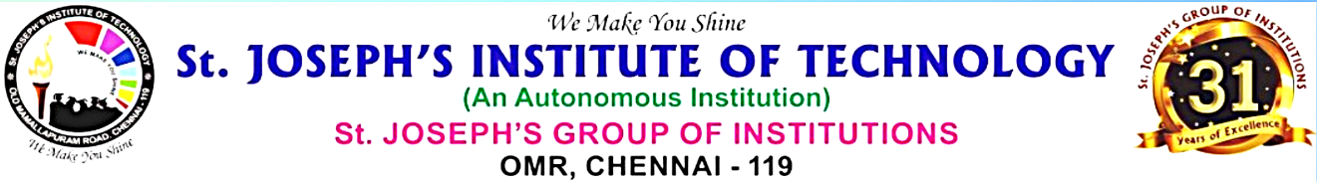

** **

**IEEE REPORT**

Department of Computer Science and Engineering along with IEEE Computer Society and Institution’s Innovation Council (IIC) of St. Joseph’s Institute of Technology conducted **IEEE DAY’ 24** **“Workshop on Idea Generation & Project Expo’ 24”** Competition on 9.10.24 & 10.10.24.

**Day 1**- Mr. Mohan HR, a distinguished leader in the IEEE community, joined the event as a keynote speaker. As an IEEE Ambassador and Chair of IEEE Events for the IEEE Madras Section, he brought immense experience and insights to the gathering. His address was aimed at inspiring students, professionals, and other attendees about the role of technology in shaping the future and the importance of active participation in IEEE initiatives. And followed by the **Idea Generation Workshop** was organized to inspire creativity, promote collaboration, and help participants explore innovative solutions to real-world problems. The workshop aimed to provide a structured environment for brainstorming and ideation, allowing participants to develop new concepts in areas such as technology, social impact, business, and more. Attended by 255 individuals from Department of CSE and Department of CSE-CS students of I and II years, the workshop created a dynamic space for innovative thinking and problem-solving.

**Day 2-** Project Expo- showcased a variety of innovative projects developed by students, researchers, and professionals across multiple disciplines. The expo aimed to provide a platform for participants to present their creative solutions to real-world challenges and demonstrate their technical expertise in various fields such as electronics, computer science, mechanical engineering, and biotechnology. And finally selected teams will award cash prize, I Prize- Rs. 1000, II Prize- Rs. 600, III Prize- Rs. 400.The program was coordinated by Dr. J. Dafni Rose, Head of Department & IEEE CS Chapter Advisor, Mr. Mithun P, Mr. M. Krishnaraj, Mrs. Sindhu- Assistant Professor & IEEE Coordinators CSE.