

IEEE COMPUTER SOCIETY SIT

CURIOUS CONFUSION 2.0

NAME OF THE ORGANIZING UNIT: IEEE COMPUTER SOCIETY SIT

DATE OF EVENT: Monday and Tuesday , 5th & 6th August , 2024

TOPIC: CURIOUS CONFUSION 2.0

MODE OF EVENT: Offline

TARGET AUDIENCE: Student Members

ATTENDANCE: 70

TIMINGS: 10:00 am – 4:00 pm

EVENT SUMMARY:
On the 5th and 6th of August 2024, the IEEE Computer Society conducted an offline event that covered detailed information about various domains—Web Development, Flutter App Development, Internet of Things (IoT), AR/VR, UI/UX, Cybersecurity, AI/ML, Data Science, and Cloud Computing.
Web development is more than just coding; it's about crafting digital experiences, enabling businesses to reach a global audience. Flutter app development allows startups to compete globally, empowering individuals to turn their ideas into reality. In cybersecurity, the critical role of protecting our digital world and ensuring the security of interconnected systems was discussed. AR/VR (Augmented Reality and Virtual Reality) were also explored. AR enhances real-world environments by overlaying digital content, while VR creates fully immersive digital experiences.
AI/ML (Artificial Intelligence and Machine Learning) were highlighted for their powerful ability to automate tasks, predict outcomes, and make intelligent decisions. From natural language processing to computer vision, AI/ML technologies are driving innovation across sectors. IoT (Internet of Things) enables devices to connect, communicate, and exchange data over the internet. The session emphasized how IoT is transforming smart homes, industrial automation, and healthcare systems by facilitating real-time monitoring, automation, and data-driven decision-making. Data Science emerged as a critical field for deriving meaningful insights from vast amounts of data.
Interactive sessions with second-year students were led by the event coordinators, keeping students highly engaged throughout the sessions due to the in-depth and practical insights provided by the speakers.

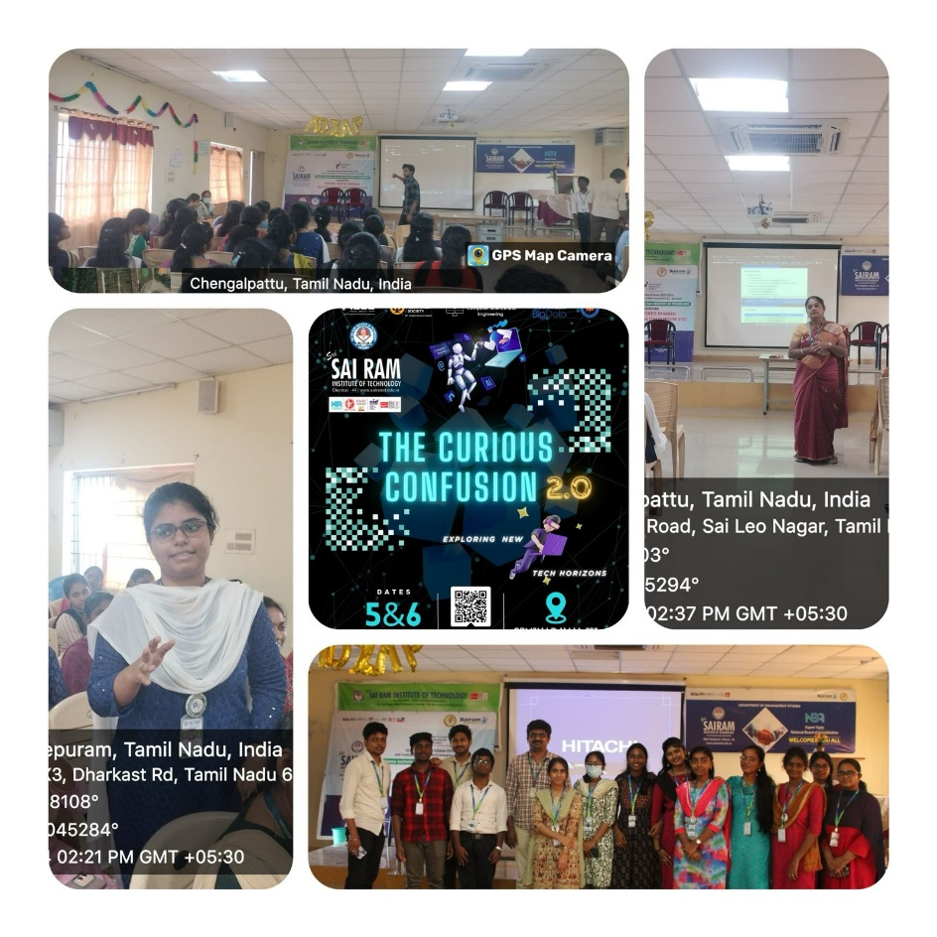

REPORTED BY:
KIRTHANA MOHAN R - – IEEE CS SECRETARY

