
IEEE COMPUTER SOCIETY SIT

THE UNVEILED SERIES EPSIDOE 15– EPIDEMIOLOGICAL MODELS

NAME OF THE ORGANIZING UNIT: IEEE COMPUTER SOCIETY SIT

DATE OF EVENT: Sunday , 1st September

TOPIC: THE UNVEILED SERIES EPSIDOE 15– EPIDEMIOLOGICAL MODELS

MODE OF EVENT: Online

TARGET AUDIENCE: Student Members

ATTENDANCE: 60

EVENT SUMMARY:
It is an online event that will cover valuable knowledge and practical skills in public health. From understanding the dynamics of disease spread to practical applications, it will also include discussions on epidemiological models, focusing on their role in predicting and managing outbreaks.
TIMINGS: 7:00 pm – 8:30 pm
It is an online event. In this enlightening session, we will explore essential public health knowledge and practical skills. The discussion will delve into epidemiological models, focusing on their applications in understanding disease dynamics and outbreak management. Participants will gain insights into predicting and controlling disease spread, ready for real-world applications. Overall, the session aims to intertwine theoretical knowledge with practical insights, empowering participants in the evolving landscape of public health.
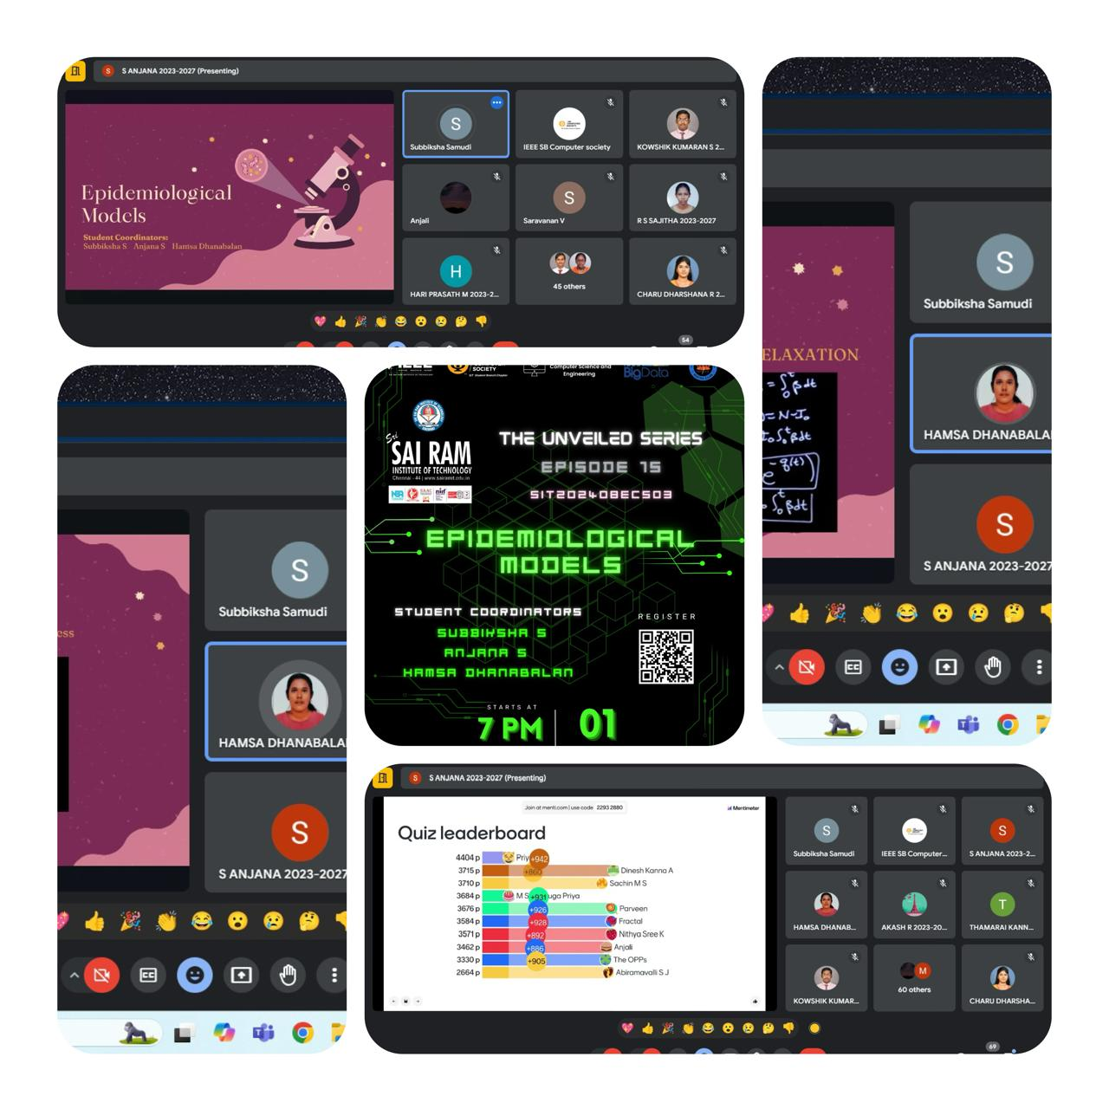

REPORTED BY:
KIRTHANA MOHAN R - – IEEE CS SECRETARY

