
IEEE COMPUTER SOCIETY SIT

THE UNVEILED SERIES EPSIDOE 16– GIT AND GITHUB

NAME OF THE ORGANIZING UNIT: IEEE COMPUTER SOCIETY SIT

DATE OF EVENT: Friday , 1st October

TOPIC: THE UNVEILED SERIES EPSIDOE 16– GIT AND GITHUB

MODE OF EVENT: Online

TARGET AUDIENCE: Student Members

ATTENDANCE: 60

EVENT SUMMARY:
It is an online event that will cover valuable knowledge and practical skills in Git and GitHub. From understanding the fundamentals of version control to hands-on exercises, it will also include discussions on best practices for coding and collaboration.
TIMINGS: 7:00 pm – 8:30 pm
It is an online event. In this enlightening session, we will explore the fundamentals of Git and GitHub, offering practical insights and hands-on exercises. The discussion will focus on mastering these indispensable tools for version control and collaboration. Participants will gain skills applicable to both academic and professional projects, enhancing their coding and teamwork abilities. Overall, the session aims to blend theoretical knowledge with practical applications, empowering participants in the evolving landscape of software development
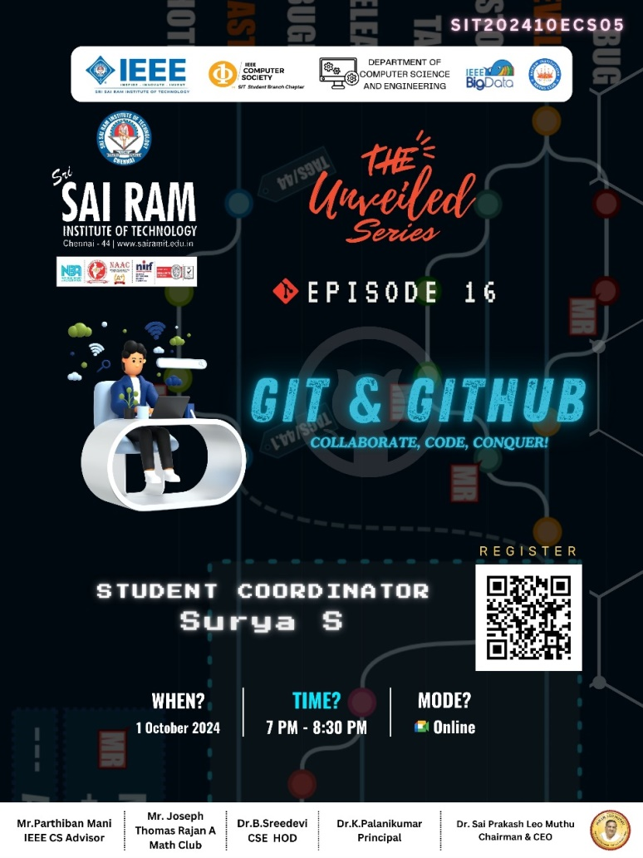
REPORTED BY:
KIRTHANA MOHAN R - – IEEE CS SECRETARY

