

IEEE COMPUTER SOCIETY SIT
CAREER CATALYST

NAME OF THE ORGANIZING UNIT: IEEE COMPUTER SOCIETY SIT

DATE OF EVENT: Wednesday , 4th September 2024

TOPIC: CAREER CATALYST

MODE OF EVENT: Offline

TARGET AUDIENCE: Student Members

ATTENDANCE: 50

TIMINGS: 10:00 am – 4:00 pm

EVENT SUMMARY:
The Career Catalyst event was focused on to equip participants with essential skills to enhance their professional presence in today's competitive job market. The agenda includes building a resume tailored to corporate needs, presenting oneself effectively, and developing a strong personality. Participants will learn key elements employers seek, how to craft impactful personal pitches, and strategies for continuous personal growth. Additional highlights include mock interviews for practical experience, insights from industry professionals, and an interactive Q&A session to address specific career challenges. Attendees will leave with actionable insights and tools to elevate their career prospects, focusing on both technical skills and personal branding to navigate their paths successfully.

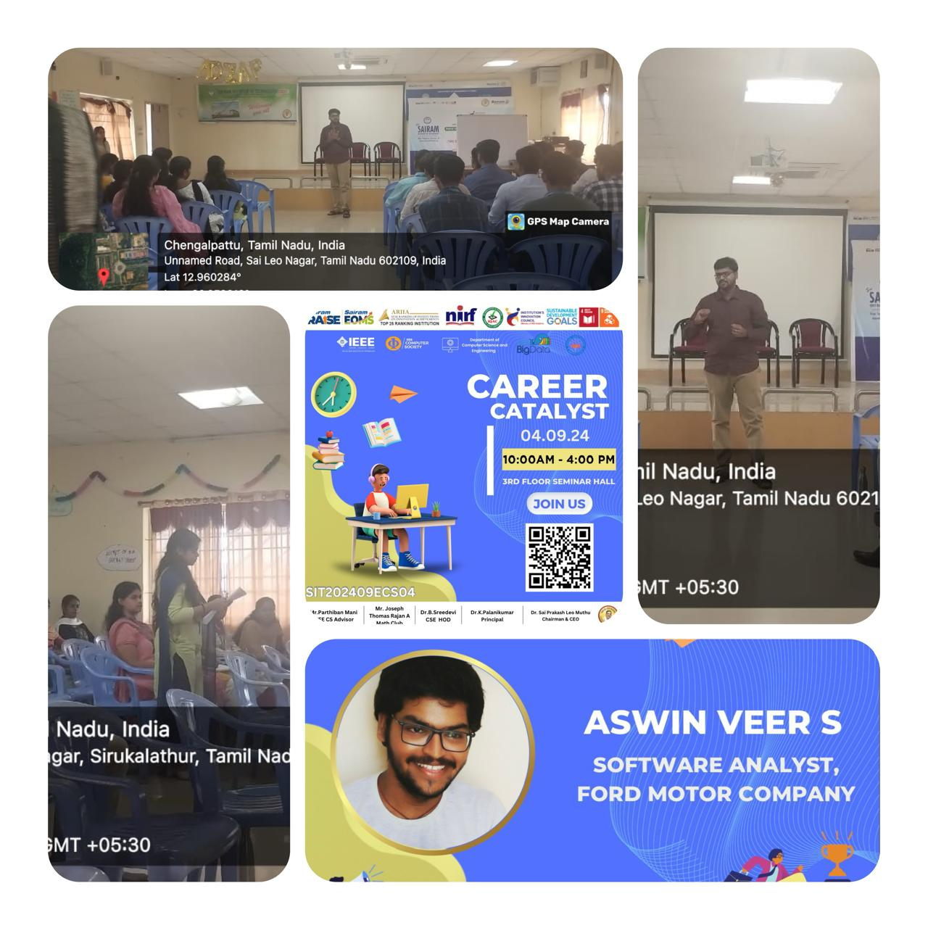
REPORTED BY:
KIRTHANA MOHAN R - – IEEE CS SECRETARY

