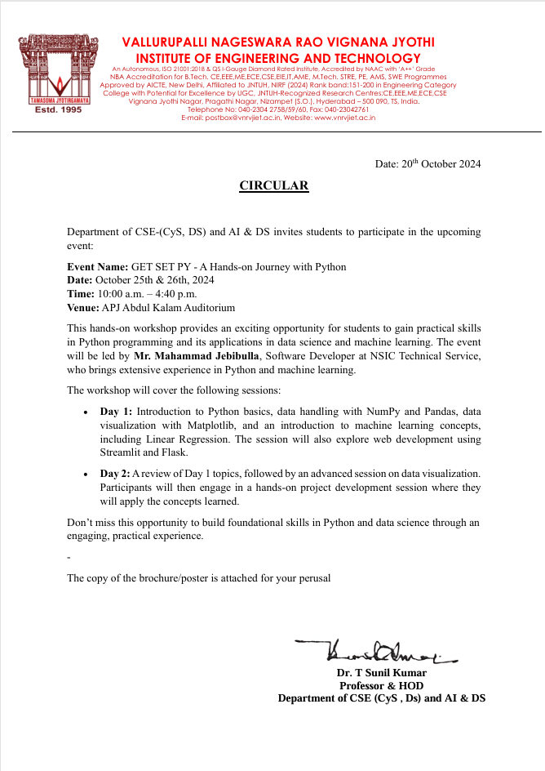

**Winners:**

1st Team : **Team MechX3**

|  |  |  |  |
| --- | --- | --- | --- |
| Name | Roll No | Branch | Section |
| Sai Vidith | 23071A67F0 | CSE-DS | C |
| T. Pranav Babu | 23071A67K1 | CSE-DS | C |
| Sethu Rohith | 23071A67F2 | CSE-DS | C |

2nd Team : **Team Insight Innovators**

|  |  |  |  |
| --- | --- | --- | --- |
| Name | Roll No | Branch | Section |
| Vishwaksen | 23071A67H6 | CSE-DS | C |
| Srishanth | 23071A67G5 | CSE-DS | C |
| Varshith | 23071A67F7 | CSE-DS | C |

**Budget Details:**

|  |  |  |
| --- | --- | --- |
| **Items** | **Quantity** | **Total** |
| Posters | 12 | 1210/- |
| Bags | 6 | 2214/- |
| Flexi | 1 | 1120/- |
| Water bottles (Bislery) | 17 | 170/- |
| Food |  | 575/- |
| Consolidation prizes |  | 977/- |
| Packing |  | 220/- |
| Speaker’s Gift |  | 400/- |
| Chocolates + Choco sticks |  | 812/- |
| Cadbury Celebrations | 1 | 1110/- |
| Printouts |  | 60/- |
| Miscellaneous |  | 200/- |
| **Total** |  | 9068/- |
| **Speaker Fee** |  | 10000/- |
| **Travelling Allowance (Speaker)** |  | 3000/- |
| **Grand Total** |  | **22068/-** |

**Speaker Introduction:**

**Mr. Mahammad Jebibulla** is a proficient **Software Developer** currently working **at NSIC Technical Service**. With a strong background in Machine Learning and Artificial Intelligence, he has completed an internship at IBM, where he developed expertise in using Python for ML and AI applications. His diverse experience includes working as an Android Developer intern at APSSDC and serving as a Data Centre Analyst at Deloitte, further enriching his technical proficiency and analytical skills.

During the event, Mr. Jebibulla shared his knowledge on essential topics in Python programming and data science, including the basics of Python, Numpy, Pandas, Matplotlib, and foundational concepts in Machine Learning. He also covered practical applications through Linear Regression and introduced participants to popular frameworks like Streamlit and Flask, enhancing their understanding of data handling and web development for machine learning applications. His session provided attendees with a comprehensive introduction to Python's role in modern data science and ML projects.

**Event Description:**

The event **“GET SET PY - A Hands-on Journey with Python”** was held on October 25th and 26th from 10:00 AM to 4:40 PM at the APJ Abdul Kalam Auditorium. Organized under the guidance of faculty coordinators Dr. N Sunanda and Mr. P Veeranjaneyulu, Assistant Professors, and with support from student coordinators Bindu Sree and Akhileshwar, the two-day workshop featured Mr. Mahammad Jebibulla, a Software Developer with expertise in Machine Learning and Python-based development. His sessions focused on fundamental Python concepts and practical applications, providing students with a hands-on learning experience.

**Event Overview:**

**GET SET PY - A Hands-on Journey with Python** was a two-day interactive workshop conducted on October 25th and 26th at the APJ Abdul Kalam Auditorium. Led by Mr. Mahammad Jebibulla, an experienced software developer, the event provided students with practical skills in Python and its applications in data science and machine learning.

**Day 1 Overview:**

On *Day 1*, Mr. Mahammad Jebibulla delivered a comprehensive introduction to Python and its essential libraries for data handling and visualization, such as **Numpy, Pandas, and Matplotlib**. Following this, he introduced basic **Machine Learning concepts** and walked participants through a **Linear Regression model** to give them foundational knowledge in ML. He also demonstrated the use of **Streamlit** and **Flask**, frameworks that enable students to create and deploy simple machine learning applications. The hands-on exercises provided throughout the day allowed students to apply and strengthen their learning, setting a solid foundation for the second day’s activities.

**Day 2 Overview:**

On *Day 2*, Mr. Jebibulla began with a **review session** to consolidate the previous day’s concepts, helping students clarify doubts and reinforce their understanding. He then introduced advanced **data visualization techniques** to enable students to create insightful graphical representations of data. The latter half of the day was dedicated to **project creation**, where participants applied their skills to develop practical mini-projects based on what they learned. These projects were then evaluated by a panel of juries, and the **top 2 projects** were recognized by the Head of the Department with awards and gifts. This practical, project-based approach helped participants gain confidence in their skills and motivated them to pursue further learning in data science and Python.

**Event Objectives:**

* To introduce participants to the basics of Python programming and libraries used in data science and machine learning.
* To provide hands-on experience in using Numpy, Pandas, and Matplotlib for data handling and visualization.
* To familiarize participants with machine learning basics, including linear regression.
* To guide participants through building simple applications using Streamlit and Flask.
* To enable students to apply their skills through project development and showcase their understanding in a competitive environment.
* To inspire continuous learning and skill enhancement in data science and Python for practical, real-world applications.

**Event Format:**

**Event Duration:**  
**Date:** October 25th and 26th  
**Time:** 10:00 AM to 4:40 PM  
**Venue:** APJ Abdul Kalam Auditorium

**Day 1: Fundamentals of Python and Machine Learning**

* **10:00 AM - 10:30 AM:** **Registration and Welcome**  
  Participants check in, receive materials, and are welcomed by the coordinators.
* **10:30 AM - 11:15 AM:** **Introduction to Python**  
  Overview of Python basics, including syntax, data types, and control structures.
* **11:15 AM - 12:30 PM:** **Working with Numpy and Pandas**  
  Hands-on session focusing on data manipulation and analysis using Numpy and Pandas.
* **12:30 PM - 1:30 PM:** **Lunch Break**
* **1:30 PM - 2:15 PM:** **Data Visualization with Matplotlib**  
  Introduction to creating visual representations of data using Matplotlib.
* **2:15 PM - 3:15 PM:** **Introduction to Machine Learning**  
  Overview of machine learning concepts with a focus on Linear Regression.
* **3:15 PM - 4:40 PM:** **Web Development with Streamlit and Flask**  
  Demonstration and hands-on session on building simple applications using Streamlit and Flask.

**Day 2: Project Development and Evaluation**

* **10:00 AM - 10:30 AM:** **Review of Day 1 Concepts**  
  A recap of the previous day’s topics to reinforce learning and address questions.
* **10:30 AM - 12:00 PM:** **Advanced Data Visualization Techniques**  
  In-depth training on creating more complex and informative visualizations.
* **12:00 PM - 1:00 PM:** **Lunch Break**
* **1:00 PM - 3:30 PM:** **Project Creation**  
  Participants work in groups to create projects utilizing the concepts learned over the two days, applying their knowledge in a practical setting.
* **3:30 PM - 4:00 PM:** **Project Presentations**  
  Each group presents their project to the jury panel for evaluation.
* **4:00 PM - 4:40 PM:** **Evaluation and Awards Ceremony**  
  The jury evaluates the projects, and the top 2 Teams are recognized by the Head of the Department with awards and gifts.

**Topics Delivered:**

1. **Introduction to Python Programming**

- Python basics: syntax, variables, data types, and control structures

- Functions and modules in Python

2. **Data Handling with Numpy and Pandas**

- Overview of Numpy for numerical computing

- Data manipulation with Pandas: Data Frames, indexing, and operations

3. **Data Visualization with Matplotlib**

- Plotting basics in Matplotlib: line charts, bar graphs, histograms

- Customizing plots for better data insights

4. **Introduction to Machine Learning**

- Key concepts in machine learning: supervised vs. unsupervised learning

- Linear Regression: theory, implementation, and practical applications

5. **Web Application Development with Streamlit and Flask**

- Overview of Streamlit for rapid web application development

- Using Flask to build web applications with Python backends

6. **Advanced Data Visualization Techniques**

- Creating complex visualizations to display data insights

- Interactive and customized visualization techniques in Python

7. **Project Development and Implementation**

- Applying learned concepts to create real-world mini-projects

- Practical integration of Python, Numpy, Pandas, Matplotlib, and machine learning models

**No of Students Registered: 109**

**No of Students Participated: 109**

**Attendance:**

**Day 1 (Attendance):**

|  |  |
| --- | --- |
|  |  |
|  |  |
|  |  |

**Day 2 (Attendance):**

|  |  |
| --- | --- |
|  |  |
|  |  |
|  |  |

**Feedback:**

**Day 1 Feedback:**

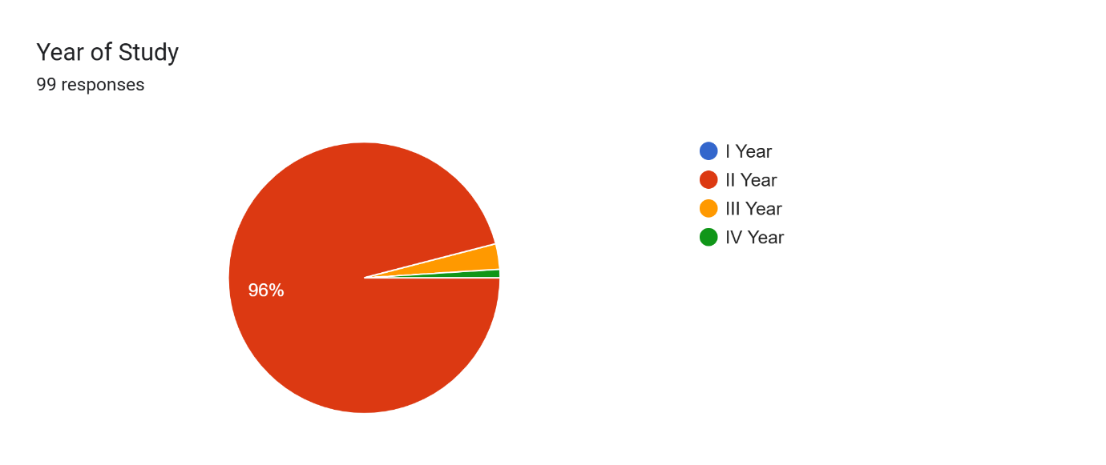

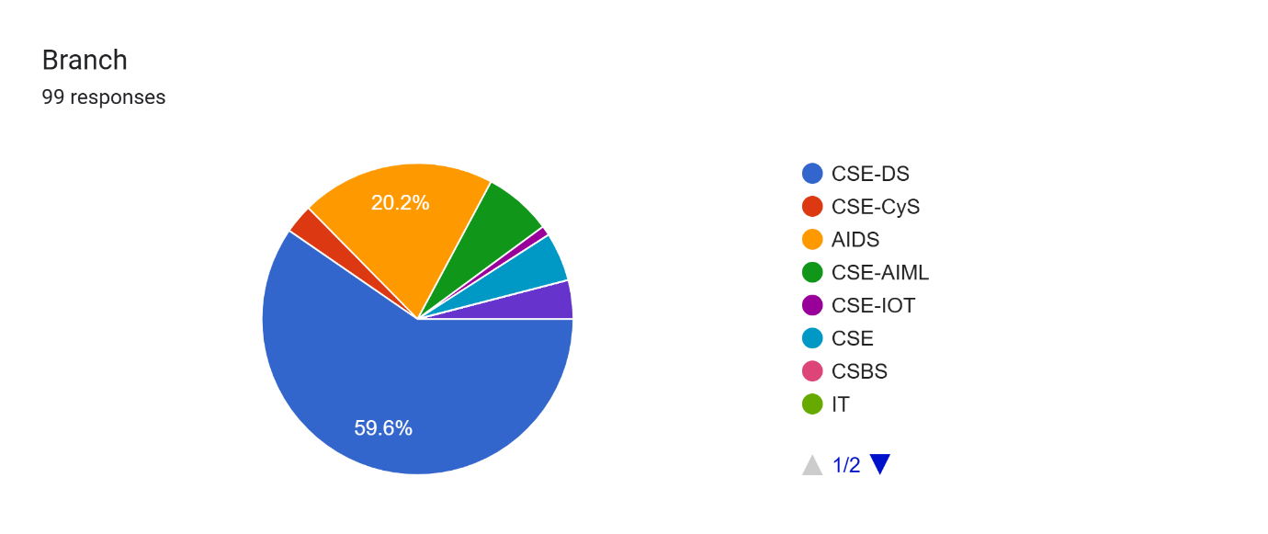

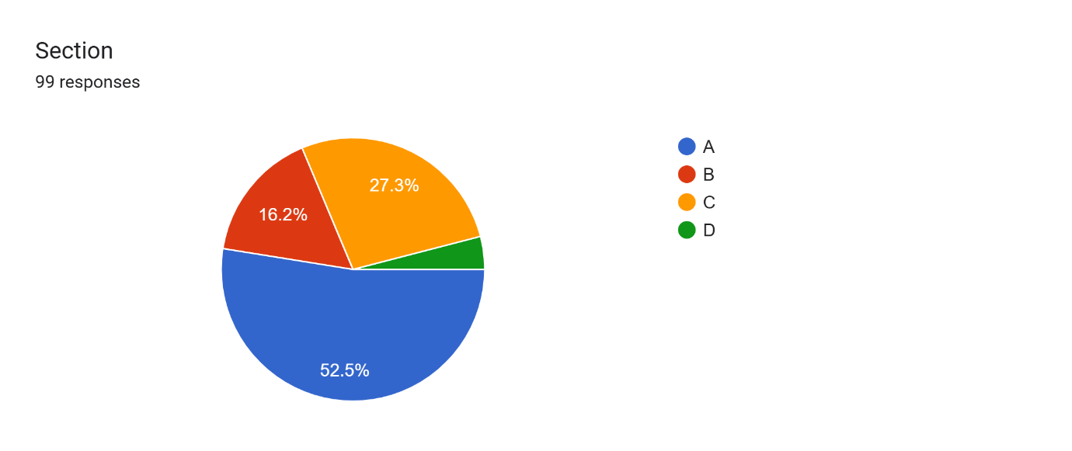

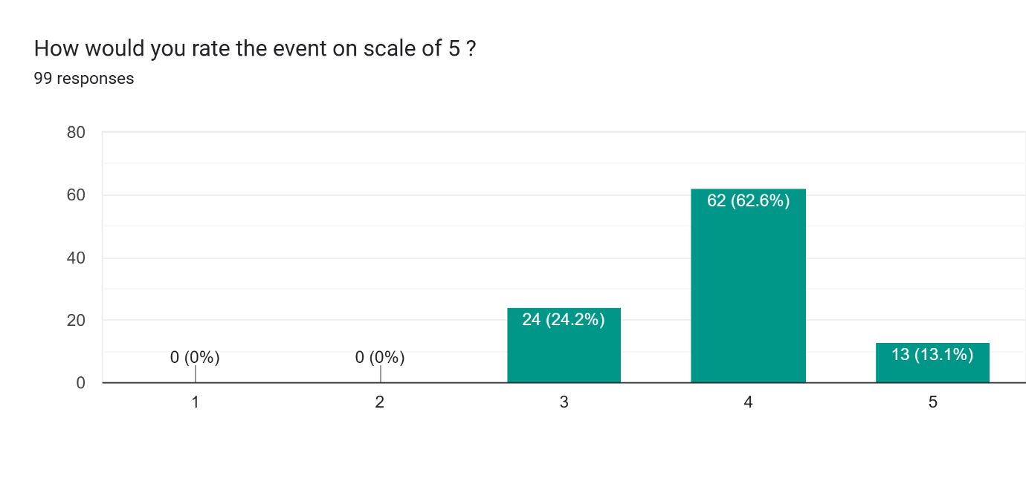

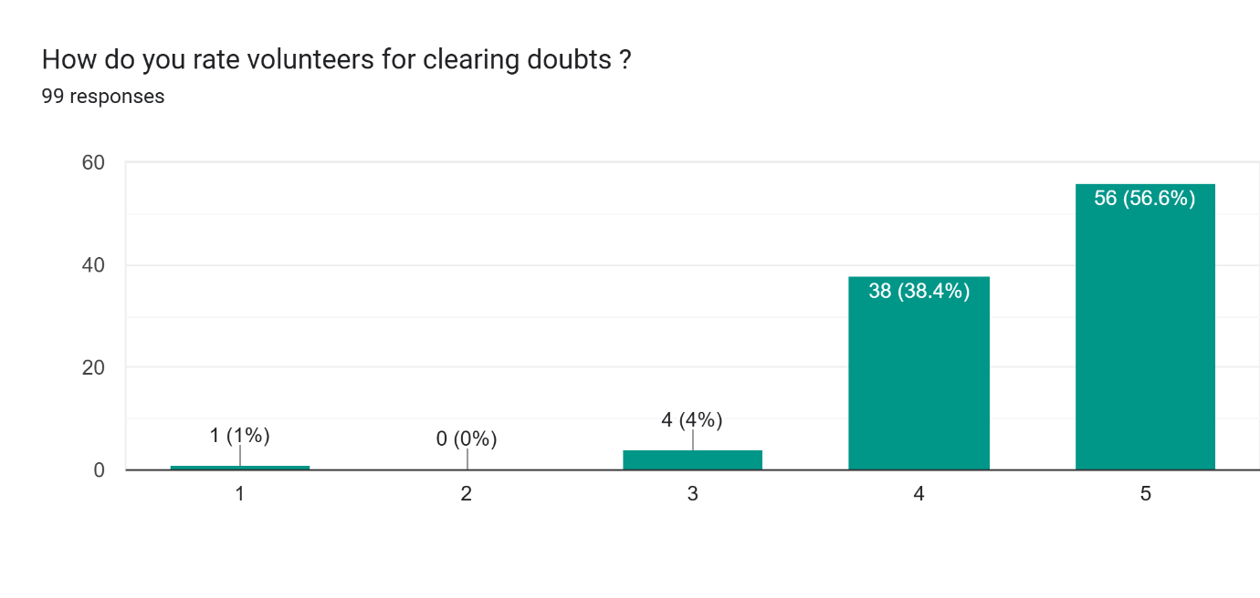

**Day 2 Feedback:**

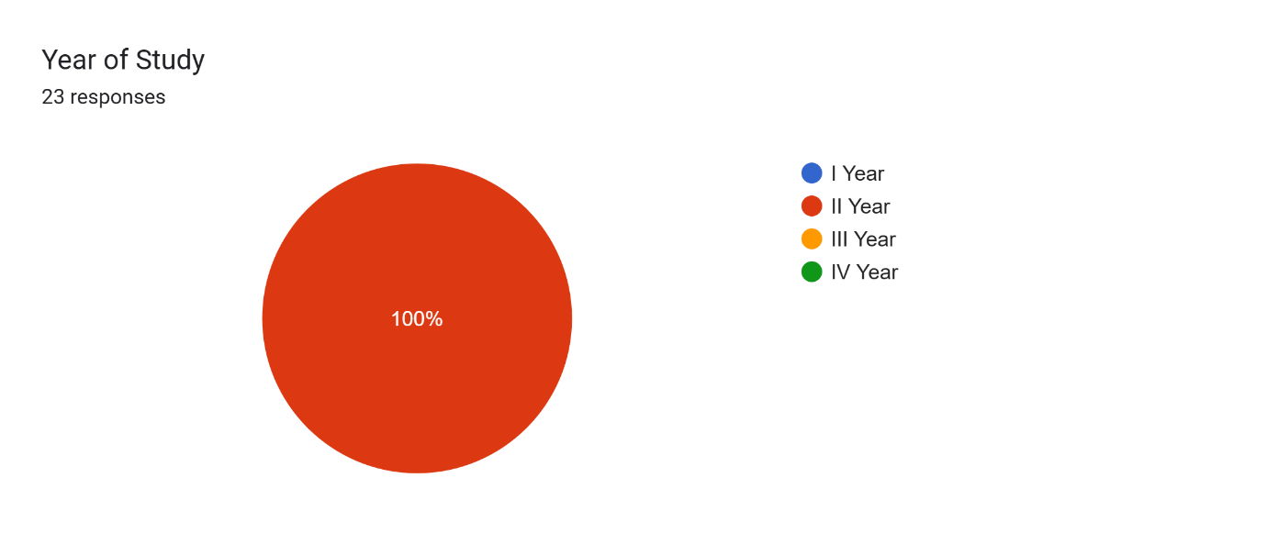

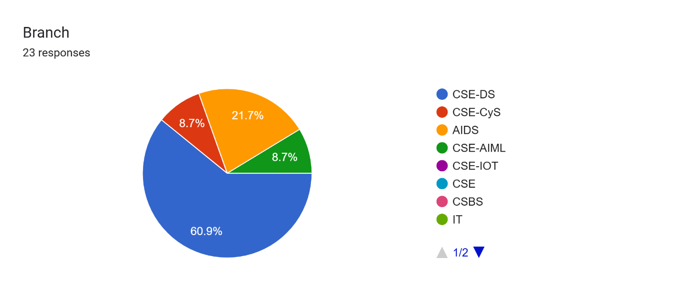

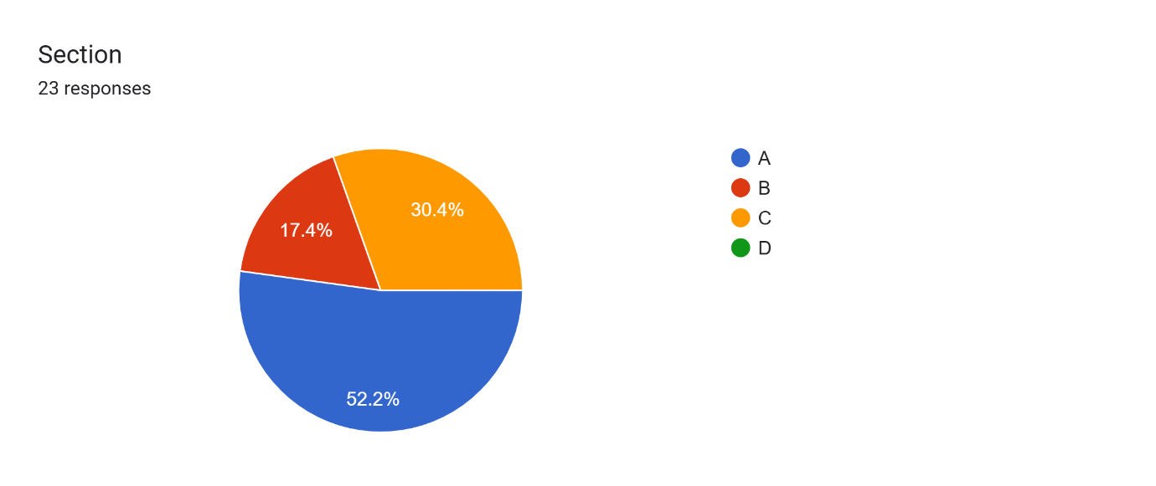

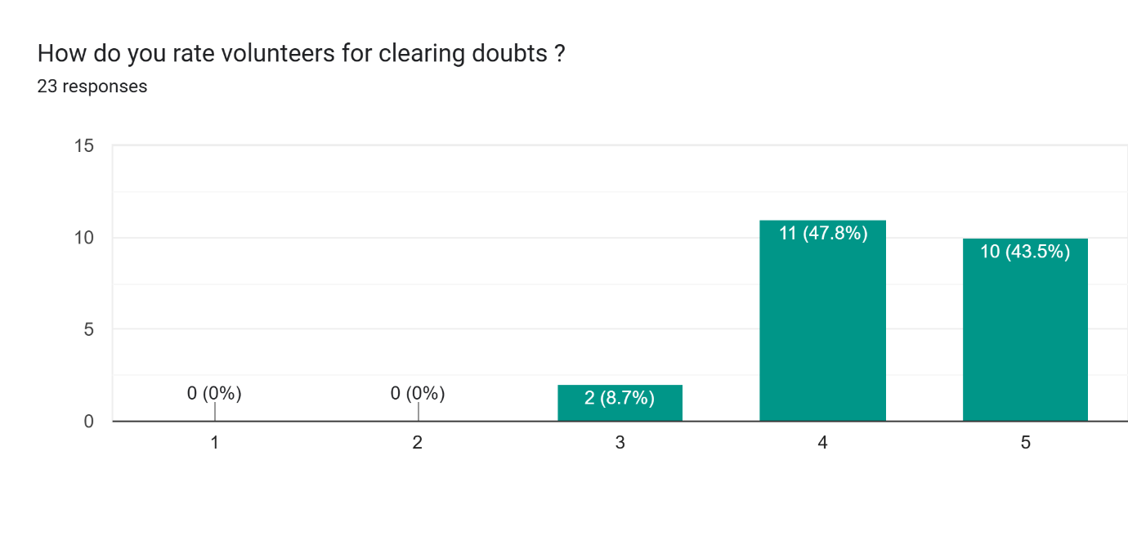

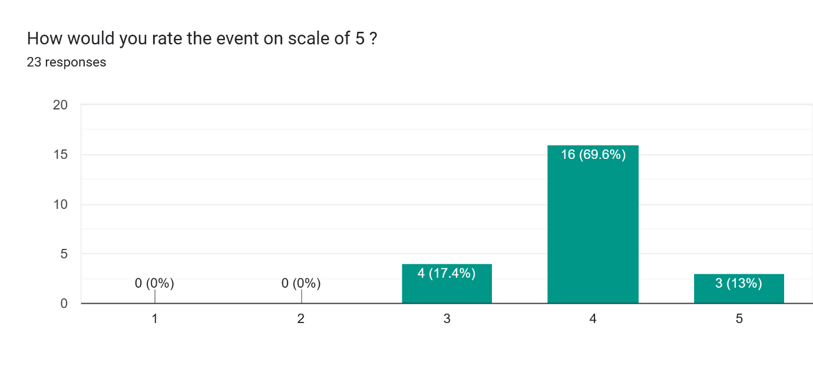

**Event Photos:**

|  |  |
| --- | --- |
|  |  |
|  |  |
|  |  |

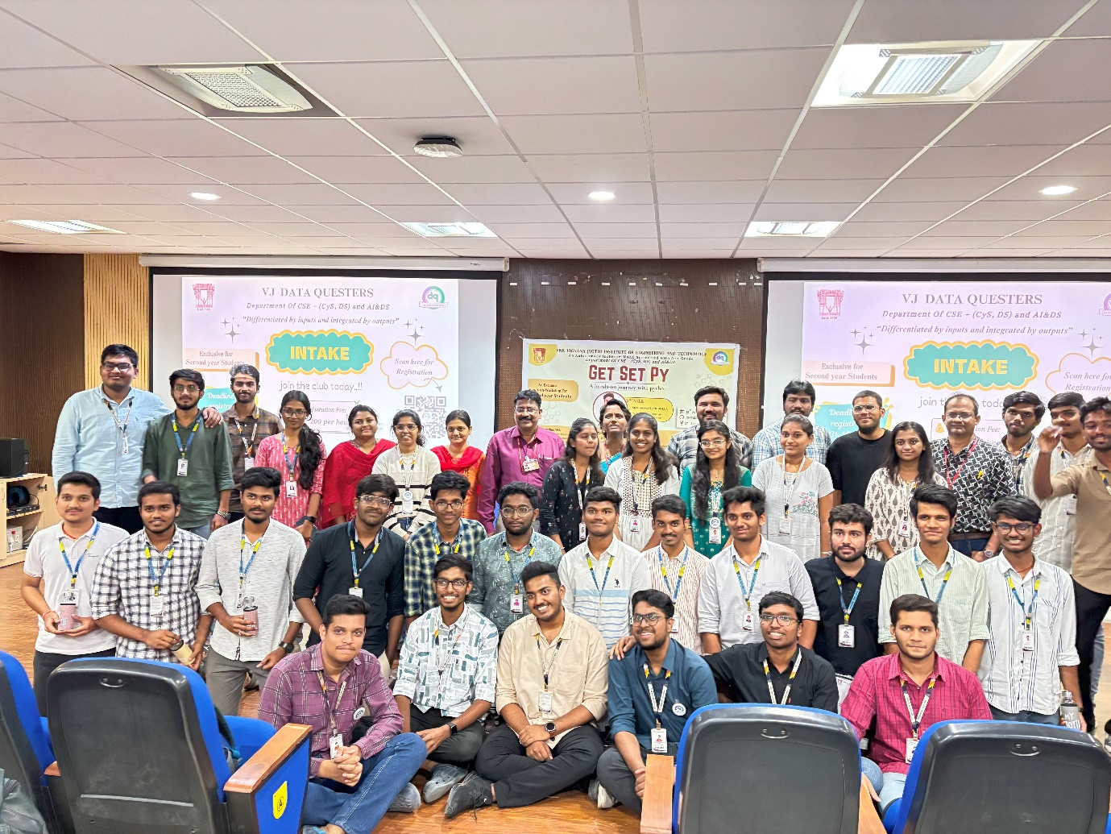

|  |  |
| --- | --- |
|  |  |

**Photos Drive Link:** <https://drive.google.com/drive/folders/1DixyVjyaP52kMwsx81bKKBDPdTmtyUk5?usp=drive_link>