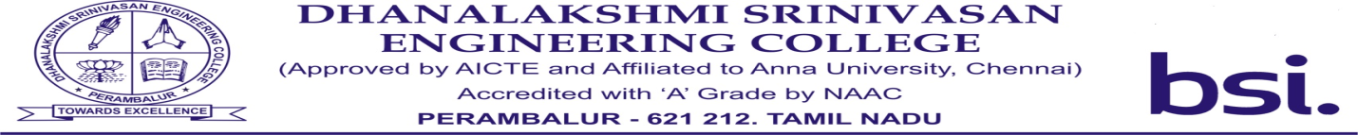

NCON 2020 is organizing with the objective to promote and disseminate knowledge on various topics and topologies of engineering fields and to apply alternative solutions to current practices. The conference is indented for PG students, Research scholars and faculties. It also paves a way for converging new developments in the field of renewable energy systems.

A total of about 200 technical papers were received from post graduate students, faculty members and Research scholars covering a wide spectrum of areas, viz. Energy management, Solar energy, Wind energy, Energy conservation, Economic dispatch, Electrical grid, Economic dispatch, Power system, Power electronics, Control system, Electrical machines, Power system protection, Special electrical machines, Energy storage system, Instrumentation and IOT Applications on Renewable energy.