 IEEE COMPUTER SOCIETY SIT

THE UNVEILED SERIES EPSIDOE 17– CLOUD COMPUTING

NAME OF THE ORGANIZING UNIT: IEEE COMPUTER SOCIETY SIT

DATE OF EVENT: Friday , 1st November

TOPIC: THE UNVEILED SERIES EPSIDOE 17– CLOUD COMPUTING

MODE OF EVENT: Online

TARGET AUDIENCE: Student Members

ATTENDANCE: 60

EVENT SUMMARY:
It is an online event that will cover valuable knowledge and insights into cloud computing. From understanding its fundamentals to exploring its applications, benefits, and future trends, it will also include discussions on how cloud computing impacts today's tech-driven world.

TIMINGS: 7:00 pm – 8:30 pm
In this enlightening session, we will explore the fundamentals of cloud computing, offering practical insights and real-world applications. The discussion will focus on understanding its core concepts, benefits, and future trends. Participants will gain knowledge applicable to both academic and professional domains, enhancing their understanding of this impactful technology. Overall, the session aims to blend theoretical knowledge with practical insights, empowering participants in the evolving landscape of cloud computing.
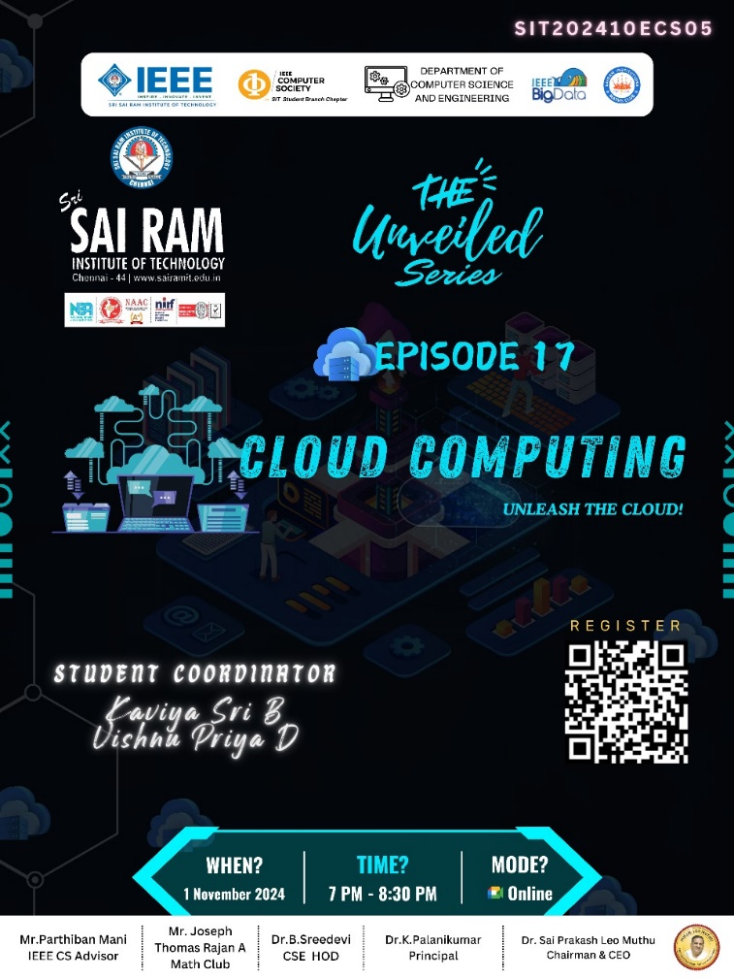

REPORTED BY:
KIRTHANA MOHAN R - – IEEE CS SECRETARY

