
IEEE COMPUTER SOCIETY SIT

QUESTRON

NAME OF THE ORGANIZING UNIT: IEEE COMPUTER SOCIETY SIT

DATE OF EVENT: Thursday , 5th December 2024

TOPIC: QUESTRON

MODE OF EVENT: Offline

TARGET AUDIENCE: Student Members

ATTENDANCE: 70

TIMINGS: 12:45 pm – 4:00 pm

EVENT SUMMARY:
The event was conducted successfully with active participation from students. The event began with participants assembling at the venue, where second-year coordinators ensured that everyone was comfortable. A brief introduction was given to explain how the event would proceed.

The first round, called the Advantage Round, involved solving abbreviations, with two teams winning the advantage of swapping problem statements later. The problem statements for the event were selected from previous Smart India Hackathon (SIH) challenges, providing participants with real-world, industry-relevant scenarios. Teams then picked chits containing their problem statements.

To guide them, a sample PowerPoint presentation template was shared, to help them structure their solution. Over the next hour, teams worked on analyzing their problem statements, drafting innovative solutions, and preparing their presentations. After submission, each team presented their ideas to the jury.

The event was a valuable experience for participants, helping them develop critical problem-solving skills, familiarize themselves with analyzing complex problem statements, and think quickly under time constraints. It also provided an opportunity to practice creating and delivering presentations effectively within a limited timeframe, fostering creativity and professional growth.
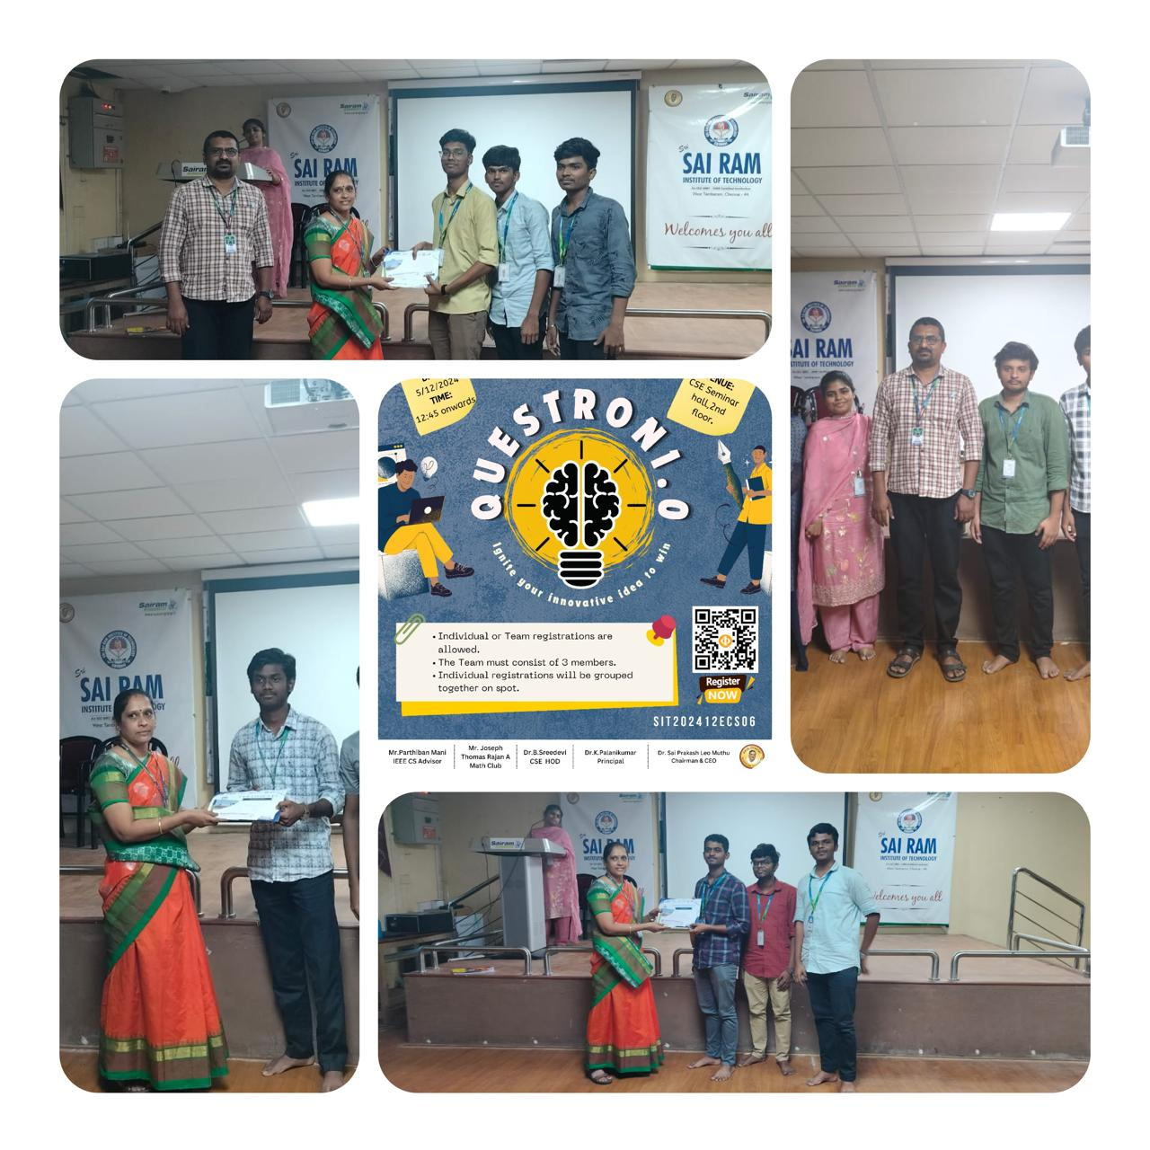
REPORTED BY:
KIRTHANA MOHAN R - – IEEE CS SECRETARY

