**IEEE CAS Society Day and Suzhou Student and Young Professional Activity Successfully Held In China, Suzhou**

On November 15, 2024, an IEEE CAS event took place in Suzhou, highlighting the growing enthusiasm and deepening collaboration between the region and global circuits and systems associations. The event was held in a picturesque rural town near Taihu Lake, Suzhou, and featured distinguished speakers and exceptional PhD students from all over the world. They shared a wealth of knowledge and expertise with local students and members. Notable speakers included Professor Wen Liu, member of the Youth Innovation Promotion Committee of the Third Generation Semiconductor Industry Technology Innovation Strategy Alliance (CASA), executive deputy director of the International Innovation Institute for third generation semiconductor power electronics devices and power integration of XJTLU, and Associate Professor Kain Lu Low of XJTLU. Their presentations focused on the latest GaN-based developments and trends in circuits and systems, providing attendees with fresh perspectives and innovative ideas.

Additionally, IEEE CASS members, including prominent doctoral representatives Professor Zhiwei Sun and Dr. Weisheng Wang, shared insights into their advanced research experiences and technological advancements, adding further depth to the event. Toward the conclusion, discussions on development directions and potential areas for improvement were held with Associate Professor Wen Liu and Associate Professor Kain Lu Low, offering valuable perspectives. The event was moderated by Qiyuan Zhang, Chair of the IEEE CASS-EDS Xi’an Jiaotong-Liverpool University Student Association. This gathering marked a significant contribution to fostering future development and promoting knowledge exchange within the IEEE CAS community in Suzhou.

During the remaining time, Professor Wen Liu, Executive Deputy Director of the International Innovation Institute for Third-Generation Semiconductor Power Electronics Devices and Power Integration at XJTLU, led members to the scenic lawn beside Taihu Lake. There, participants engaged in advanced technology exchanges, interactive award-winning Q&A sessions, and other activities, which garnered enthusiastic responses from attendees.

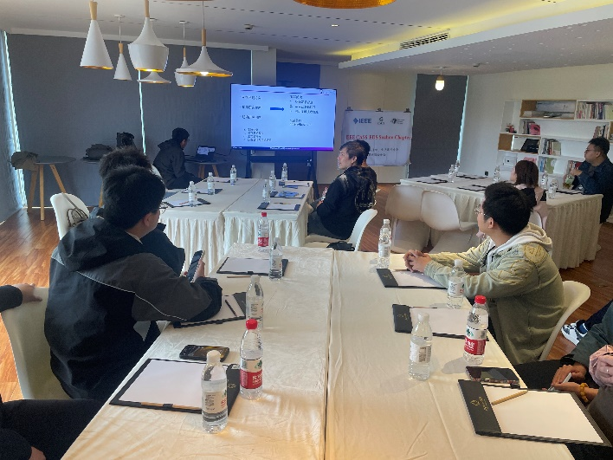Co-organized by the IEEE Student Association of Xi'an Jiaotong Liverpool University, more than ten students, young professionals, and IEEE members, including senior and new members, participated in this event.

During this dynamic conference, outstanding doctoral student Dr. Weisheng Wang shared his advanced research experiences with both new and senior members, sparking lively engagement. Following his presentation, attendees participated in in-depth discussions, delving into advanced topics related to GaN-based circuits and addressing challenges encountered in ongoing research.

In summary, the successful execution of this event not only enhanced the cohesion among IEEE students and young scholars in Suzhou but also established a solid foundation for IEEE CASS to engage more deeply and effectively in driving technological advancements and innovation in Suzhou, China.

Suzhou, Xi’an Jiaotong-Liverpool University Student Branch