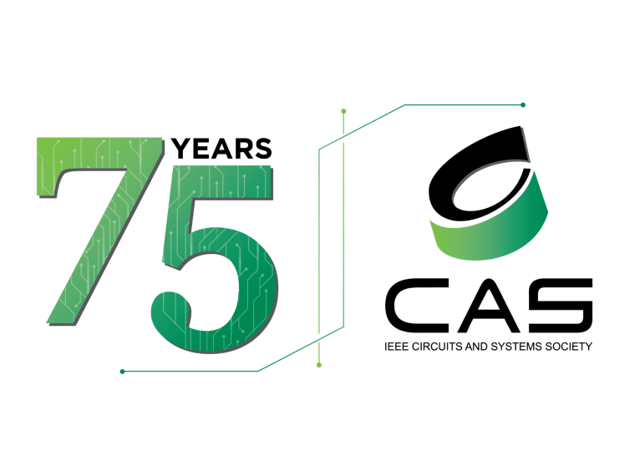
Report on
IEEE CASS INDUSTRY FORUM ON NEUROMORPHIC COMPUTING: AI -INSPIRED CHIP ARCHITECTURES
18.12.2024

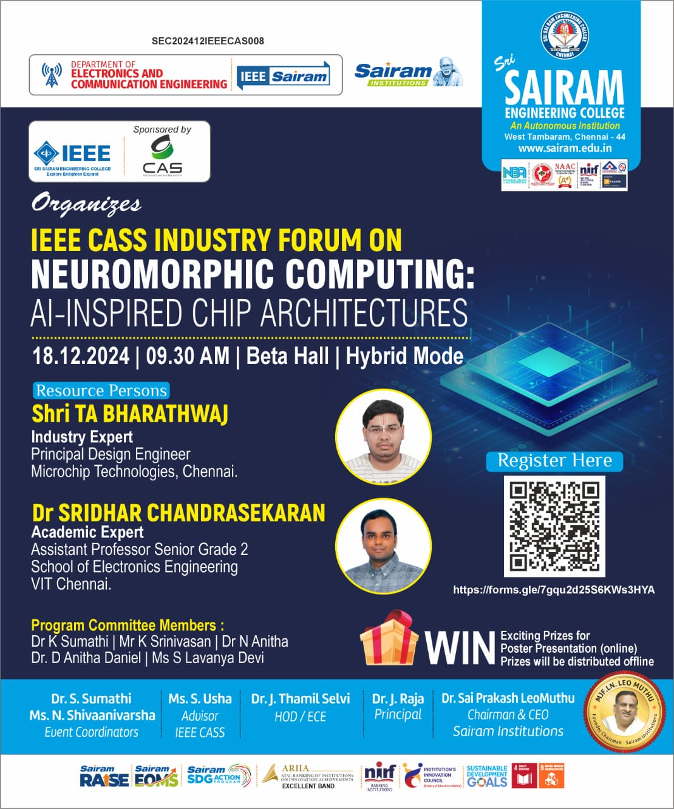
Expert speakers
Shri T A Bharathwaj
Industry Expert,Microchip Technologies, Chennai

Dr.Sridhar Chandrasekaran
Assistant Professor,VIT ,Chennai

Objective of the event

The event's objective is to give an overview on neuromorphic computation which are efficiencies like those of the human braining terms of processing power, storage capacity and energy consumption. The lecture will focus extensively on the algorithm's model and its potential advancement in new research applications. Towards the end, with a broad discussion and a viable plan for the latest application prospects to facilitate students with a better understanding of the aforementioned model in order to build their own artificial intelligence projects.

The session chief guest was welcomed by Dr S.Sumathi and the chief guest Dr.Sridhar Chandrasekaran was honored by Dr J Thamilselvi, HOD-ECE. Shri T A Bharathwaj
was honored by the Event coordinator Dr S.Sumathi, Prof-ECE.

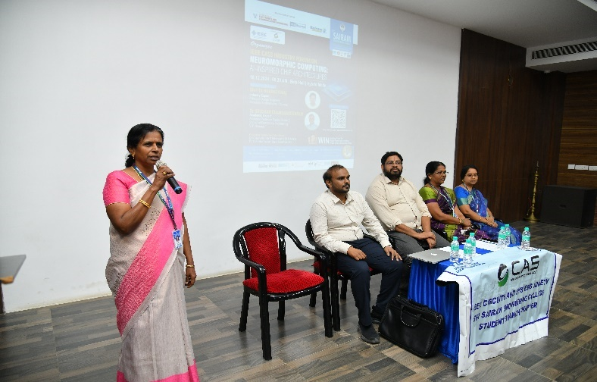 | 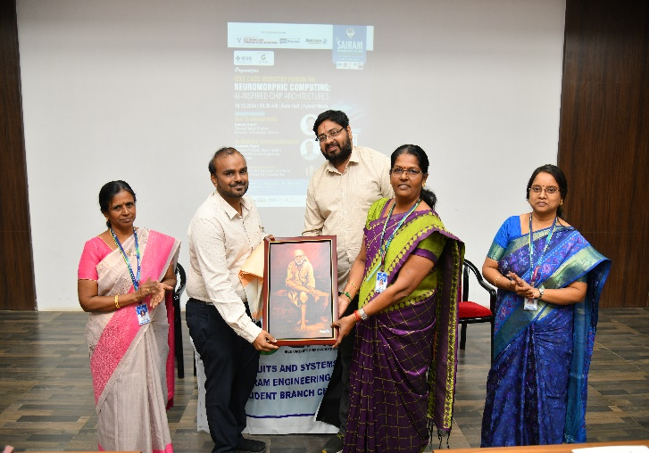
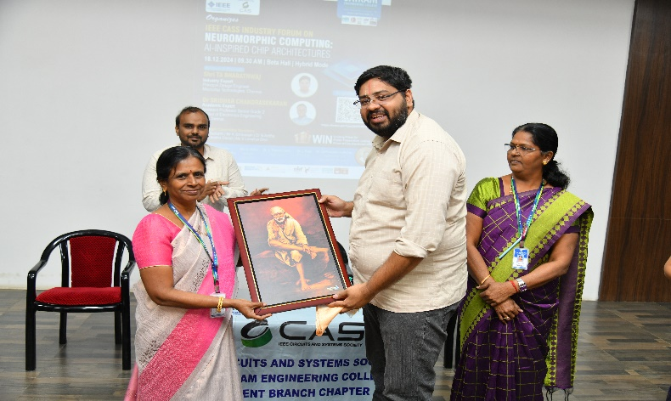 | 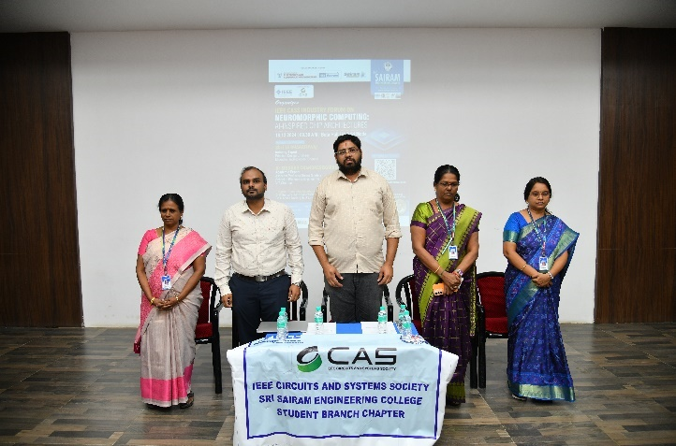

Dr J Thamil Selvi, HOD-ECE given special address about the event. Highlights the benefits and innovations in neuromorphic computation.

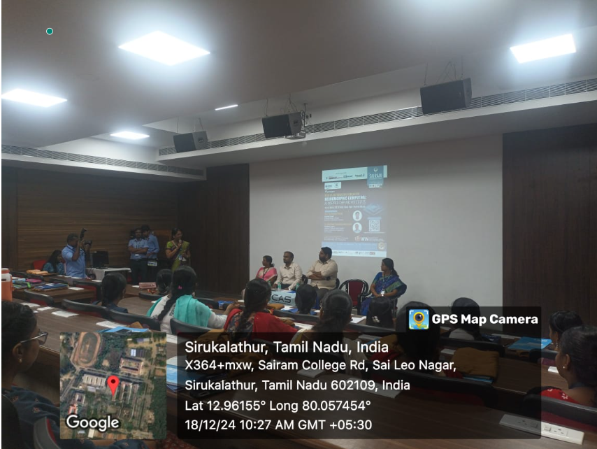 | 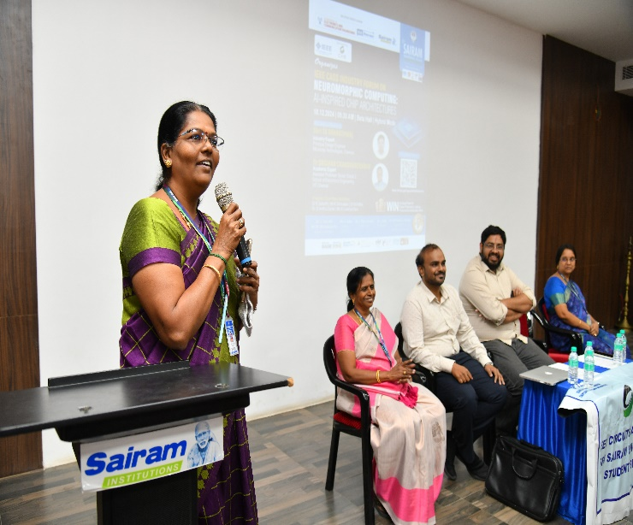

Dr. Sridhar Chandrasekaran explores the cutting-edge field of neuromorphic engineering, providing a thorough analysis of its principles, hardware design, and practical uses. He highlights that event-driven mechanisms, parallel processing, and synaptic plasticity are essential for neuromorphic chip design. This event examines the revolutionary influence of neuromorphic devices across multiple disciplines, such as speech recognition, robotics, and computer vision. Technical and ethical challenges are explained, emphasizing standardization, scalability, and societal ramifications. Besides, this research considers how neuromorphic chips can transform computers and artificial intelligence. It emphasizes the necessity of continual multidisciplinary research and innovation to overcome obstacles and realize this paradigm shift's full potential.

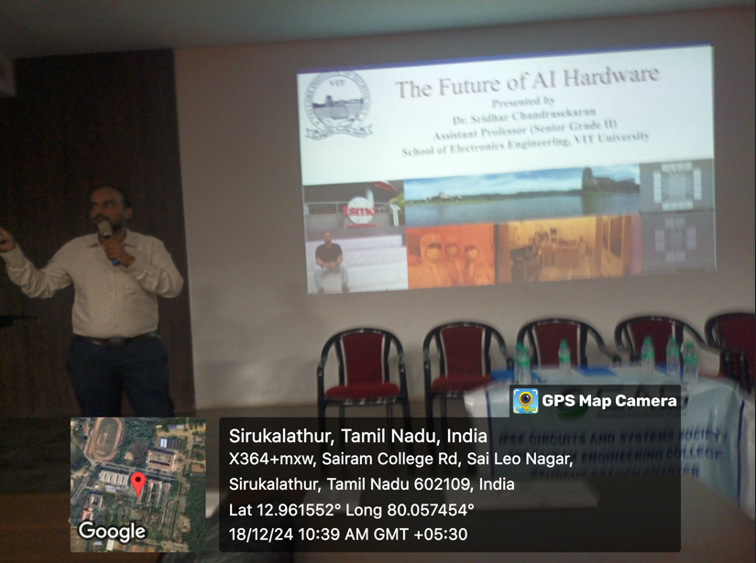 | 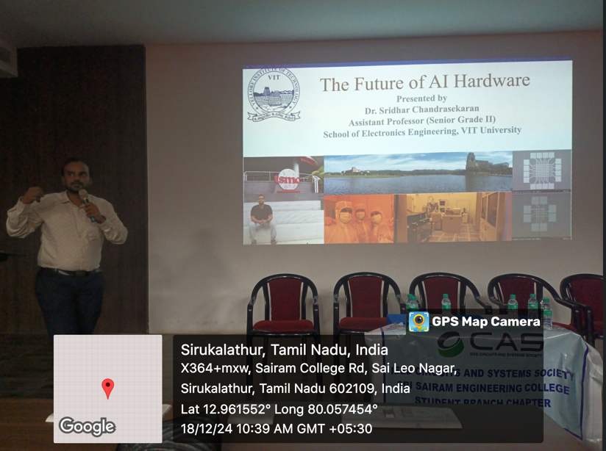
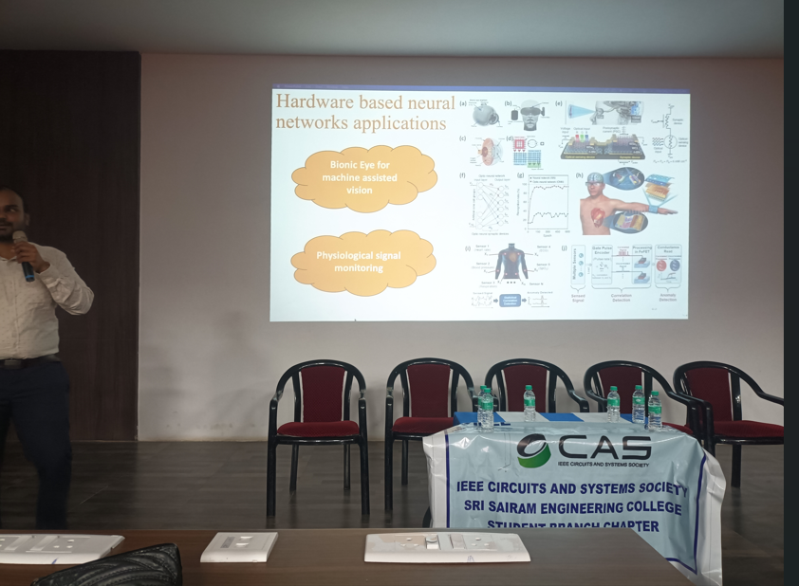 | 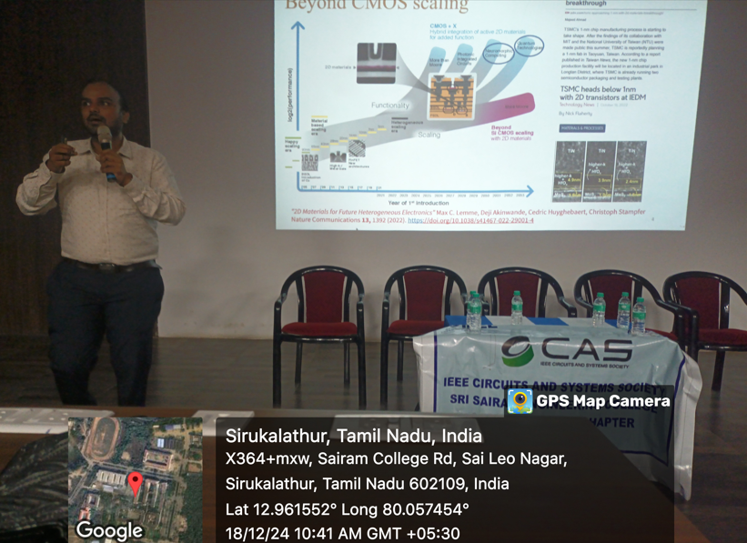

Shri T A Bharathwaj explains its goal to emulate the neural structure of the human brain to improve computational speed and efficiency. Provide insight into how the human brain processes information through a vast network of neurons and synapses and how this biological model inspires the architecture of neuromorphic chips. He explains how neuromorphic chips can potentially address the limitations of current AI technologies by enabling more efficient processing of complex algorithms and enhancing machine learning capabilities.

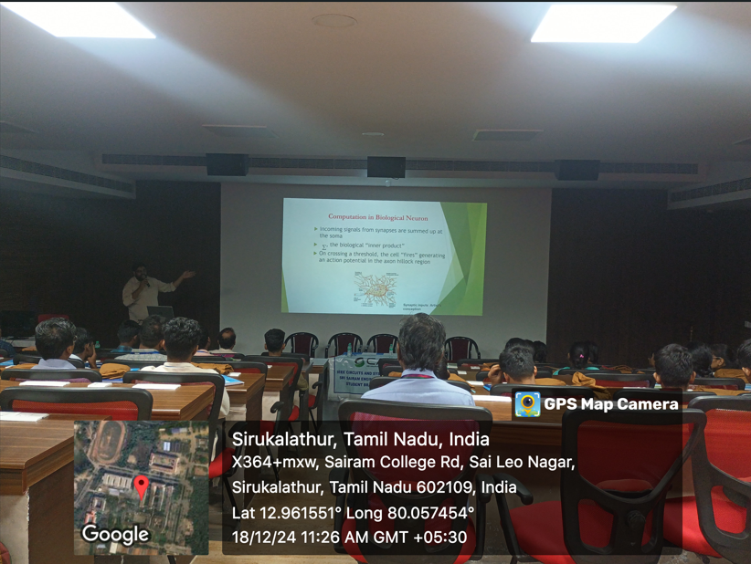 | 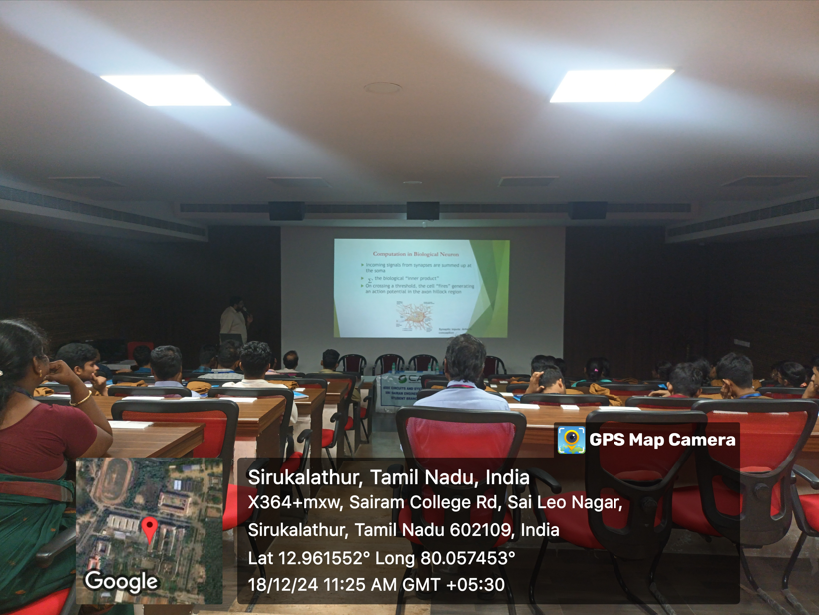
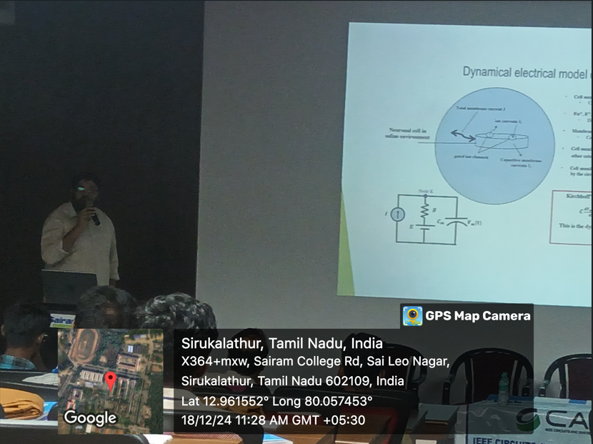 | 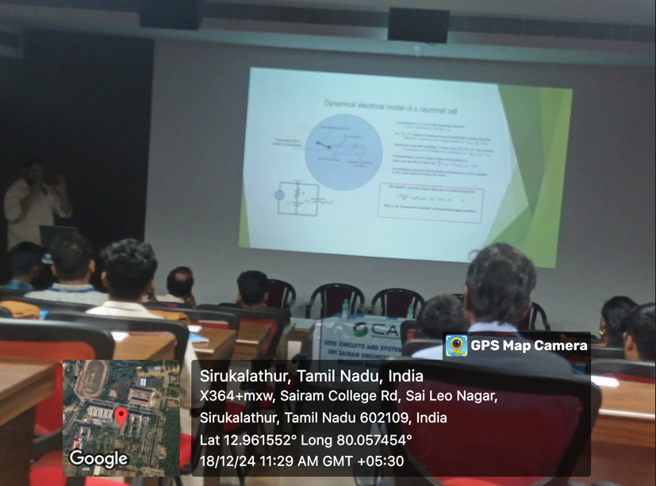
The forum has thoroughly examined the field of neuromorphic engineering and clarified essential aspects of its applications, hardware, and challenges. The fundamental concepts of neuromorphic engineering, which are based on parallel processing and synaptic plasticity, have been thoroughly covered. Their transformational potential is highlighted by analyzing different neuromorphic chip architectures and their applications in speech recognition, computer vision, and robotics.
Vote of thanks was given by the Event Coordinator Ms N Shivaanivarsha. She thanked the session handled person for the wonderful effort provided to the students during the event. Students were given feedback about the session . The forum was very interactive with many questions from the students and faculty members on Neuromorphic computing .Very positive feedback was given by the students on the forum .
IEEE Attended: 63
Guest Attended :2

