***IEEE Eureka 2024***

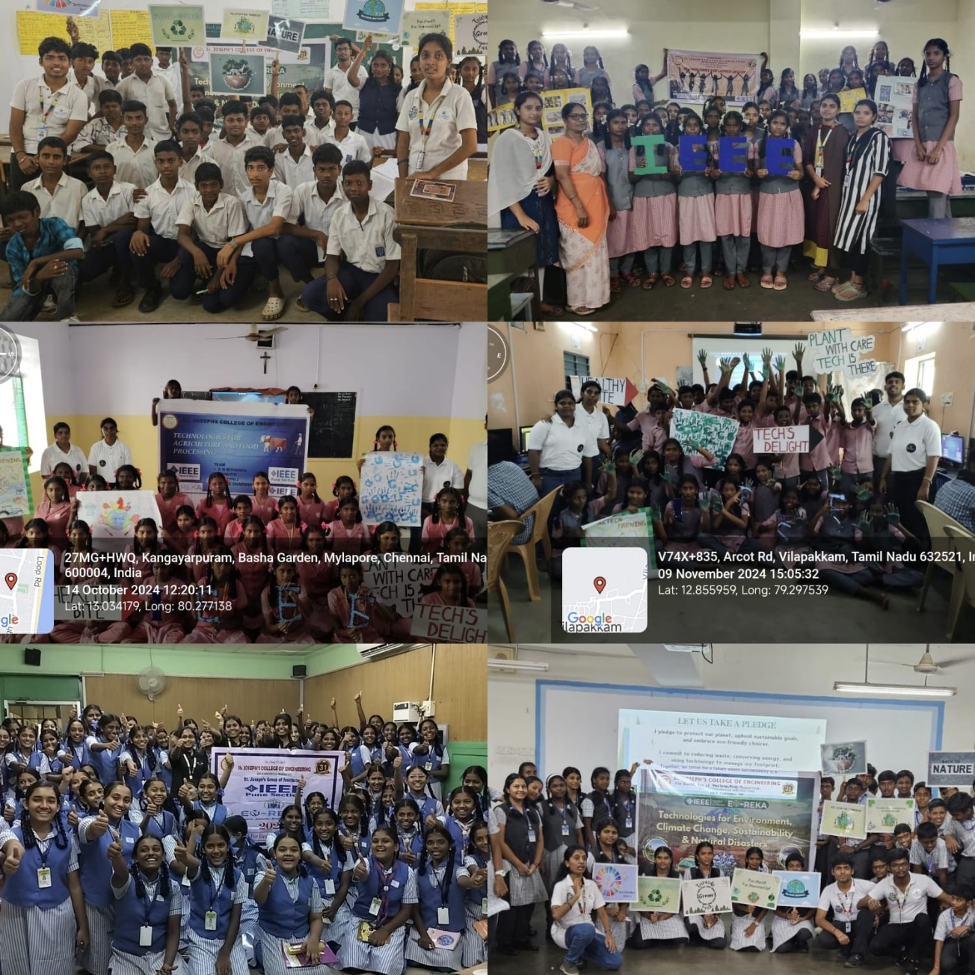

The IEEE SJCE Student Branch actively participated in the Eureka 2024 competition, conducted by the IEEE Pune Section from October 9 to November 9, 2024. This initiative witnessed the involvement of 2nd-year, 3rd-year, and final-year EEE students, who made significant contributions to the event's objective of educating and inspiring young minds. Participants visited multiple schools, with some teams exceeding the requirement of two urban and two rural schools by covering up to seven schools. They engaged with students from the 8th and 9th grades, addressing topics such as women welfare, artificial intelligence, agriculture, and food, among others. The sessions included interactive activities, demo project demonstrations, and the distribution of participation certificates, encouraging enthusiasm and learning among the students. The IEEE SJCE SB team collectively addressed a total of 3,086 students across 65 schools, spanning 11 districts, including Kanniyakumari, Virudhachalam, Cuddalore, Thiruvannamalai, Chengalpattu, Chennai, Neyveli, Thirunelveli, Kanchipuram, Theni, and Vellore. This impactful participation highlighted the students' dedication to societal betterment through education and innovation, leaving a lasting impression on the schools and students they interacted with.