MATLAB MAGIC
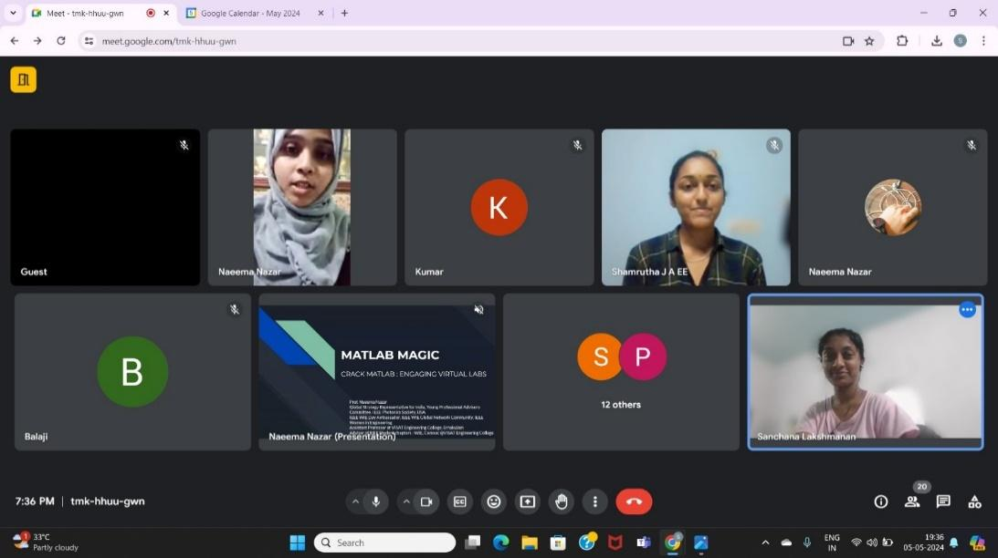
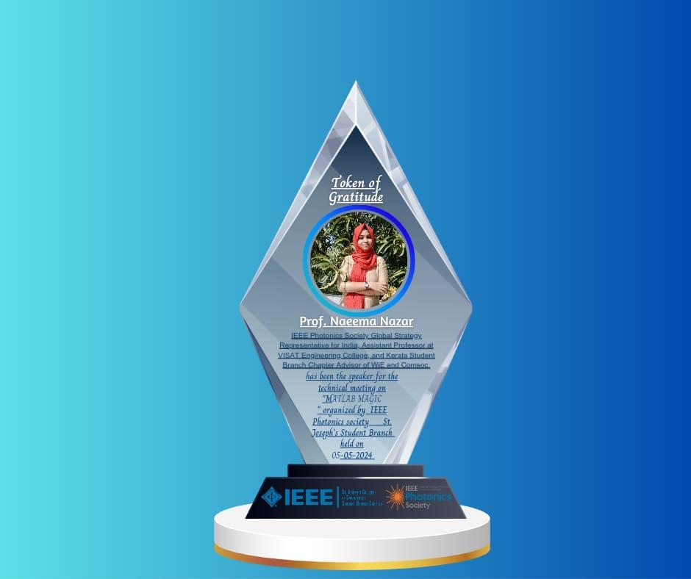
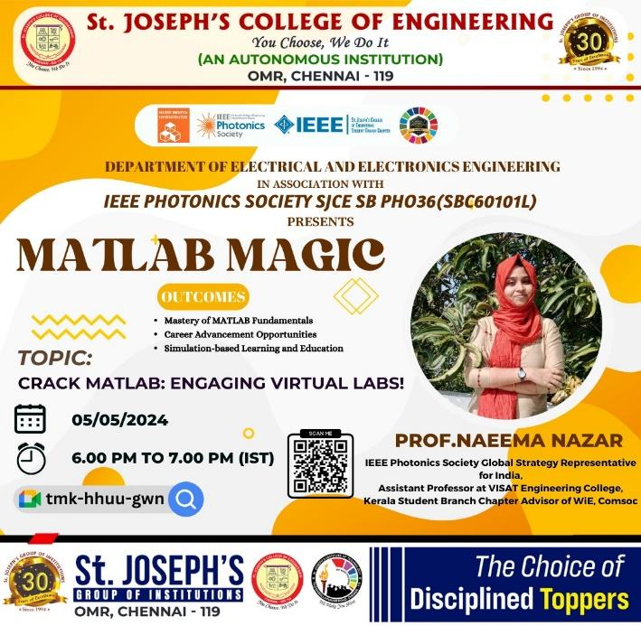

The IEEE Photonics Society of SJCE SB Conducted “MATLAB MAGIC” a technical online mode webinar for 2nd and 3rd year EEE students, on 05.05.24 from 6.00 PM to 7.00 PM (IST). The event aimed to give fundamentals and a HANDS-ON session of MATLAB by Prof. Naeema Nazar Assistant Professor at VISAT Engineering College, IEEE Photonics Society Global Strategy Representative for India, Kerala Student Branch Chapter Advisor of WIE, Comsoc 2024 IEEE WIE Day Ambassador, IEEE Global Network Community. She shared her wonderful insights on the topic "Crack MATLAB: Engaging Virtual Labs!". The event saw the cumulative participation of 50 students. The session was generally well-received by the participants and was very informative. E-certificates were provided to all who participated in the event.

