***INDUSTRIAL VISIT***

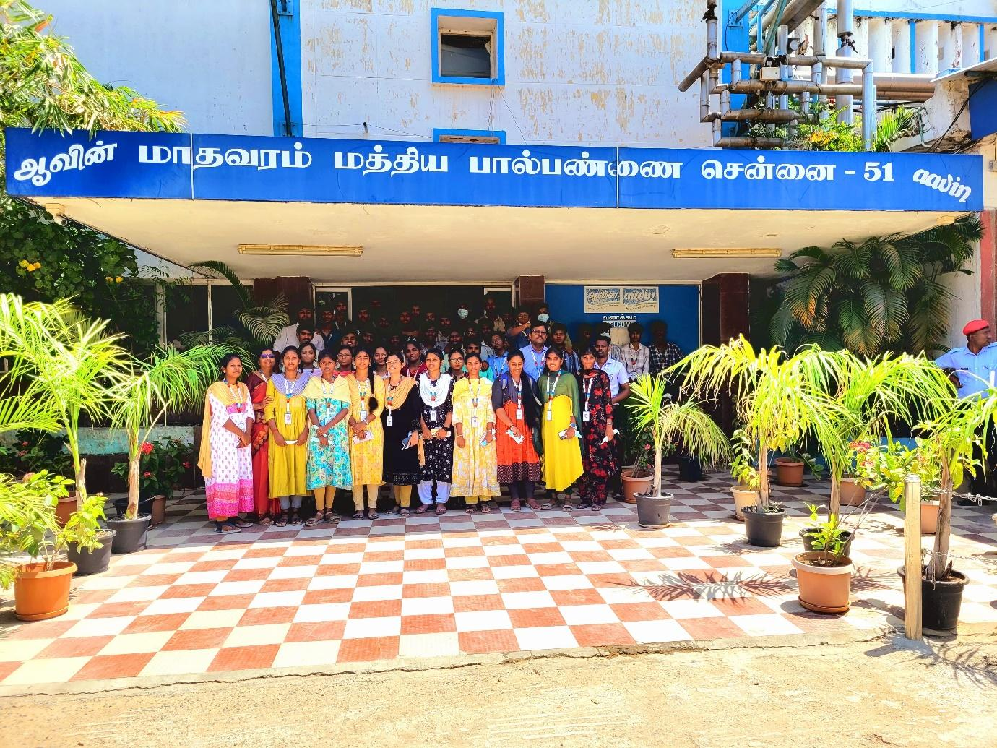

IEEE St. JOSEPH’S COLLEGE OF ENGINEERING STUDENT BRANCH CHAPTER in association with the Department of Electrical and Electronics Engineering organized an insightful industrial visit to Aavin Ambathur on September 17th, 2024, involving students from second-year Section A. The primary goal was to provide these students with practical exposure to the operations and management of a large-scale dairy processing facility. During the visit, students observed essential processes such as milk processing, packaging, and quality control, gaining valuable insights into the technology and machinery used in the dairy industry.

The visit offered students a unique opportunity to bridge the gap between theoretical knowledge and real-world applications in industrial environments. Engaging with technical staff and witnessing the operational procedures firsthand, students enhanced their understanding of the complexities involved in managing large-scale production and maintaining quality standards. This experience not only reinforced their academic learning but also prepared them for practical challenges in their future careers as engineers.

OUTCOME:  
The industrial visit provided students with a practical understanding of dairy processing operations and the critical role of quality control in large-scale production. This hands-on experience significantly enhanced their grasp of theoretical concepts and prepared them for real-world applications in industrial engineering.