***AGNI SIRAGUGAL***

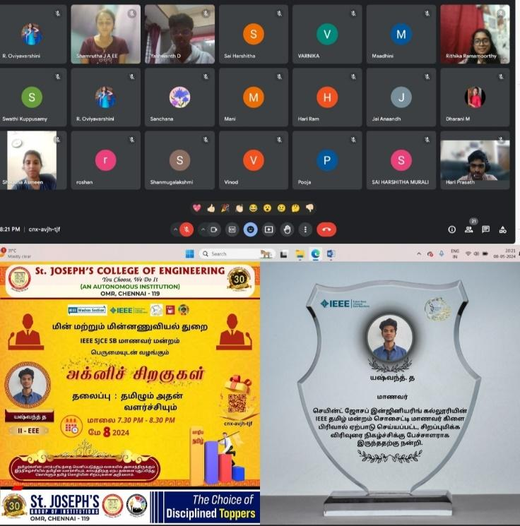

The **IEEE SJCE SB MAANAVAR MANDRAM** of St. Joseph’s College of Engineering organized an engaging online webinar titled **"AGNI SIRAGUGAL"** exploring the rich tapestry of Tamil literature. The event, conducted with finesse in a virtual setting on the date of 8TH MAY 2024 with a total of 30 participants. **Yashwanth D**, student, eloquently discussed the evolution of Tamil and its significant developments. The event's seamless execution was credited to the dedicated student coordinators, Jayavarshini M J, Oviya Varshini R, Nivetha B,  Saniya Benzer E, Isha T, Hassan A, and Anas Javith A. The event concluded with a virtual photo session.