***TAMIZH MEDAI:***

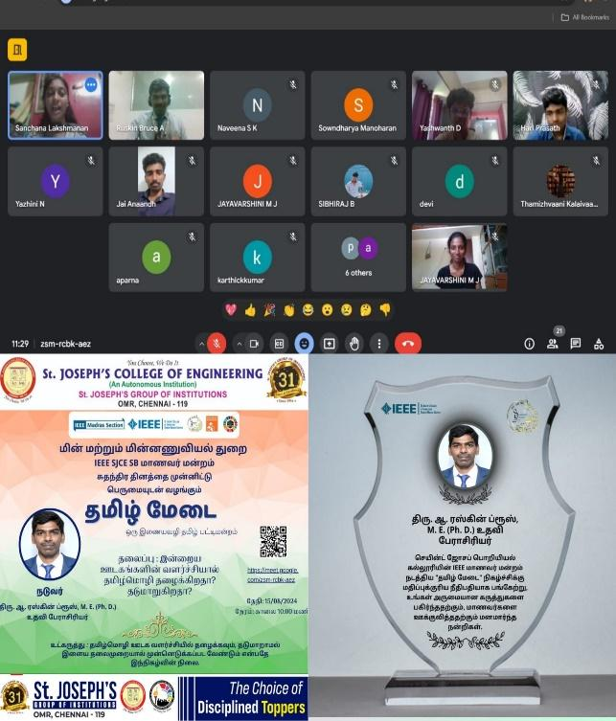

The **IEEE SJCE SB MAANAVAR MANDRAM** of St. Joseph’s College of Engineering organized an engaging online pattimandram titled **"INDRIYA OODAGANGALIN VALARCHIYAAL TAMIZHMOZHI THAZHAIKIRADHA? THADUMARUGIRADHA?"** exploring the rich tapestry of Tamil language. The event, conducted with finesse in a virtual setting on the date of **15TH AUGUST 2024** with a total of 35 participants. **Members of IEEE** eloquently discussed the evolution of Tamil and its significant developments. The event's seamless execution was credited to the dedicated student coordinators. Jayavarshini M J, Oviya Varshini R, Nivetha B,  Saniya Benzer E, Isha T, Hassan A, and Anas Javith A. The event concluded with a virtual photo session.

Special thanks to **RUSKIN BRUCE A,** Assistant Professor, Department Of Mechanical Engineering, for judging the event in a right manner. Special thanks to **Naveena. S. K, Hariprasath. S, Yazhini. N, Yashwanth. D, Anaandh. J, Sowndharya. M** for raising voice for Tamil Language.