**Academic Year: 2023-24**

**Program Type:**

**Level 4:** Tech Fest/Challenges/Hackathons (Training and Certification)

**Duration of the activity:** Greater than 18 contact hours: More than 2 days

**Type of Activity: (**IPR & Technology Transfer)

Start Date: 08/11/2024

End Date: 10/11/2024

Duration of the Activity in hours: 18 hours

No of Students participants: 72

No of External participants: 79

Expenditure: Rs.65,000/-

Mode of Delivery (Online, Offline, Hybrid): Offline

Objectives (100 Words Maximum):

The objectives of the workshop are:

1. Understanding of Lean and Six Sigma methodologies, including their core principles, history, and how they complement each other in driving process improvement.
2. Identify various forms of waste (e.g., defects, overproduction, waiting, non-utilized talent) within processes and how to apply Lean tools to eliminate or reduce these wastes.
3. Train participants in the DMAIC (Define, Measure, Analyze, Improve, Control) framework, which is central to Six Sigma, for solving problems and improving processes systematically.
4. Develop participants' ability to collect and analyze data to identify root causes of problems and assess process performance.

Benefits (in terms of learning / Skills / Knowledge Obtained) (100 Words Maximum):

1. Ability to differentiate between Lean (focused on waste reduction) and Six Sigma (focused on variation reduction) and recognize when to apply each.

2. Develop the skill to map processes, identify inefficiencies, and apply Lean tools (e.g., 5S, Kaizen, Value Stream Mapping) to eliminate waste.

3. Develop skills in each stage of DMAIC, such as defining problems, measuring key metrics, analyzing data, improving processes, and controlling outcomes

4. Enhance data analysis skills, including statistical analysis, root cause analysis, and performance measurement using tools like Pareto charts, histograms, and control charts.

Brochure: Attach JPEG max size 2MB

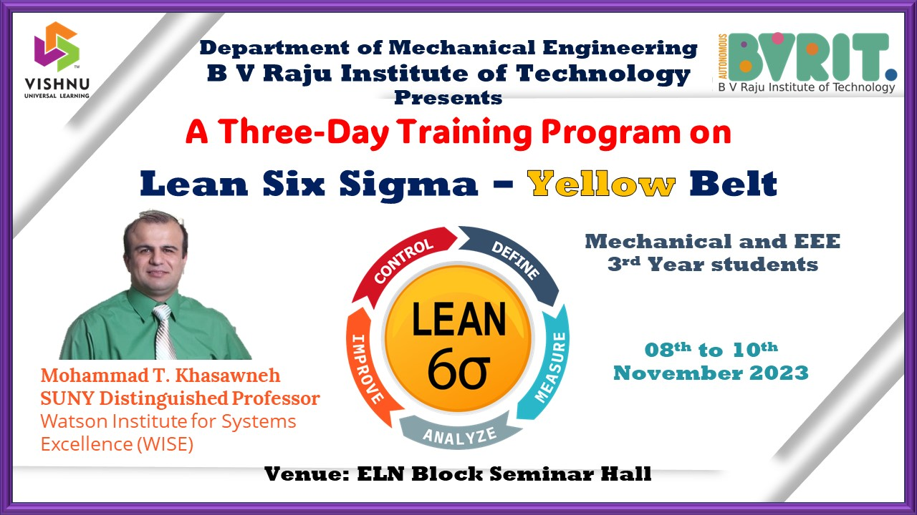

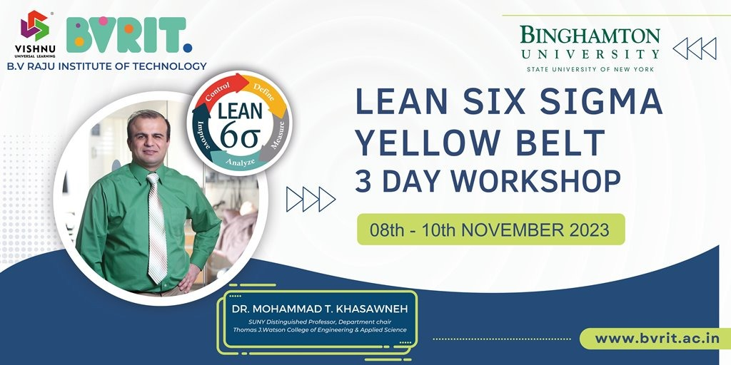

Photographs: Attach JPEGs max size 2MB (Merge atleast 4 Photos in a single file)

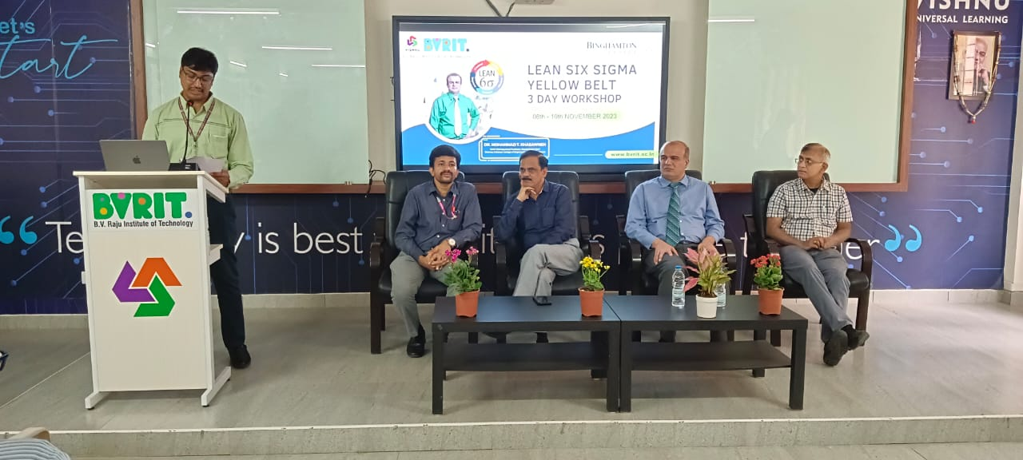

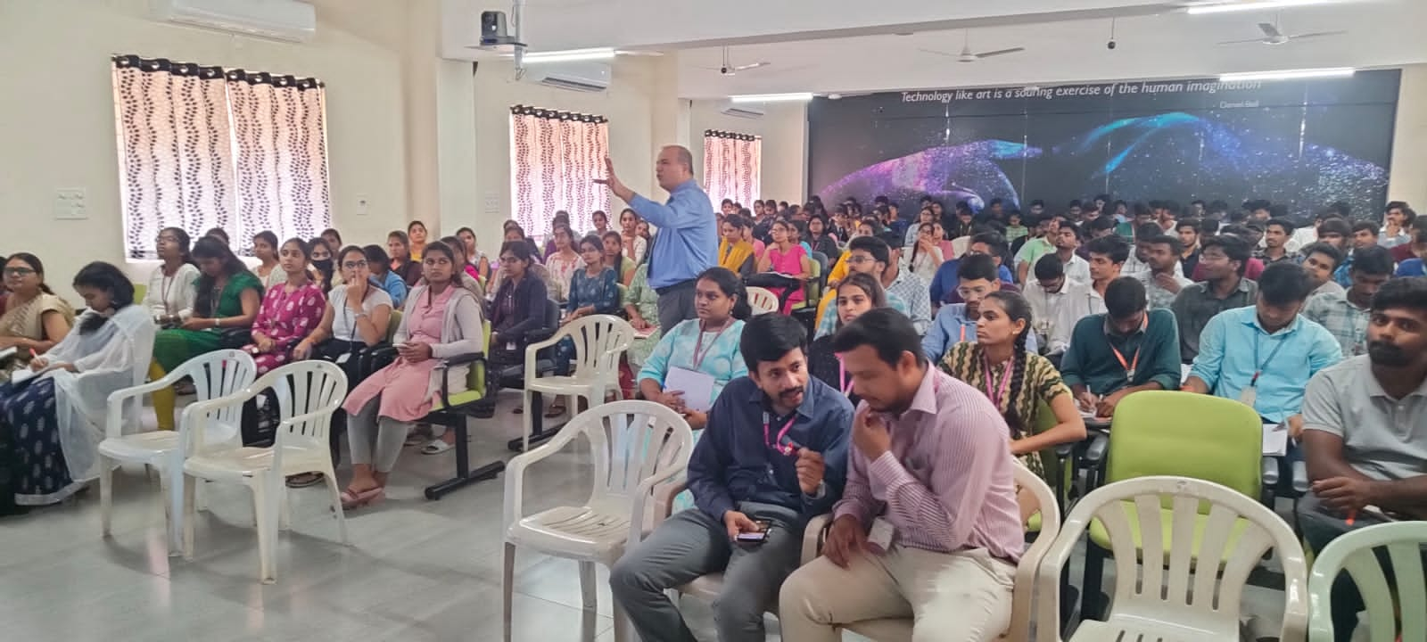

Complete Report: PDF File max size 2MB (Report includes Brochure, Approval letters, Budget Utilization, One page write-up, Objectives and Outcomes, Event Content, Resource Person Profiles, Photos (Atleast 6 -12 Photos, Student signed Attendance Report, Feedback, News Coverage, Social Media Links.)

Program schedule:

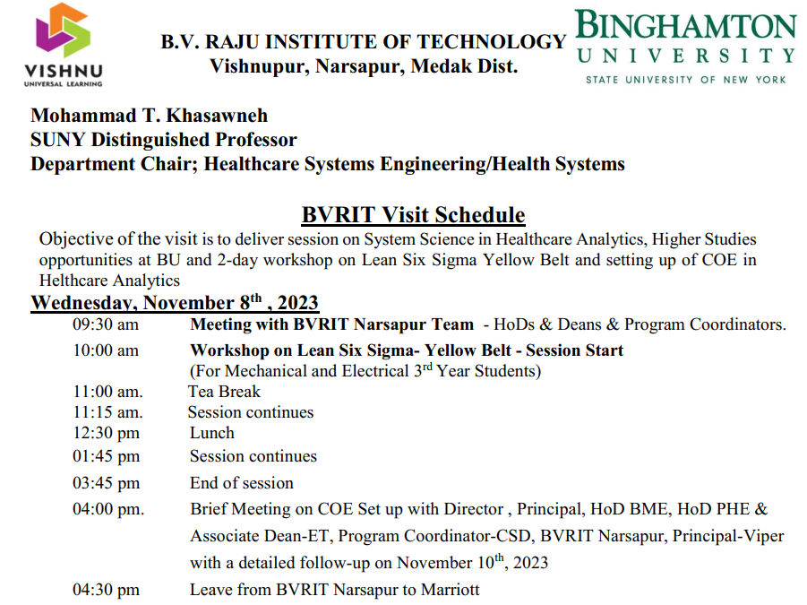

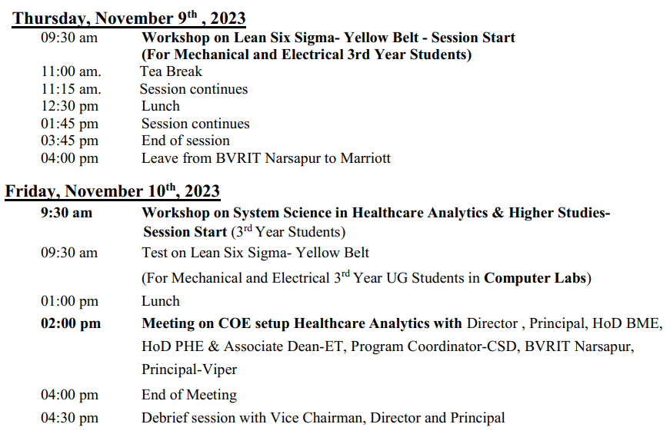

List of students participated in the program

|  |  |  |  |  |
| --- | --- | --- | --- | --- |
| **S.No** | **Roll Number of the student** | **Name of the student** | **College** | **Branch** |
| 1 | 20WH1A0225 | Kethavath Renuka | BVRITH | EEE |
| 2 | 20WH1A0239 | Sneha Manoharan | BVRITH | EEE |
| 3 | 20wh1a0243 | R.likhitha | BVRITH | EEE |
| 4 | 20WH1A0226 | Chandana Rapelly | BVRITH | EEE |
| 5 | 20wh1a0240 | GVS Snehitha | BVRITH | EEE |
| 6 | 20wh1a0207 | J.Divya | BVRITH | EEE |
| 7 | 22215A0352 | A.sai srikar | BVRITN | MECH |
| 8 | 22215A0308 | Ravuri Bhargava Ram | BVRITN | MECH |
| 9 | 22215a0321 | M. Manoher | BVRITN | MECH |
| 10 | 22215a0330 | Pavan kumar | BVRITN | MECH |
| 11 | 22215a0345 | D.SAI KOUSHIK | BVRITN | MECH |
| 12 | 21211a0839 | Shireen Fathima | BVRITN | CHEM |
| 13 | 21211a0354 | VANGARI SAIKIRAN | BVRITN | MECH |
| 14 | 21211a0347 | Silamkota vishnu | BVRITN | MECH |
| 15 | 22215a0360 | K.shiva sharan | BVRITN | MECH |
| 16 | 22215a070 | J upender | BVRITN | MECH |
| 17 | 22215a0365 | GONTELA SRIKANTH | BVRITN | MECH |
| 18 | 21211a0815 | Anjali kanganti | BVRITN | CHEM |
| 19 | 22215a0334 | KUMMARI RAKESH | BVRITN | MECH |
| 20 | 22215a0353 | V. Sai Teja | BVRITN | MECH |
| 21 | 21211a0802 | B.Viswa Vathsa | BVRITN | CHEM |
| 22 | 21211a0319 | K.sai ram chary | BVRITN | MECH |
| 23 | 22215a0359 | G Shiva Shanker Chary | BVRITN | MECH |
| 24 | 22215A0350 | AMBATI SAIRAM | BVRITN | MECH |
| 25 | 22215A0376 | Vivek Siripuram | BVRITN | MECH |
| 26 | 21211A0346 | Shameerpet Bhavya Sree | BVRITN | MECH |
| 27 | 22215a0327 | Chandampeta Nikhil | BVRITN | MECH |
| 28 | 21211a0803 | Chepyala Shivani Reddy | BVRITN | CHEM |
| 29 | 22215a0346 | CH.SAI KUMAR | BVRITN | MECH |
| 30 | 21211a0323 | KOTHAPALLI KASHI VISHWANATH | BVRITN | MECH |
| 31 | 22215a0323 | Mohammed Sameer Ahmed | BVRITN | MECH |
| 32 | 22215a0373 | M.vigneshwar reddy | BVRITN | MECH |
| 33 | 21211a0842 | Praveen | BVRITN | CHEM |
| 34 | 22215a0301 | Abhija Sunkara | BVRITN | MECH |
| 35 | 21211a0343 | Pundru Bhavana | BVRITN | MECH |
| 36 | 22215A0303 | P AKHIL | BVRITN | MECH |
| 37 | 22215A0356 | Shaik faizul abiddin | BVRITN | MECH |
| 38 | 22215a0804 | Burra pavan | BVRITN | CHEM |
| 39 | 22215A0335 | Y. Rakesh vardhan | BVRITN | MECH |
| 40 | 22215a0342 | Talari Sai Ganesh | BVRITN | MECH |
| 41 | 21211A0304 | Saketh sarma | BVRITN | MECH |
| 42 | 22215a0336 | Ramesh Budala | BVRITN | MECH |
| 43 | 22215a0332 | ATHKURI PRASAD | BVRITN | MECH |
| 44 | 22215a0304 | Kummari Anil kumar | BVRITN | MECH |
| 45 | 22215a0318 | G.Mahender reddy | BVRITN | MECH |
| 46 | 22215a0805 | V ramesh babu | BVRITN | CHEM |
| 47 | 22215a0358 | M.SHIVA | BVRITN | MECH |
| 48 | 22215A0361 | Polasa Shivani | BVRITN | MECH |
| 49 | 22215A0349 | Gujjari Sai Prakash | BVRITN | MECH |
| 50 | 22215A0810 | P. Susheel Kumar | BVRITN | CHEM |
| 51 | 22215A0358 | Mailagani shiva | BVRITN | MECH |
| 52 | 22215a0326 | Vinayak Akena | BVRITN | MECH |
| 53 | 22215A0344 | Kota Sai Kiran Somana | BVRITN | MECH |
| 54 | 22215a0331 | Pranay | BVRITN | MECH |
| 55 | 22215A0313 | V Gagan deep | BVRITN | MECH |
| 56 | 22215a0306 | DYAGATI ANUSHA | BVRITN | MECH |
| 57 | 22215A0329 | Billa Pallavi | BVRITN | MECH |
| 58 | 22215A0320 | Mallesham | BVRITN | MECH |
| 59 | 22215a0325 | Mukesh | BVRITN | MECH |
| 60 | 22215A0328 | Ch.Nithish Kumar | BVRITN | MECH |
| 61 | 22215a0364 | BOINI SRIKANTH | BVRITN | MECH |
| 62 | 22215a0314 | Golla Hareesh | BVRITN | MECH |
| 63 | 21211a0814 | K krishna | BVRITN | CHEM |
| 64 | 21211A0837 | Shaik Firdos | BVRITN | CHEM |
| 65 | 21211A0355 | Varaganti Saikumar | BVRITN | MECH |
| 66 | 21211A0345 | S. Md. Aadil | BVRITN | MECH |
| 67 | 22215a0315 | GADILA HRITHIKESH REDDY | BVRITN | MECH |
| 68 | 22215a0366 | V. T. B. Thrishank | BVRITN | MECH |
| 69 | 21211A0325 | L.Yashwanth | BVRITN | MECH |
| 70 | 21211a0338 | PATANGE SANHEETH KUMAR | BVRITN | MECH |
| 71 | 21211A0333 | M.Mahesh Goud | BVRITN | MECH |
| 72 | 21211A0357 | Nandarapu Dhanush | BVRITN | MECH |
| 73 | 21B01A0337 | P.jayasri | SVECW | MECH |
| 74 | 21B01A0305 | A S M S DEEPIKA | SVECW | MECH |
| 75 | 22B05A0304 | M.Jaya sri | SVECW | MECH |
| 76 | 21b01a0332 | L.B.K.L.Manikyamba | SVECW | MECH |
| 77 | 21B01A0344 | P.s.s.n.surekha | SVECW | MECH |
| 78 | 21B01A0312 | Dandu Kasi Annapurna | SVECW | MECH |
| 79 | 21B01A0316 | Komya harini Donga | SVECW | MECH |
| 80 | 21B01A0333 | Usha sri Maddukuri | SVECW | MECH |
| 81 | 21B01A0325 | K.Malleswari | SVECW | MECH |
| 82 | 21b01a0323 | J. Supraja devi | SVECW | MECH |
| 83 | 21b01a0347 | Siva parvathi Sameerupeta | SVECW | MECH |
| 84 | 21b01a0320 | Gorrela.Navya | SVECW | MECH |
| 85 | 21b01a0319 | Madhu Haritha Goriparthi | SVECW | MECH |
| 86 | 21b01a0301 | ADABALA PRANAVI | SVECW | MECH |
| 87 | 21B01A0334 | HARIKA MALLISETTY | SVECW | MECH |
| 88 | 21b01a0324 | Sirisha Javvadi | SVECW | MECH |
| 89 | 21B01A0309 | Chalapati Mounika | SVECW | MECH |
| 90 | 21B01A0314 | D.H.Pravallika devi | SVECW | MECH |
| 91 | 21b01a0355 | V.Bhavya Lakshmi | SVECW | MECH |
| 92 | 21B01A0350 | S. Rama satya swathi | SVECW | MECH |
| 93 | 21B01A0311 | Chitturi Roja | SVECW | MECH |
| 94 | 21B01A0313 | Dandu yasaswini naga sai sirisha | SVECW | MECH |
| 95 | 21B01A0340 | Panja Deepthi Sri Satya | SVECW | MECH |
| 96 | 22B05A0301 | CHUNDRU SWATHI DURGA | SVECW | MECH |
| 97 | 22b05a0303 | M Deepthi | SVECW | MECH |
| 98 | 21B01A0335 | M.SUSHMA | SVECW | MECH |
| 99 | 21B01A0303 | Devi Sri Lakshmi | SVECW | MECH |
| 100 | 21B01A0345 | Penmetsa Harika | SVECW | MECH |
| 101 | 21B01A0331 | KUNAPARAJU CHINMAYI SAI | SVECW | MECH |
| 102 | 21dh1r0037 | G.Ramya sree | VIPER | VIPER |
| 103 | 21dh1r0031 | Manasa patnaik | VIPER | VIPER |
| 104 | 21dh1r0082 | R.Sahitya Madhuri | VIPER | VIPER |
| 105 | 21dh1r0029 | Dhannaram Navya | VIPER | VIPER |
| 106 | 21dh1r0013 | Apurva Masireddy | VIPER | VIPER |
| 107 | 20dh1r0063 | N.vyshnavi | VIPER | VIPER |
| 108 | 21dh1r0014 | Akshitha | VIPER | VIPER |
| 109 | 21dhr00a6 | Vishwagna reddy patlolla | VIPER | VIPER |
| 110 | 21DH1R0045 | Kasa sai Namitha laharika | VIPER | VIPER |
| 111 | 21dh1r0063 | Sai jayachandra | VIPER | VIPER |
| 112 | 21dh1r0080 | R Madhuri | VIPER | VIPER |
| 113 | 21dh1r0044 | K. Loukya | VIPER | VIPER |
| 114 | 21dh1R0026 | D.sangeetha | VIPER | VIPER |
| 115 | 21dh1r0043 | K.Vennela | VIPER | VIPER |
| 116 | 21dh1r00a0 | Vaddadi Vaishnavi | VIPER | VIPER |
| 117 | 21dh1r0020 | B Gayathri | VIPER | VIPER |
| 118 | 21dh1r0051 | K.shiva bindu | VIPER | VIPER |
| 119 | 21DH1R0039 | Hima Bindhu Indukuri | VIPER | VIPER |
| 120 | 21DH1R0098 | T.Sharath Chandrika | VIPER | VIPER |
| 121 | 20dh1r0022 | Edara.Kyathi nandini | VIPER | VIPER |
| 122 | 20dh1r0029 | G Sri vaishnavi | VIPER | VIPER |
| 123 | 21dh1R0006 | S Shivani | VIPER | VIPER |
| 124 | 20DH1R0066 | Nayakwadi Pravalika | VIPER | VIPER |
| 125 | 20DH1R0017 | Ch pooja | VIPER | VIPER |
| 126 | 20DH1R0008 | Athelli Sai Pranavi | VIPER | VIPER |
| 127 | 20PA1A0376 | MOHANKRISHNA PALAVALASA | VIT | MECH |
| 128 | 21PA5A0334 | YELLAPU SESHU | VIT | MECH |
| 129 | 21PA5A0320 | MANEM LINGAMURTY | VIT | MECH |
| 130 | 20PA1A0321 | Ch.Bhanu prakash | VIT | MECH |
| 131 | 20PA1A0381 | PITHANI HIMAGIRI | VIT | MECH |
| 132 | 21PA5A0314 | KAMIDI VENKATA SAI SAMEER | VIT | MECH |
| 133 | 20PA1A0310 | BALUSU SONENDRA CHOWDARY | VIT | MECH |
| 134 | 20PA1A0307 | B Sri Naga Amar | VIT | MECH |
| 135 | 20PA1A0358 | KUNKATI LEELA KRISHNA CHANDRA SEKHAR | VIT | MECH |
| 136 | 20PA1A0369 | MOLLETI MADHU SAI | VIT | MECH |
| 137 | 21PA5A0307 | BUDIGINA SAI KIRAN | VIT | MECH |
| 138 | 20PA1A0342 | KADIMI PAVAN NAGA SAI KUMAR | VIT | MECH |
| 139 | 20pa1a0373 | Nandivada.Hema Latha Durga | VIT | MECH |
| 140 | 20PA1A0336 | GUNNAM LOKESWARA RAO | VIT | MECH |
| 141 | 20pa1a0318 | BOTSA SUNEEL | VIT | MECH |
| 142 | 21PA5A0333 | YARRAMSETTI JANAKI RAMA NAGA KANAKAM | VIT | MECH |
| 143 | 20PA1A0365 | MATTAPARTHI TEJASWA | VIT | MECH |
| 144 | 20PA1A0355 | Korasika Vaishnavi | VIT | MECH |
| 145 | 20pa1a0356 | Kosuri Daakshinya | VIT | MECH |
| 146 | 20PA1A0353 | KOKKIRALA JITENDRA VENKATA SAI RAM VAMSI | VIT | MECH |
| 147 | 21PA5A0326 | Pitaka Kumarsai deep | VIT | MECH |
| 148 | 20PA1A03A4 | G S Lakshmi meghana Vishnuvarjula | VIT | MECH |
| 149 | 20pa1a0335 | Guduri pavani | VIT | MECH |
| 150 | 20PA1A0364 | Mantena. Yamini | VIT | MECH |
| 151 | 21PA5A0304 | BALLAVARAPU VENKATA SAI PRASAD | VIT | MECH |