B. V. RAJU INSTITUTE OF TECHNOLOGY

(UGC-AUTONOMOUS, Accredited by NBA, NAAC, Affiliated to JNTU Hyderabad & Approved by A.I.C.T.E)

**Vishnupur, Narsapur, Medak (Dt.), Telangana 502313**

**Report**

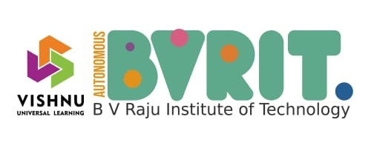

**DEPARTMENT OF ELECTRICAL AND ELECTRONICS ENGINEERING**

&

BVRIT IEEE SB & IEEE PES CHAPTER

**Institution’s Innovation Council-6.0**

Organized

Two Days Workshop on

Prototype/Process Design and Development

8th & 9th August 2024

10:00 AM to 1.00 PM

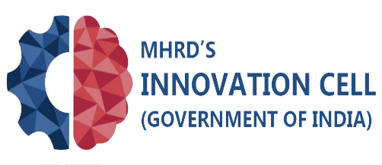  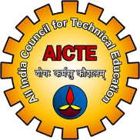 



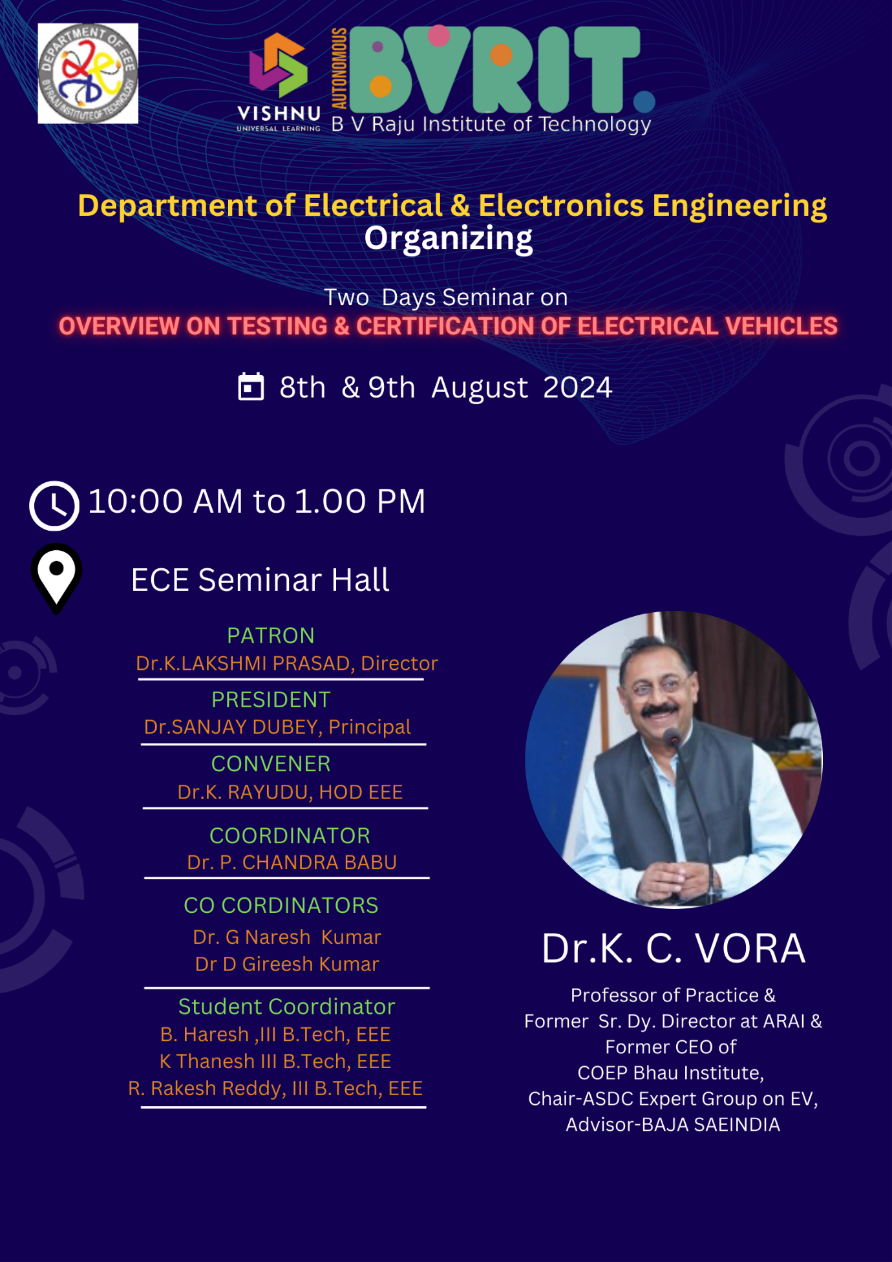

The Department of Electrical and Electronics Engineering (EEE) and the BVRIT IEEE SB & IEEE PES Chapter, organized a two-day workshop titled “**Overview on Testing & Certification of Electrical Vehicles**” on the 8th and 9th of August 2024, from 10:00 AM to 1:00 PM. The workshop was coordinated by **Dr. P. Chandra Babu**, Associate Professor, Department of EEE, with **Dr. G. Naresh Kumar**, Assistant Professor, and **Dr. D. Gireesh Kumar**, Associate Professor, serving as co-coordinators.

The event was inaugurated by the Principal and the Head of the Department (HOD), EEE.

Dr. P. Chandra Babu welcomed the participants and outlined the objectives and schedule of the two-day program. Following this, the HOD and Principal shared their perspectives on the importance of testing and certification in the context of electric vehicles.

Subsequent sessions featured expert speakers who delved into various aspects of the topic. The event concluded with a vote of thanks delivered by Dr. G. Naresh Kumar and Dr. D. Gireesh Kumar, acknowledging the contributions of the organizers, speakers, and participants.

**Objectives of the Workshop**

**1.Understanding Standards and Protocols:** To familiarize participants with the fundamental standards, protocols, and certifications required for electric vehicles **(EVs), and** testing methodologies involved in evaluating the safety, reliability, and performance of EV components and systems.

**2. Exploring Emerging Trends:** To discuss the latest advancements, challenges, and opportunities in the field of electric vehicle testing and certification.

Duration: 6 Hours

Total students attended: 75

Total faculty attended:10

Budget: 5500/-

**Chief Patron:**

Sri K V Vishnu Raju, Hon’ble Chairman, Sri Vishnu Educational Society.

**Patrons:**

Sri Ravichandran Rajagopal, Vice- Chairman, Sri Vishnu Educational Society.

Sri K. Aditya Vissam, respected Secretary, Sri Vishnu Educational Society.

**Co-Patron:**

Dr.K.LAKSHMI PRASAD, Director,BVRIT

**PRESIDENT**

Dr. Sanjay Dubey, Principal, BVRIT

CONVENER

Dr.K. RAYUDU, HOD EEE

**COORDINATOR**

Dr. P. CHANDRA BABU

**CO-CORDINATORS**

Dr. G Naresh Kumar

Dr D Gireesh Kumar

**Student Coordinator**

B. Haresh ,III B.Tech, EEE K Thanesh III B.Tech, EEE R. Rakesh Reddy, III B.Tech, EEE

**Speaker Details**:

Dr. K. C. VORA

Professor of Practice & Former Sr. Dy. Director at ARAI & Former CEO of COEP Bhau Institute, Chair-ASDC Expert Group on EV, Advisor-BAJA SAEINDIA

DAY – I

SEMINAR

The event started by an Inauguration function, with the Welcome address from the Program co-coordinator Dr.P Chandrababu to the Chief Guest Dr.K C Vora, Principal Dr. Sanjay Dubey, Head of the Department Dr. K Rayudu, Faculties and Participants. Dr. P Chandrababu has addressed the schedule regarding the two days workshop. The principal Dr Sanjay Dubey has addressed on the importance of the prototype design need. The Head of the Department Dr. K Rayudu, have addressed the various tools used in prototype design by EEE students and its challenges. The resource person Dr KC Vora has started the session with brief introduction on the topic followed with the challenges and tools, market trends. Conceptualization, Sketching/Modeling and Material Selection. Question and Answer Session from the participants. Finally, the session on First day was concluded with the closing remarks by Dr G Naresh Kumar.

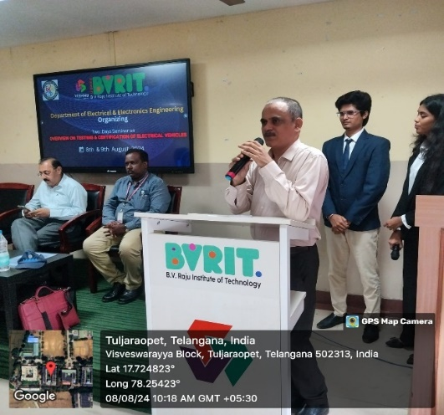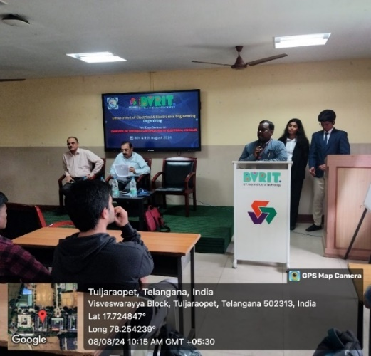

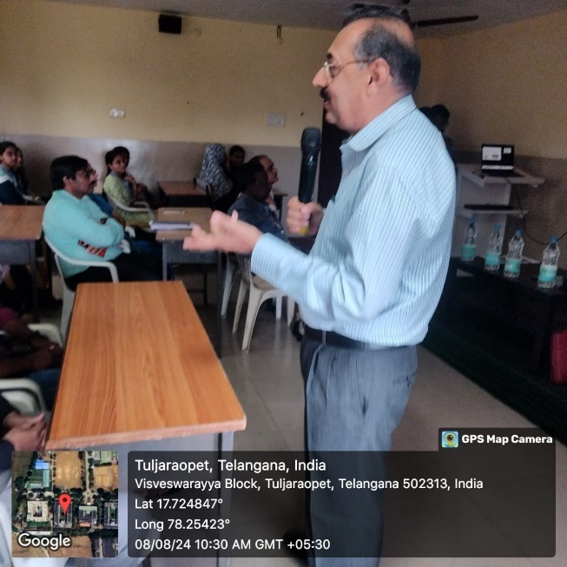

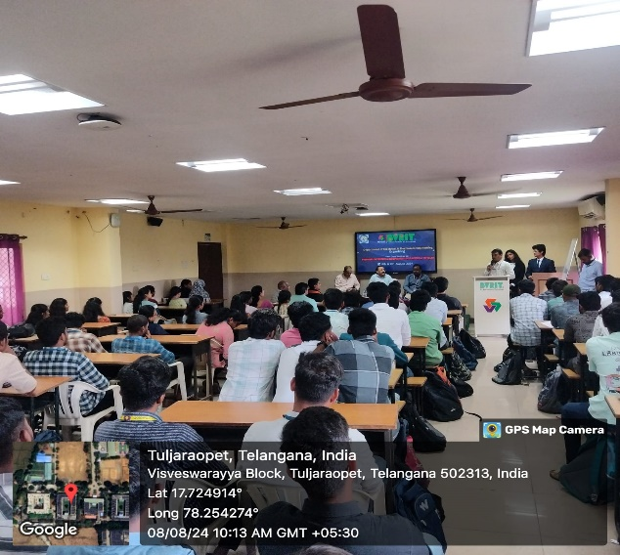 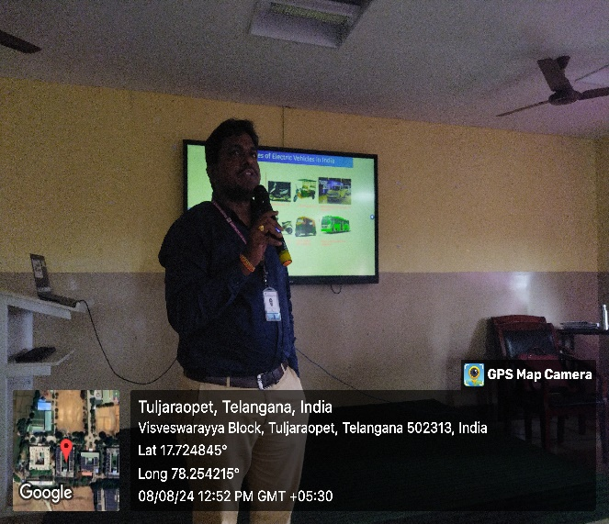

DAY – II

On the Second day, the resource person Dr KC Vora has started the session with the Prototyping Tools (**Physical Prototyping:** Using tools like 3D printers, CNC machines, or manual fabrication techniques. **Digital Prototyping:** Using CAD software, design platforms, or code to create virtual prototypes). Process Design and Development, Importance of Prototype/Process Design and Development and addressed the Question and Answer Session from the participants. Finally, the two day seminar was concluded with the vote of thanks by Dr G Naresh Kumar (Prototype and process design and development are critical in transforming ideas into functional products and efficient systems. Through iterative design, testing, and refinement, businesses can ensure that their solutions meet user needs and market demands while optimizing resources and reducing risks)

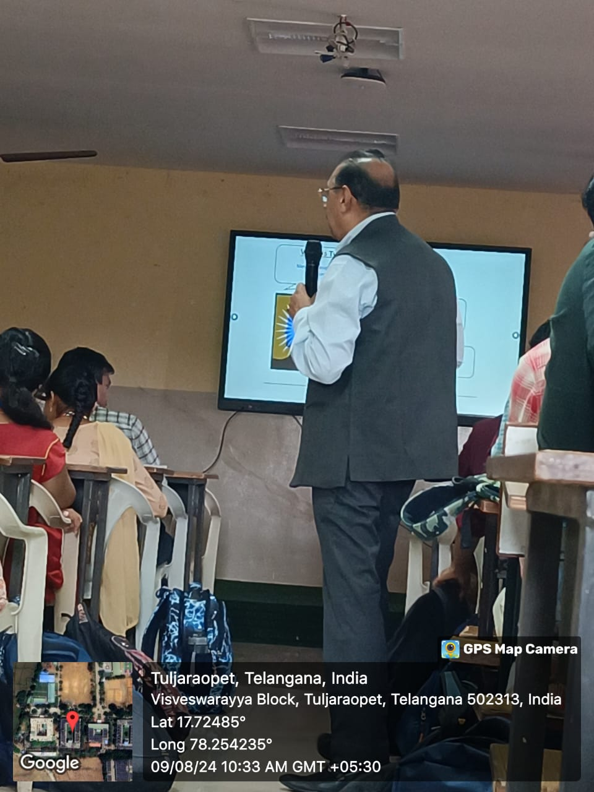

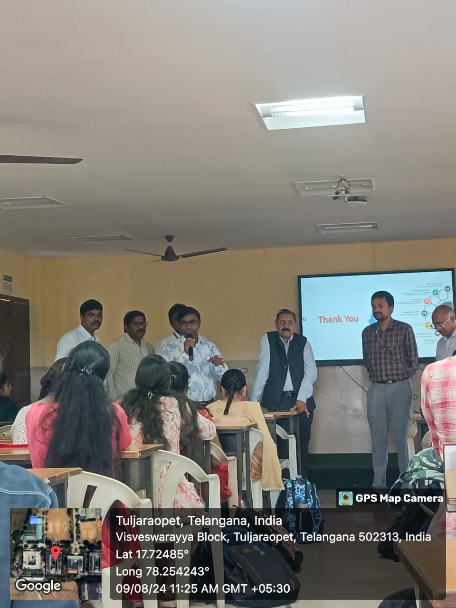

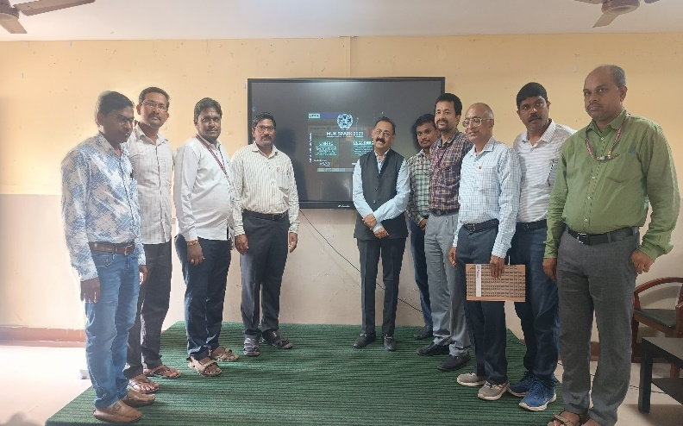

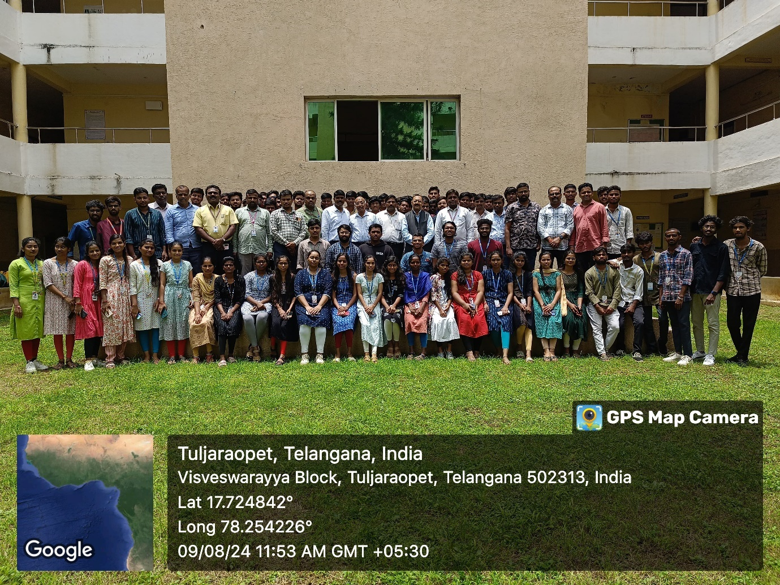

Day -1

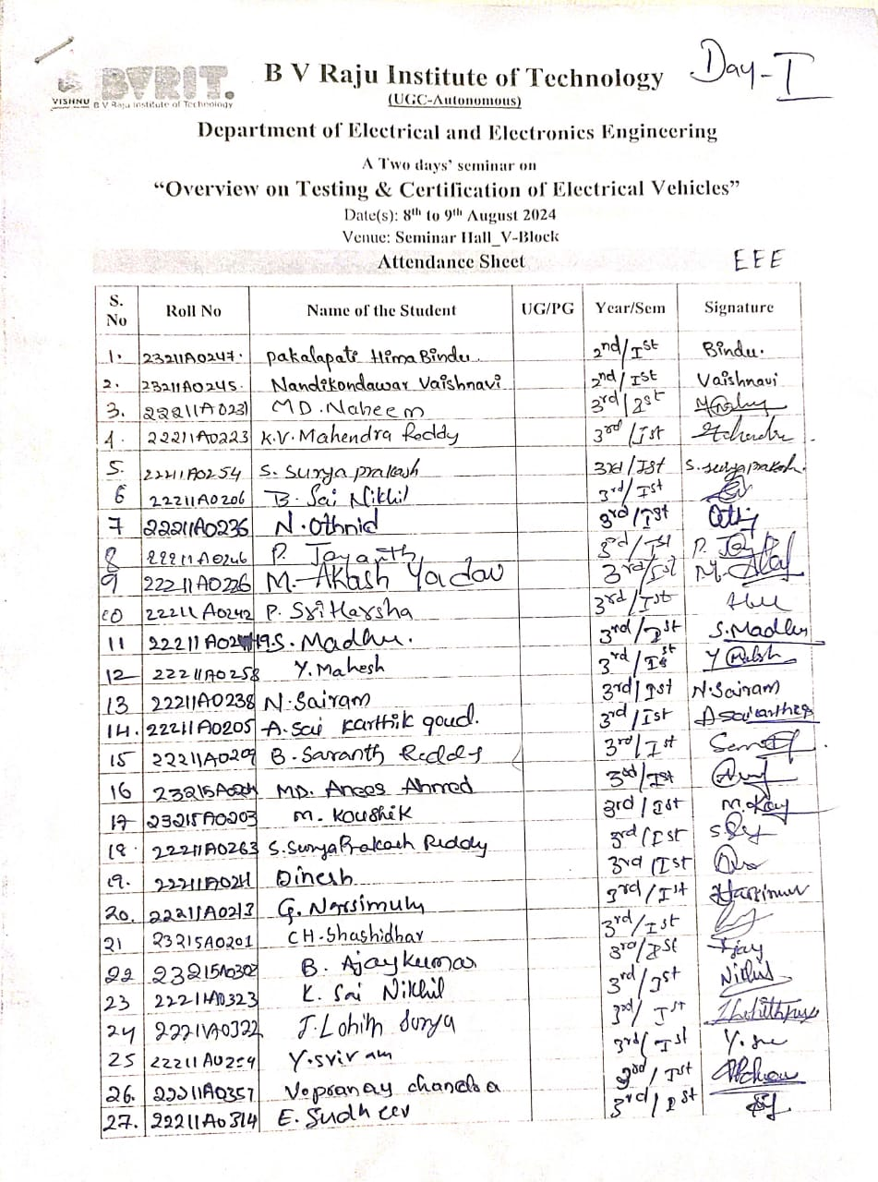

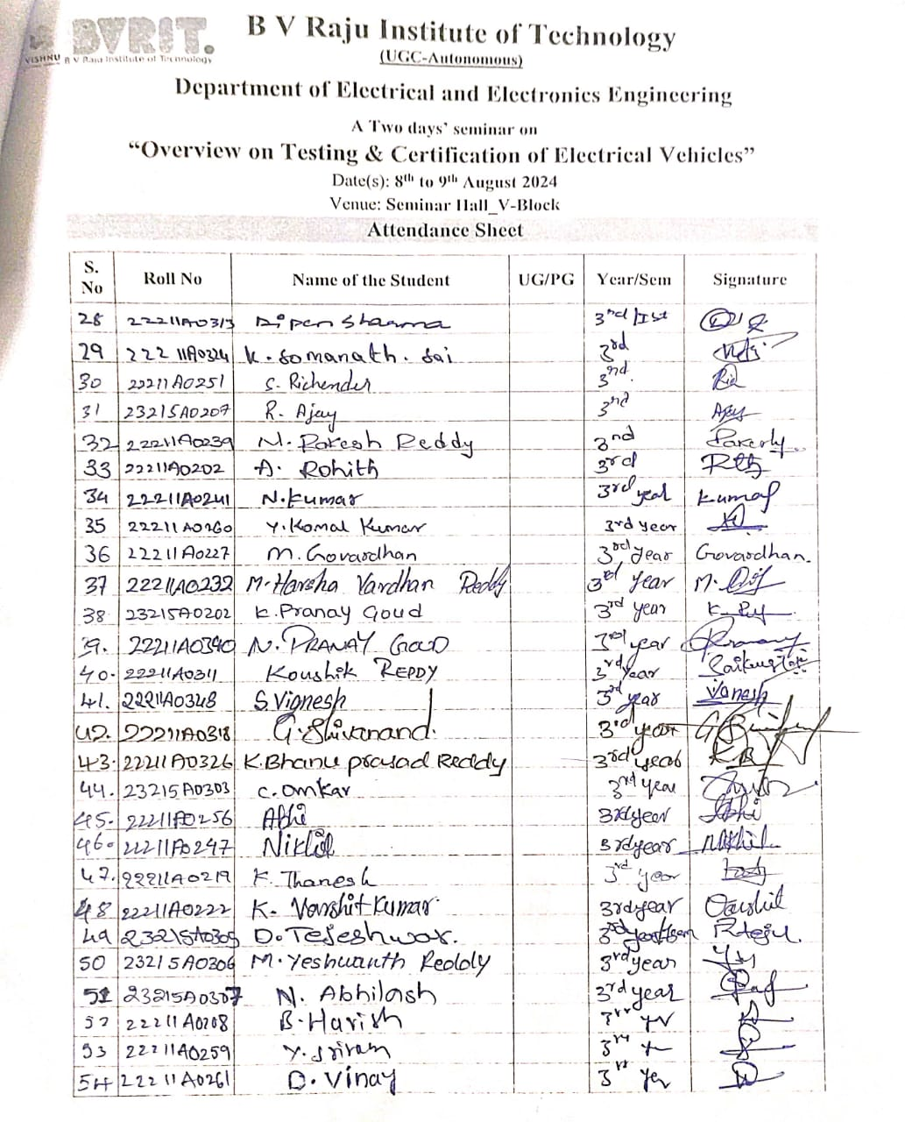

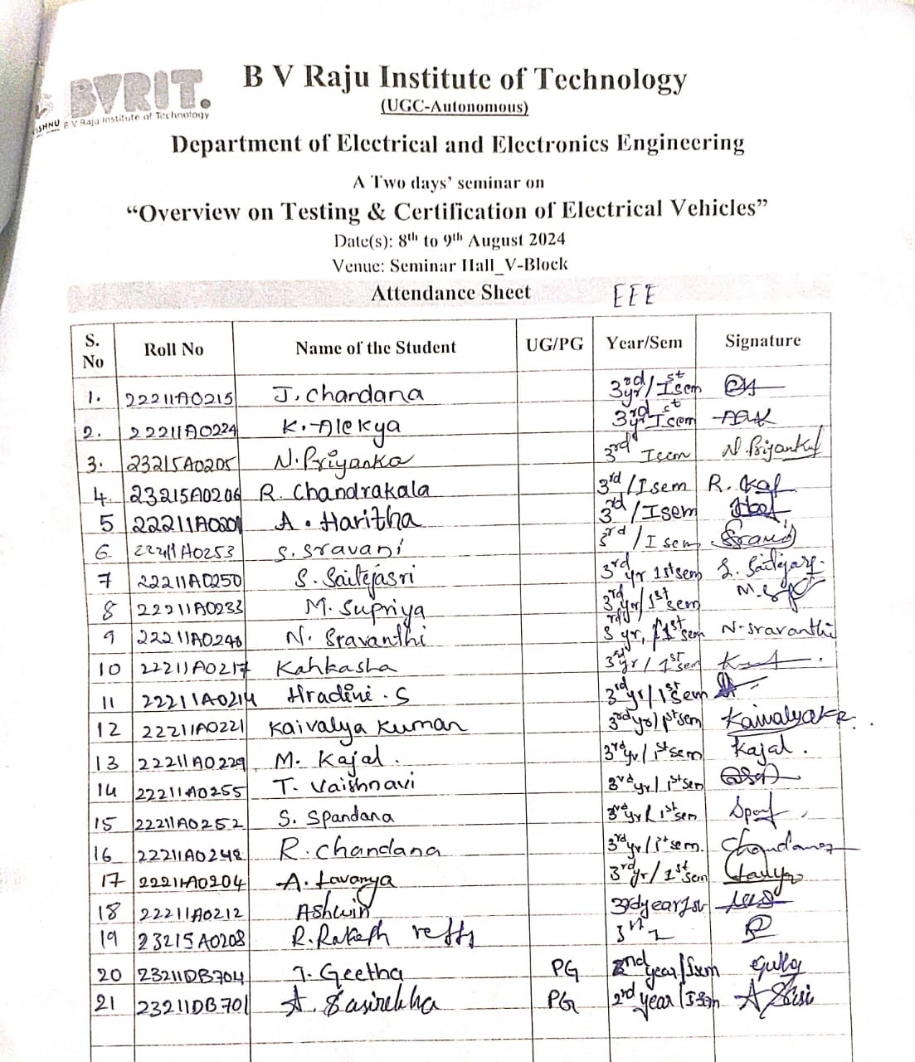

Day -2

