# Department of Humanities and Sciences

## 

## Report on ICAMADA-2024

## Track: Mathematics

**Venue: VJIM AUDITORIUM**

## Day-1: 25thApril, Thursday, 2024

International Conference on Applied Mathematics and Advanced Data Analytics for Industry 5.0, (ICAMADA-2024) Organized by the Department of Humanities and Sciences (Mathematics), CSE-(CyS,DS) and AI&DS, VNR Vignana Jyothi Institute of Engineering and Technology, Hyderabad, Telangana, India-500 090 in collaboration with Andhra Pradesh and Telangana Society for Mathematical Sciences (APTSMS) and Cyber Security Center of Excellence (CCOE) co-hosted by National Remote Sensing Center (NRSC), ISRO.

The programme started with a very energetic traditional dance by team Nrithya Tarang

It was followed by inviting the dignitaries on to the stage.

1. Dr.T.Jaya Shree, Head, Department of Humanities& Sciences, VNRVJIET, Conference Chair, ICAMADA-2024
2. Dr. B. Chennakesava Rao, Director-Advancement, VNRVJIET
3. Dr.C.D.Naidu, Principal, VNRVJIET
4. Er.J.S.Rao, General Secretary, Vignana Jyothi
5. Lt. General Girish Kumar,Advisor to the Ministry of External Affairs, New Delhi.
6. Mrs. Ritu Karidhal, Senior Scientist, Indian Space Research Organization (ISRO)
7. Prof. Arun Kumar Pujari, Advisor & Professor Emeritus, Department of CSE, Mahindra University, Hyderabad
8. Dr.K.Sreenivas, Scientist / Engineer-G and Deputy Director,

Remote Sensing Applications Area, National Remote Sensing Center, Hyderabad

1. Dr.Sriram Birudavolu, CEO, Cyber Security Centre of Excellence, Hyderabad,

Conference Chair, ICAMADA-2024

1. Prof. D. Srinivasacharya, President - APTSMS, NIT Warangal
2. Dr. Ravi Sadasivuni, Visiting Professor, VNR VJIET (AGU Nominated Scientist for the state of Mississippi University, USA), Conference Chair, ICAMADA-2024

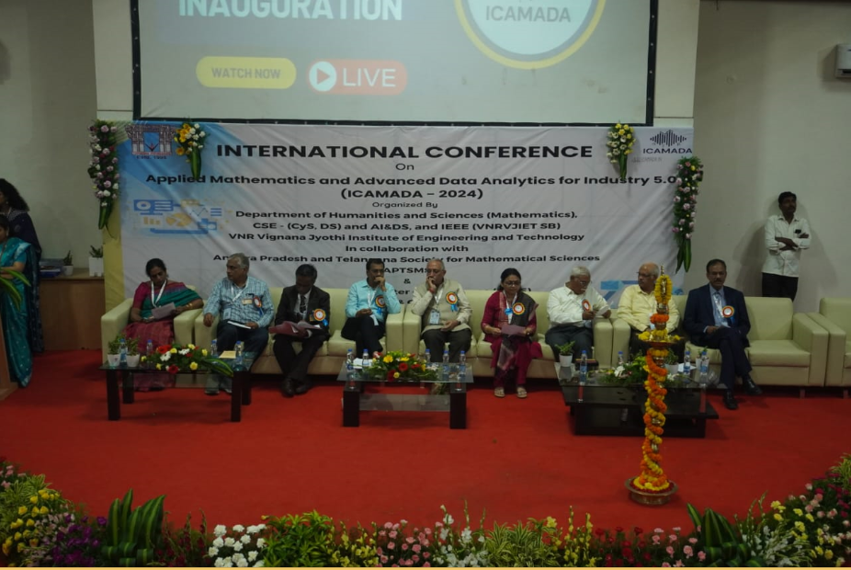

The guests were welcomed to the lightning of lamp followed by a prayer song. In the outset, the hosts of the event briefed about VNRVJIET.

The conference's official inauguration was preceded by the launch of the souvenir.After the official inauguration ceremony, the dignitaries addressed the gathering.

**Lt General Girish Kumar** gave a stirring speech on the technologies used to calculate the positions on earth and their gradual improvement and encouraged the young minds to continue further research in geospherical fields using deep learning.

**Ms. Ritu Karidhal**, a senior scientist in ISRO talked about the challenges faced by ISRO and their ways of overcoming them to success. She gave insights into the Aryabhata, Chandrayan1, Mars project and the solving of 4 body problems into a 2 body problem. She also gave useful data collection sites to further their research in this field.

**Prof.Arun Kumar Pujari** impelled the audience to visit the Buddha statue in Hyderabad as he spoke about the controversies and other informative things about its construction. He related this to the importance of doing precise calculations for safety and efficiency.

**Dr.Sriram Birudavolu** emphasized on the importance of cyber security and the threats of cyber-crimes.

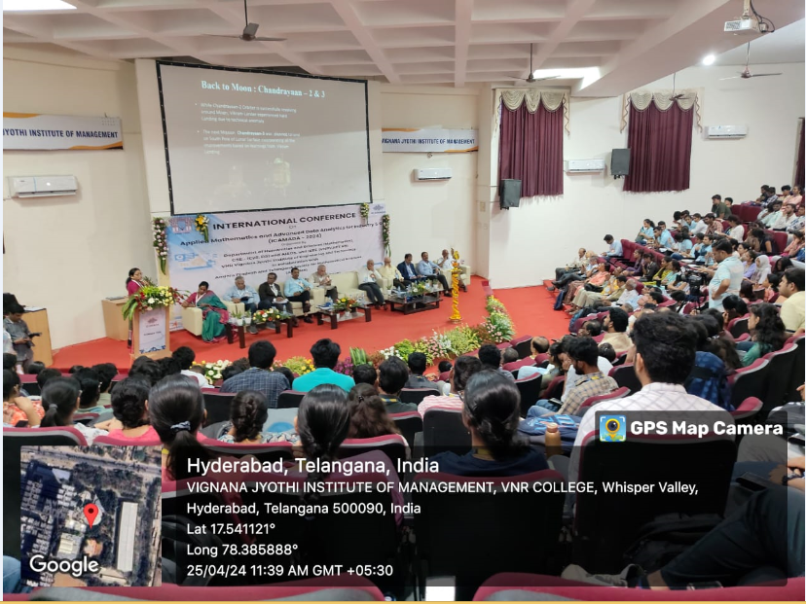

The inauguration ceremony ended in a spectacular fashion with the felicitation of esteemed dignitaries, followed by a group photo. This event left a lasting impact on the students as they were deeply inspired by the distinguished guests and the occasion's significance.

**Key note speakers sessions:**

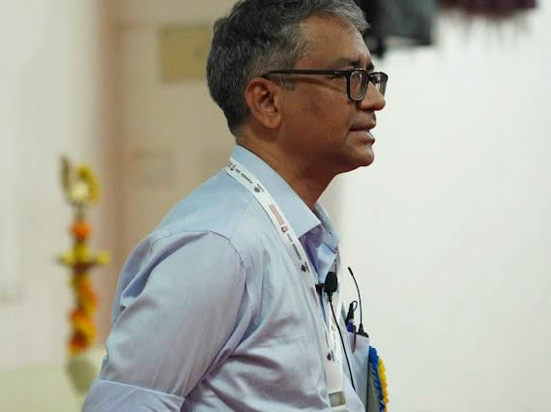**1.**

## Prof. B.S. DayaSagar

**Title:** Overview on Mathematical Morphology, Fractals

And Power- Laws in (Geo) Spatial Sciences

His introduction remarks “There is no Artificial Intelligence without Natural Intelligence”explained everything he was going to say. He passionately talked about its applications in the fields of geoscience, remote sensing etc. He explained about the algorithm implementation of morphology. Elaborate discussions were made about practical geometry and geo spatial data sciences. He emphasized “My algorithms can never go wrong given that the data set is correct, because it is based on the mathematical formula”.

# 2.

## Prof. Balasubramaniam Jayaram

**Title:** Searching In (And For) Metric Spaces

His precise explanation of metric spaces and its three conditions -Indisernity, symmetry and triangle inequality. He gave an example of a query searching for easy understanding of the topic. He briefed about the Euclidean distance and triangle inequality emphasizing on its differences. His attention-grabbing comment at the end was “There are only two kinds of mathematics - Applied mathematics and yet to be applied maths”.

## 3. Prof. D. Srinivasacharya

Title: **Artificial Neural network modelling of the Casson**

**fluid flow over unsteady radially stretching sheet**

**with Soret and Dufour effects**

He started with explaining the basics about artificial neural network and its mathematical representation before delving into his research. He highlighted “Neural Network Methods for Solving Boundary Layer Equations”. He spoke in depth about “ANN Solution for the Casson fluid flow over unsteady radially stretching sheet with Soret and Dufour effects”

# 

# Day-2: 26thApril, Friday, 2024

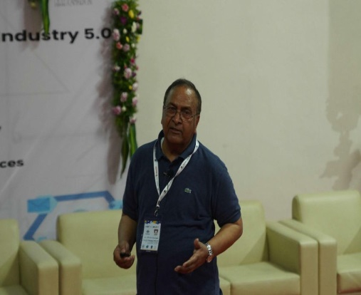**1.**

## Prof. Sat Narain Gupta

Title: Not Reenhancing Trust in Quantitative

Optional Randomized Response Technique (RRT) Models while accounting for measurement errors

He interacted with the audience for their opinions regarding sensitive questions. Then he continued with his own research based experiences after moving to the USA. He insisted on the importance of “Trust”,“optionality”,“RRT”, “Measurement Error” and their codependency for the final results. He referred to Warner and Greenberg models for validating his research. RRT fundamentals, innovation, MOET mean estimator and Auxiliary information was also briefed upon.

## 2. Prof. Aaron Didlake

Title: Harnessing High Performance Computing

and Calming the Network Storm

Awakening the spirits of the audience, he introduced the importance of HPC as pen and paper are no longer enough to do the required calculations no matter how muchof a genius they are. He further emphasized its importance by giving real life examples of how big and small organizations reached out to them for their HPC resources and cross-disciplinary approach. HPC’s growth is only possible through experimental, theoretical, computational and data science. He emphasized on innovative principles like - Multidisciplinary approach, Return to first principles and Simplicity.

# 3.

## Prof. Ganjam Radha krishnamacharaya

Title: **Bio-Fluid Dynamics**

He mainly focused on fluid and bio-fluid dynamics. He strongly believes in the saying “Both living and non living are governed by the same laws of physics”. He explained about newtonian and non-newtonian fluids and continued with different kinds of fluids. He went into detail about the applications like cardio vascularity system, cardiac cycle, pulse identification, heart attack prevention, sphygmomanometer. He summarized it with the importance of mathematics in this subject by taking hemodynamic forces, wave propagation- simple linear model and Moens-Korteweg equation.

## 4. Prof. G.P Raja Sekhar

Title: **Computational Modeling of Composite Fluid-**

**Porous Structures and Gravity Wave**

**Interaction with Coastal Structures**

His approach to make the audience enthusiastic and convey the importance was to provide the current devastated lands due to improper control of floods. Boundary integral equations were explained to validate the need of coastal engineering. He spoke about Multi domain Boundary element method (BEM) and Dual BEM. Such further applications include A/C installation units, carbon capture and Modeling flow through Endothelial Glycocalyx layer (ECL).

5.

**Ramana Reddy A V**

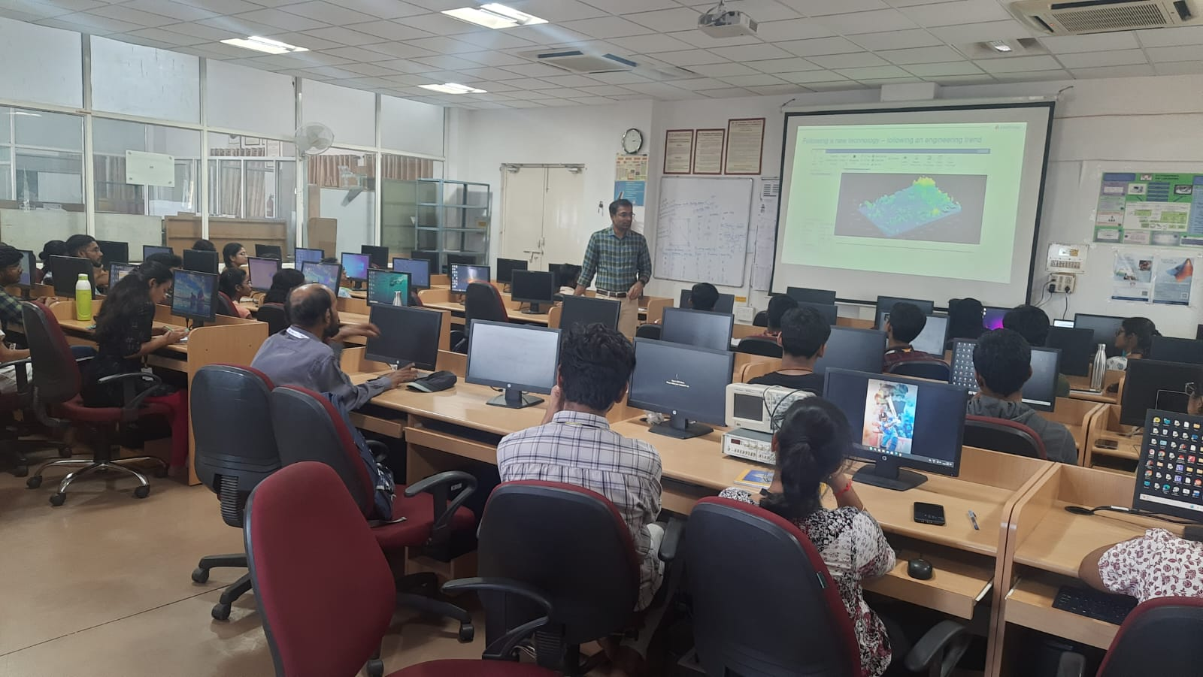

Title: **Enabling Students & Researchers for Digital Transformation across AI, Electrification & Wireless**

Discussed about how Matlab is useful for researchers and students in this AI era. This talk provided a comprehensive overview of the pivotal role these technologies play in contemporary research and education. The session was highly informative, targeting students, researchers, and educators, and it addressed the ways in which digital transformation can be harnessed to drive innovation and advancement in these fields.

# Day-3:

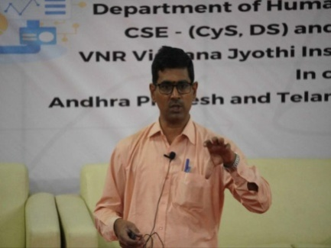**1.**

# 27thApril, Saturday, 2024

## Prof. Subrahmanya Sastry Challa

Title:Compressive Sensing: Theory and applications

The complexity and careful calculations for the placement of geophones in petrol reserve digging was analyzed in depth to understand the use and importance of compressed sensing. He explained about finding sparse solutions of system equations (Problem of scarcity).Further applications which were discussed in depth which are - Medical CBIR , computed tomography and tele-cardiology. He also discussed mathematics behind Machine Learning of how it is experience to expertise.

## 2. Prof. Kottakkaran Sooppy Nisar

## Title: An introduction to intelligent Computing and

## Applications

He initially shares the steps in shaping one's research - existing literature, problem identification, mathematical techniques, analysis and visualization, existing work and its applications. He explained each step with detailed examples like matrix in communication, Pascal’s triangle and results. He also shared his thoughts on a few research papers revolving around intelligent computing and some of the famous algorithms.